END TERM 3 2026
GRADE 10
WOODWORK
CUMULATIVE SUMMATIVE ASSESSMENT
TIME: 2 HOURS 30 MINUTES
TOTAL MARKS: 80
Name | ____________________________________________
Assessment Number | ____________________________________________
Class / Stream | ____________________________________________
Date | ____________________________________________
INSTRUCTIONS TO CANDIDATES
1. Answer ALL questions.
2. Read each question carefully and show clear working where applicable.
3. Study all figures carefully before answering related questions.
4. Use appropriate woodwork terminology.
5. Observe safety requirements when describing tools, equipment and processes.
6. Write neatly in the spaces provided.

EXAMINER'S USE ONLY
Questions | Maximum Score | Candidate Score | Remarks
Q1–Q4 | 22
Q5–Q8 | 25
Q9–Q11 | 19
Q12–Q13 | 14
TOTAL | 80

SECTION A — FOUNDATIONS OF WOODWORK
1. Woodwork and the Workshop. State five reasons why studying Woodwork is important to an individual and the economy. (5 marks)
________________________________________________________________________________
________________________________________________________________________________
________________________________________________________________________________
________________________________________________________________________________
________________________________________________________________________________
________________________________________________________________________________
2. Study Figure 1, a simplified wood workshop layout. (5 marks)
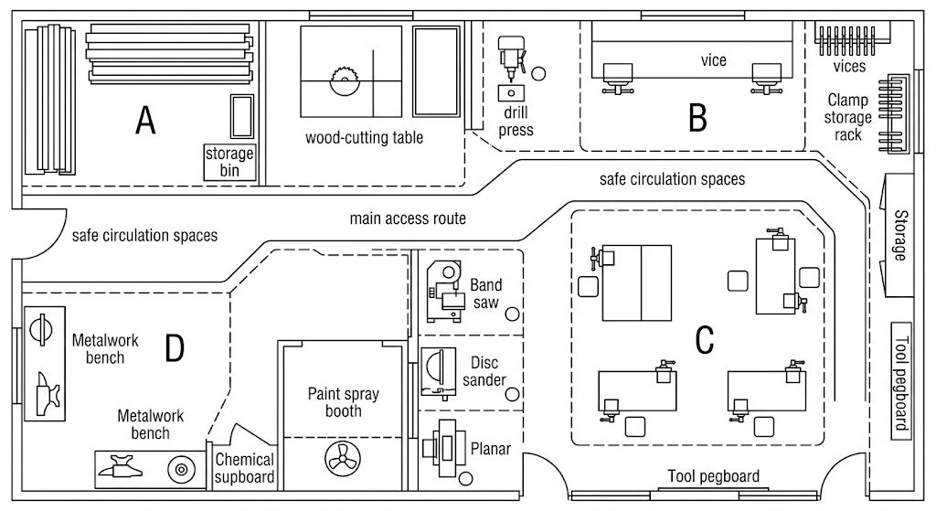
Figure 1
(a) State two features of a well-organised wood workshop that can be identified or inferred from the figure. (2 marks)
________________________________________________________________________________
________________________________________________________________________________
(b) State three safety measures that should be observed in a wood workshop. (3 marks)
________________________________________________________________________________
________________________________________________________________________________
________________________________________________________________________________
3. Hand Tools and Equipment. Study Figure 2. (6 marks)
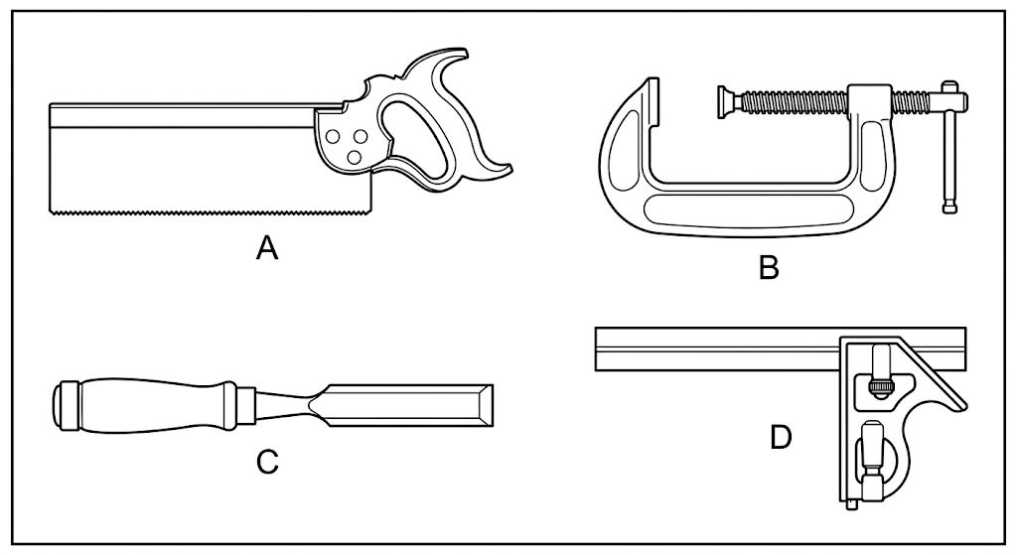
Figure 2
(a) Identify tools A, B, C and D. (4 marks)
________________________________________________________________________________
________________________________________________________________________________
________________________________________________________________________________
________________________________________________________________________________
(b) State two rules for safe care and maintenance of hand tools and equipment. (2 marks)
________________________________________________________________________________
________________________________________________________________________________
4. Materials — Growth of Timber Trees. Study Figure 3. (6 marks)
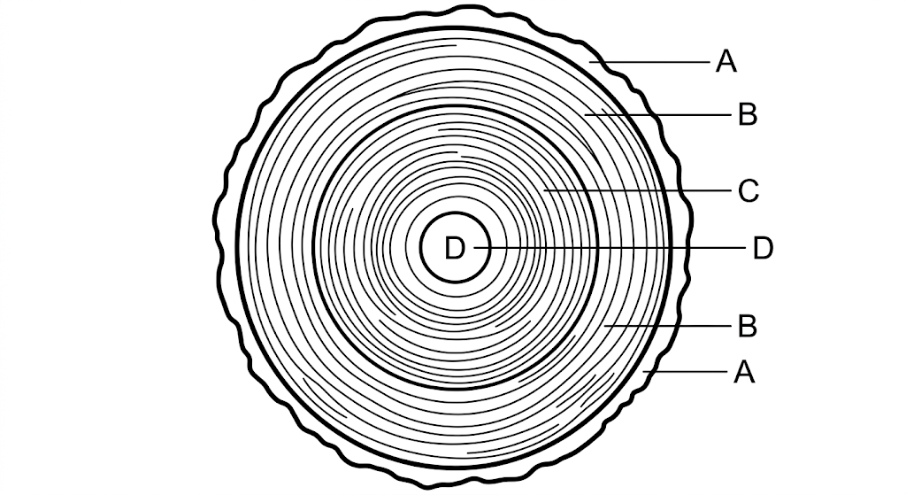
Figure 3
(a) Identify any three parts represented by A–D. (3 marks)
________________________________________________________________________________
________________________________________________________________________________
________________________________________________________________________________
(b) State three reasons why knowledge of tree growth is important in Woodwork. (3 marks)
________________________________________________________________________________
________________________________________________________________________________
________________________________________________________________________________
SECTION B — MATERIALS AND WOOD PROCESSES
5. Timber Conversion and Seasoning. (a) Explain timber conversion. (b) State three methods of timber conversion. (c) Give two reasons why timber seasoning is necessary. (6 marks)
________________________________________________________________________________
________________________________________________________________________________
________________________________________________________________________________
________________________________________________________________________________
________________________________________________________________________________
________________________________________________________________________________
________________________________________________________________________________
6. Adhesives. (a) State three types or classifications of adhesives used in bonding materials. (b) State two precautions when using or disposing of wood adhesives. (5 marks)
________________________________________________________________________________
________________________________________________________________________________
________________________________________________________________________________
________________________________________________________________________________
________________________________________________________________________________
________________________________________________________________________________________________________________________________________________________________
________________________________________________________________________________
________________________________________________________________________________
________________________________________________________________________________
________________________________________________________________________________
________________________________________________________________________________
________________________________________________________________________________
________________________________________________________________________________

7. Preparation of Wood. A learner is preparing a timber piece for a furniture item. State the appropriate tools/equipment and explain five operations that may be carried out during preparation of wood. (7 marks)
________________________________________________________________________________
________________________________________________________________________________
________________________________________________________________________________
________________________________________________________________________________
________________________________________________________________________________
________________________________________________________________________________
________________________________________________________________________________
________________________________________________________________________________
8. Woodworking Joints. Study Figure 4. (7 marks)
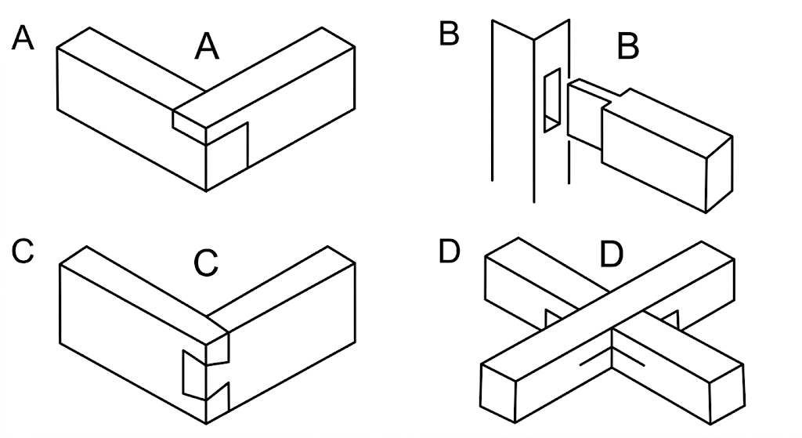
Figure 4
(a) Identify any three joint types represented in the figure. (3 marks)
________________________________________________________________________________
________________________________________________________________________________
________________________________________________________________________________
(b) State two reasons why joints are important in making wood products. (2 marks)
________________________________________________________________________________
________________________________________________________________________________
(c) State two considerations when selecting a joint for a furniture item. (2 marks)
________________________________________________________________________________
________________________________________________________________________________
SECTION C — SURFACE PREPARATION AND PROJECT ACTIVITY
9. Surface Preparation. Explain the purpose of preparing a wooden surface before receiving a finish. State four materials/tools that may be used during surface preparation. (5 marks)
________________________________________________________________________________
________________________________________________________________________________
________________________________________________________________________________
________________________________________________________________________________
________________________________________________________________________________
________________________________________________________________________________
10. Project Activity — Furniture Item. A learner is required to make a small wooden furniture item. Outline eight major stages from selecting materials and tools to final sanding/finishing, including safe working practices. (8 marks)
________________________________________________________________________________
________________________________________________________________________________
________________________________________________________________________________
________________________________________________________________________________
________________________________________________________________________________
________________________________________________________________________________
________________________________________________________________________________
________________________________________________________________________________
________________________________________________________________________________
________________________________________________________________________________
11. Production Decision-Making. A workshop has limited timber, tools and time. Explain six decisions the learner should make to complete the project efficiently while minimising waste and maintaining safety. (6 marks)
________________________________________________________________________________
________________________________________________________________________________
________________________________________________________________________________
________________________________________________________________________________
________________________________________________________________________________
________________________________________________________________________________
________________________________________________________________________________
________________________________________________________________________________
SECTION D — RELATED DRAWINGS AND APPLICATION
12. Study Figure 5, an isometric representation of a simple wooden block. (7 marks)
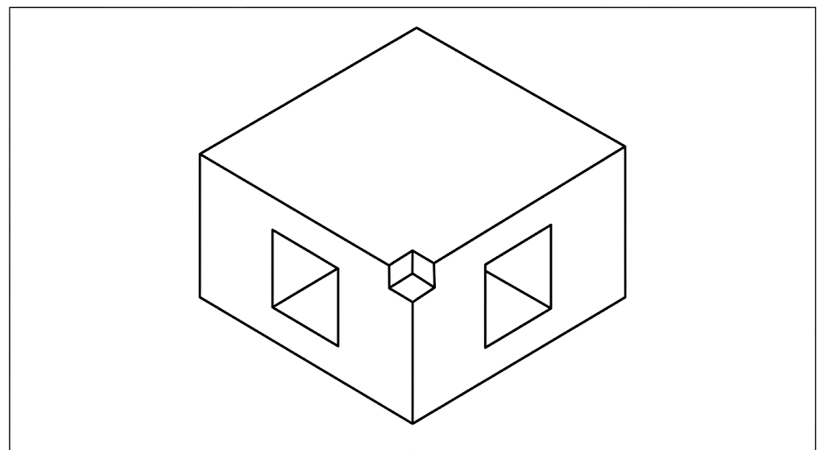
Figure 5
(a) State the type of pictorial drawing represented by Figure 5. (1 marks)
________________________________________________________________________________
(b) Sketch the front orthographic view of the object. (3 marks)
________________________________________________________________________________
________________________________________________________________________________
________________________________________________________________________________
________________________________________________________________________________
________________________________________________________________________________
(c) State three uses of drawings in the Woodwork design and production process. (3 marks)
________________________________________________________________________________
________________________________________________________________________________
________________________________________________________________________________
________________________________________________________________________________
13. Integrated Woodwork Application. A learner plans to produce a useful furniture item for the school. Describe how the learner should use drawing/sketching, material selection, joint selection, wood preparation, surface preparation and safe tool use to produce the item successfully. (7 marks)
________________________________________________________________________________
________________________________________________________________________________
________________________________________________________________________________
________________________________________________________________________________
________________________________________________________________________________
________________________________________________________________________________
________________________________________________________________________________
________________________________________________________________________________
________________________________________________________________________________
________________________________________________________________________________
________________________________________________________________________________

