END TERM 3 2026
GRADE 10
THEATRE AND FILM
CUMULATIVE SUMMATIVE ASSESSMENT
TIME: 2 HOURS 30 MINUTES
TOTAL MARKS: 80
Name | ____________________________________________
Assessment Number | ____________________________________________
Class / Stream | ____________________________________________
Date | ____________________________________________
INSTRUCTIONS TO CANDIDATES
1. Answer ALL questions.
2. Read each question carefully before answering.
3. Where a figure is provided, study it carefully and use it in your response.
4. Give clear, relevant and well-organised responses.
5. Where a practical, design or performance response is requested, present your work systematically.
6. Use the spaces provided and write legibly.
7. Answer in English.
EXAMINER'S USE ONLY
Questions | Maximum Score | Candidate Score | Remarks
Q1–Q5 | 27
Q6–Q10 | 26
Q11–Q15 | 27
TOTAL | 80

SECTION A — CREATING
1. Traditional Kenyan Theatre. Study Figure 1 and answer the questions.
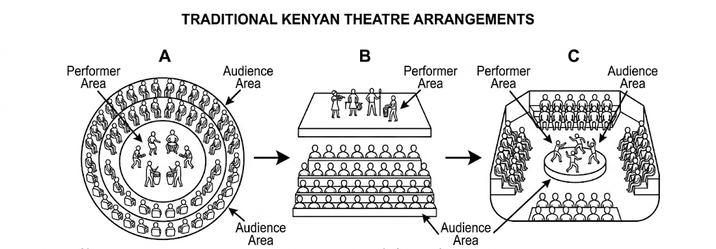
Figure 1
(a) State two functions of traditional Kenyan theatre. (2 marks)
________________________________________________________________________________
________________________________________________________________________________
(b) State three characteristics of traditional Kenyan theatre forms, considering aspects such as storytelling, music, dance, rituals, costume, communal settings, audience participation or moral function. (3 marks)
________________________________________________________________________________
________________________________________________________________________________
________________________________________________________________________________
________________________________________________________________________________
2. Play Writing. A community wants a short play addressing road safety. Using the play structure in Figure 2, answer the questions.
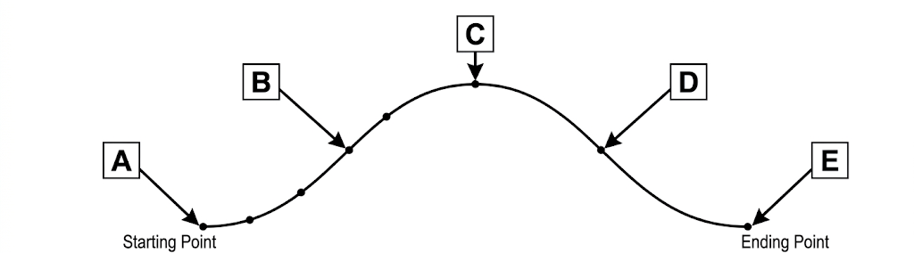
Figure 2
(a) Name the five major stages represented by the play structure, beginning with A. (5 marks)
________________________________________________________________________________
________________________________________________________________________________
________________________________________________________________________________
________________________________________________________________________________
________________________________________________________________________________
(b) Write a suitable theme for the road-safety play and give one Pertinent and Contemporary Issue that the play could address. (2 marks)
________________________________________________________________________________
________________________________________________________________________________
3. Poetry Writing — Spoken Word. Write a short spoken-word poem of approximately 12–16 lines on one social issue affecting young people. Your poem should demonstrate poetic elements and an appropriate spoken-word voice. (6 marks)
________________________________________________________________________________
________________________________________________________________________________
________________________________________________________________________________
________________________________________________________________________________
________________________________________________________________________________
________________________________________________________________________________
________________________________________________________________________________
________________________________________________________________________________
________________________________________________________________________________
________________________________________________________________________________
________________________________________________________________________________
________________________________________________________________________________
________________________________________________________________________________
________________________________________________________________________________
________________________________________________________________________________
________________________________________________________________________________
________________________________________________________________________________
________________________________________________________________________________
________________________________________________________________________________
________________________________________________________________________________
________________________________________________________________________________
________________________________________________________________________________
________________________________________________________________________________
________________________________________________________________________________
________________________________________________________________________________
________________________________________________________________________________

SECTION B — PRODUCTION
4. Acting. (a) State the three actor's tools identified in the curriculum. (b) Explain how any two of the tools can be used to improve a character's performance. (c) State one purpose of de-roling after a performance. (6 marks)
________________________________________________________________________________
________________________________________________________________________________
________________________________________________________________________________
________________________________________________________________________________
________________________________________________________________________________
________________________________________________________________________________
________________________________________________________________________________
5. Theatre Directing. Study Figure 3. (6 marks)
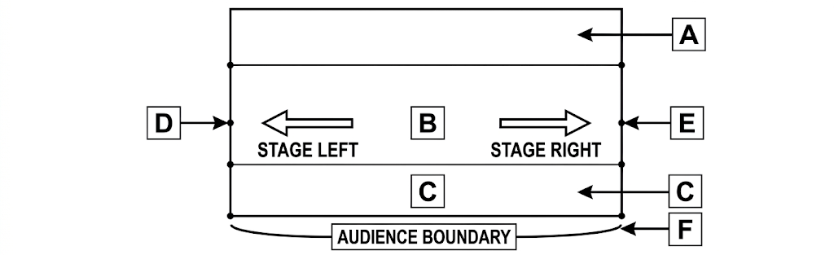
Figure 3
(a) Identify any three stage areas shown in the figure. (3 marks)
________________________________________________________________________________
________________________________________________________________________________
________________________________________________________________________________
(b) State three responsibilities of a theatre director. (3 marks)
________________________________________________________________________________
________________________________________________________________________________
________________________________________________________________________________
6. Theatre Design. Study Figure 4. (6 marks)
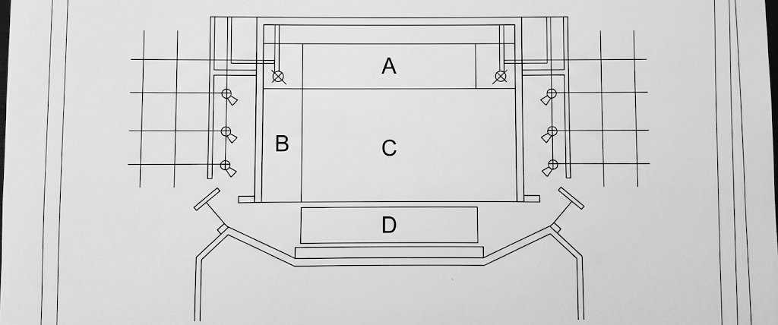
Figure 4
(a) State four components of theatre design that should be considered when preparing a performance. (4 marks)
________________________________________________________________________________
________________________________________________________________________________
________________________________________________________________________________
________________________________________________________________________________
(b) State two reasons for using available or improvised resources in theatre design. (2 marks)
________________________________________________________________________________
________________________________________________________________________________
SECTION C — THEATRE, FILM AND SOCIETY
7. Theatre Adjudication. Study Figure 5, which represents an adjudication record.
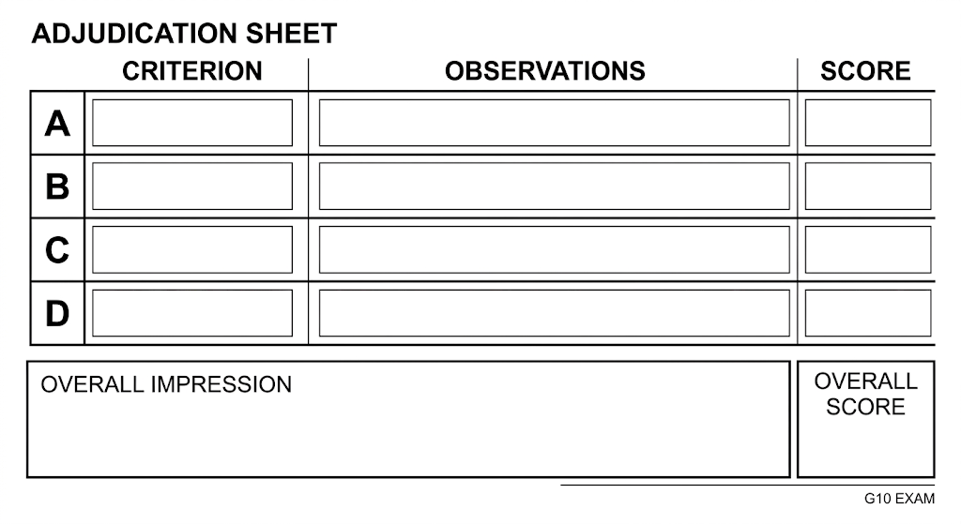
Figure 5
(a) State three criteria that may be used when adjudicating a stage or poetry performance. (3 marks)
________________________________________________________________________________
________________________________________________________________________________
________________________________________________________________________________
(b) Explain two qualities of effective feedback after adjudication. (2 marks)
________________________________________________________________________________
________________________________________________________________________________
(c) State two reasons why an adjudication report should be clear and well organised. (2 marks)
________________________________________________________________________________
________________________________________________________________________________
8. Theatre and Community. Study Figure 6. (5 marks)
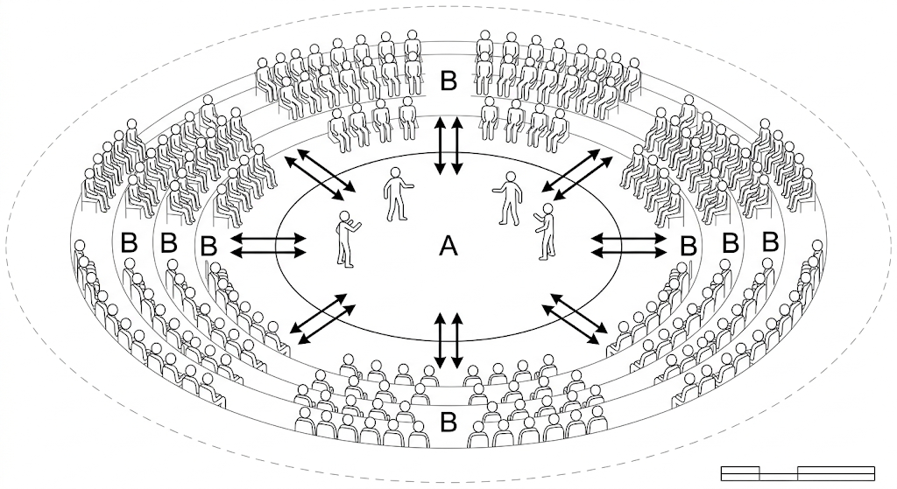
Figure 6
(a) State two roles theatre can play in society. (2 marks)
________________________________________________________________________________
________________________________________________________________________________
(b) State three ways a school theatre or film club can contribute to community engagement. (3 marks)
________________________________________________________________________________
________________________________________________________________________________
________________________________________________________________________________
9. Integrated Production Scenario. A school is preparing a short community performance. State five steps the learners should take from planning through rehearsal and presentation. (5 marks)
________________________________________________________________________________
________________________________________________________________________________
________________________________________________________________________________
________________________________________________________________________________
________________________________________________________________________________
________________________________________________________________________________
10. Film and Digital Literacy Application. State five ways technology can support theatre and film activities, including areas such as recording, editing, sound, lighting or digital presentation. (5 marks)
________________________________________________________________________________
________________________________________________________________________________
________________________________________________________________________________
________________________________________________________________________________
________________________________________________________________________________
________________________________________________________________________________
SECTION D — APPLICATION AND CREATIVE RESPONSE
11. Play Development. Develop a concise three-act outline for a play addressing a Pertinent and Contemporary Issue affecting the community. Include a suitable title and show the main event in each act. (6 marks)
________________________________________________________________________________
________________________________________________________________________________
________________________________________________________________________________
________________________________________________________________________________
________________________________________________________________________________
________________________________________________________________________________
________________________________________________________________________________
________________________________________________________________________________
12. Character Development. Create a character bible for one character in your proposed play. Include: name, role, physical characteristics, emotional characteristics, relationships with other characters and character background. (6 marks)
________________________________________________________________________________
________________________________________________________________________________
________________________________________________________________________________
________________________________________________________________________________
________________________________________________________________________________
________________________________________________________________________________
________________________________________________________________________________
________________________________________________________________________________
13. Directing and Performance. Explain how a director can use blocking, actor's tools, rehearsal and feedback to improve a performance. (5 marks)
________________________________________________________________________________
________________________________________________________________________________
________________________________________________________________________________
________________________________________________________________________________
________________________________________________________________________________
________________________________________________________________________________
14. Theatre Design and Production. A school has limited resources. Describe five practical decisions that can help the production team create an effective stage using available resources while observing responsibility for theatre equipment and the environment. (5 marks)
________________________________________________________________________________
________________________________________________________________________________
________________________________________________________________________________
________________________________________________________________________________
________________________________________________________________________________
________________________________________________________________________________
15. Community Advocacy Performance. Design a brief concept for a community theatre piece addressing a contemporary issue. State the issue, target audience, purpose, performance approach and one way the audience/community will participate or respond. (6 marks)
________________________________________________________________________________
________________________________________________________________________________
________________________________________________________________________________
________________________________________________________________________________
________________________________________________________________________________
________________________________________________________________________________
________________________________________________________________________________
________________________________________________________________________________

