END TERM 3 2026
GRADE 10
SPORTS AND RECREATION
CUMULATIVE SUMMATIVE ASSESSMENT
TIME: 2 HOURS 30 MINUTES
TOTAL MARKS: 80

Name | ____________________________________________________________
Assessment Number | ____________________________________________________________
Class / Stream | ____________________________________________________________
Date | ____________________________________________________________

INSTRUCTIONS TO CANDIDATES
1. Write your name and assessment details in the spaces provided.
2. Answer ALL questions.
3. Read each question carefully before answering.
4. Show all working where calculations are required.
5. Label and interpret figures clearly where required.
6. Use appropriate units in calculations.
7. Write your answers in the spaces provided where applicable.
8. Use clear and legible handwriting.
9. Candidates should check that all pages and questions are present.
10. Answer in English.

EXAMINER'S USE ONLY
Section / Questions | Maximum Score | Candidate's Score | Remarks
Q1–Q6 | 31
Q7–Q12 | 33
Q13–Q15 | 16
TOTAL | 80

SECTION A — HEALTH AND FITNESS
1. Sports and Society. (a) State two benefits of sports to an individual. (b) Give two ways in which a school can use sports to strengthen its relationship with the community. (4 marks)
________________________________________________________________________________
________________________________________________________________________________
________________________________________________________________________________
________________________________________________________________________________
2. Body Composition. A learner has a mass of 72 kg and a height of 1.8 m. (5 marks)
(a) Calculate the learner's Body Mass Index (BMI). (2 marks)
________________________________________________________________________________
________________________________________________________________________________
(b) State two factors that can determine body composition. (2 marks)
________________________________________________________________________________
________________________________________________________________________________
(c) State one reason why BMI should be interpreted together with other information when assessing fitness. (1 marks)
________________________________________________________________________________
3. Posture for Efficient Performance. Study Figure 1. (6 marks)
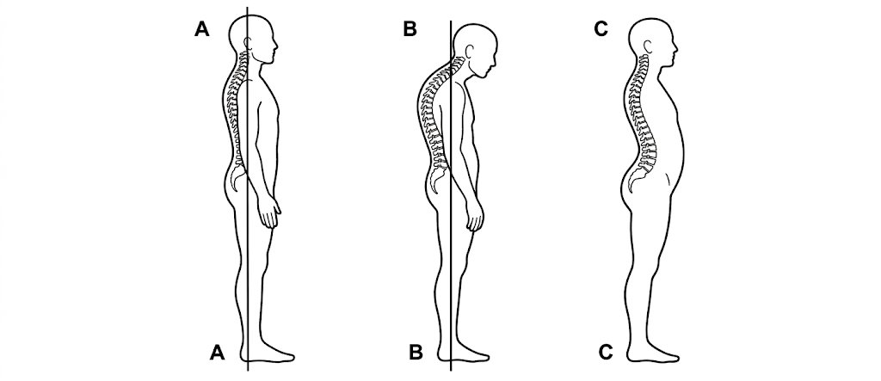
Figure 1
(a) Which sketch represents the most correctly aligned posture? (1 marks)
________________________________________________________________________________
(b) Identify one visible postural problem in each of the other two sketches. (2 marks)
________________________________________________________________________________
________________________________________________________________________________
(c) State three reasons why correct posture is important when performing sports movements. (3 marks)
________________________________________________________________________________
________________________________________________________________________________
________________________________________________________________________________
4. Aerobics. Study Figure 2. (5 marks)
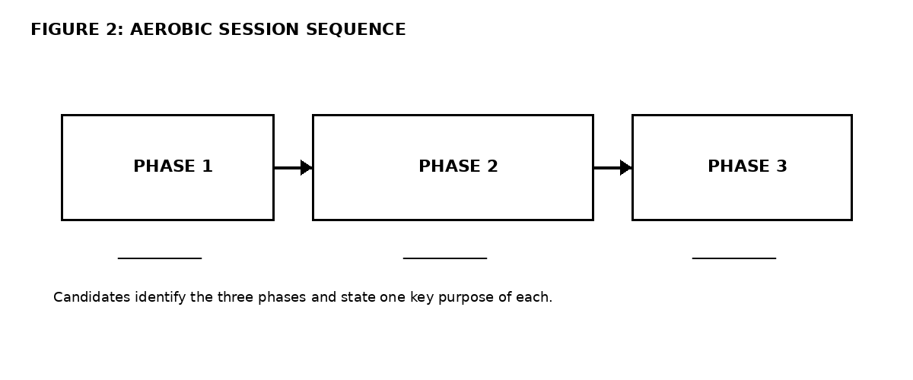
Figure 2
(a) Name the three phases of the aerobics session. (3 marks)
________________________________________________________________________________
________________________________________________________________________________
________________________________________________________________________________
(b) State one purpose of the first phase. (1 marks)
________________________________________________________________________________
(c) State one purpose of the final phase. (1 marks)
________________________________________________________________________________
5. Recreation and Wellness. (a) State the six dimensions of wellness referred to in the curriculum. (b) State one safety measure to observe when participating in a recreational activity on or near a road. (5 marks)
________________________________________________________________________________
________________________________________________________________________________
________________________________________________________________________________
________________________________________________________________________________
________________________________________________________________________________
________________________________________________________________________________
6. Injuries in Sports. (a) Distinguish between an acute injury and a chronic injury. (b) Give one example of each. (c) State two strategies for preventing sports injuries. (5 marks)
________________________________________________________________________________
________________________________________________________________________________
________________________________________________________________________________
________________________________________________________________________________
________________________________________________________________________________
________________________________________________________________________________
SECTION B — COACHING
7. Introduction to Coaching. (a) Explain the concept of coaching in sports. (b) State three elements that should be included when developing a training programme for a selected game or track event. (5 marks)
________________________________________________________________________________
________________________________________________________________________________
________________________________________________________________________________
________________________________________________________________________________
________________________________________________________________________________
________________________________________________________________________________
8. Facilities and Equipment in Sports and Recreation. A school is preparing for football, basketball and a middle-distance running event. (a) State one important facility/equipment requirement for each activity. (b) Give two criteria that should be considered when evaluating the suitability of sports facilities and equipment. (5 marks)
________________________________________________________________________________
________________________________________________________________________________
________________________________________________________________________________
________________________________________________________________________________
________________________________________________________________________________
________________________________________________________________________________
9. Improvisation of Equipment and Modification of Facilities. Study Figure 3. (5 marks)
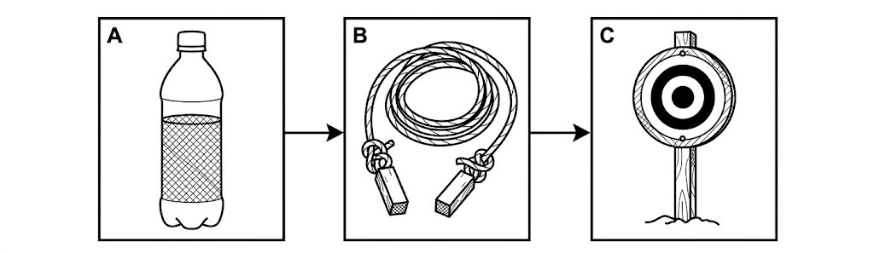
Figure 3
(a) Identify one possible reusable/recycled material represented in any one of the improvised items. (1 marks)
________________________________________________________________________________
(b) State two criteria that should be considered before using improvised sports equipment. (2 marks)
________________________________________________________________________________
________________________________________________________________________________
(c) Explain one benefit of improvising or modifying sports equipment/facilities for a school or community. (2 marks)
________________________________________________________________________________
________________________________________________________________________________
10. Tactical Skills in Athletics. Study Figure 4, which shows a middle-distance race situation. (8 marks)
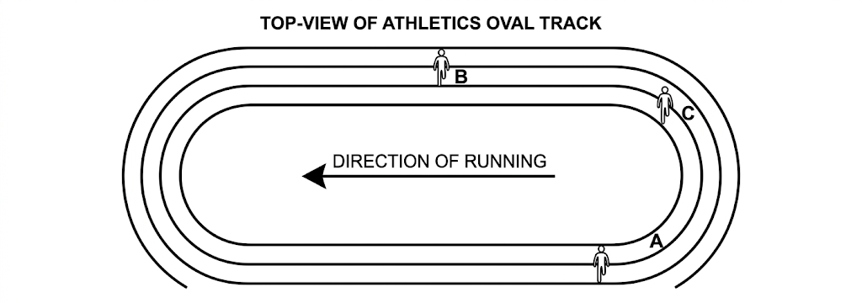
Figure 4
(a) State two tactical considerations a runner should make before attempting to overtake another runner. (2 marks)
________________________________________________________________________________
________________________________________________________________________________
(b) Using the situation in Figure 4, explain one possible tactical decision that runner C could make. (2 marks)
________________________________________________________________________________
________________________________________________________________________________
(c) State two safety precautions that should be observed during middle-distance training or competition. (2 marks)
________________________________________________________________________________
________________________________________________________________________________
(d) Give two ways in which effective tactics can improve performance in a track event. (2 marks)
________________________________________________________________________________
________________________________________________________________________________
11. Formations in Games I. (a) Explain what a formation is in a team game. (b) State two benefits of using an appropriate formation. (c) Name two team games in which formations are used. (5 marks)
________________________________________________________________________________
________________________________________________________________________________
________________________________________________________________________________
________________________________________________________________________________
________________________________________________________________________________
________________________________________________________________________________
12. Talent Detection and Identification. Design a five-item checklist that a school sports teacher could use when identifying talent in a learner. Your checklist should cover different relevant attributes such as physical, psychological, behavioural, skills, fitness or technical attributes. (5 marks)
________________________________________________________________________________
________________________________________________________________________________
________________________________________________________________________________
________________________________________________________________________________
________________________________________________________________________________
________________________________________________________________________________
________________________________________________________________________________
SECTION C — OFFICIATING AND INTEGRATED APPLICATION
13. Principles of Officiating. Study Figure 5. (6 marks)
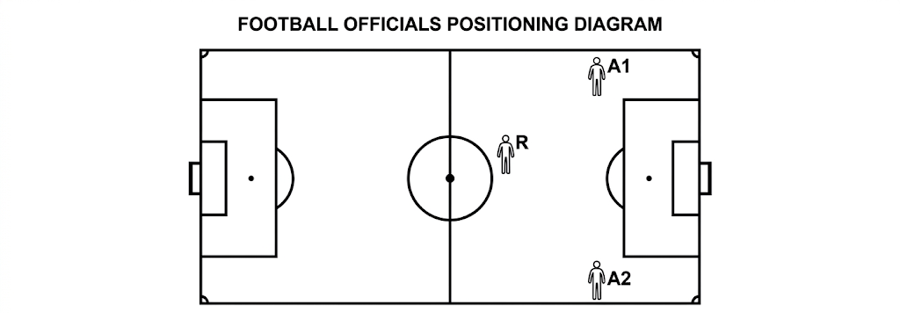
Figure 5
(a) Identify the official represented by R and state one reason for the official's position. (2 marks)
________________________________________________________________________________
________________________________________________________________________________
(b) State three principles of effective officiating. (3 marks)
________________________________________________________________________________
________________________________________________________________________________
________________________________________________________________________________
(c) State one way in which integrity can be demonstrated by an official. (1 marks)
________________________________________________________________________________
14. Team and Meet/Game Officials. Study Figure 6. (6 marks)
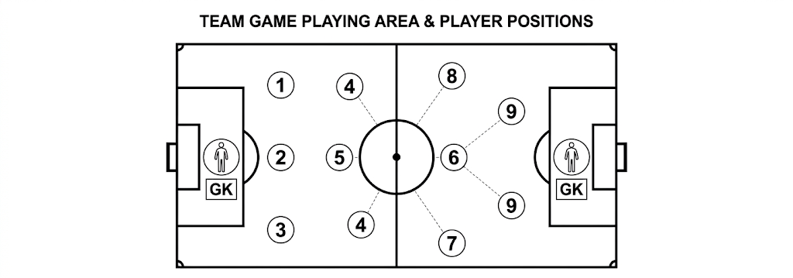
Figure 6
(a) State two responsibilities of a team captain during a school sports event. (2 marks)
________________________________________________________________________________
________________________________________________________________________________
(b) State two responsibilities of a game or meet official. (2 marks)
________________________________________________________________________________
________________________________________________________________________________
(c) State two qualities that should be demonstrated by technical officials. (2 marks)
________________________________________________________________________________
________________________________________________________________________________
15. Integrated Sports Programme Scenario. A school wants to organise a community sports and recreation programme that promotes health and wellness, uses available resources responsibly, develops sporting talent and ensures fair play. State five actions the school should take to make the programme effective. (5 marks)
________________________________________________________________________________
________________________________________________________________________________
________________________________________________________________________________
________________________________________________________________________________
________________________________________________________________________________
________________________________________________________________________________
________________________________________________________________________________

