END TERM 3 2026
GRADE 10
POWER MECHANICS
SUMMATIVE ASSESSMENT
TIME: 2 HOURS 30 MINUTES
Name: ______________________________________________
Assessment Number: _________________________________
Class / Stream: ____________________________________
Date: ______________________________________________
INSTRUCTIONS
1. Answer ALL questions.
2. Read each question carefully and show all working where applicable.
3. Use appropriate technical drawing instruments where a construction is required.
4. All sketches and diagrams must be clear and well labelled.
5. Use the spaces provided.

SECTION A — FUNDAMENTALS OF POWER MECHANICS (30 MARKS)
1. Overview and evolution of power mechanics (8 marks)
(a) Define Power Mechanics as a learning area. (2 marks)
_________________________________________________________________________________________________________
_________________________________________________________________________________________________________
(b) State two opportunities for further study or careers related to power mechanics. (2 marks)
_________________________________________________________________________________________________________
_________________________________________________________________________________________________________
(c) State two ways in which power mechanics contributes to society. (2 marks)
_________________________________________________________________________________________________________
_________________________________________________________________________________________________________
(d) State two important developments in the historical evolution of motor vehicles. (2 marks)
_________________________________________________________________________________________________________
_________________________________________________________________________________________________________
2. Power mechanics workshop layout.
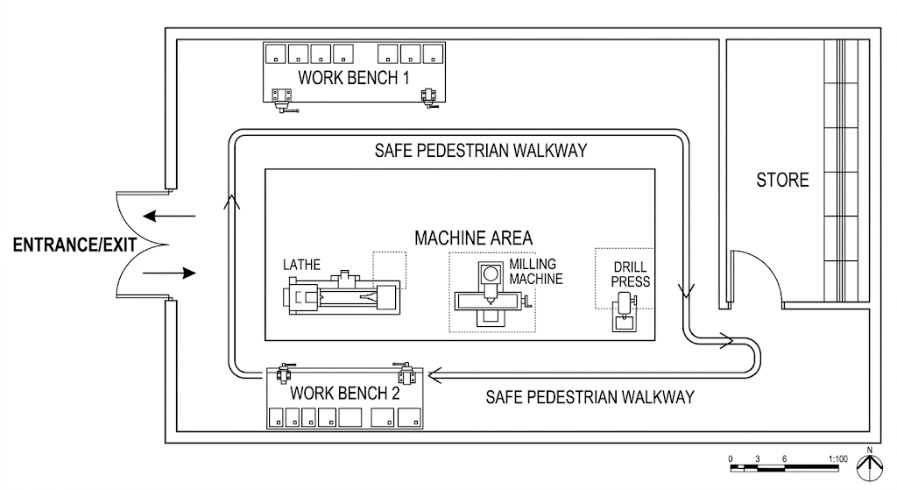
(a) Identify four main areas that should be considered in a power mechanics workshop layout. (4 marks)
_________________________________________________________________________________________________________
_________________________________________________________________________________________________________
_________________________________________________________________________________________________________
_________________________________________________________________________________________________________
(b) State two reasons why a good workshop layout is important. (2 marks)
_________________________________________________________________________________________________________
_________________________________________________________________________________________________________
(c) State two safety considerations when arranging workshop floor markings. (2 marks)
_________________________________________________________________________________________________________
_________________________________________________________________________________________________________
3. General workshop rules and regulations (7 marks)
(a) State three general safety rules applicable in a power mechanics workshop. (3 marks)
_________________________________________________________________________________________________________
_________________________________________________________________________________________________________
_________________________________________________________________________________________________________
(b) State two behaviours that should be avoided in a power mechanics work environment. (2 marks)
_________________________________________________________________________________________________________
_________________________________________________________________________________________________________
(c) Name two items of personal protective equipment (PPE) and state the purpose of each. (2 marks)
_________________________________________________________________________________________________________
_________________________________________________________________________________________________________
4. Safety signs and PPE (7 marks)
(a) Differentiate between prohibition, mandatory, warning and fire-equipment signs. (4 marks)
_________________________________________________________________________________________________________
_________________________________________________________________________________________________________
_________________________________________________________________________________________________________
_________________________________________________________________________________________________________
(b) State three situations in which PPE is necessary in a power mechanics workshop. (3 marks)
_________________________________________________________________________________________________________
_________________________________________________________________________________________________________
_________________________________________________________________________________________________________
SECTION B — RELATED TECHNICAL DRAWING (25 MARKS)
5. Diagonal scale.
(a) State the purpose of a diagonal scale in technical drawing. (2 marks)
_________________________________________________________________________________________________________
_________________________________________________________________________________________________________
(b) Construct a diagonal scale capable of measuring metres, decimetres and centimetres for a representative scale of 1:10. Clearly show the construction and subdivisions. (5 marks)
_________________________________________________________________________________________________________
_________________________________________________________________________________________________________
_________________________________________________________________________________________________________
_________________________________________________________________________________________________________
_________________________________________________________________________________________________________
_________________________________________________________________________________________________________
_________________________________________________________________________________________________________
_________________________________________________________________________________________________________
_________________________________________________________________________________________________________
_________________________________________________________________________________________________________

(c) State two applications of diagonal scales. (2 marks)

_________________________________________________________________________________________________________
_________________________________________________________________________________________________________
6. Loci in power mechanics.
(a) Define a locus in technical drawing. (2 marks)
_________________________________________________________________________________________________________
_________________________________________________________________________________________________________
(b) Name two types of loci that may be used in technical drawing. (2 marks)
_________________________________________________________________________________________________________
_________________________________________________________________________________________________________
(c) Describe the procedure you would use to construct the locus of point P in the mechanism shown. (4 marks)
_________________________________________________________________________________________________________
_________________________________________________________________________________________________________
_________________________________________________________________________________________________________
_________________________________________________________________________________________________________
7. Tangency and blending of lines and curves (8 marks)
(a) Define tangency. (2 marks)
_________________________________________________________________________________________________________
_________________________________________________________________________________________________________
(b) State two methods or constructions used when drawing tangents. (2 marks)
_________________________________________________________________________________________________________
_________________________________________________________________________________________________________
(c) Describe how to construct a tangent from a point outside a circle. (4 marks)
_________________________________________________________________________________________________________
_________________________________________________________________________________________________________
_________________________________________________________________________________________________________
_________________________________________________________________________________________________________
SECTION C — MOTOR VEHICLE SYSTEMS (25 MARKS)
8. Road wheels and tyres (8 marks)
(a) State three functions of tyres on a motor vehicle. (3 marks)
_________________________________________________________________________________________________________
_________________________________________________________________________________________________________
_________________________________________________________________________________________________________
(b) Explain how incorrect tyre pressure can affect road safety. (2 marks)
_________________________________________________________________________________________________________
_________________________________________________________________________________________________________
(c) State three basic tyre-maintenance practices. (3 marks)
_________________________________________________________________________________________________________
_________________________________________________________________________________________________________
_________________________________________________________________________________________________________
9. Motor vehicle body and chassis.
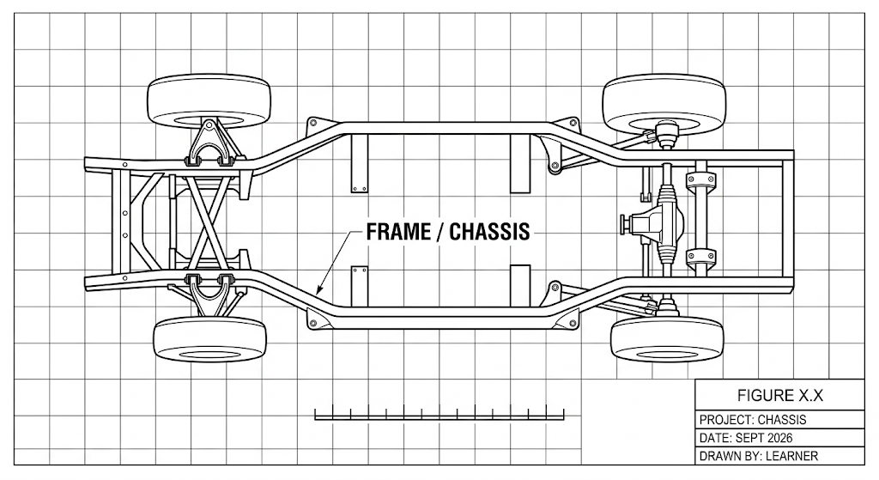
(a) State three functions of a motor vehicle body. (3 marks)
_________________________________________________________________________________________________________
_________________________________________________________________________________________________________
_________________________________________________________________________________________________________
(b) Name three types of chassis/frame sections used in motor vehicles. (3 marks)
_________________________________________________________________________________________________________
_________________________________________________________________________________________________________
_________________________________________________________________________________________________________
(c) State three safety features incorporated into a motor vehicle chassis or body. (3 marks)
_________________________________________________________________________________________________________
_________________________________________________________________________________________________________
_________________________________________________________________________________________________________
10. Motor vehicle body joining processes.
(a) Name four joining processes used in motor vehicle body work. (4 marks)
_________________________________________________________________________________________________________
_________________________________________________________________________________________________________
_________________________________________________________________________________________________________
_________________________________________________________________________________________________________
(b) State two examples of threaded fasteners used in motor vehicle body joining. (2 marks)
_________________________________________________________________________________________________________
_________________________________________________________________________________________________________
(c) State two advantages of using adhesives in motor vehicle body joining. (2 marks)
_________________________________________________________________________________________________________
_________________________________________________________________________________________________________
SECTION D — ENGINES (20 MARKS)
11. Introduction to engines and engine terminology (7 marks)
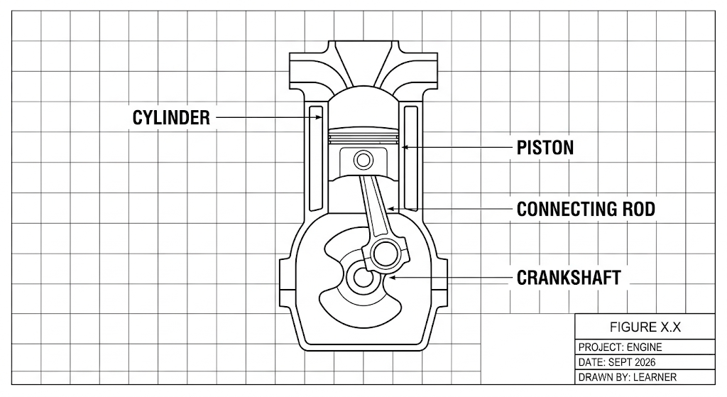
(a) Define an engine as used in power mechanics. (2 marks)
_________________________________________________________________________________________________________
_________________________________________________________________________________________________________
(b) State the meaning of bore, stroke and engine capacity. (3 marks)
_________________________________________________________________________________________________________
_________________________________________________________________________________________________________
_________________________________________________________________________________________________________
(c) A cylinder has a bore diameter of 80 mm and a stroke of 90 mm. Calculate its swept volume using V = πd²L/4. Give the answer in cm³. (2 marks)
_________________________________________________________________________________________________________
_________________________________________________________________________________________________________
12. Classification and types of engines (6 marks)
(a) State three methods of classifying engines. (3 marks)
_________________________________________________________________________________________________________
_________________________________________________________________________________________________________
_________________________________________________________________________________________________________
(b) Distinguish between external combustion and internal combustion engines. (2 marks)
_________________________________________________________________________________________________________
_________________________________________________________________________________________________________
(c) Give one example of an engine classified according to fuel type. (1 marks)
_________________________________________________________________________________________________________
_________________________________________________________________________________________________________
13. Engine components and functions (7 marks)
(a) Name four major components of an internal-combustion engine. (4 marks)
_________________________________________________________________________________________________________
_________________________________________________________________________________________________________
_________________________________________________________________________________________________________
_________________________________________________________________________________________________________
(b) State the function of the crankshaft, camshaft and piston. (3 marks)
_________________________________________________________________________________________________________
_________________________________________________________________________________________________________
_________________________________________________________________________________________________________
END OF QUESTION PAPER

