END TERM 3 2026
GRADE 10
PHYSICS
SUMMATIVE ASSESSMENT
TIME: 2 HOURS
Name: ______________________________________________
Assessment Number: _________________________________
Class / Stream: ____________________________________
Date: ______________________________________________
INSTRUCTIONS
1. Answer ALL questions.
2. Show all working for numerical calculations.
3. Use appropriate SI units and give answers to the required degree of accuracy.
4. Where a diagram is provided, study it carefully before answering.
5. Draw clear labelled diagrams where required.
6. Use the spaces provided for your answers.

SECTION A — MECHANICS AND THERMAL PHYSICS (30 MARKS)
1. Pressure and its applications are important in everyday life. (10 marks)
(a) State two factors that affect pressure in a liquid. (2 marks)
_________________________________________________________________________________________________________
_________________________________________________________________________________________________________
(b) A liquid has density 800 kg m⁻³ and a depth of 2.5 m. Calculate the pressure due to the liquid. Take g = 10 N kg⁻¹. (3 marks)
_________________________________________________________________________________________________________
_________________________________________________________________________________________________________
_________________________________________________________________________________________________________
(c) Explain two applications of atmospheric pressure in everyday life. (2 marks)
_________________________________________________________________________________________________________
_________________________________________________________________________________________________________
(d) Explain why pressure in a liquid increases with depth. (3 marks)
_________________________________________________________________________________________________________
_________________________________________________________________________________________________________
_________________________________________________________________________________________________________
2. Study the hydraulic system below. (10 marks)
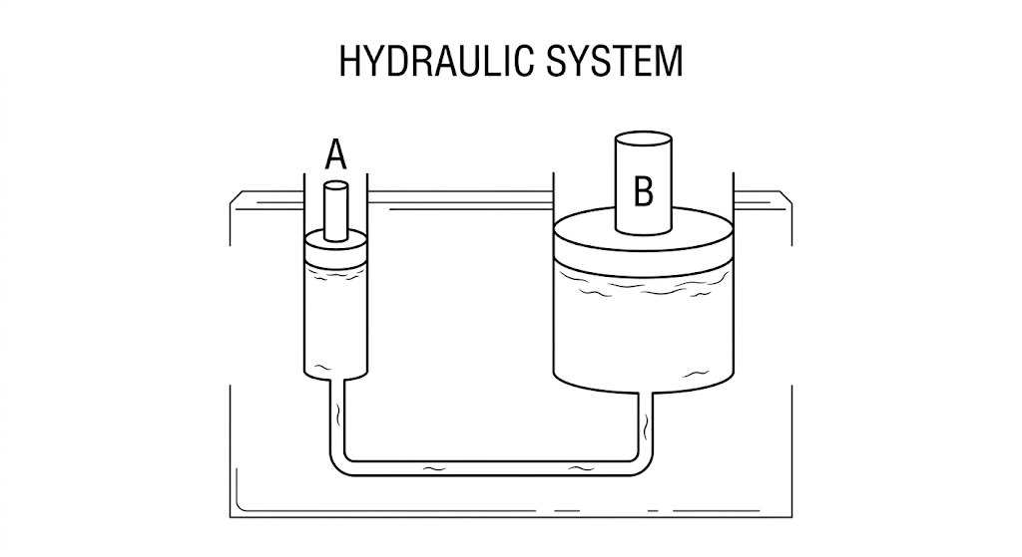
(a) State the principle on which the hydraulic system operates. (2 marks)
_________________________________________________________________________________________________________
_________________________________________________________________________________________________________
(b) Explain how a small force applied at A can produce a larger force at B. (3 marks)
_________________________________________________________________________________________________________
_________________________________________________________________________________________________________
_________________________________________________________________________________________________________
(c) Give two applications of hydraulic systems. (2 marks)
_________________________________________________________________________________________________________
_________________________________________________________________________________________________________
(d) State three safety considerations when using hydraulic equipment. (3 marks)
_________________________________________________________________________________________________________
_________________________________________________________________________________________________________
_________________________________________________________________________________________________________
3. Mechanical properties and thermal expansion affect the choice and use of materials. (10 marks)
(a) Define ductility, malleability and elasticity. (3 marks)
_________________________________________________________________________________________________________
_________________________________________________________________________________________________________
_________________________________________________________________________________________________________
(b) A wire of cross-sectional area 2.0 × 10⁻⁶ m² carries a tensile force of 100 N. Calculate its tensile stress. (2 marks)
_________________________________________________________________________________________________________
_________________________________________________________________________________________________________
(c) State two applications of thermal expansion in solids. (2 marks)
_________________________________________________________________________________________________________
_________________________________________________________________________________________________________
(d) Explain why a gap is left between sections of railway tracks or bridges. (3 marks)
_________________________________________________________________________________________________________
_________________________________________________________________________________________________________
_________________________________________________________________________________________________________
SECTION B — MECHANICS, WAVES AND RADIOACTIVITY (30 MARKS)
4. Study the lever diagram below.
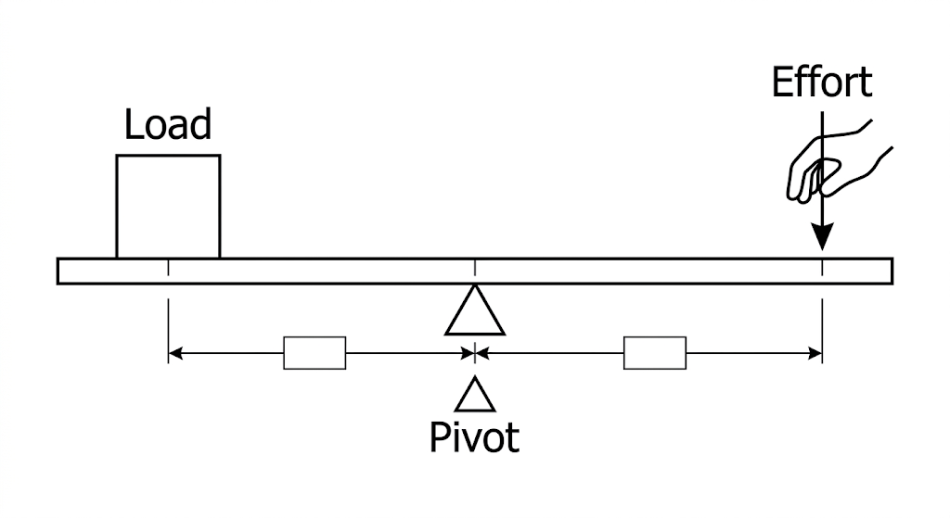
(a) State the principle of moments. (2 marks)
_________________________________________________________________________________________________________
_________________________________________________________________________________________________________
(b) A 40 N load acts 0.20 m from the pivot. Calculate the moment of the load about the pivot. (2 marks)
_________________________________________________________________________________________________________
_________________________________________________________________________________________________________
(c) State two factors that affect the stability of an object. (2 marks)
_________________________________________________________________________________________________________
_________________________________________________________________________________________________________
(d) Describe how kinetic and potential energy are transformed when a raised object falls. (4 marks)
_________________________________________________________________________________________________________
_________________________________________________________________________________________________________
_________________________________________________________________________________________________________
_________________________________________________________________________________________________________
5. Study the wave diagram below.
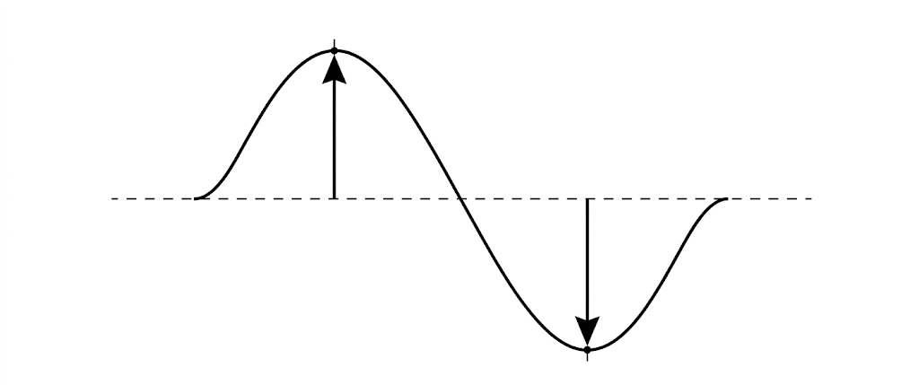
(a) Name the two measurable quantities indicated by the vertical arrows and the horizontal distance between successive similar points. (3 marks)
_________________________________________________________________________________________________________
_________________________________________________________________________________________________________
_________________________________________________________________________________________________________
(b) State two properties of waves included in the Grade 10 curriculum. (2 marks)
_________________________________________________________________________________________________________
_________________________________________________________________________________________________________
(c) Explain the Doppler effect using a moving sound source as an example. (3 marks)
_________________________________________________________________________________________________________
_________________________________________________________________________________________________________
_________________________________________________________________________________________________________
(d) State two applications of stationary waves or resonance. (2 marks)
_________________________________________________________________________________________________________
_________________________________________________________________________________________________________
6. Radioactivity involves unstable nuclei, radiation and safety precautions.
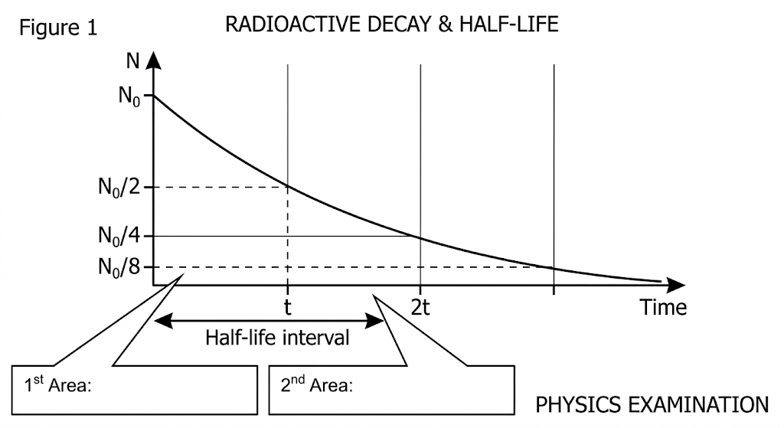
(a) Define half-life. (2 marks)
_________________________________________________________________________________________________________
_________________________________________________________________________________________________________
(b) Describe how the graph can be used to determine the half-life of a radioactive substance. (3 marks)
_________________________________________________________________________________________________________
_________________________________________________________________________________________________________
_________________________________________________________________________________________________________
(c) State three safety precautions when handling radioactive substances. (3 marks)
_________________________________________________________________________________________________________
_________________________________________________________________________________________________________
_________________________________________________________________________________________________________
(d) Distinguish between nuclear fission and nuclear fusion. (2 marks)
_________________________________________________________________________________________________________
_________________________________________________________________________________________________________
SECTION C — ELECTRICITY, MAGNETISM AND ENVIRONMENTAL PHYSICS (20 MARKS)
7. Study the simple circuit below.
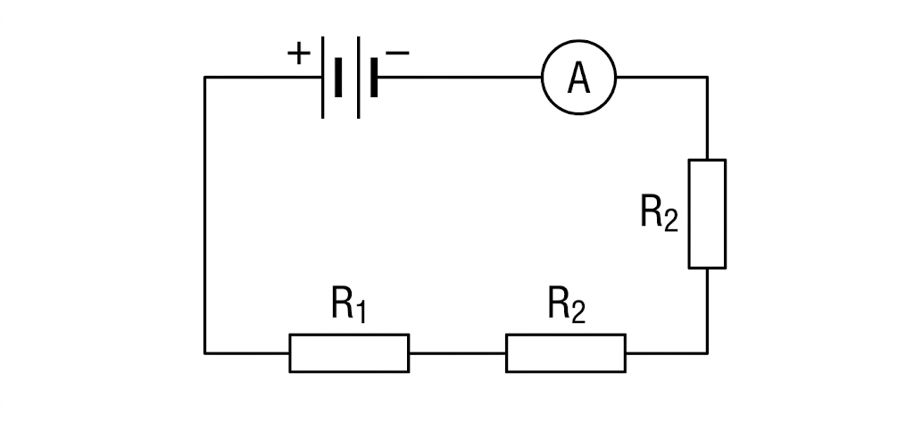
(a) State the relationship between current, potential difference and resistance for an ohmic conductor. (2 marks)
_________________________________________________________________________________________________________
_________________________________________________________________________________________________________
(b) A resistor has a potential difference of 12 V across it and a current of 3 A through it. Calculate its resistance. (2 marks)
_________________________________________________________________________________________________________
_________________________________________________________________________________________________________
(c) State two methods of determining resistance experimentally. (2 marks)
_________________________________________________________________________________________________________
_________________________________________________________________________________________________________
(d) Give two applications or uses of resistors in electrical circuits. (2 marks)
_________________________________________________________________________________________________________
_________________________________________________________________________________________________________
(e) State two electrical safety precautions. (2 marks)
_________________________________________________________________________________________________________
_________________________________________________________________________________________________________
8. Study the greenhouse-effect diagram below. (10 marks)
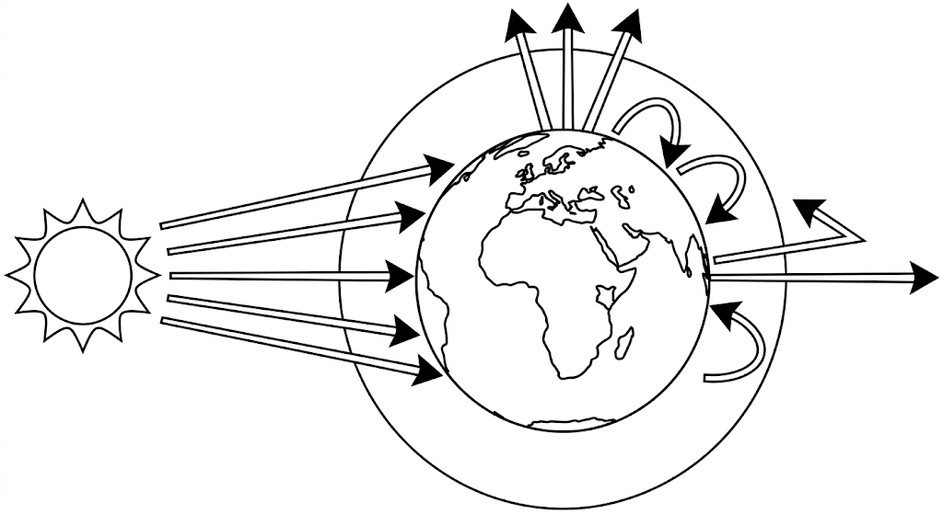
(a) Explain the greenhouse effect as represented in the diagram. (3 marks)
_________________________________________________________________________________________________________
_________________________________________________________________________________________________________
_________________________________________________________________________________________________________
(b) State two factors that can contribute to climate change. (2 marks)
_________________________________________________________________________________________________________
_________________________________________________________________________________________________________
(c) Explain one environmental effect of climate change. (2 marks)
_________________________________________________________________________________________________________
_________________________________________________________________________________________________________
(d) State two benefits of space technology or planetary observation to society. (2 marks)
_________________________________________________________________________________________________________
_________________________________________________________________________________________________________
(e) Name one career related to space exploration or space flight and state one role associated with it. (1 marks)
_________________________________________________________________________________________________________
END OF QUESTION PAPER

