END TERM 3 2026
GRADE 10
PHYSICAL EDUCATION
SUMMATIVE ASSESSMENT
TIME: 2 HOURS

Name: _________________________________________________
Assessment Number: ____________________________________
Class / Stream: ________________________________________
Date: _________________________________________________
INSTRUCTIONS TO CANDIDATES
1. Write your name and assessment details in the spaces provided.
2. Read all questions carefully before answering.
3. Answer ALL questions.
4. Use clear and legible handwriting.
5. Where a diagram is provided, study it carefully and respond to the instructions given.
6. Where drawing or labelling is required, make your work clear and accurate.
7. Give practical examples where required.
8. All answers should be written in the spaces provided where applicable.
9. Check that all pages and questions are present before beginning.

EXAMINER'S USE ONLY
Section | Question Numbers | Maximum Score | Candidate's Score
A | 1–3 | 30
B | 4–6 | 30
C | 7–8 | 20
TOTAL |  | 80

SECTION A — GAMES (30 MARKS)
1. Football requires coordinated technical skills, teamwork and safe participation.
(a) State two correct procedures for restarting play in football. (2 marks)
________________________________________________________________________________
________________________________________________________________________________
(b) Explain three important coaching points when performing a lofted pass. (3 marks)
________________________________________________________________________________
________________________________________________________________________________
________________________________________________________________________________
(c) Describe two ways a defender can use body positioning when marking an opponent. (2 marks)
________________________________________________________________________________
________________________________________________________________________________
(d) Explain three ways participation in football can contribute to individual wellbeing. (3 marks)
________________________________________________________________________________
________________________________________________________________________________
________________________________________________________________________________
2. Study the simplified Netball movement figure below.
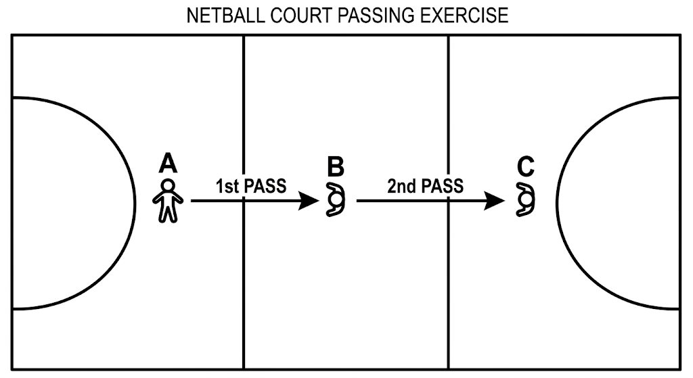
(a) Identify the skill sequence represented by the arrows and explain how the movement supports effective passing. (4 marks)
________________________________________________________________________________
________________________________________________________________________________
________________________________________________________________________________
________________________________________________________________________________
(b) State three coaching points for performing a running shot or pass accurately in Netball. (3 marks)
________________________________________________________________________________
________________________________________________________________________________
________________________________________________________________________________
(c) Give three benefits of teamwork during a mini Netball game. (3 marks)
________________________________________________________________________________
________________________________________________________________________________
________________________________________________________________________________
3. Basketball involves controlled movement, deception and accurate shooting.
(a) Describe four coaching points for effective crossover dribbling. (4 marks)
________________________________________________________________________________
________________________________________________________________________________
________________________________________________________________________________
________________________________________________________________________________
(b) Explain how faking and feinting can help a player create space for a shot. (2 marks)
________________________________________________________________________________
________________________________________________________________________________
(c) State two key points for a correct lay-up and two key points for a jump shot. (4 marks)
________________________________________________________________________________
________________________________________________________________________________
________________________________________________________________________________
________________________________________________________________________________
SECTION B — GAMES AND ATHLETICS (30 MARKS)
4. Study the badminton stroke figure below.
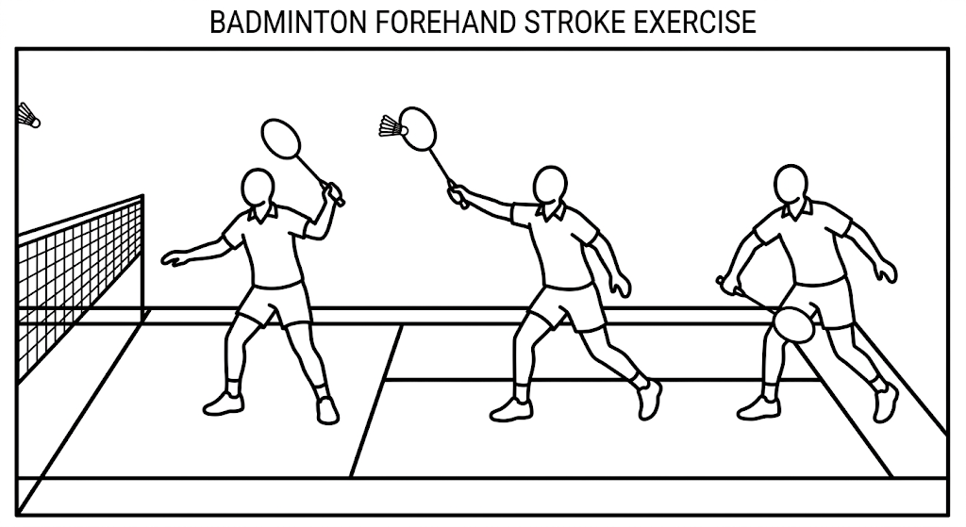
(a) Name the three stages represented in the figure. (3 marks)
________________________________________________________________________________
________________________________________________________________________________
________________________________________________________________________________
(b) For any two stages, describe two important technical aspects of grip, stance, swing, contact or follow-through. (4 marks)
________________________________________________________________________________
________________________________________________________________________________
________________________________________________________________________________
________________________________________________________________________________
(c) State three safety or fair-play practices that should be observed during a badminton game. (3 marks)
________________________________________________________________________________
________________________________________________________________________________
________________________________________________________________________________
5. Hurdling requires coordinated technique from the start to recovery.
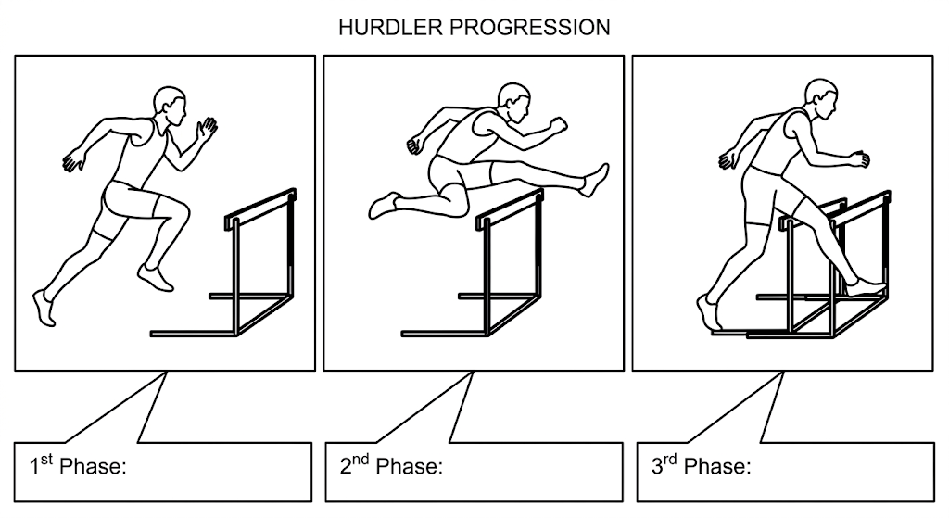
(a) Identify the three phases shown. (3 marks)
________________________________________________________________________________
________________________________________________________________________________
________________________________________________________________________________
(b) Explain four safety precautions that should be observed when practising hurdling. (4 marks)
________________________________________________________________________________
________________________________________________________________________________
________________________________________________________________________________
________________________________________________________________________________
(c) State three ways hurdling can contribute to individual wellness. (3 marks)
________________________________________________________________________________
________________________________________________________________________________
________________________________________________________________________________
6. Middle-distance running depends on efficient pacing and recovery.
(a) State the three key techniques emphasised in the curriculum for middle-distance races. (3 marks)
________________________________________________________________________________
________________________________________________________________________________
________________________________________________________________________________
(b) Explain how pacing and breathing contribute to performance in a middle-distance race. (4 marks)
________________________________________________________________________________
________________________________________________________________________________
________________________________________________________________________________
________________________________________________________________________________
(c) Give three appropriate recovery practices after a middle-distance race. (3 marks)
________________________________________________________________________________
________________________________________________________________________________
________________________________________________________________________________
SECTION C — ATHLETICS AND OUTDOOR EDUCATION (20 MARKS)
7. Cross-country running is performed over varied terrain and requires effective management of effort and recovery.
(a) Describe five techniques used in cross-country running, including starting, pacing, terrain management, breathing, finishing or recovery. (5 marks)
________________________________________________________________________________
________________________________________________________________________________
________________________________________________________________________________
________________________________________________________________________________
________________________________________________________________________________
(b) Explain three ways a learner can maintain safety when running over different terrains. (3 marks)
________________________________________________________________________________
________________________________________________________________________________
________________________________________________________________________________
(c) State two ways cross-country activities can promote environmental awareness. (2 marks)
________________________________________________________________________________
________________________________________________________________________________
8. A school is planning a camping adventure. Study the campsite layout below and answer the questions.
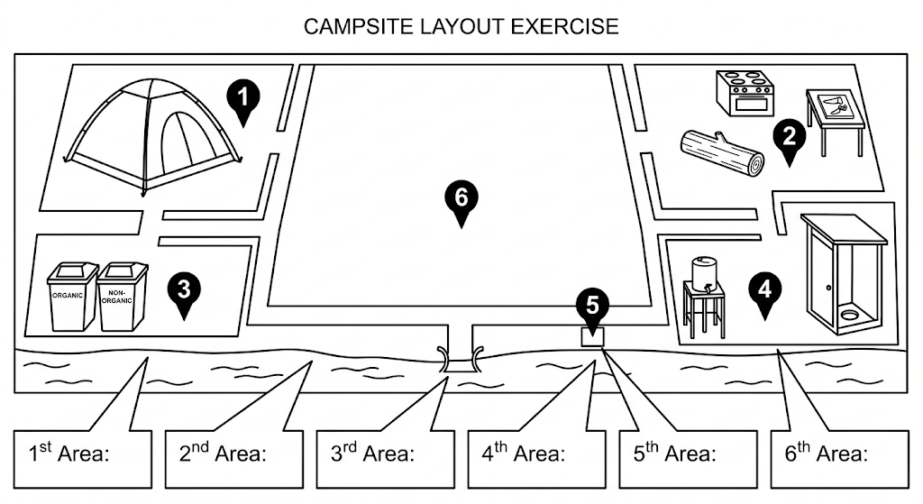
(a) Identify the six numbered areas in the campsite layout and state one safety consideration for any two of them. (6 marks)
________________________________________________________________________________
________________________________________________________________________________
________________________________________________________________________________
________________________________________________________________________________
________________________________________________________________________________
________________________________________________________________________________
(b) State two important considerations when selecting a campsite. (2 marks)
________________________________________________________________________________
________________________________________________________________________________
(c) Give two examples of responsible activities that may be undertaken during a camping adventure while conserving the environment. (2 marks)
________________________________________________________________________________
________________________________________________________________________________

END OF QUESTION PAPER

