END TERM 3 2026
GRADE 10
METALWORK
PAPER 1 – SUMMATIVE ASSESSMENT
TIME: 2 HOURS 30 MINUTES

Name: ________________________________________________________________
Assessment Number: _________________________________________________
Class / Stream: _____________________________________________________
Date: _______________________________________________________________
INSTRUCTIONS TO CANDIDATES
1. Write your name and assessment details in the spaces provided.
2. Read all questions carefully before answering.
3. Answer ALL questions.
4. Show all working and construction steps where required.
5. Use appropriate drawing instruments for technical drawing questions.
6. Label sketches and diagrams clearly.
7. Use correct units and conventions where applicable.
8. All answers must be written in the spaces provided where applicable.
9. Use clear and legible handwriting.
10. Check that all pages and questions are present before beginning.
EXAMINER'S USE ONLY
Section | Question Numbers | Maximum Score | Candidate's Score
A | 1–10 | 30
B | 11–16 | 30
C | 17–19 | 20
D | 20–22 | 20
TOTAL |  | 100

SECTION A — FUNDAMENTALS, TOOLS AND MATERIALS (30 marks)
Answer all questions.
1. Define the term metalwork as a learning area and state two reasons for studying metalwork. (3 marks)
________________________________________________________________________________
________________________________________________________________________________
________________________________________________________________________________
2. State three workshop safety rules that should be observed when working with metal. (3 marks)
________________________________________________________________________________
________________________________________________________________________________
________________________________________________________________________________
3. (a) State two examples of hand tools used in a metal workshop. (2 marks)
________________________________________________________________________________
________________________________________________________________________________
________________________________________________________________________________
(b) Give one use for each tool named in (a). (2 marks)
________________________________________________________________________________
________________________________________________________________________________
________________________________________________________________________________
________________________________________________________________________________
4. Distinguish between a measuring tool and a marking-out tool, giving one example of each. (4 marks)
________________________________________________________________________________
________________________________________________________________________________
________________________________________________________________________________
________________________________________________________________________________
5. State three factors to consider when selecting a hand or bench tool for a given task. (3 marks)
________________________________________________________________________________
________________________________________________________________________________
________________________________________________________________________________
6. (a) Distinguish between ferrous and non-ferrous metals. (2 marks)
________________________________________________________________________________
________________________________________________________________________________
________________________________________________________________________________
(b) Give two examples of ferrous metals and two examples of non-ferrous metals. (4 marks)
________________________________________________________________________________
________________________________________________________________________________
________________________________________________________________________________
________________________________________________________________________________
________________________________________________________________________________
________________________________________________________________________________
7. State three properties of metals that influence their selection for workshop applications. (3 marks)
________________________________________________________________________________
________________________________________________________________________________
________________________________________________________________________________
8. State two forms in which metal may be supplied for use in a metal workshop. (2 marks)
________________________________________________________________________________
________________________________________________________________________________

SECTION B — MEASURING, DRAWING AND WORKSHOP APPLICATION (30 marks)
Answer all questions.
11. A learner is required to prepare a small sheet-metal component from a rectangular blank. Explain the sequence of operations that should be followed from measurement and marking-out to completion. (6 marks)
________________________________________________________________________________
________________________________________________________________________________
________________________________________________________________________________
________________________________________________________________________________
________________________________________________________________________________
________________________________________________________________________________
________________________________________________________________________________
12. The following visual is to be used to assess identification of common metalwork tools.
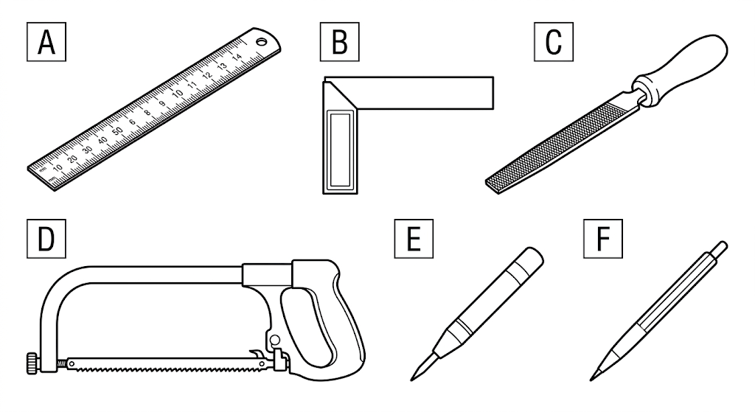
(a) Identify tools A, B and C. (3 marks)
________________________________________________________________________________
________________________________________________________________________________
________________________________________________________________________________
(b) State one use of each of the three tools identified in (a). (3 marks)
________________________________________________________________________________
________________________________________________________________________________
________________________________________________________________________________
13. (a) State three purposes of using scales, symbols, abbreviations and conventions in technical drawing. (3 marks)
________________________________________________________________________________
________________________________________________________________________________
________________________________________________________________________________
________________________________________________________________________________
(b) Explain the difference between a plane scale and a diagonal scale. (2 marks)
________________________________________________________________________________
________________________________________________________________________________
________________________________________________________________________________
________________________________________________________________________________
________________________________________________________________________________
14. (a) What is pictorial drawing? (2 marks)
________________________________________________________________________________
________________________________________________________________________________
________________________________________________________________________________
(b) Name the two pictorial projections studied in Grade 10 Metalwork. (2 marks)
________________________________________________________________________________
________________________________________________________________________________
________________________________________________________________________________
(c) State two characteristics of an isometric drawing. (2 marks)
________________________________________________________________________________
________________________________________________________________________________
________________________________________________________________________________
________________________________________________________________________________
________________________________________________________________________________
________________________________________________________________________________
15. A learner is asked to prepare an isometric sketch of a simple rectangular metal box measuring 80 mm × 50 mm × 30 mm. Construct a neat isometric sketch of the box and show the three given dimensions. (6 marks)
________________________________________________________________________________
________________________________________________________________________________
________________________________________________________________________________
________________________________________________________________________________
________________________________________________________________________________
________________________________________________________________________________
________________________________________________________________________________
________________________________________________________________________________
________________________________________________________________________________
________________________________________________________________________________
________________________________________________________________________________
________________________________________________________________________________

16. State three ways in which good maintenance of measuring and marking-out tools improves workshop work. (3 marks)
________________________________________________________________________________
________________________________________________________________________________
________________________________________________________________________________

SECTION C — METAL JOINING AND SHEET-METAL PROCESSES (20 marks)
Answer all questions.
17. (a) Name three methods of joining sheet metal covered in the curriculum. (3 marks)
________________________________________________________________________________
________________________________________________________________________________
________________________________________________________________________________
________________________________________________________________________________
(b) State one suitable application for each method named in (a). (3 marks)
________________________________________________________________________________
________________________________________________________________________________
________________________________________________________________________________
________________________________________________________________________________
________________________________________________________________________________
________________________________________________________________________________
18. A learner has to join two pieces of sheet metal permanently. Explain four factors that should guide the selection of the joining method. (4 marks)
________________________________________________________________________________
________________________________________________________________________________
________________________________________________________________________________
________________________________________________________________________________
________________________________________________________________________________
19. (a) Explain the following sheet-metal processes: edge treatment, hollowing, sinking and raising. (8 marks)
________________________________________________________________________________
________________________________________________________________________________
________________________________________________________________________________
________________________________________________________________________________
________________________________________________________________________________
________________________________________________________________________________
________________________________________________________________________________
________________________________________________________________________________
________________________________________________________________________________
________________________________________________________________________________
(b) State two safety precautions to observe when carrying out sheet-metal processes. (2 marks)
________________________________________________________________________________
________________________________________________________________________________
________________________________________________________________________________
________________________________________________________________________________

SECTION D — INTEGRATED APPLICATION AND PROJECT WORK (20 marks)
Answer all questions.
20. A community has identified a need for a simple metal item that can be fabricated using locally available materials.
(a) State a suitable metal item that could solve a practical community problem. (2 marks)
________________________________________________________________________________
________________________________________________________________________________
(b) Describe the problem the item would solve and the users who would benefit from it. (4 marks)
________________________________________________________________________________
________________________________________________________________________________
________________________________________________________________________________
________________________________________________________________________________
________________________________________________________________________________
(c) Outline four stages you would follow from identifying the problem to presenting the fabricated item. (4 marks)
________________________________________________________________________________
________________________________________________________________________________
________________________________________________________________________________
________________________________________________________________________________
________________________________________________________________________________
21. Explain four ways in which safety, responsibility and care for tools and materials should be demonstrated during a metalwork project. (4 marks)
________________________________________________________________________________
________________________________________________________________________________
________________________________________________________________________________
________________________________________________________________________________
________________________________________________________________________________
22. Prepare a simple labelled project plan for fabricating the item proposed in Question 20. Your plan should show: materials, tools/equipment, major operations, safety precautions and the expected final product. (6 marks)
________________________________________________________________________________
________________________________________________________________________________
________________________________________________________________________________
________________________________________________________________________________
________________________________________________________________________________
________________________________________________________________________________
________________________________________________________________________________
________________________________________________________________________________
END OF QUESTION PAPER

