END TERM 3 2026
GRADE 10
MEDIA TECHNOLOGY
SUMMATIVE ASSESSMENT
TIME: 2 Hours 30 Minutes
TOTAL MARKS: 100

Name: _________________________________________________
Assessment Number: ______________________________________
Class / Stream: __________________________________________
Date: _________________________________________________
INSTRUCTIONS TO CANDIDATES
1. Write your name and assessment details in the spaces provided.
2. Read all questions carefully before answering.
3. Answer all questions.
4. Show all working where calculations or planning are required.
5. Label diagrams clearly where required.
6. Use appropriate technical terminology.
7. All answers should be written in the spaces provided where applicable.
8. Use clear and legible handwriting.
9. Check the question paper to ensure that all pages and questions are present.

EXAMINER'S USE ONLY
Section | Question Numbers | Maximum Score | Candidate's Score
A | 1–8 | 20
B | 9–12 | 40
C | 13–15 | 40
TOTAL |  | 100

SECTION A — FOUNDATIONAL STRUCTURED QUESTIONS (20 MARKS)
1. Differentiate between print media and electronic media, giving one example of each. (3 marks)
__________________________________________________________________________________________________________________________________________________________________________________________________________________________________________________________________________________________________________________________
2. State three duties of personnel involved in the pre-production phase of media content creation. (3 marks)
___________________________________________________________________________________________________________________________________________________________________________________________________________________________________________________________________________________________________________________________
3. Give two reasons why research is important before producing media content. (2 marks)
__________________________________________________________________________________________________________________________________________________________________________________________________________________
4. State three key activities carried out during the production phase of a media project. (3 marks)
___________________________________________________________________________________________________________________________________________________________________________________________________________________________________________________________________________________________________________________________
5. State two functions of post-production in media content creation. (2 marks)
__________________________________________________________________________________________________________________________________________________________________________________________________________________
6. Name two photography genres and state one suitable subject or situation for each. (4 marks)
____________________________________________________________________________________________________________________________________________________________________________________________________________________________________________________________________________________________________________________________________________________________________________________________________________________________________
7. State two functions of a camera component and two functions of an audio-production component. (4 marks)
____________________________________________________________________________________________________________________________________________________________________________________________________________________________________________________________________________________________________________________________________________________________________________________________________________________________________
8. State three factors a learner should consider when choosing a media company structure or ownership arrangement in Kenya. (3 marks)
___________________________________________________________________________________________________________________________________________________________________________________________________________________________________________________________________________________________________________________________
SECTION B — APPLICATION, DATA, DIAGRAMS AND PROBLEM SOLVING (40 MARKS)
9. A school media club is preparing a short educational video on cyber safety. The producer has asked the team to prepare before recording begins. (8 marks)
(a) Outline four activities that should be completed during pre-production. (4 marks)
____________________________________________________________________________________________________________________________________________________________________________________________________________________________________________________________________________________________________________________________________________________________________________________________________________________________________
(b) Explain two ways the target audience should influence the media production plan. (4 marks)
____________________________________________________________________________________________________________________________________________________________________________________________________________________________________________________________________________________________________________________________________________________________________________________________________________________________________
Figure 1: Basic studio set-up
10. Study the figure below and answer the following.
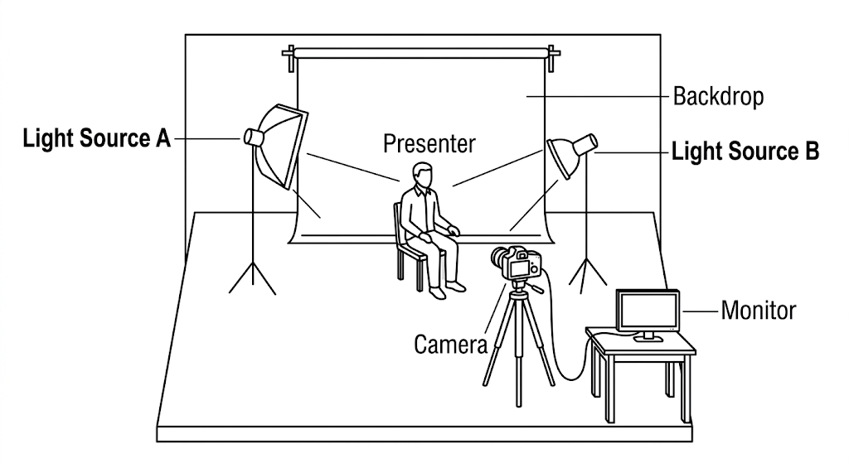
(a) Identify the purpose of the two light sources labelled A and B in the set-up. (2 marks)
__________________________________________________________________________________________________________________________________________________________________________________________________________________
(b) State four precautions that should be observed when setting up and operating equipment in a media studio. (4 marks)
____________________________________________________________________________________________________________________________________________________________________________________________________________________________________________________________________________________________________________________________________________________________________________________________________________________________________
(c) State two pieces of information that should be checked before recording begins. (4 marks)
____________________________________________________________________________________________________________________________________________________________________________________________________________________________________________________________________________________________________________________________________________________________________________________________________________________________________
Figure 2: Digital camera
11. Study the figure shown below and answer the following.
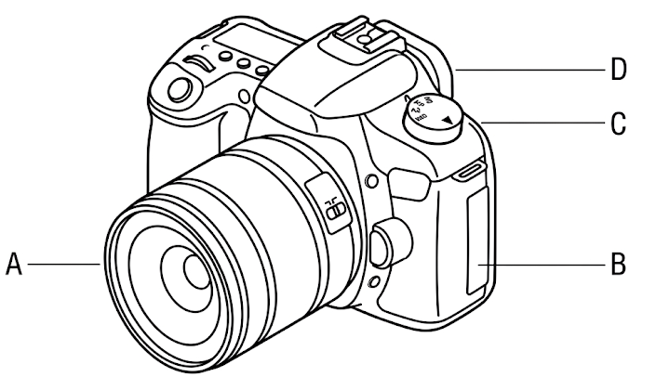
(a) Name the four indicated camera components. (4 marks)
____________________________________________________________________________________________________________________________________________________________________________________________________________________________________________________________________________________________________________________________________________________________________________________________________________________________________
(b) Explain two ways camera accessories can improve the quality or stability of photographic work. (4 marks)
____________________________________________________________________________________________________________________________________________________________________________________________________________________________________________________________________________________________________________________________________________________________________________________________________________________________________
(c) State two photography genres that can be used to tell a story visually. (2 marks)
__________________________________________________________________________________________________________________________________________________________________________________________________________________
12. A student records a one-minute spoken audio clip. The recording contains unwanted background noise and inconsistent volume. Explain four steps the student could take during or after recording to improve the final audio. (12 marks)
____________________________________________________________________________________________________________________________________________________________________________________________________________________________________________________________________________________________________________________________________________________________________________________________________________________________________________________________________________________________________________________________________________________________________________________________________________________________________________________________________________________________________________________________________________________________________________________________________________________________________________________________________________________________________________________________________________________________________________________________________________________________________________________________________________________________________________________________________________________________________________________________________________________________________________________________________________________________________________
SECTION C — EXTENDED STRUCTURED APPLICATION (40 MARKS)
13. A school plans to produce a five-minute documentary about responsible use of digital media. Develop a production plan covering the following. (14 marks)
____________________________________________________________________________________________________________________________________________________________________________________________________________________________________________________________________________________________________________________________________________________________________________________________________________________________________
(a) State the purpose and target audience of the documentary. (2 marks)
__________________________________________________________________________________________________________________________________________________________________________________________________________________
(b) Outline four pre-production activities, showing the order in which they should be undertaken. (4 marks)
____________________________________________________________________________________________________________________________________________________________________________________________________________________________________________________________________________________________________________________________________________________________________________________________________________________________________
(c) Describe four production activities that will help the team obtain usable video and sound. (4 marks)
____________________________________________________________________________________________________________________________________________________________________________________________________________________________________________________________________________________________________________________________________________________________________________________________________________________________________
(d) Explain two post-production activities that should be carried out before distribution. (4 marks)
____________________________________________________________________________________________________________________________________________________________________________________________________________________________________________________________________________________________________________________________________________________________________________________________________________________________________
14. A learner intends to establish a small media enterprise that offers photography, video and audio services. (12 marks)
(a) Describe three forms of media ownership that may be found in Kenya. (6 marks)
______________________________________________________________________________________________________________________________________________________________________________________________________________________________________________________________________________________________________________________________________________________________________________________________________________________________________________________________________________________________________________________________________________________________________________________________________________________________________________________
(b) Explain three factors the learner should consider when selecting an appropriate ownership structure for the enterprise. (6 marks)
______________________________________________________________________________________________________________________________________________________________________________________________________________________________________________________________________________________________________________________________________________________________________________________________________________________________________________________________________________________________________________________________________________________________________________________________________________________________________________________
15. A media company is preparing to release a video created using photographs, recorded interviews and background audio. Analyse the workflow from the original content to the final distributed product. In your response, include: research and planning, production, post-production, safe and ethical handling of media content, and at least two ways technology can affect the process. (14 marks)
______________________________________________________________________________________________________________________________________________________________________________________________________________________________________________________________________________________________________________________________________________________________________________________________________________________________________________________________________________________________________________________________________________________________________________________________________________________________________________________________________________________________________________________________________________________________________________________________________________________________________________________________________________________________________________________________________________________________________________________________________________________________________________________________________________________________________________________________________________________________________________________________________________________________________________________________________________________________________________________________________________________________________________________________________________________________________________________________________________________________________________________________
END OF QUESTION PAPER

