END TERM 3 2026
GRADE 10
MARINE AND FISHERIES TECHNOLOGY
TIME: 2 HOURS 30 MINUTES
Name: ________________________________________________________________________
Assessment Number: ________________________________________________________________________
Class / Stream: ________________________________________________________________________
Date: ________________________________________________________________________

INSTRUCTIONS TO CANDIDATES
- Write your name and assessment details in the spaces provided.
- Answer ALL questions.
- Read each question carefully before answering.
- Show all working and reasoning where required.
- Label all diagrams clearly and draw neatly where a drawing is required.
- Use appropriate terminology relating to marine and fisheries technology.
- Write your answers in the spaces provided or immediately following the question.
- Check that all pages and questions are present before leaving the examination room.

EXAMINER'S USE ONLY
Section | Question Numbers | Maximum Score | Candidate's Score
Section A | 1–3 | 24
Section B | 4–6 | 26
Section C | 7–9 | 30
TOTAL |  | 80

GRADE 10 END TERM 3 2026 SUMMATIVE ASSESSMENT
Cumulative coverage: ALL Grade 10 strands and sub-strands in the KICD Curriculum Design.

SECTION A: FISH BIOLOGY AND ECOLOGY
1. (a) State four opportunities available in marine and freshwater fisheries. (4 marks)
_________________________________________________________________________________________________________
_________________________________________________________________________________________________________
_________________________________________________________________________________________________________
_________________________________________________________________________________________________________
(b) Describe two basic characteristics of marine or freshwater environments that support fish life. (4 marks)
_________________________________________________________________________________________________________
_________________________________________________________________________________________________________
_________________________________________________________________________________________________________
_________________________________________________________________________________________________________
2. (a) Study the fish diagram below and answer the question that follows. (5 marks)
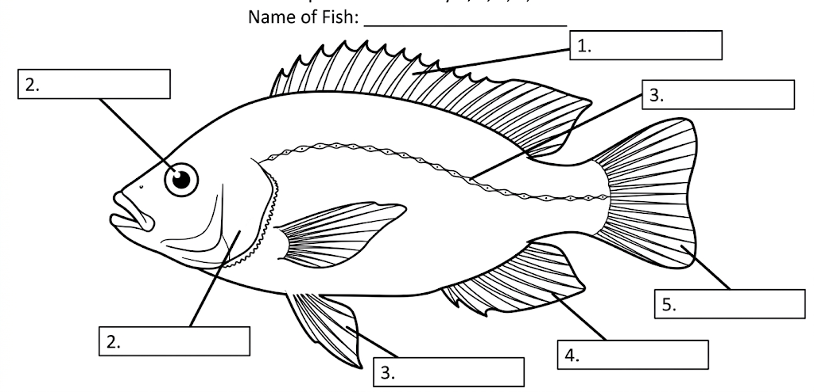
Label on the diagram five indicated external features. (5 marks)
(b) Give three differences between bony fishes and cartilaginous fishes. (3 marks)
_________________________________________________________________________________________________________
_________________________________________________________________________________________________________
_________________________________________________________________________________________________________
3. Explain four ways in which an aquatic ecosystem can support fish and other aquatic organisms. (8 marks)
_________________________________________________________________________________________________________
_________________________________________________________________________________________________________
_________________________________________________________________________________________________________
_________________________________________________________________________________________________________
_________________________________________________________________________________________________________
_________________________________________________________________________________________________________
_________________________________________________________________________________________________________
_________________________________________________________________________________________________________

SECTION B: AQUACULTURE
4. (a) Describe three different types of aquaculture systems. (3 marks)
_________________________________________________________________________________________________________
_________________________________________________________________________________________________________
_________________________________________________________________________________________________________
(b) Explain three reasons why aquaculture is economically important to Kenya. (3 marks)
_________________________________________________________________________________________________________
_________________________________________________________________________________________________________
_________________________________________________________________________________________________________
(c) State two challenges facing aquaculture development in Kenya. (2 marks)
_________________________________________________________________________________________________________
_________________________________________________________________________________________________________
5. A school intends to establish a small fish production unit. Answer the following. (8 marks)
(a) Identify four factors that should be considered when selecting a suitable site for a fish pond. (4 marks)
_________________________________________________________________________________________________________
_________________________________________________________________________________________________________
_________________________________________________________________________________________________________
_________________________________________________________________________________________________________
(b) State four features that should be considered when constructing a simple fish pond. (4 marks)
_________________________________________________________________________________________________________
_________________________________________________________________________________________________________
_________________________________________________________________________________________________________
_________________________________________________________________________________________________________
6. (a) Draw and label a simple fish production system suitable for a school aquaculture project. (4 marks)
_________________________________________________________________________________________________________
_________________________________________________________________________________________________________
_________________________________________________________________________________________________________
_________________________________________________________________________________________________________
_________________________________________________________________________________________________________
_________________________________________________________________________________________________________
_________________________________________________________________________________________________________
_________________________________________________________________________________________________________
_________________________________________________________________________________________________________
_________________________________________________________________________________________________________
_________________________________________________________________________________________________________
_________________________________________________________________________________________________________
(b) State four management practices that should be carried out after stocking a fish pond. (4 marks)
_________________________________________________________________________________________________________
_________________________________________________________________________________________________________
_________________________________________________________________________________________________________
_________________________________________________________________________________________________________

SECTION C: CAPTURE FISHERIES, SAFETY AND APPLICATION
7. (a) Identify the three main types of capture fisheries given in the Curriculum Design. (3 marks)
_________________________________________________________________________________________________________
_________________________________________________________________________________________________________
_________________________________________________________________________________________________________
(b) Explain three characteristics of artisanal/small-scale fisheries. (3 marks)
_________________________________________________________________________________________________________
_________________________________________________________________________________________________________
_________________________________________________________________________________________________________
(c) Explain two ways in which capture fisheries contribute to the Kenyan economy. (2 marks)
_________________________________________________________________________________________________________
_________________________________________________________________________________________________________
8. A fishing crew is preparing to operate a vessel in an aquatic environment. (12 marks)
(a) Describe four types of accidents that may occur during fishing activities and state one possible cause of each. (4 marks)
_________________________________________________________________________________________________________
_________________________________________________________________________________________________________
_________________________________________________________________________________________________________
_________________________________________________________________________________________________________
_________________________________________________________________________________________________________
_________________________________________________________________________________________________________
(b) Identify four pieces of safety equipment required in a fishing vessel and state the purpose of each. (4 marks)
_________________________________________________________________________________________________________
_________________________________________________________________________________________________________
_________________________________________________________________________________________________________
_________________________________________________________________________________________________________
_________________________________________________________________________________________________________
_________________________________________________________________________________________________________
_________________________________________________________________________________________________________
_________________________________________________________________________________________________________
(c) State two basic survival techniques that can be practised in an aquatic environment. (2 marks)
_________________________________________________________________________________________________________
_________________________________________________________________________________________________________
(d) State two first-aid actions that may be taken for injuries related to fishing activities. (2 marks)
_________________________________________________________________________________________________________
_________________________________________________________________________________________________________
9. A community is considering whether to expand a capture-fishing activity or establish a fish pond. Using knowledge from the Grade 10 course: (10 marks)
(a) Compare the two options under four relevant considerations, such as production system, management requirements, safety, or resource use. (4 marks)
_________________________________________________________________________________________________________
_________________________________________________________________________________________________________
_________________________________________________________________________________________________________
_________________________________________________________________________________________________________
_________________________________________________________________________________________________________
(b) Recommend four responsible practices that would promote safe, sustainable and productive use of fisheries resources. (4 marks)
_________________________________________________________________________________________________________
_________________________________________________________________________________________________________
_________________________________________________________________________________________________________
_________________________________________________________________________________________________________
_________________________________________________________________________________________________________
(c) State two ways learners can promote awareness of safety and sustainable fisheries practices in their community. (2 marks)
_________________________________________________________________________________________________________
_________________________________________________________________________________________________________
END OF QUESTION PAPER

