END TERM 3 2026
GRADE 10
INFORMATION AND COMMUNICATION TECHNOLOGY (ICT)
SUMMATIVE ASSESSMENT
TIME: 2 HOURS 30 MINUTES TOTAL MARKS: 80
Name: ______________________________________________________________
Assessment Number: ____________________________________________
Class / Stream: _______________________________________________
Date: ___________________________________________________________

INSTRUCTIONS TO CANDIDATES
• Write your name and assessment details in the spaces provided.
• Read all questions carefully before answering.
• Answer ALL questions.
• Show all working where calculations or step-by-step procedures are required.
• Label diagrams, interface components and other visual responses clearly where required.
• Use clear and legible handwriting and appropriate ICT terminology.
• All answers must be written in the spaces provided where applicable.
• Check that all questions and pages are present before handing in the paper.

EXAMINER'S USE ONLY
Section / Question | Question Numbers | Maximum Score | Candidate's Score
Section A | 1–8 | 20
Section B | 9–12 | 24
Section C | 13–16 | 20
Section D | 17–18 | 16
TOTAL |  | 80

SECTION A — FOUNDATIONAL STRUCTURED QUESTIONS (20 MARKS)
1. State four components of ICT infrastructure in an organisation. (4 marks)
________________________________________________________________________________
________________________________________________________________________________
________________________________________________________________________________
________________________________________________________________________________
________________________________________________________________________________
2. Give two application areas of ICT in society and state one benefit of ICT in each area. (4 marks)
________________________________________________________________________________
________________________________________________________________________________
________________________________________________________________________________
________________________________________________________________________________
________________________________________________________________________________
3. (a) State two functions of an operating system. (b) Give two examples of operating systems used on digital devices. (4 marks)
________________________________________________________________________________
________________________________________________________________________________
________________________________________________________________________________
________________________________________________________________________________
________________________________________________________________________________
4. Distinguish between a file and a folder in a computing device. (2 marks)
________________________________________________________________________________
________________________________________________________________________________
________________________________________________________________________________
5. State two measures that can be used to protect personal information when using online platforms. (2 marks)
________________________________________________________________________________
________________________________________________________________________________
________________________________________________________________________________
6. Give two reasons why digital citizenship is important in society. (2 marks)
________________________________________________________________________________
________________________________________________________________________________
________________________________________________________________________________
7. State two productivity tools that can be used to produce or present information. (2 marks)
________________________________________________________________________________
________________________________________________________________________________
________________________________________________________________________________
SECTION B — PRODUCTIVITY TOOLS, DATA AND VISUAL REPRESENTATION (24 MARKS)
8. A school is preparing a three-page information leaflet for parents. State four word-processing features that can be used to make the document professional and explain the purpose of each feature. (8 marks)
________________________________________________________________________________
________________________________________________________________________________
________________________________________________________________________________
________________________________________________________________________________
________________________________________________________________________________
________________________________________________________________________________
________________________________________________________________________________
________________________________________________________________________________
________________________________________________________________________________
________________________________________________________________________________
9. A learner has prepared a presentation on road safety for a community audience. (a) State two features that can make the presentation interactive and engaging. (b) Explain one way of using hyperlinks or navigation features to improve the presentation. (5 marks)
________________________________________________________________________________
________________________________________________________________________________
________________________________________________________________________________
________________________________________________________________________________
________________________________________________________________________________
________________________________________________________________________________
________________________________________________________________________________
________________________________________________________________________________
________________________________________________________________________________
10. Study the simplified desktop interface below and answer the questions that follow. (5 marks)
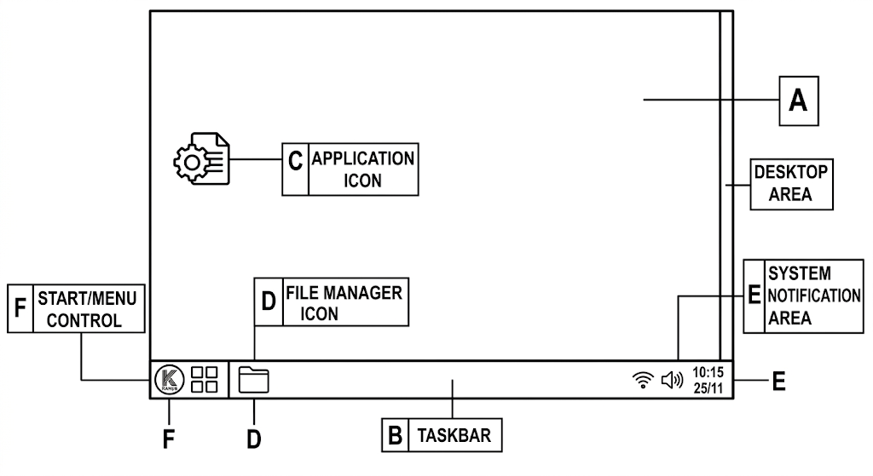
(a) Identify the component that is primarily used to launch applications and access system options. (1 marks)
________________________________________________________________________________
(b) State two functions of a file manager. (2 marks)
________________________________________________________________________________
________________________________________________________________________________
________________________________________________________________________________
(c) State two reasons why a graphical user interface can make interaction with an operating system easier. (2 marks)
________________________________________________________________________________
________________________________________________________________________________
________________________________________________________________________________
11. Explain three document-production activities that can be improved through collaboration features in a word processor. (6 marks)
________________________________________________________________________________
________________________________________________________________________________
________________________________________________________________________________
________________________________________________________________________________
________________________________________________________________________________
________________________________________________________________________________
________________________________________________________________________________
________________________________________________________________________________
SECTION C — INTERNET, DIGITAL CITIZENSHIP AND DIGITAL COMMUNICATION (20 MARKS)
12. A learner needs to obtain reliable information from the Internet for a school project. (a) State three services offered through the Internet. (b) Explain three practices that can help the learner obtain reliable information using search engines. (7 marks)
________________________________________________________________________________
________________________________________________________________________________
________________________________________________________________________________
________________________________________________________________________________
________________________________________________________________________________
________________________________________________________________________________
________________________________________________________________________________
________________________________________________________________________________
________________________________________________________________________________
13. A school is connecting a computer to the Internet for the first time. State three components or requirements needed to establish an Internet connection and explain the purpose of each. (6 marks)
________________________________________________________________________________
________________________________________________________________________________
________________________________________________________________________________
________________________________________________________________________________
________________________________________________________________________________
________________________________________________________________________________
________________________________________________________________________________
________________________________________________________________________________
14. Read the situation below. A learner receives a message asking for a password and personal details through an unfamiliar online platform. The learner is also considering sharing the message with friends. (a) Identify two online safety risks in the situation. (b) Explain four responsible digital-citizenship actions the learner should take. (7 marks)
________________________________________________________________________________
________________________________________________________________________________
________________________________________________________________________________
________________________________________________________________________________
________________________________________________________________________________
________________________________________________________________________________
________________________________________________________________________________
________________________________________________________________________________
________________________________________________________________________________
SECTION D — INTEGRATED APPLICATION AND PROBLEM SOLVING (16 MARKS)
15. A youth group wants to advertise a community health activity using a desktop-publishing tool. Describe four steps the group should follow to create a professional publication and identify one publication type suitable for the activity. (6 marks)
________________________________________________________________________________
________________________________________________________________________________
________________________________________________________________________________
________________________________________________________________________________
________________________________________________________________________________
________________________________________________________________________________
________________________________________________________________________________
________________________________________________________________________________
16. A community organisation uses e-mail, instant messaging and video conferencing to coordinate activities. Explain four ways digital communication can improve collaboration and identify two precautions that should be observed when sharing files or information online. (6 marks)
________________________________________________________________________________
________________________________________________________________________________
________________________________________________________________________________
________________________________________________________________________________
________________________________________________________________________________
________________________________________________________________________________
________________________________________________________________________________
________________________________________________________________________________
17. Compare a word processor, presentation software and desktop-publishing software by giving one suitable use for each and one feature that makes each tool appropriate for that use. (4 marks)
________________________________________________________________________________
________________________________________________________________________________
________________________________________________________________________________
________________________________________________________________________________
________________________________________________________________________________
________________________________________________________________________________
________________________________________________________________________________

