END TERM 3 2026
GRADE 10
GEOGRAPHY
SUMMATIVE ASSESSMENT
TIME: 2 HOURS 30 MINUTES
Name | ________________________________________________________
Assessment Number | ________________________________
Class / Stream | ________________________________
Date | ________________________________
INSTRUCTIONS TO CANDIDATES
• Answer ALL questions.
• Read each question carefully before answering.
• Use a pencil for maps, diagrams and graphs where appropriate.
• Show all calculations and working.
• Where a sketch map or diagram is required, include appropriate labels.
• Use the spaces provided and write clearly and legibly.
• All questions carry the marks indicated.
TOTAL: 100 MARKS

EXAMINER'S USE ONLY
Section | Questions | Maximum Score | Candidate Score
A | 1–10 | 20
B | 11–15 | 40
C | 16–19 | 40
TOTAL |  | 100
SECTION A — SHORT STRUCTURED QUESTIONS (20 MARKS)
1. State two branches of Geography. (2 marks)
________________________________________________________________________________________________
________________________________________________________________________________________________
________________________________________________________________________________________________
2. State two uses of topographical maps. (2 marks)
________________________________________________________________________________________________
________________________________________________________________________________________________
________________________________________________________________________________________________
3. Name two methods of collecting geographical data. (2 marks)
________________________________________________________________________________________________
________________________________________________________________________________________________
________________________________________________________________________________________________
4. State two components of a Geographical Information System (GIS). (2 marks)
________________________________________________________________________________________________
________________________________________________________________________________________________
________________________________________________________________________________________________
5. Name the three major types of rocks according to mode of formation. (2 marks)
________________________________________________________________________________________________
________________________________________________________________________________________________
________________________________________________________________________________________________
6. State two causes of earthquakes. (2 marks)
________________________________________________________________________________________________
________________________________________________________________________________________________
________________________________________________________________________________________________
7. State two types of agriculture practised in the world. (2 marks)
________________________________________________________________________________________________
________________________________________________________________________________________________
________________________________________________________________________________________________
8. State two methods of extracting minerals. (2 marks)
________________________________________________________________________________________________
________________________________________________________________________________________________
________________________________________________________________________________________________
9. Name two renewable sources of energy. (2 marks)
________________________________________________________________________________________________
________________________________________________________________________________________________
________________________________________________________________________________________________
10. State two factors influencing the location of industries. (2 marks)
________________________________________________________________________________________________
________________________________________________________________________________________________
________________________________________________________________________________________________
SECTION B — MAPS, DATA, NATURAL SYSTEMS AND HUMAN ACTIVITIES (40 MARKS)
11. Study the simplified topographical map extract below and answer the questions that follow.
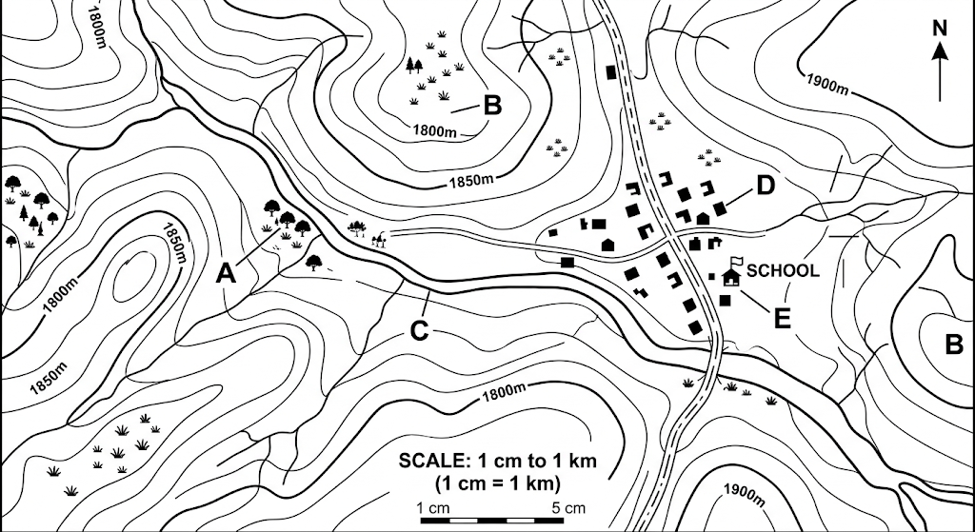
(a) Identify features A, B and C from the map. (3 marks)
________________________________________________________________________________________________
________________________________________________________________________________________________
________________________________________________________________________________________________
________________________________________________________________________________________________
(b) State three methods of representing relief that may be used on a topographical map. (3 marks)
________________________________________________________________________________________________
________________________________________________________________________________________________
________________________________________________________________________________________________
________________________________________________________________________________________________
(c) Explain two ways in which drainage and vegetation information on a topographical map can assist resource mapping. (2 marks)
________________________________________________________________________________________________
________________________________________________________________________________________________
________________________________________________________________________________________________
12. The table below shows the number of households participating in selected income-generating activities in a locality.
Activity | Number of households
Crop farming | 120
Livestock keeping | 80
Small-scale mining | 30
Trade and services | 70
(a) Calculate the total number of households represented in the table. (2 marks)
________________________________________________________________________________________________
________________________________________________________________________________________________
________________________________________________________________________________________________
(b) Calculate the percentage of households involved in crop farming. (2 marks)
________________________________________________________________________________________________
________________________________________________________________________________________________
________________________________________________________________________________________________
(c) State two ways in which data such as these can be presented graphically. (2 marks)
________________________________________________________________________________________________
________________________________________________________________________________________________
________________________________________________________________________________________________
(d) State two advantages of using statistics in geographical studies. (2 marks)
________________________________________________________________________________________________
________________________________________________________________________________________________
________________________________________________________________________________________________
13. A region experiences frequent volcanic activity and occasional earthquakes.
(a) Distinguish between intrusive and extrusive volcanic features. (2 marks)
________________________________________________________________________________________________
________________________________________________________________________________________________
________________________________________________________________________________________________
(b) State two effects of volcanic activity on the environment. (2 marks)
________________________________________________________________________________________________
________________________________________________________________________________________________
________________________________________________________________________________________________
(c) Explain two ways in which communities can prepare for and manage earthquake disasters. (2 marks)
________________________________________________________________________________________________
________________________________________________________________________________________________
________________________________________________________________________________________________
(d) State two scales used in measuring earthquakes and indicate what each measures. (2 marks)
________________________________________________________________________________________________
________________________________________________________________________________________________
________________________________________________________________________________________________
14. Study the diagram below representing a fold produced by tectonic forces.
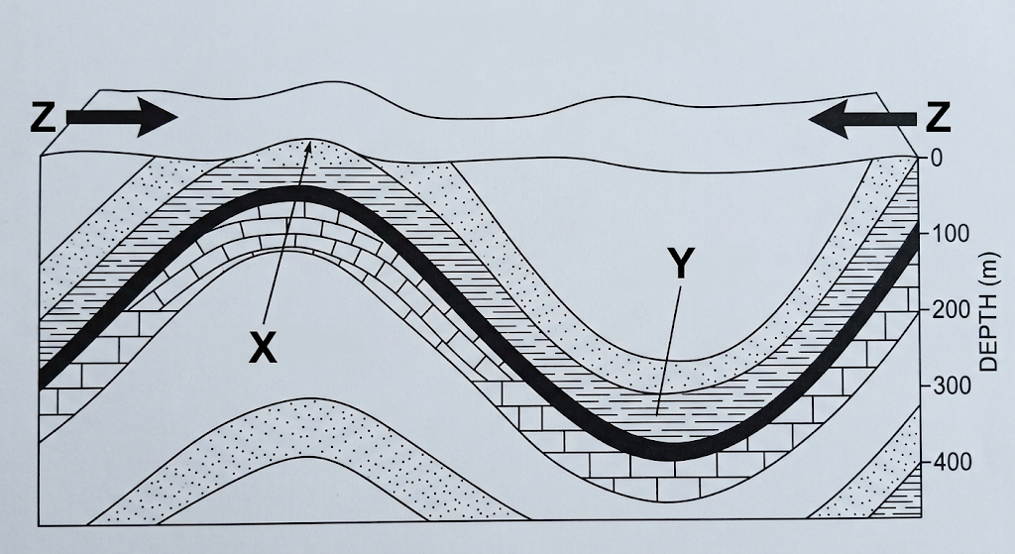
(a) Identify the fold labelled X and the fold labelled Y. (2 marks)
________________________________________________________________________________________________
________________________________________________________________________________________________
________________________________________________________________________________________________
(b) Explain how folding occurs. (2 marks)
________________________________________________________________________________________________
________________________________________________________________________________________________
________________________________________________________________________________________________
(c) State two resultant features or forms associated with folding. (2 marks)
________________________________________________________________________________________________
________________________________________________________________________________________________
________________________________________________________________________________________________
(d) Explain two ways in which folding can influence human activities. (2 marks)
________________________________________________________________________________________________
________________________________________________________________________________________________
________________________________________________________________________________________________
15. A county plans to expand agriculture, mining, energy production and industry while conserving its environment.
(a) State two strategies for enhancing agricultural productivity in Kenya. (2 marks)
________________________________________________________________________________________________
________________________________________________________________________________________________
________________________________________________________________________________________________
(b) Explain two environmental problems associated with mining and give one possible solution for each. (4 marks)
________________________________________________________________________________________________
________________________________________________________________________________________________
________________________________________________________________________________________________
________________________________________________________________________________________________
________________________________________________________________________________________________
(c) State two reasons why renewable energy is important for socio-economic development. (2 marks)
________________________________________________________________________________________________
________________________________________________________________________________________________
________________________________________________________________________________________________
SECTION C — EXTENDED APPLICATION AND ANALYSIS (40 MARKS)
16. A mineral occurs in a region where it can be extracted by open-cast mining. The mining company plans to increase production.
(a) Explain three factors that influence the occurrence and exploitation of minerals. (3 marks)
________________________________________________________________________________________________
________________________________________________________________________________________________
________________________________________________________________________________________________
________________________________________________________________________________________________
(b) Describe the main stages involved in extracting a mineral by open-cast mining. (3 marks)
________________________________________________________________________________________________
________________________________________________________________________________________________
________________________________________________________________________________________________
________________________________________________________________________________________________
(c) Explain two environmental effects of mining and suggest one rehabilitation measure for each. (4 marks)
________________________________________________________________________________________________
________________________________________________________________________________________________
________________________________________________________________________________________________
________________________________________________________________________________________________
________________________________________________________________________________________________
17. A geothermal power project is proposed in a volcanic region of Kenya.
(a) Explain why geothermal energy is associated with volcanic regions. (3 marks)
________________________________________________________________________________________________
________________________________________________________________________________________________
________________________________________________________________________________________________
________________________________________________________________________________________________
(b) Describe how electricity can be generated from geothermal energy. (3 marks)
________________________________________________________________________________________________
________________________________________________________________________________________________
________________________________________________________________________________________________
________________________________________________________________________________________________
(c) Explain two advantages and two challenges of renewable energy development in Kenya. (4 marks)
________________________________________________________________________________________________
________________________________________________________________________________________________
________________________________________________________________________________________________
________________________________________________________________________________________________
________________________________________________________________________________________________
18. A company intends to establish a manufacturing industry in Kenya.
(a) Explain four factors that should be considered when selecting the location of the industry. (4 marks)
________________________________________________________________________________________________
________________________________________________________________________________________________
________________________________________________________________________________________________
________________________________________________________________________________________________
________________________________________________________________________________________________
(b) Discuss three ways in which industries contribute to economic and social development. (3 marks)
________________________________________________________________________________________________
________________________________________________________________________________________________
________________________________________________________________________________________________
________________________________________________________________________________________________
(c) State three challenges associated with industrialisation in Kenya and suggest one solution to each. (3 marks)
________________________________________________________________________________________________
________________________________________________________________________________________________
________________________________________________________________________________________________
________________________________________________________________________________________________
19. A county government wants to use Geography and digital technologies to plan development in a rapidly growing settlement.
(a) Explain how GIS can be used to locate and manage designated crossing points on roads. (3 marks)
________________________________________________________________________________________________
________________________________________________________________________________________________
________________________________________________________________________________________________
________________________________________________________________________________________________
(b) Describe how geographical data can be collected, analysed and presented when investigating a local geographical problem. (3 marks)
________________________________________________________________________________________________
________________________________________________________________________________________________
________________________________________________________________________________________________
________________________________________________________________________________________________
(c) Using examples, explain how agriculture, energy, mining and industry can be managed sustainably to support socio-economic development. (4 marks)
________________________________________________________________________________________________
________________________________________________________________________________________________
________________________________________________________________________________________________
________________________________________________________________________________________________
________________________________________________________________________________________________

