END TERM 3 2026
GRADE 10
GENERAL SCIENCE
SUMMATIVE ASSESSMENT
TIME: 2 HOURS 30 MINUTES

Name | ____________________________________________________________
Assessment Number | ________________________________________
Class / Stream | ________________________________________
Date | ________________________________________
INSTRUCTIONS TO CANDIDATES
• Write your name and assessment details in the spaces provided.
• This paper contains structured-response questions only. Answer all questions.
• Read each question carefully before answering.
• Show all working where calculations are required.
• Give units for numerical answers where applicable.
• Draw and label diagrams clearly where required.
• Use the spaces provided and write clearly and legibly.
• All questions carry the marks indicated.
• Check that all pages and questions are present before handing in your paper.

TOTAL: 100 MARKS

EXAMINER'S USE ONLY
Section | Question Numbers | Maximum Score | Candidate's Score
A | 1–10 | 20
B | 11–15 | 40
C | 16–19 | 40
TOTAL |  | 100
SECTION A — FOUNDATIONAL STRUCTURED QUESTIONS (20 marks)
1. State two reasons why General Science is important in everyday life. (2 marks)
________________________________________________________________________________
________________________________________________________________________________
________________________________________________________________________________
2. Distinguish between a light microscope and an electron microscope. (2 marks)
________________________________________________________________________________
________________________________________________________________________________
________________________________________________________________________________
3. State two adaptations of the human digestive system that enable efficient digestion and absorption of food. (2 marks)
________________________________________________________________________________
________________________________________________________________________________
________________________________________________________________________________
4. Differentiate between aerobic and anaerobic respiration. (2 marks)
________________________________________________________________________________
________________________________________________________________________________
________________________________________________________________________________
5. State two factors necessary for seed germination. (2 marks)
________________________________________________________________________________
________________________________________________________________________________
________________________________________________________________________________
6. State two methods of preventing the transmission of microorganisms that cause infections in human beings. (2 marks)
________________________________________________________________________________
________________________________________________________________________________
________________________________________________________________________________
7. Write the electron arrangement of: (a) sodium, Na; (b) chlorine, Cl. (2 marks)
________________________________________________________________________________
________________________________________________________________________________
________________________________________________________________________________
8. State two differences between ionic bonding and covalent bonding. (2 marks)
________________________________________________________________________________
________________________________________________________________________________
________________________________________________________________________________
9. State two factors that affect the rate of a chemical reaction. (2 marks)
________________________________________________________________________________
________________________________________________________________________________
________________________________________________________________________________
10. Define: (a) moment of a force about a point; (b) wavelength. (2 marks)
________________________________________________________________________________
________________________________________________________________________________
________________________________________________________________________________
SECTION B — APPLICATION, DATA, DIAGRAMS AND PROBLEM SOLVING (40 marks)
11. Study the diagram below and answer the questions that follow.
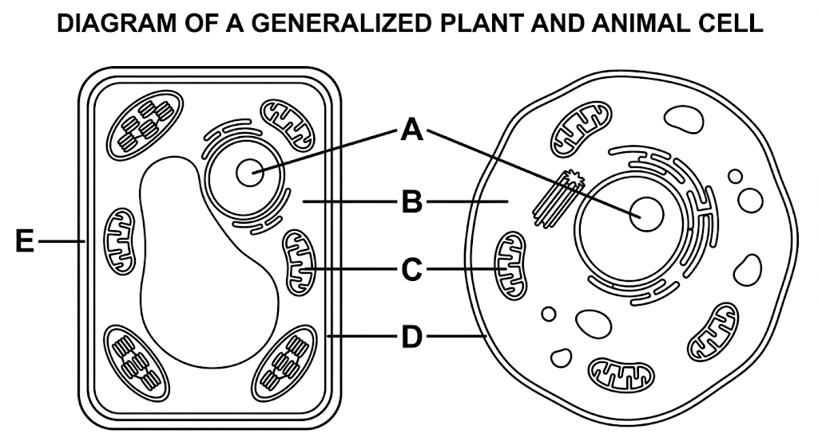
(a) Name the structures labelled A, B and C. (3 marks)
________________________________________________________________________________
________________________________________________________________________________
________________________________________________________________________________
________________________________________________________________________________
(b) State one function of each of the three structures named in (a). (3 marks)
________________________________________________________________________________
________________________________________________________________________________
________________________________________________________________________________
________________________________________________________________________________
(c) State one difference between the organization of a cell and that of an organ system. (2 marks)
________________________________________________________________________________
________________________________________________________________________________
________________________________________________________________________________
(d) Explain why the cell is regarded as the basic unit of life. (2 marks)
________________________________________________________________________________
________________________________________________________________________________
________________________________________________________________________________
12. A learner carried out food tests on a sample of food and obtained the observations shown below.
Test | Observation
Benedict's solution + heating | Blue solution changed to orange-red
Iodine solution | No blue-black colour
Biuret test | Violet colour formed
(a) Identify the food substances indicated by the Benedict's and Biuret tests. (2 marks)
________________________________________________________________________________
________________________________________________________________________________
________________________________________________________________________________
(b) Explain the role of enzymes in the digestion of food. (3 marks)
________________________________________________________________________________
________________________________________________________________________________
________________________________________________________________________________
________________________________________________________________________________
(c) Explain how the structure of the small intestine is adapted for absorption of digested food. (3 marks)
________________________________________________________________________________
________________________________________________________________________________
________________________________________________________________________________
________________________________________________________________________________
13. A farmer investigates water loss from leaves. Four similar potted plants are placed under different conditions. The percentage mass loss after a fixed period is recorded as follows.
Plant | Condition | Percentage mass loss
A | Well-watered, exposed to moving air | 18%
B | Well-watered, sheltered from moving air | 11%
C | Well-watered, high humidity | 6%
D | Well-watered, leaves partly covered | 8%
(a) Identify the process responsible for the loss of water from the leaves. (1 marks)
________________________________________________________________________________
(b) Using the data, explain the effect of moving air on the rate of water loss. (2 marks)
________________________________________________________________________________
________________________________________________________________________________
________________________________________________________________________________
(c) State two factors, other than moving air, that can affect transpiration. (2 marks)
________________________________________________________________________________
________________________________________________________________________________
________________________________________________________________________________
(d) Explain why transport of water and mineral salts is important to plant growth. (3 marks)
________________________________________________________________________________
________________________________________________________________________________
________________________________________________________________________________
________________________________________________________________________________
14. The first twenty elements of the periodic table are arranged according to increasing atomic number.
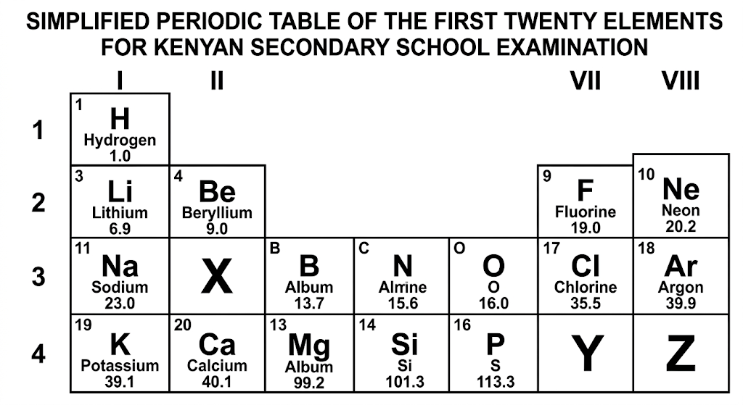
(a) State the group and period occupied by an element whose electron arrangement is 2,8,1. (2 marks)
________________________________________________________________________________
________________________________________________________________________________
________________________________________________________________________________
(b) Explain why elements in the same group of the periodic table have similar chemical properties. (2 marks)
________________________________________________________________________________
________________________________________________________________________________
________________________________________________________________________________
(c) Write the chemical formula of aluminium oxide using the valencies of aluminium and oxygen. (2 marks)
________________________________________________________________________________
________________________________________________________________________________
________________________________________________________________________________
(d) State two uses of elements or their compounds from the periodic table in everyday life. (2 marks)
________________________________________________________________________________
________________________________________________________________________________
________________________________________________________________________________
15. A student investigates the rate of reaction between a solid and an acid. The student repeats the experiment at different temperatures while keeping other conditions constant.
(a) State the independent variable and one controlled variable in the investigation. (2 marks)
________________________________________________________________________________
________________________________________________________________________________
________________________________________________________________________________
(b) Describe how increasing temperature generally affects the rate of a chemical reaction. (2 marks)
________________________________________________________________________________
________________________________________________________________________________
________________________________________________________________________________
(c) Give two other factors that can affect the rate of a chemical reaction. (2 marks)
________________________________________________________________________________
________________________________________________________________________________
________________________________________________________________________________
(d) Explain why safety precautions are necessary when investigating rates of chemical reactions. (2 marks)
________________________________________________________________________________
________________________________________________________________________________
________________________________________________________________________________
SECTION C — EXTENDED STRUCTURED APPLICATION (40 marks)
16. A student balances a metre rule on a pivot. A force of 4 N acts at a distance of 0.50 m from the pivot. A second force is applied on the opposite side at a distance of 0.25 m.
(a) Calculate the moment produced by the 4 N force about the pivot. (3 marks)
________________________________________________________________________________
________________________________________________________________________________
________________________________________________________________________________
________________________________________________________________________________
(b) Calculate the magnitude of the second force required to balance the metre rule. (3 marks)
________________________________________________________________________________
________________________________________________________________________________
________________________________________________________________________________
________________________________________________________________________________
(c) State two applications of the turning effect of force in real life. (2 marks)
________________________________________________________________________________
________________________________________________________________________________
________________________________________________________________________________
(d) Explain why a long spanner is generally more effective than a short spanner when loosening a tight nut. (2 marks)
________________________________________________________________________________
________________________________________________________________________________
________________________________________________________________________________
17. A ball is dropped from a height. Its motion is observed as it falls towards the ground.
(a) Define acceleration and state the direction of acceleration of a freely falling body near the Earth's surface. (2 marks)
________________________________________________________________________________
________________________________________________________________________________
________________________________________________________________________________
(b) A body starts from rest and accelerates uniformly at 2 m/s² for 5 s. Calculate its final velocity. (3 marks)
________________________________________________________________________________
________________________________________________________________________________
________________________________________________________________________________
________________________________________________________________________________
(c) Explain two safety measures that can reduce injuries associated with falling objects or falls. (2 marks)
________________________________________________________________________________
________________________________________________________________________________
________________________________________________________________________________
(d) Distinguish between distance and displacement. (2 marks)
________________________________________________________________________________
________________________________________________________________________________
________________________________________________________________________________
(e) State one example of linear motion with constant acceleration in real life. (1 marks)
________________________________________________________________________________
18. A wave has a frequency of 5 Hz and a wavelength of 0.8 m.
(a) Calculate the speed of the wave. (3 marks)
________________________________________________________________________________
________________________________________________________________________________
________________________________________________________________________________
________________________________________________________________________________
(b) State two properties of waves. (2 marks)
________________________________________________________________________________
________________________________________________________________________________
________________________________________________________________________________
(c) Explain one application of reflection, refraction or diffraction of waves in real life. (2 marks)
________________________________________________________________________________
________________________________________________________________________________
________________________________________________________________________________
(d) Explain one way in which waves can affect the environment and state one mitigation measure. (3 marks)
________________________________________________________________________________
________________________________________________________________________________
________________________________________________________________________________
________________________________________________________________________________
19. Study the electromagnetic induction arrangement shown below.
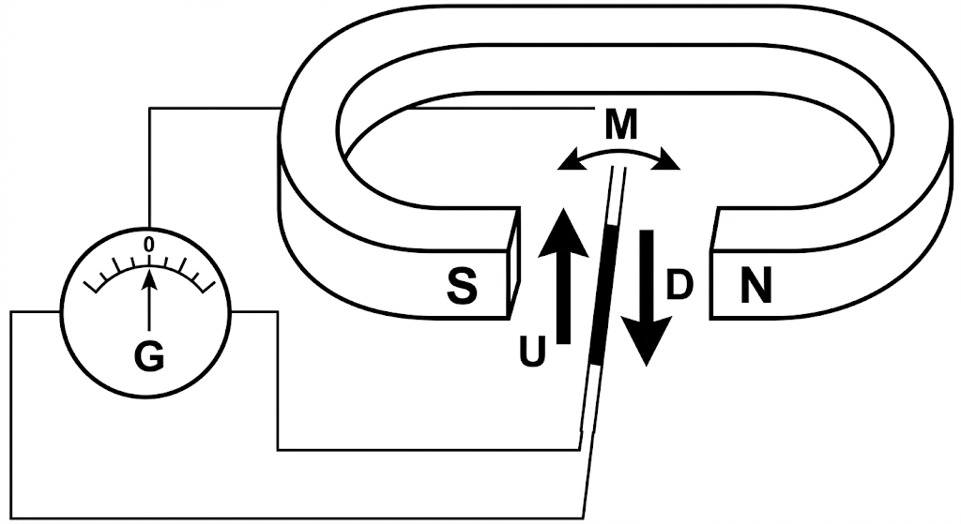
(a) State what is observed on the galvanometer when the conductor is moved through the magnetic field. (2 marks)
________________________________________________________________________________
________________________________________________________________________________
________________________________________________________________________________
(b) Explain how the magnitude of the induced electromotive force can be increased. (3 marks)
________________________________________________________________________________
________________________________________________________________________________
________________________________________________________________________________
________________________________________________________________________________
(c) Describe how a simple electromagnet can be made stronger. (2 marks)
________________________________________________________________________________
________________________________________________________________________________
________________________________________________________________________________
(d) State two applications of electromagnetic induction in everyday life. (2 marks)
________________________________________________________________________________
________________________________________________________________________________
________________________________________________________________________________
(e) State one safety or responsibility consideration when carrying out an electromagnetic induction experiment. (1 marks)
________________________________________________________________________________

