END TERM 3 2026
GRADE 10
ESSENTIAL MATHEMATICS
TIME: 2 HOURS 30 MINUTES
Name: ___________________________________________________________________________
Assessment Number: _________________________________________________________________
Class / Stream: ___________________________________________________________________
Date: _________________________________________________________________________

INSTRUCTIONS TO CANDIDATES
- Answer ALL questions.
- Show all working clearly. Unsupported answers may not earn full marks.
- Use a calculator where appropriate.
- Give answers to a suitable degree of accuracy where necessary.
- Use π = 22/7 unless otherwise stated.
- Draw and label diagrams accurately where required.
- All answers must be written in the spaces provided or in the space immediately following each question.

EXAMINER'S USE ONLY
Section | Questions | Maximum Score | Candidate's Score
A | 1–5 | 30
B | 6–10 | 35
C | 11–15 | 35
TOTAL |  | 100

GRADE 10 END TERM 3 2026 SUMMATIVE ASSESSMENT
This is a cumulative assessment of the complete Grade 10 Essential Mathematics Curriculum Design.

SECTION A: NUMBERS AND ALGEBRA
1. (a) Classify each number as rational or irrational: √49, √7, 0.125, π. (4 marks)
_________________________________________________________________________________________________________
_________________________________________________________________________________________________________
_________________________________________________________________________________________________________
_________________________________________________________________________________________________________
(b) Evaluate: 3/4 − 2/3 × 9/8. (3 marks)
_________________________________________________________________________________________________________
_________________________________________________________________________________________________________
_________________________________________________________________________________________________________
(c) A patient's temperature changes from 38.6 °C to 37.2 °C. Determine the change in temperature. (2 marks)
_________________________________________________________________________________________________________
_________________________________________________________________________________________________________
2. (a) Simplify: 2³ × 2⁵ ÷ 2⁴. (2 marks)
_________________________________________________________________________________________________________
_________________________________________________________________________________________________________
(b) Express 0.00072 in index form and state the value of its reciprocal. (3 marks)
_________________________________________________________________________________________________________
_________________________________________________________________________________________________________
_________________________________________________________________________________________________________
(c) Simplify: (3² × 3⁻¹)². (3 marks)
_________________________________________________________________________________________________________
_________________________________________________________________________________________________________
_________________________________________________________________________________________________________
3. (a) Factorise completely: x² − 7x + 12. (3 marks)
_________________________________________________________________________________________________________
_________________________________________________________________________________________________________
_________________________________________________________________________________________________________
(b) Solve by factorisation: x² − 5x − 14 = 0. (4 marks)
_________________________________________________________________________________________________________
_________________________________________________________________________________________________________
_________________________________________________________________________________________________________
_________________________________________________________________________________________________________
(c) The length of a rectangle is 3 m more than its width. Its area is 40 m². Form a quadratic equation and determine its dimensions. (4 marks)
_________________________________________________________________________________________________________
_________________________________________________________________________________________________________
_________________________________________________________________________________________________________
_________________________________________________________________________________________________________
_________________________________________________________________________________________________________
4. (a) Two similar containers have corresponding lengths in the ratio 2:5. Determine the ratio of their areas. (2 marks)
_________________________________________________________________________________________________________
_________________________________________________________________________________________________________
(b) A model is enlarged using a linear scale factor of 3. State the corresponding area scale factor and volume scale factor. (3 marks)
_________________________________________________________________________________________________________
_________________________________________________________________________________________________________
_________________________________________________________________________________________________________
5. A learner's weekly transport expenditure is shown below. (6 marks)
Day | Mon | Tue | Wed | Thu | Fri
Amount (KSh) | 120 | 150 | 100 | 180 | 200
(a) Calculate the mean daily expenditure. (2 marks)
_________________________________________________________________________________________________________
_________________________________________________________________________________________________________
(b) If the learner has KSh 1,000 for transport, determine the balance after the five days. (2 marks)
_________________________________________________________________________________________________________
_________________________________________________________________________________________________________
(c) Give one reason why organising and interpreting such data can support decision-making. (2 marks)
_________________________________________________________________________________________________________
_________________________________________________________________________________________________________

SECTION B: MEASUREMENTS AND GEOMETRY
6. The coordinates of A(2, 3) and B(8, 3) are given. A reflection is made in the y-axis. (6 marks)
(a) State the coordinates of A′ and B′. (2 marks)
_________________________________________________________________________________________________________
_________________________________________________________________________________________________________
(b) Describe the transformation used. (2 marks)
_________________________________________________________________________________________________________
_________________________________________________________________________________________________________
(c) State the perpendicular distance of A from the mirror line before reflection. (2 marks)
_________________________________________________________________________________________________________
_________________________________________________________________________________________________________
7. A right-angled triangular field has perpendicular sides 9 m and 12 m. (7 marks)
(a) Determine the length of the hypotenuse. (2 marks)
_________________________________________________________________________________________________________
_________________________________________________________________________________________________________
(b) Determine sin θ, cos θ and tan θ for the angle opposite the 9 m side. (3 marks)
_________________________________________________________________________________________________________
_________________________________________________________________________________________________________
_________________________________________________________________________________________________________
(c) A tree is observed from a point on level ground at an angle of elevation of 30°. If the point is 12 m from the foot of the tree, determine the height of the tree. (2 marks)
_________________________________________________________________________________________________________
_________________________________________________________________________________________________________
8. (a) A triangle has sides 13 cm and 14 cm enclosing an angle of 30°. Determine its area. (3 marks)
_________________________________________________________________________________________________________
_________________________________________________________________________________________________________
_________________________________________________________________________________________________________
(b) Determine the area of a rhombus whose diagonals are 10 cm and 16 cm. (2 marks)
_________________________________________________________________________________________________________
_________________________________________________________________________________________________________
(c) A regular hexagon has side length 8 cm. Explain one method that could be used to determine its area. (2 marks)
_________________________________________________________________________________________________________
_________________________________________________________________________________________________________
_________________________________________________________________________________________________________
9. A circular garden has radius 14 m. (7 marks)
(a) Determine its area. (3 marks)
_________________________________________________________________________________________________________
_________________________________________________________________________________________________________
_________________________________________________________________________________________________________
(b) A sector subtends 90° at the centre. Determine the area of the sector. (2 marks)
_________________________________________________________________________________________________________
_________________________________________________________________________________________________________
(c) Determine the area of the corresponding segment if the triangle formed by the two radii and chord has area 98 m². (2 marks)
_________________________________________________________________________________________________________
_________________________________________________________________________________________________________
10. (a) A cuboid measures 8 cm by 5 cm by 3 cm. Determine its total surface area. (3 marks)
_________________________________________________________________________________________________________
_________________________________________________________________________________________________________
_________________________________________________________________________________________________________
(b) A cone has radius 7 cm and height 24 cm. Determine its volume. (3 marks)
_________________________________________________________________________________________________________
_________________________________________________________________________________________________________
_________________________________________________________________________________________________________
(c) A container is in the shape of a frustum. State the information required to calculate its volume. (1 marks)
_________________________________________________________________________________________________________

SECTION C: VOLUME, COMMERCIAL ARITHMETIC, STATISTICS AND PROBABILITY
11. A cylindrical water tank has radius 1.4 m and height 2.5 m. (6 marks)
(a) Calculate its capacity in cubic metres. (3 marks)
_________________________________________________________________________________________________________
_________________________________________________________________________________________________________
_________________________________________________________________________________________________________
(b) Convert the capacity to litres. (1 marks)
_________________________________________________________________________________________________________
(c) If the tank is 80% full, determine the volume of water in it. (2 marks)
_________________________________________________________________________________________________________
_________________________________________________________________________________________________________
12. A trader buys goods for KSh 24,000. The goods are sold at a profit of 15%. (7 marks)
(a) Determine the profit. (2 marks)
_________________________________________________________________________________________________________
_________________________________________________________________________________________________________
(b) Determine the selling price. (2 marks)
_________________________________________________________________________________________________________
_________________________________________________________________________________________________________
(c) A customer is given a 10% discount on the selling price. Determine the amount paid by the customer. (3 marks)
_________________________________________________________________________________________________________
_________________________________________________________________________________________________________
_________________________________________________________________________________________________________
13. The numbers of books read by 12 learners in a month are: 2, 4, 3, 5, 2, 6, 4, 3, 2, 5, 4, 8. (8 marks)
(a) Prepare a frequency distribution table. (3 marks)
_________________________________________________________________________________________________________
_________________________________________________________________________________________________________
_________________________________________________________________________________________________________
_________________________________________________________________________________________________________
(b) Determine the mode and median. (3 marks)
_________________________________________________________________________________________________________
_________________________________________________________________________________________________________
_________________________________________________________________________________________________________
(c) State one conclusion that can be made from the data. (2 marks)
_________________________________________________________________________________________________________
_________________________________________________________________________________________________________
14. The following data show the number of learners using different modes of transport to school. (6 marks)
Mode | Walking | Bicycle | Matatu | School bus
Number of learners | 12 | 8 | 20 | 10
(a) Draw a suitable bar graph to represent the data. (3 marks)
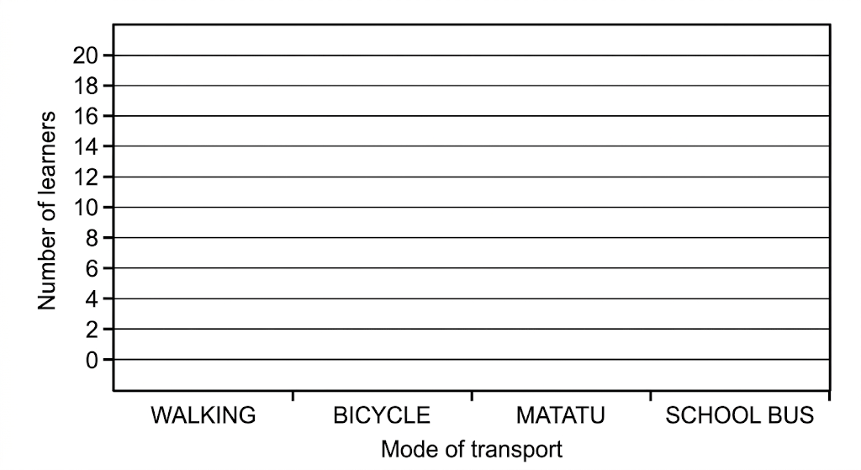
(b) State which mode is most common and give the number of learners using it. (2 marks)
_________________________________________________________________________________________________________
_________________________________________________________________________________________________________
(c) Give one reason why a graph can be useful when interpreting data. (1 marks)
_________________________________________________________________________________________________________
15. (a) A fair die is rolled once. Determine the probability of obtaining an even number. (2 marks)
_________________________________________________________________________________________________________
_________________________________________________________________________________________________________
(b) A bag contains 4 red balls and 6 blue balls. One ball is selected at random. Determine the probability of selecting a red ball. (2 marks)
_________________________________________________________________________________________________________
_________________________________________________________________________________________________________
(c) A coin is tossed and a die is rolled. Determine the probability of obtaining a head and a six. (3 marks)
_________________________________________________________________________________________________________
_________________________________________________________________________________________________________
_________________________________________________________________________________________________________
(d) Explain why understanding probability can help a person make responsible decisions in real-life situations. (3 marks)
_________________________________________________________________________________________________________
_________________________________________________________________________________________________________
_________________________________________________________________________________________________________
END OF QUESTION PAPER

