END TERM 3 2026
GRADE 10
CORE MATHEMATICS
TIME: 2 HOURS 30 MINUTES
Name: ___________________________________________________________________________
Assessment Number: _________________________________________________________________
Class / Stream: ___________________________________________________________________
Date: _________________________________________________________________________

INSTRUCTIONS TO CANDIDATES
- Answer ALL questions.
- This is a cumulative assessment of the Grade 10 Core Mathematics Curriculum Design.
- Show all working clearly. Full working is required for questions involving calculations.
- Use a calculator where appropriate.
- Give answers to a suitable degree of accuracy where necessary.
- Use π = 22/7 unless otherwise stated.

EXAMINER'S USE ONLY
Section | Questions | Maximum Score | Score
A | 1–2 | 20
B | 3–8 | 60
C | 9–12 | 20
TOTAL |  | 100

GRADE 10 END TERM 3 2026 SUMMATIVE ASSESSMENT

SECTION A: NUMBERS AND ALGEBRA
1. (a) Classify √49, √7, 0.125 and π as rational or irrational. (4 marks)
____________________________________________________________________________________________________________
____________________________________________________________________________________________________________
____________________________________________________________________________________________________________
____________________________________________________________________________________________________________
(b) Find the reciprocal of 5/8. (2 marks)
____________________________________________________________________________________________________________
____________________________________________________________________________________________________________
(c) Evaluate 2³ × 2⁻¹ ÷ 2². (2 marks)
____________________________________________________________________________________________________________
____________________________________________________________________________________________________________
(d) Find log₁₀ 1000. (2 marks)
____________________________________________________________________________________________________________
____________________________________________________________________________________________________________
2. (a) Factorise x² − 9x + 20. (3 marks)
____________________________________________________________________________________________________________
____________________________________________________________________________________________________________
____________________________________________________________________________________________________________
(b) Solve x² − 7x + 12 = 0 by factorisation. (4 marks)
____________________________________________________________________________________________________________
____________________________________________________________________________________________________________
____________________________________________________________________________________________________________
____________________________________________________________________________________________________________
(c) A rectangle has area 48 m² and length 2 m more than its width. Form a quadratic equation and determine its dimensions. (3 marks)
____________________________________________________________________________________________________________
____________________________________________________________________________________________________________
____________________________________________________________________________________________________________
____________________________________________________________________________________________________________

SECTION B: MEASUREMENTS AND GEOMETRY
3. (a) Similar figures have corresponding lengths in the ratio 2:5. Find the ratio of their areas and volumes. (4 marks)
____________________________________________________________________________________________________________
____________________________________________________________________________________________________________
____________________________________________________________________________________________________________
____________________________________________________________________________________________________________
(b) Reflect A(3,2) in the y-axis and state A′. (2 marks)
____________________________________________________________________________________________________________
____________________________________________________________________________________________________________
(c) State the coordinate rule for a 90° anticlockwise rotation about the origin. (2 marks)
____________________________________________________________________________________________________________
____________________________________________________________________________________________________________
4. A vector is (6,8). (a) Find its magnitude. (b) If u=(2,−1) and v=(4,3), find u+v. (c) State the translation represented by (−3,5). (6 marks)
____________________________________________________________________________________________________________
____________________________________________________________________________________________________________
____________________________________________________________________________________________________________
____________________________________________________________________________________________________________
____________________________________________________________________________________________________________
____________________________________________________________________________________________________________
5. Study the figure below and answer questions that follow.
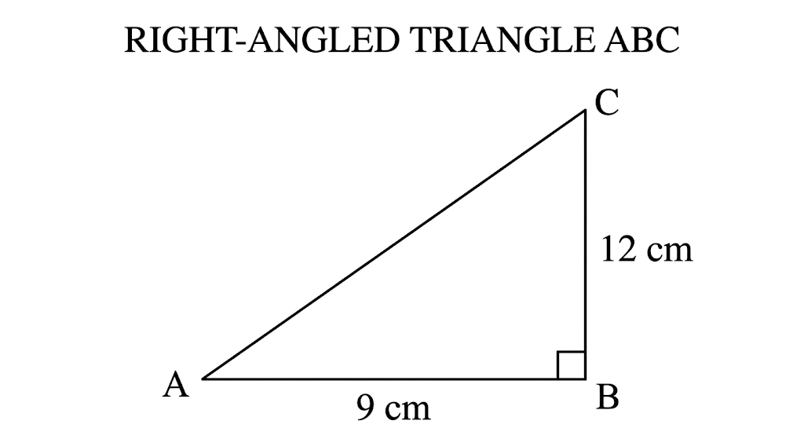
(a) Find the hypotenuse. (2 marks)
____________________________________________________________________________________________________________
____________________________________________________________________________________________________________
____________________________________________________________________________________________________________
____________________________________________________________________________________________________________
____________________________________________________________________________________________________________
(b) For the angle opposite 9 cm, find sin θ, cos θ and tan θ. (2 marks)
____________________________________________________________________________________________________________
____________________________________________________________________________________________________________
____________________________________________________________________________________________________________
____________________________________________________________________________________________________________
(c) State exact values of sin30°, cos60° and tan45°. (3 marks)
____________________________________________________________________________________________________________
____________________________________________________________________________________________________________
____________________________________________________________________________________________________________
____________________________________________________________________________________________________________
____________________________________________________________________________________________________________
6. (a) A triangle has sides 13 cm and 14 cm enclosing 30°. Find its area. (b) Find the area of a regular hexagon of side 8 cm. (c) A circle has radius 14 cm. Find the area of a 90° sector. (8 marks)
____________________________________________________________________________________________________________
____________________________________________________________________________________________________________
____________________________________________________________________________________________________________
____________________________________________________________________________________________________________
____________________________________________________________________________________________________________
____________________________________________________________________________________________________________
____________________________________________________________________________________________________________
____________________________________________________________________________________________________________
7. (a) Study the figure below. Find its volume. (2 marks)
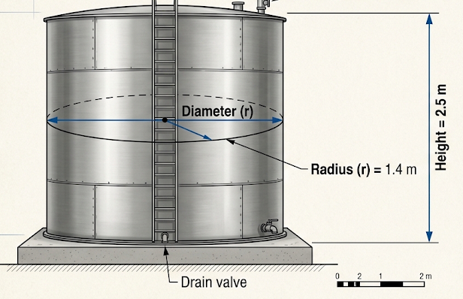
____________________________________________________________________________________________________________
____________________________________________________________________________________________________________
____________________________________________________________________________________________________________
____________________________________________________________________________________________________________
____________________________________________________________________________________________________________
(b) A cuboid is 8 cm × 5 cm × 3 cm. Find its total surface area. (2 marks)
____________________________________________________________________________________________________________
____________________________________________________________________________________________________________
____________________________________________________________________________________________________________
____________________________________________________________________________________________________________
____________________________________________________________________________________________________________

(c) State the information needed to calculate the volume of a frustum. (3 marks)
____________________________________________________________________________________________________________
____________________________________________________________________________________________________________
____________________________________________________________________________________________________________
____________________________________________________________________________________________________________
____________________________________________________________________________________________________________
____________________________________________________________________________________________________________
____________________________________________________________________________________________________________
____________________________________________________________________________________________________________
8. A car has the following displacement-time data. (8 marks)
Time (s) | 0 | 2 | 4 | 6 | 8
Displacement (m) | 0 | 10 | 20 | 30 | 40
(a) Plot a displacement-time graph.
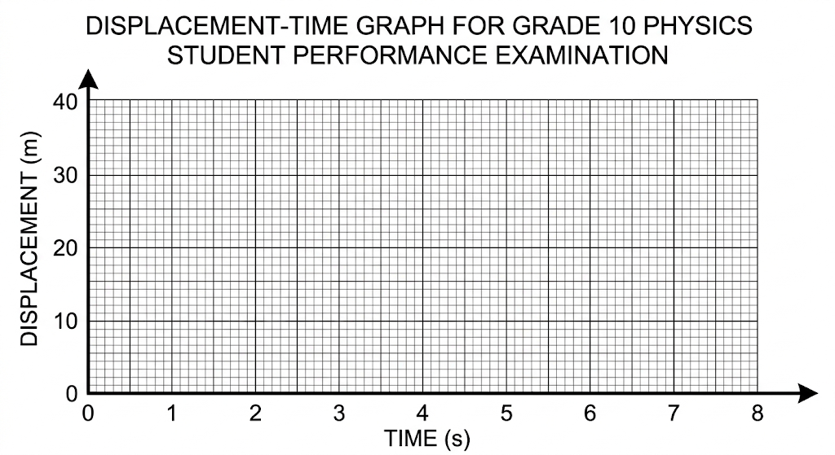
(b) Determine the speed represented by the graph. (2 marks)
____________________________________________________________________________________________________________
____________________________________________________________________________________________________________
(c) A second car travels at 8 m/s in the same direction. Find the relative speed. (3 marks)
____________________________________________________________________________________________________________
____________________________________________________________________________________________________________
____________________________________________________________________________________________________________

SECTION C: STATISTICS AND PROBABILITY
9. The numbers of books read by 12 learners are 2, 4, 3, 5, 2, 6, 4, 3, 2, 5, 4, 8. (a) Prepare a frequency table. (b) Find the mean, mode and median. (8 marks)
____________________________________________________________________________________________________________
____________________________________________________________________________________________________________
____________________________________________________________________________________________________________
____________________________________________________________________________________________________________
____________________________________________________________________________________________________________
____________________________________________________________________________________________________________
____________________________________________________________________________________________________________
____________________________________________________________________________________________________________
10. Test scores are grouped as follows. (8 marks)
Score | 0–9 | 10–19 | 20–29 | 30–39 | 40–49
Frequency | 3 | 7 | 12 | 6 | 2
(a) State the modal class. (2 marks)
____________________________________________________________________________________________________________
____________________________________________________________________________________________________________
(b) Find the total frequency. (2 marks)
____________________________________________________________________________________________________________
____________________________________________________________________________________________________________
(c) Explain two differences between a histogram and a frequency polygon. (4 marks)
____________________________________________________________________________________________________________
____________________________________________________________________________________________________________
____________________________________________________________________________________________________________
____________________________________________________________________________________________________________
11. A bag contains 4 red, 3 blue and 3 green balls. (a) Find P(red). (b) Find P(blue or green). (c) A fair die and fair coin are used. Find P(six and head). (d) State the range of probability. (8 marks)
____________________________________________________________________________________________________________
____________________________________________________________________________________________________________
____________________________________________________________________________________________________________
____________________________________________________________________________________________________________
____________________________________________________________________________________________________________
____________________________________________________________________________________________________________
____________________________________________________________________________________________________________
____________________________________________________________________________________________________________
____________________________________________________________________________________________________________
____________________________________________________________________________________________________________
____________________________________________________________________________________________________________
____________________________________________________________________________________________________________
____________________________________________________________________________________________________________
____________________________________________________________________________________________________________
____________________________________________________________________________________________________________
____________________________________________________________________________________________________________

12. Events W and B are independent, with P(W)=0.4 and P(B)=0.7. (a) Draw a probability tree. (b) Find P(W and B). (c) Find P(W and not B). (d) Explain why multiplication is appropriate. (10 marks)
____________________________________________________________________________________________________________
____________________________________________________________________________________________________________
____________________________________________________________________________________________________________
____________________________________________________________________________________________________________
____________________________________________________________________________________________________________
____________________________________________________________________________________________________________
____________________________________________________________________________________________________________
____________________________________________________________________________________________________________
____________________________________________________________________________________________________________
____________________________________________________________________________________________________________
____________________________________________________________________________________________________________
____________________________________________________________________________________________________________
____________________________________________________________________________________________________________
____________________________________________________________________________________________________________

END OF QUESTION PAPER

