END TERM 3 2026
GRADE 10
COMPUTER STUDIES
SUMMATIVE ASSESSMENT
TIME: 2 HOURS 30 MINUTES | TOTAL: 100 MARKS

Name | ________________________________________________________
Assessment Number | ________________________________________________________
Class / Stream | ________________________________________________________
Date | ________________________________________________________

INSTRUCTIONS TO CANDIDATES
• Write your name and assessment details in the spaces provided.
• Answer ALL questions.
• Read each question carefully before answering.
• Show all working where calculations are required.
• Label diagrams clearly where required.
• Use appropriate units where applicable.
• Write answers in the spaces provided.
• Use clear and legible handwriting.
• Check that all pages and questions are present.
EXAMINER'S USE ONLY
Section | Question Numbers | Maximum Score | Candidate's Score
A | 1–10 | 20
B | 11–15 | 40
C | 16–19 | 40
SECTION A — FOUNDATIONAL STRUCTURED QUESTIONS
Answer ALL questions in this section. (20 marks)
1. State two technological developments that distinguished an early generation of computers from a later generation. (2 marks)
____________________________________________________________________________________________
____________________________________________________________________________________________
2. Name two functional units shown in the diagram below and state one role of each. (2 marks)
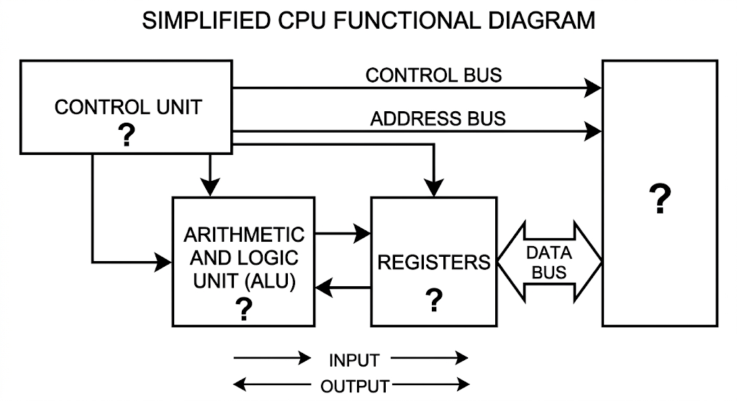
____________________________________________________________________________________________
____________________________________________________________________________________________
3. Give one example of an input device and one example of an output device. State one criterion used when selecting an input or output device. (2 marks)
____________________________________________________________________________________________
____________________________________________________________________________________________
4. Distinguish between primary storage and secondary storage, giving one example of each. (2 marks)
____________________________________________________________________________________________
____________________________________________________________________________________________
5. State two factors that may be considered when selecting a CPU for a computer. (2 marks)
____________________________________________________________________________________________
____________________________________________________________________________________________
6. State two functions performed by an operating system. (2 marks)
____________________________________________________________________________________________
____________________________________________________________________________________________
7. State two safety precautions that should be observed when setting up a computer. (2 marks)
____________________________________________________________________________________________
____________________________________________________________________________________________
8. Differentiate between analogue data and digital data in data communication. (2 marks)
____________________________________________________________________________________________
____________________________________________________________________________________________
9. Name two components/elements required to form a computer network. (2 marks)
____________________________________________________________________________________________
____________________________________________________________________________________________
10. State two rules that should be observed when choosing identifiers in a programming language. (2 marks)
____________________________________________________________________________________________
____________________________________________________________________________________________
SECTION B — APPLICATION, DATA, DIAGRAMS AND PROBLEM SOLVING
Answer ALL questions in this section. (40 marks)
11. A school has acquired computers of different generations.
(a) Explain two major technological changes that occurred as computers evolved, and relate each change to improved computer performance or capability. (4 marks)
____________________________________________________________________________________________
____________________________________________________________________________________________
____________________________________________________________________________________________
____________________________________________________________________________________________
(b) Explain the fetch-decode-execute cycle and state the role of the Control Unit in the cycle. (4 marks)
____________________________________________________________________________________________
____________________________________________________________________________________________
____________________________________________________________________________________________
____________________________________________________________________________________________
12. A learner wants to purchase devices and storage media for a computer laboratory.
(a) Explain two factors that should guide the selection of input/output devices for the laboratory. (4 marks)
____________________________________________________________________________________________
____________________________________________________________________________________________
____________________________________________________________________________________________
____________________________________________________________________________________________
(b) Recommend one suitable primary storage technology and two suitable secondary storage media, giving one reason for each choice. (4 marks)
____________________________________________________________________________________________
____________________________________________________________________________________________
____________________________________________________________________________________________
____________________________________________________________________________________________
____________________________________________________________________________________________
13. A school is preparing computers for a new laboratory.
(a) Explain two functions of an operating system that would be important in the laboratory. (2 marks)
____________________________________________________________________________________________
____________________________________________________________________________________________
(b) Describe two structural elements of a CPU and state the role of each. (4 marks)
____________________________________________________________________________________________
____________________________________________________________________________________________
____________________________________________________________________________________________
____________________________________________________________________________________________
(c) State two precautions to observe when connecting cables and ports during computer setup. (2 marks)
____________________________________________________________________________________________
____________________________________________________________________________________________
14. A computer network is being installed between two offices.
(a) Explain the following data-communication concepts: sender, message, medium and receiver. (4 marks)
____________________________________________________________________________________________
____________________________________________________________________________________________
____________________________________________________________________________________________
____________________________________________________________________________________________
(b) Distinguish between simplex and full-duplex communication. (2 marks)
____________________________________________________________________________________________
____________________________________________________________________________________________
____________________________________________________________________________________________
(c) State two types of transmission media used in computer networks. (2 marks)
____________________________________________________________________________________________
____________________________________________________________________________________________
15. A school wants a network that connects several computers to a central switch. Use the diagram below.
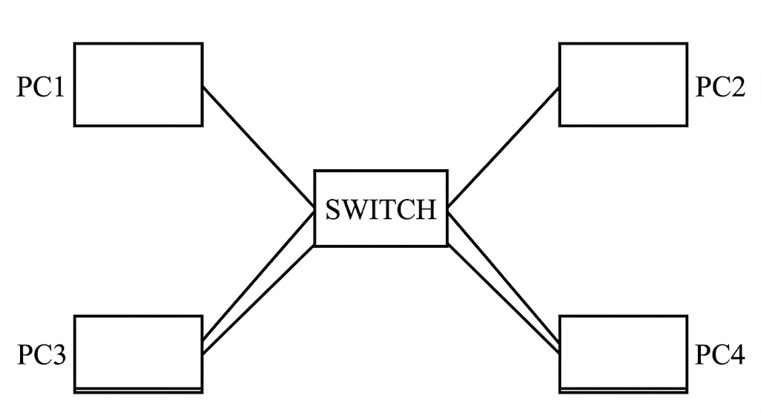
(a) Identify the network topology shown. (2 marks)
____________________________________________________________________________________________
____________________________________________________________________________________________
(b) State two advantages of the topology shown. (4 marks)
____________________________________________________________________________________________
____________________________________________________________________________________________
____________________________________________________________________________________________
____________________________________________________________________________________________
(c) Name two devices/components, other than the computers, that may be used when establishing a computer network. (2 marks)
____________________________________________________________________________________________
____________________________________________________________________________________________
SECTION C — EXTENDED STRUCTURED APPLICATION
Answer ALL questions in this section. (40 marks)
16. A learner is developing a simple program to determine whether a traffic-light instruction should allow a vehicle to proceed.
(a) Explain the stages of the program development process from problem definition to maintenance. (4 marks)
____________________________________________________________________________________________
____________________________________________________________________________________________
____________________________________________________________________________________________
____________________________________________________________________________________________
(b) Write a pseudocode algorithm that accepts a traffic-light colour and displays an appropriate instruction for RED, YELLOW or GREEN. (4 marks)
____________________________________________________________________________________________
____________________________________________________________________________________________
____________________________________________________________________________________________
____________________________________________________________________________________________
____________________________________________________________________________________________
(c) State one reason why algorithms are important in problem solving. (2 marks)
____________________________________________________________________________________________
____________________________________________________________________________________________
17. A programming learner writes a program that accepts two numbers and performs an operation selected by the user.
(a) Differentiate between an identifier, a variable and a constant. (3 marks)
____________________________________________________________________________________________
____________________________________________________________________________________________
____________________________________________________________________________________________
(b) Explain three categories of programming operators and give one example of each. (3 marks)
____________________________________________________________________________________________
____________________________________________________________________________________________
____________________________________________________________________________________________
____________________________________________________________________________________________
(c) Write a suitable programming statement/pseudocode instruction that accepts two numbers, adds them and displays the result. (2 marks)
____________________________________________________________________________________________
____________________________________________________________________________________________
____________________________________________________________________________________________
(d) Explain how a selection control structure can be used to choose an operation based on the user's choice. (2 marks)
____________________________________________________________________________________________
____________________________________________________________________________________________
18. A school records the names of learners using a program.
(a) Distinguish between a list/array and a dictionary as data structures. (4 marks)
____________________________________________________________________________________________
____________________________________________________________________________________________
____________________________________________________________________________________________
____________________________________________________________________________________________
(b) Write a short pseudocode example showing how a collection of three learner names can be stored and accessed. (3 marks)
____________________________________________________________________________________________
____________________________________________________________________________________________
____________________________________________________________________________________________
(c) State three reasons why data structures are important in programming. (3 marks)
____________________________________________________________________________________________
____________________________________________________________________________________________
____________________________________________________________________________________________
19. A teacher wants to avoid repeating the same calculation in several parts of a program.
(a) Explain what a function is and state two benefits of using functions in programming. (4 marks)
____________________________________________________________________________________________
____________________________________________________________________________________________
____________________________________________________________________________________________
____________________________________________________________________________________________
(b) Distinguish between a parameter and an argument. (2 marks)
____________________________________________________________________________________________
____________________________________________________________________________________________
(c) Write pseudocode for a user-defined function named calculate_area that accepts length and width and returns the area of a rectangle. Show how the function is called. (4 marks)
____________________________________________________________________________________________
____________________________________________________________________________________________
____________________________________________________________________________________________
____________________________________________________________________________________________
____________________________________________________________________________________________

