END TERM 3 2026
GRADE 10
BUILDING CONSTRUCTION
TIME: 2 HOURS 30 MINUTES
Name: ________________________________________________
Assessment Number: ____________________________________
Class / Stream: ________________________________________
Date: _________________________________________________
INSTRUCTIONS TO CANDIDATES
1. Write your name, assessment number, class/stream and date in the spaces provided.
2. Answer ALL questions.
3. Read each question carefully and use appropriate technical terminology.
4. Show all working and calculations where required.
5. Draw neat, well-proportioned diagrams where required and label them clearly.
6. Use appropriate units and dimensions.
7. Observe all relevant construction and workshop safety requirements when describing procedures.
8. The paper contains structured-response questions only.
EXAMINER'S USE ONLY
Section | Questions | Maximum Score | Score
A | 1–5 | 25
B | 6–9 | 25
C | 10–12 | 30
TOTAL |  | 80
SECTION A — FOUNDATION AND RELATED DRAWING
1. State four functions of a building in day-to-day life. (4 marks)
2. Site preparation is carried out before construction begins. (5 marks)
(a) State two factors to consider when selecting a building site. (2 marks)
(b) State three methods of disposing of building waste safely. (3 marks)
3. Distinguish between isometric drawing and ordinary two-dimensional representation. (4 marks)
(a) State two characteristics of an isometric drawing. (2 marks)
(b) State two uses of isometric drawing in building construction. (2 marks)
4. A contractor is preparing to construct a small building. (5 marks)
(a) State three reasons for setting out a building accurately. (3 marks)
(b) Name two tools used when setting out a building. (2 marks)
5. State five safety precautions that should be observed during site preparation and clearing. (5 marks)
SECTION B — BUILDING CONSTRUCTION PROCESSES AND DRAWING
6. The diagram below represents a simplified cross-section of a strip foundation. (8 marks)
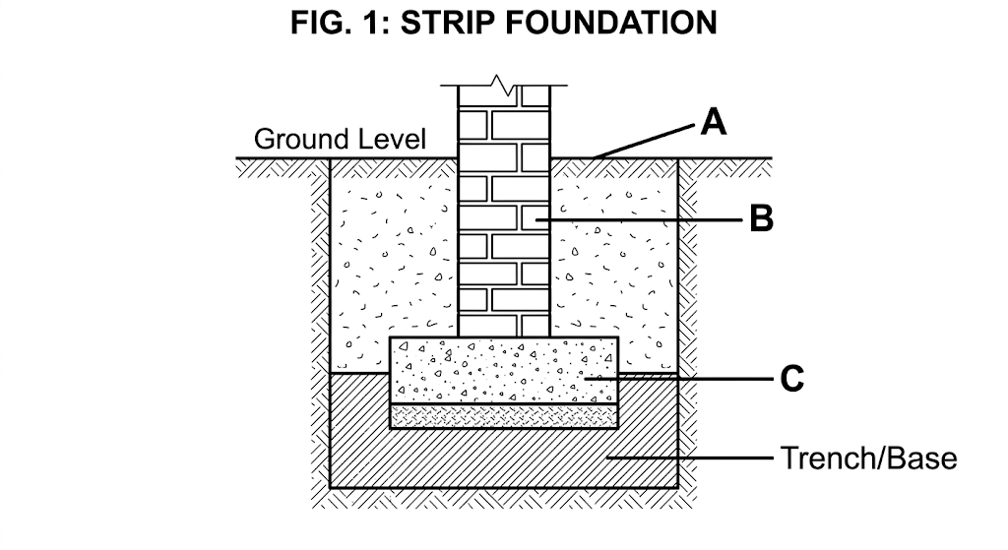
(a) Identify A, B and C. (3 marks)
(b) State the function of D. (2 marks)
(c) State three precautions to observe when preparing a foundation trench. (3 marks)
7. Concrete is required for a building project. (7 marks)
(a) Name the four constituent materials of ordinary concrete. (4 marks)
(b) State one purpose of compaction during concrete production. (1 marks)
(c) State two safety precautions when making or placing concrete. (2 marks)
8. The diagram below represents a simple isometric block. (5 marks)
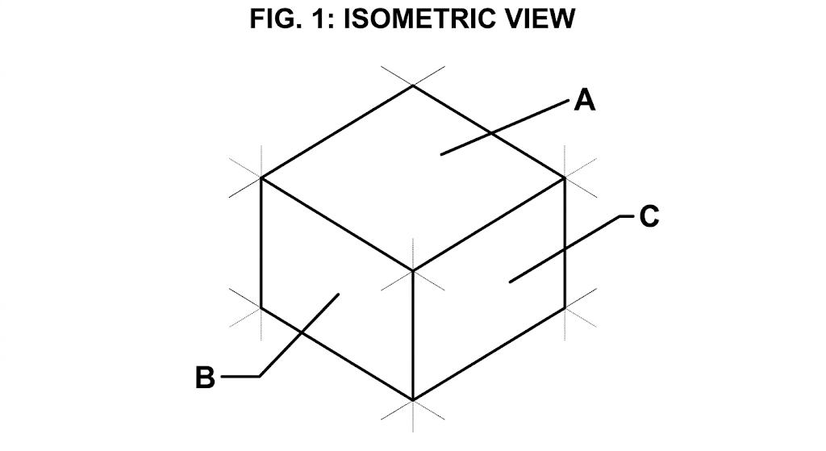

(a) Identify the three visible faces represented by A, B and C. (3 marks)
(b) State one reason for using isometric projection in building drawing. (2 marks)
9. Foundation walling requires accurate setting out and construction. (5 marks)
(a) Name three tools or equipment used when constructing foundation walling. (3 marks)
(b) State two purposes of providing proper bonding in masonry walling. (2 marks)
SECTION C — APPLIED CONSTRUCTION AND BUILDING SERVICES
10. Timbering is used in foundation trenches. (8 marks)
(a) State two circumstances in which timbering of a foundation trench may be necessary. (2 marks)
(b) State three materials or components that may be used in timbering. (3 marks)
(c) Explain three safety precautions to observe when timbering a trench. (3 marks)
11. Ground floors may be constructed using different methods. (10 marks)
(a) Distinguish between a solid ground floor and a suspended ground floor. (4 marks)
(b) State three components or materials used in constructing a solid ground floor. (3 marks)
(c) State three purposes of damp-proofing in a ground floor. (3 marks)
12. The diagram below represents a simplified pipework arrangement. (8 marks)
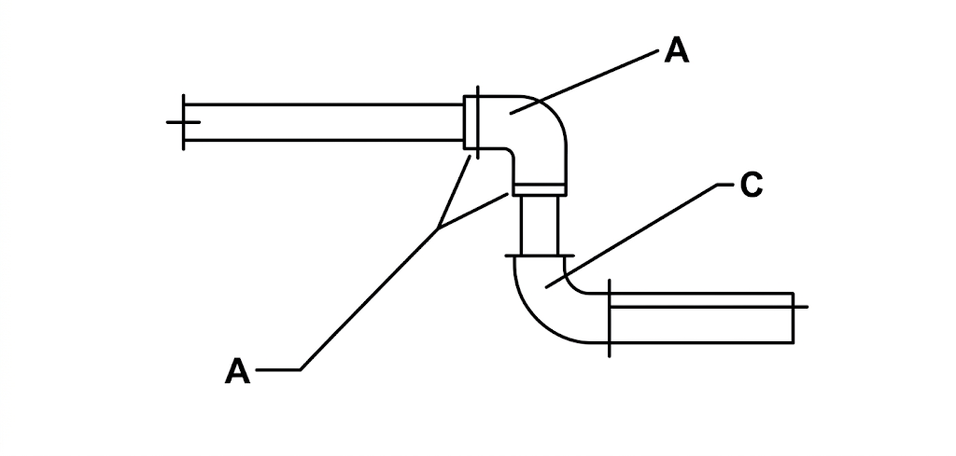
(a) Identify A, B and C. (3 marks)
(b) State two factors to consider when selecting plumbing materials for a particular use. (2 marks)
(c) Describe the main steps followed when preparing a pipe joint. (3 marks)

