END TERM 3 2026
GRADE 10
BIOLOGY
TIME: 2 HOURS 30 MINUTES

Name: ________________________________________________
Assessment Number: ____________________________________
Class / Stream: ________________________________________
Date: _________________________________________________

INSTRUCTIONS TO CANDIDATES
1. Write your name, assessment number, class/stream and date in the spaces provided.
2. Read all questions carefully before answering.
3. Answer ALL questions.
4. Show all working where calculations are required.
5. Draw and label diagrams clearly where required.
6. Use appropriate units in calculations.
7. Answer in the spaces provided where applicable.
8. Use clear and legible handwriting.
9. Check that all pages and questions are present before beginning.
10. The paper contains structured-response questions only.

EXAMINER'S USE ONLY
Section | Question Numbers | Maximum Score | Candidate's Score
A | 1–5 | 25
B | 6–9 | 25
C | 10–12 | 30
TOTAL |  | 80

SECTION A — STRUCTURED QUESTIONS
1. State two functions of the mouthparts of insects in relation to feeding. (4 marks)
(a) Name the type of mouthpart adapted for biting and chewing in insects. (1 marks)
(b) Give two features of this type of mouthpart that make it suitable for its mode of feeding. (3 marks)
2. Birds have different types of beaks adapted to different feeding habits. (5 marks)
(a) State two types of food on which birds may feed. (2 marks)
(b) Explain how the shape of a bird's beak is related to its feeding habit. (3 marks)
3. Distinguish between open and closed circulatory systems. (4 marks)
(a) Name one group of animals that has an open circulatory system. (1 marks)
(b) State one advantage of a closed circulatory system. (2 marks)
(c) State one type of circulatory system found in fish. (1 marks)
4. Explain the importance of transport systems in animals. (4 marks)
(a) State two substances transported in the blood of mammals. (2 marks)
(b) Give two materials that must be transported away from body tissues. (2 marks)
5. A learner investigates pulse rate before and after physical exercise. (8 marks)
Condition | Pulse rate (beats per minute)
Before exercise | 72
Immediately after exercise | 126
Five minutes after exercise | 94
Ten minutes after exercise | 76
(a) Calculate the increase in pulse rate immediately after exercise. (2 marks)
(b) Describe the trend in pulse rate during the ten-minute recovery period. (2 marks)
(c) Explain why pulse rate increases during vigorous exercise. (2 marks)
(d) State two factors that could affect the rate at which pulse returns towards the resting value. (2 marks)
SECTION B — APPLICATION, DATA AND DIAGRAMS
6. The diagram below represents a simplified insect mouthpart structure. (8 marks)
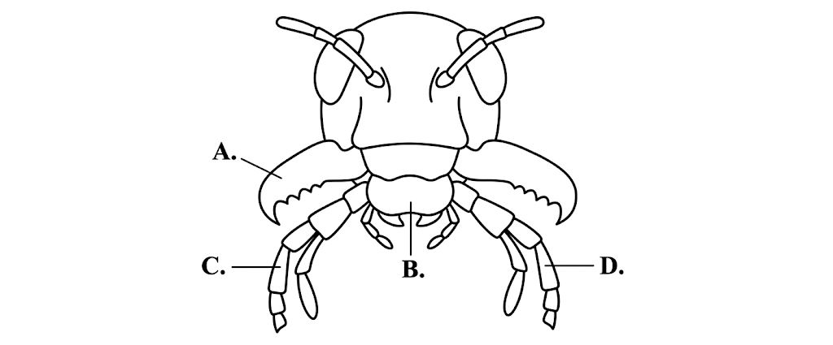

(a) Identify structures A and B. (2 marks)
(b) State one function of structure C. (2 marks)
(c) Explain how the structures shown enable the insect to obtain and process solid food. (4 marks)
7. The diagram below represents a simplified mammalian heart. (7 marks)
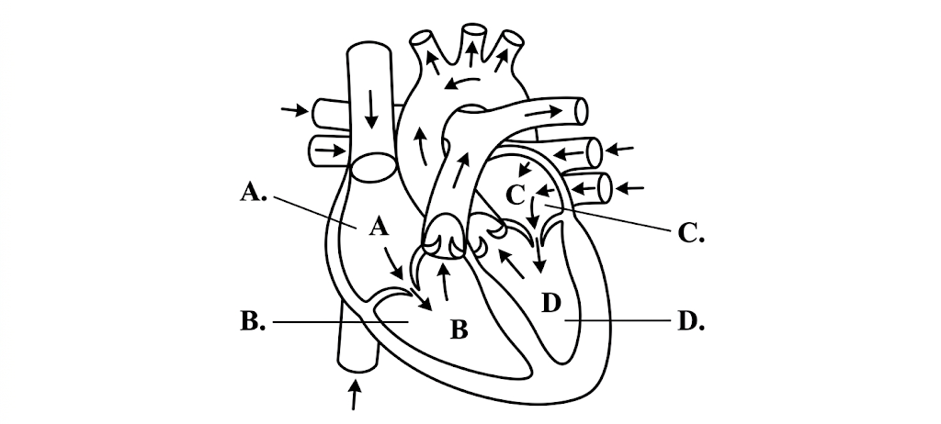
(a) Name chamber A and chamber D. (2 marks)
(b) State the function of the valve system in the heart. (2 marks)
(c) Explain why the left side of the mammalian heart has a thicker muscular wall than the right side. (3 marks)
8. A learner records the following observations from blood-group tests. (5 marks)
Sample | Reaction with anti-A | Reaction with anti-B
P | Agglutination | No agglutination
Q | No agglutination | Agglutination
R | Agglutination | Agglutination
S | No agglutination | No agglutination
(a) Determine the ABO blood group of samples P and R. (2 marks)
(b) Explain why ABO compatibility is important during blood transfusion. (3 marks)
9. The diagram below represents a simplified respiratory system. (5 marks)
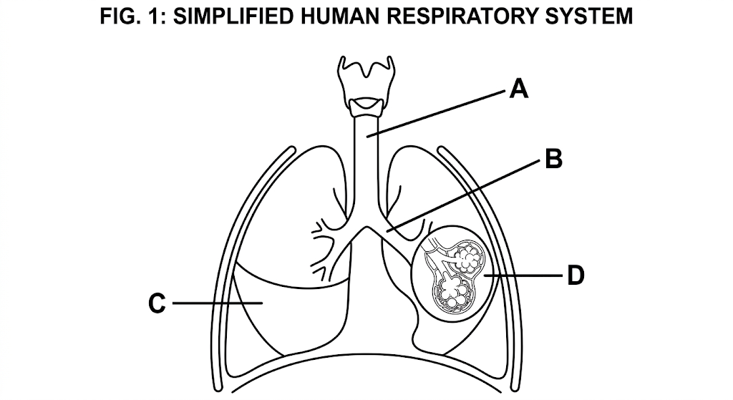

(a) Identify structures A and B. (2 marks)
(b) State two adaptations of the alveoli for efficient gaseous exchange. (3 marks)
SECTION C — EXTENDED STRUCTURED APPLICATION
10. A learner compares gaseous exchange in a fish and in a mammal. (10 marks)
(a) Name the main gaseous exchange surface in a fish and that in a mammal. (2 marks)
(b) Explain how the structure of fish gills is suited to gaseous exchange in water. (4 marks)
(c) Describe how oxygen reaches body cells in a mammal after it enters the lungs. (4 marks)
11. Respiration provides energy required for activities in animals. (10 marks)
(a) Distinguish between aerobic and anaerobic respiration. (4 marks)
(b) State the products of anaerobic respiration in animal muscle cells. (2 marks)
(c) Explain two circumstances in which anaerobic respiration may occur in muscles. (2 marks)
(d) State two reasons why anaerobic respiration is less efficient than aerobic respiration. (2 marks)
12. A learner investigates factors affecting breathing rate during exercise. (10 marks)
(a) State the relationship expected between exercise intensity and breathing rate. (2 marks)
(b) Explain why breathing rate increases during strenuous physical activity. (4 marks)
(c) Describe a simple investigation that could be used to determine the effect of exercise intensity on breathing rate. Include the variable to change, the variable to measure, two control variables and one safety precaution. (4 marks)

