END TERM 3 2026
GRADE 10
AVIATION
END TERM SUMMATIVE ASSESSMENT
TIME: 2 HOURS

Name: | ________________________________________
Assessment Number: | ________________________________________
Class / Stream: | ________________________________________
Date: | ________________________________________

INSTRUCTIONS TO CANDIDATES
1. Write your name and assessment details in the spaces provided.
2. Read all questions carefully before answering.
3. Answer all questions.
4. Show clear working where calculations or reasoning are required.
5. Label diagrams clearly where required.
6. Use appropriate aviation terminology in your responses.
7. Write all answers in the spaces provided where applicable.
8. Use clear and legible handwriting.
9. Check the question paper to ensure that all pages and questions are present.
10. Answer the paper in English.

EXAMINER'S USE ONLY
Section / Question Numbers | Maximum Score | Candidate's Score | Examiner's Initials
Section A — Questions 1–5 | 20
Section B — Questions 6–9 | 20
Section C — Questions 10–13 | 20
Section D — Questions 14–19 | 20
TOTAL | 80

SECTION A — AVIATION WEATHER
1. State four elements of weather that are relevant to flight operations. (4 marks)
________________________________________________________________________________
________________________________________________________________________________
2. Explain four ways in which weather conditions can affect an aircraft in flight. (4 marks)
________________________________________________________________________________
________________________________________________________________________________
________________________________________________________________________________
3. Distinguish between cirrus, stratus and cumulus clouds in terms of their general appearance and altitude characteristics. (6 marks)
________________________________________________________________________________
________________________________________________________________________________
________________________________________________________________________________
________________________________________________________________________________
4. A pilot is preparing for a flight and receives information indicating strong winds, high humidity, heavy precipitation and reduced visibility. Explain two operational concerns associated with the reported conditions. (4 marks)
________________________________________________________________________________
________________________________________________________________________________
________________________________________________________________________________
5. Explain two reasons why accurate measurement and observation of weather elements are important in flight operations. (2 marks)
________________________________________________________________________________
________________________________________________________________________________
SECTION B — AVIATION COMMUNICATION
6. State four purposes of standard words and phrases in aviation communication. (4 marks)
________________________________________________________________________________
________________________________________________________________________________
________________________________________________________________________________
7. Explain the meaning and use of the following aviation communication phrases: (a) ground-to-ground; (b) ground-to-air; (c) read back; (d) transmission. (8 marks)
________________________________________________________________________________
________________________________________________________________________________
________________________________________________________________________________
________________________________________________________________________________
________________________________________________________________________________
8. Describe four features of effective radio communication in an aviation environment. (4 marks)
________________________________________________________________________________
________________________________________________________________________________
________________________________________________________________________________
9. An aircraft is approaching an aerodrome where several ground personnel are working around the movement area. Explain how clear communication between flight crew and ground personnel contributes to safety. (4 marks)
________________________________________________________________________________
________________________________________________________________________________
________________________________________________________________________________
SECTION C — AERODYNAMICS OF FLIGHT
10. (a) Name the two lower layers of the atmosphere discussed in the study of flight. (b) State one characteristic of each layer that is relevant to aviation. (4 marks)
________________________________________________________________________________
________________________________________________________________________________
________________________________________________________________________________

Figure 1
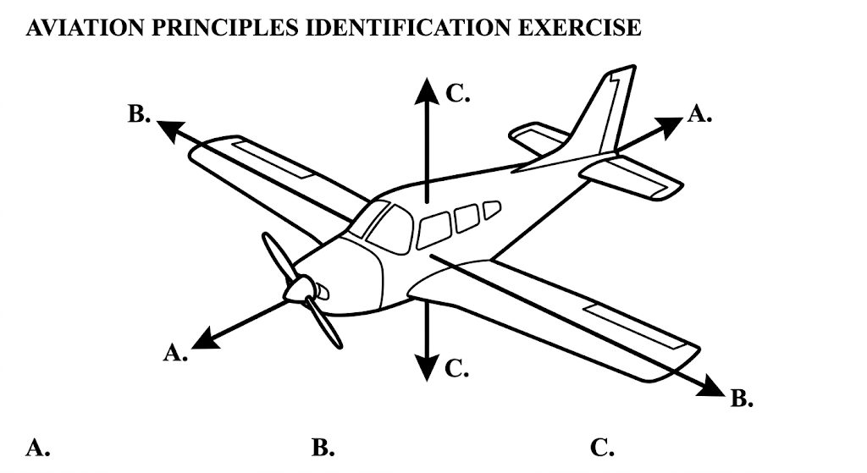

11. Using Figure 1, identify the three principal axes of an aircraft and state the rotational movement associated with each axis. (6 marks)
________________________________________________________________________________
________________________________________________________________________________
________________________________________________________________________________
________________________________________________________________________________
12. Name the four main forces that act on an aircraft in flight and explain the role of each force. (6 marks)
________________________________________________________________________________
________________________________________________________________________________
________________________________________________________________________________
________________________________________________________________________________
________________________________________________________________________________
13. Explain how Bernoulli's principle and Newton's laws help to explain the generation of forces involved in aircraft flight. (4 marks)
________________________________________________________________________________
________________________________________________________________________________
________________________________________________________________________________
________________________________________________________________________________
SECTION D — AIRPORT OPERATIONS
14. (a) State three categories of airports identified in the Curriculum Design. (b) Give one characteristic or use associated with each category. (6 marks)
________________________________________________________________________________
________________________________________________________________________________
________________________________________________________________________________
________________________________________________________________________________
Figure 2
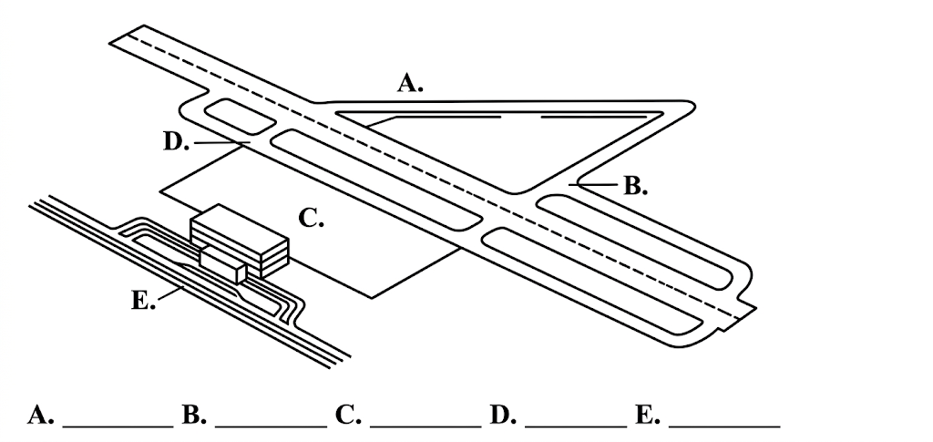

15. Using Figure 2, (a) identify the runway, taxiway, apron and terminal; (b) explain the function of any two of the identified areas. (6 marks)
________________________________________________________________________________
________________________________________________________________________________
________________________________________________________________________________
________________________________________________________________________________
________________________________________________________________________________
16. Explain the roles of the following roads in airport operations: (a) runway; (b) taxiway; (c) service road; (d) access road. (4 marks)
________________________________________________________________________________
________________________________________________________________________________
________________________________________________________________________________
________________________________________________________________________________
17. State four consumer rights that should be observed in airport operations. (4 marks)
________________________________________________________________________________
________________________________________________________________________________
________________________________________________________________________________
18. A small aviation business records the following amounts during one month: revenue KSh 480,000; expenses KSh 350,000. Calculate the profit and explain why keeping accurate financial records is important to an aviation business. (4 marks)
________________________________________________________________________________
________________________________________________________________________________
________________________________________________________________________________
________________________________________________________________________________
19. Explain two roles played by aviation businesses in airport operations and two ways in which consumer protection agencies contribute to protecting consumers. (4 marks)
________________________________________________________________________________
________________________________________________________________________________
________________________________________________________________________________
________________________________________________________________________________
END OF QUESTION PAPER

