END TERM 3 2026
GRADE 10
AGRICULTURE
CANDIDATE QUESTION PAPER
TIME: 2 HOURS 30 MINUTES
TOTAL: 80 MARKS

Name: ____________________________________________
Assessment Number: ________________________________
Class / Stream: ______________________________
Date: ______________________________

INSTRUCTIONS TO CANDIDATES
1. Write your name, assessment number, class/stream and date in the spaces provided.
2. Read all questions carefully before answering.
3. Answer ALL questions.
4. Show all working where calculations are required.
5. Use clear and legible handwriting.
6. Where a diagram is required, use clear labels and appropriate proportions.
7. Use the units specified in the question where applicable.
8. Check the question paper to ensure that all pages and questions are present.
9. Answer all questions in English unless otherwise directed by the teacher.

EXAMINER'S USE ONLY
Section | Question Numbers | Maximum Score | Candidate's Score
A | 1–2 | 20
B | 3–4 | 30
C | 5–6 | 30
TOTAL |  | 80

SECTION A — AGRICULTURAL TECHNOLOGIES
Answer Questions 1 and 2.
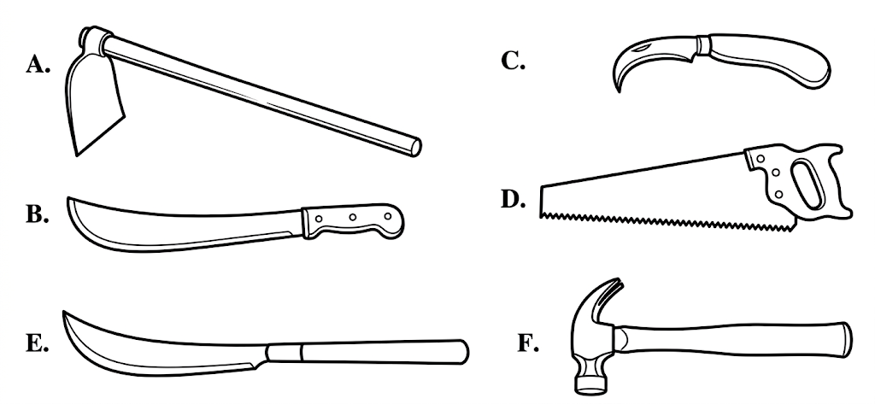
1. Study the agricultural tools represented by the diagram above.
(a) Name the tools labelled A, B, C and D. (4 marks)
________________________________________________________________________________________________________________
________________________________________________________________________________________________________________
________________________________________________________________________________________________________________
________________________________________________________________________________________________________________
(b) State one agricultural use of each of the four tools named in (a). (4 marks)
________________________________________________________________________________________________________________
________________________________________________________________________________________________________________
________________________________________________________________________________________________________________
________________________________________________________________________________________________________________
(c) State two safety precautions that should be observed when using agricultural tools. (2 marks)
________________________________________________________________________________________________________________
________________________________________________________________________________________________________________
2. Agricultural produce may be processed to increase its usefulness and value.
(a) Explain the meaning of value addition in agricultural production. (2 marks)
________________________________________________________________________________________________________________
________________________________________________________________________________________________________________
(b) Give three examples of agricultural produce that may be subjected to value addition. (3 marks)
________________________________________________________________________________________________________________
________________________________________________________________________________________________________________
________________________________________________________________________________________________________________
(c) State three considerations that should be observed when processing agricultural produce. (3 marks)
________________________________________________________________________________________________________________
________________________________________________________________________________________________________________
________________________________________________________________________________________________________________
(d) Explain two benefits of processing agricultural produce before it reaches the consumer. (2 marks)
________________________________________________________________________________________________________________
________________________________________________________________________________________________________________

SECTION B — AGRICULTURAL ENTERPRISE AND MARKETING
Answer Questions 3 and 4.
3. A school agriculture club intends to establish a small vegetable enterprise.
(a) Explain the following factors of production as they apply to an agricultural enterprise: land, labour, capital and entrepreneurship. (8 marks)
________________________________________________________________________________________________________________
________________________________________________________________________________________________________________
________________________________________________________________________________________________________________
________________________________________________________________________________________________________________
________________________________________________________________________________________________________________
________________________________________________________________________________________________________________
________________________________________________________________________________________________________________
________________________________________________________________________________________________________________
(b) Describe three ways through which the club could acquire capital to establish the enterprise. (3 marks)
________________________________________________________________________________________________________________
________________________________________________________________________________________________________________
________________________________________________________________________________________________________________
(c) State four factors that the club should consider when selecting an agricultural enterprise. (4 marks)
________________________________________________________________________________________________________________
________________________________________________________________________________________________________________
________________________________________________________________________________________________________________
________________________________________________________________________________________________________________
4. A farmer prepares vegetables for sale. During one marketing exercise, the following costs and sales were recorded:
Item | Amount (Ksh)
Transportation | 2,500
Advertising | 1,000
Market authority charges | 500
Taxes | 750
Packaging | 1,250
Total sales | 18,000
(a) State five ways in which agricultural produce can be prepared for marketing. (5 marks)
________________________________________________________________________________________________________________
________________________________________________________________________________________________________________
________________________________________________________________________________________________________________
________________________________________________________________________________________________________________
________________________________________________________________________________________________________________
(b) Calculate the total marketing expenses and the net return from the sale. (4 marks)
________________________________________________________________________________________________________________
________________________________________________________________________________________________________________
________________________________________________________________________________________________________________
________________________________________________________________________________________________________________
(c) Distinguish between a physical market outlet and a digital market outlet for agricultural produce. Give one example of each. (4 marks)
________________________________________________________________________________________________________________
________________________________________________________________________________________________________________
________________________________________________________________________________________________________________
________________________________________________________________________________________________________________
(d) Explain one importance of properly preparing agricultural produce before marketing it. (2 marks)
________________________________________________________________________________________________________________
________________________________________________________________________________________________________________

SECTION C — COMPOSTING AND INTEGRATED APPLICATION
Answer Questions 5 and 6.
5. Composting is one of the techniques used to produce organic manure.
(a) Define compost manure. (2 marks)
________________________________________________________________________________________________________________
________________________________________________________________________________________________________________
(b) Describe four factors that influence the quality of compost manure. (4 marks)
________________________________________________________________________________________________________________
________________________________________________________________________________________________________________
________________________________________________________________________________________________________________
________________________________________________________________________________________________________________
(c) Describe two methods that may be used to produce compost manure, including one conventional method and one innovative method. (4 marks)
________________________________________________________________________________________________________________
________________________________________________________________________________________________________________
________________________________________________________________________________________________________________
________________________________________________________________________________________________________________
(d) State three ways in which composting contributes to soil improvement. (3 marks)
________________________________________________________________________________________________________________
________________________________________________________________________________________________________________
________________________________________________________________________________________________________________
(e) State two conditions that should be maintained to support effective decomposition during composting. (2 marks)
________________________________________________________________________________________________________________
________________________________________________________________________________________________________________
6. A youth agriculture group has Ksh 20,000 and plans to start a small agricultural enterprise involving crop produce, simple processing and compost production.
(a) State four tools or pieces of equipment the group may require when carrying out agricultural production, processing or related enterprise activities. (4 marks)
________________________________________________________________________________________________________________
________________________________________________________________________________________________________________
________________________________________________________________________________________________________________
________________________________________________________________________________________________________________
(b) Outline three steps the group could follow when carrying out value addition on a selected crop product. (3 marks)
________________________________________________________________________________________________________________
________________________________________________________________________________________________________________
________________________________________________________________________________________________________________
(c) State three possible ways through which the group could acquire additional capital if the Ksh 20,000 is insufficient. (3 marks)
________________________________________________________________________________________________________________
________________________________________________________________________________________________________________
________________________________________________________________________________________________________________
(d) State three market outlets through which the group could sell its agricultural produce. (3 marks)
________________________________________________________________________________________________________________
________________________________________________________________________________________________________________
________________________________________________________________________________________________________________
(e) Explain two ways in which the compost produced by the group could support an existing crop enterprise. (2 marks)
________________________________________________________________________________________________________________
________________________________________________________________________________________________________________
END OF QUESTION PAPER

