NAME: ………………………………………………….. INDEX NO: …………………………………...

SCHOOL: ………………………………………………. CANDIDATE SIGN: ………………………….
DATE: ………………………………………...

FORM 3 END OF TERM 3 2026

232/3
PHYSICS
(PRACTICAL)
PAPER 3

TIME: 2 $1/2$ HOURS
INSTRUCTIONS TO CANDIDATES
1. Answer all the questions in the spaces provided
2. Mathematical tables and electronic calculators may be used.
3. All workings MUST be clearly shown necessary.

For examiners use only
QUESTIONS | MAX.SCORE | CANDIDATE SCORE
1 | 20
2 | 20
Total score | 40

This paper consists of 6 printed pages.
Candidates should check the question paper to
Ensure that all the pages are printed as indicated and no questions are missing.

1. You are provided with;
(a) A Marble with a piece of the thread attached.
(b) Two wooden blocks.
(c) Clamp, stand + boss
(d) Metre rule.
(e) ½ metre rule supported on a wooden block.
(f) 2 pieces of cellotape.
(g) Stop watch.

Procedure:
(I) Fix the thread between the wooden blocks and fasten in the clamp. Adjust the thread so that the length, L, shown in the figure below is 50cm.

(II) Fix the metre rule horizontally to the bench using the cello tape provided.

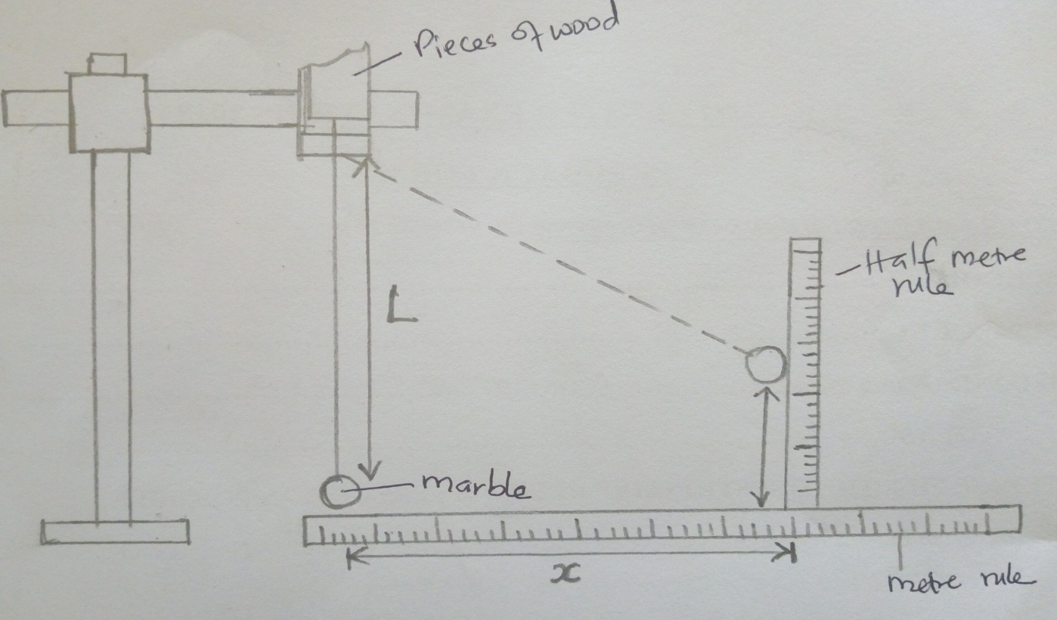

(III) Adjust the clamp so that the marble is next to the end of the metre rule as shown above.

(IV) Displace the marble by a horizontal distance X=20cm and measure the corresponding vertical
displacement h=____________ cm. (1mark)

(V) Repeat the experiment to find h for each of the following values of X and complete the table. (6 marks)
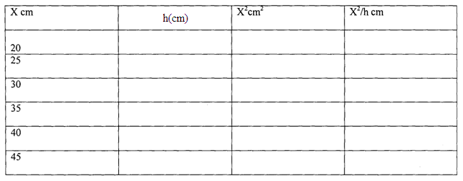
(VI) plot a graph X²/h against h. (4 marks)


(VII) Determine the slope of the graph. (2mks)

(VIII) From the graph find the value of X²/ h when h=0 (2mks)

(IX) With the metre rule and half-metre rule removed — Displace the marble through a horizontal distance of about 10cm and let it to swing freely, Time 20 oscillations.

Time for 20 oscillations ______________________ (lmk)

(X) Determine periodic time , T
Periodic time, T=_____________________________ (1 mk)

(XI) Calculate the value of P from the following equations. (3mks)
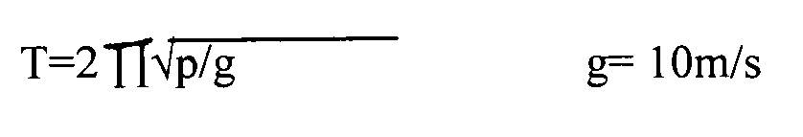

QUESTION 2
PART A
You are provided with the following:-
- A 250ml glass beaker
- A Bunsen burner
- A Thermometer
- A Stop watch
- A Tripod stand and a Wire gauze
- A measuring cylinder 100ml
- Water
Set the apparatus as shown in figure 2 below.
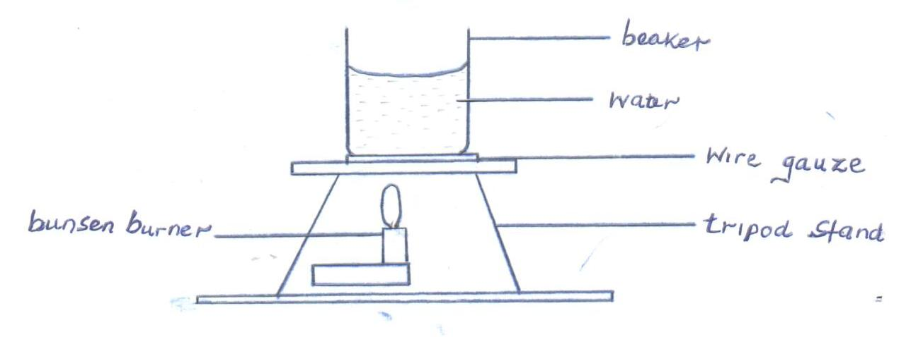
Fig. 2
    - Measure 100cm³ of water and pour it into the beaker. Take the initial temperature of the water.

T₀ = …………………………………………….⁰C (1mk)

Now heat the water to a temperature of 80⁰C switch off the gas tap and place a thermometer into the beaker and start the stop watch when the temperature is 65⁰C. Take the temperature T⁰C of water ever two minutes. Record your results in the table below.
Time, t(min) | 2 | 4 | 6 | 8 | 10 | 12 | 14
Temperature (T) ⁰C
(T - T₀)
Log (T - T₀)
(5mks)

    - Plot a graph of Log (T - T₀) against Time (t). (5mks)

    - Find the value of P of log (T - T₀) when t = 0. (1mk)

    - Determine N, where N is the antilog of P. (1mk)

    - Calculate the temperature of the surrounding T_{R} using the expression N = 65–T_{R}
(2mks)

PART B
You are provided with the following:
- A concave mirror with holder
- A screen
- A meter rule
- A candle
- A match box (to be shared)
Proceed as follow:
(f) Set up the apparatus as in figure 3 below.
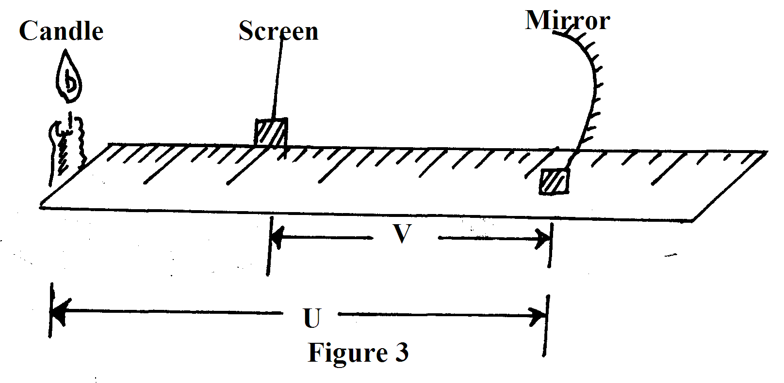
(g) Put the object at a distance u = 30cm from the mirror. Adjust the position of the screen until a sharp image is formed on the screen. Record the distance V.
(h) Repeat procedure (b) above for the distance u = 40cm and record the new distance V. complete the table 3 below. (2mks)

U(cm) | V(cm) | M=^{v}/_{u} | (m+1)
30
40

(i) Given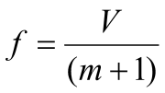, calculate the values of f hence determine the average value f_{av} (3mks)

