NAME _____________________________________ ADM NO. _________
CLASS ____________________________________ DATE _____________

PHYSICS
232/2
FORM III
2 HOURS
OCTOBER 2026

END OF TERM THREE EVALUATION TEST 2026
FORM 3
PHYSICS PAPER 2

INSTRUCTIONS
- Write your name and Adm no. in spaces provided above.
- This paper consists of two section A and B.
- Answer all questions in spaces provided
- All working must be clearly shown
- Electronic calculator and mathematical tables may be used.

Section | Question | Maximum score | Candidates score
A | 1 – 13 | 25
A | 14 | 12
A | 15 | 15
B | 16 | 12
B | 17 | 11
B | 18 | 05
TOTAL SCORE |  | 80

SECTION A (25 MKS)

- Complete diagram below showing nature of the shadows formed and label the shadows. (2 mks)

Screen
Light source

Opaque object

- Determine the angle of reflection if figure below is rotated 10º clockwise. (2 mks)

38º

- A charged body is brought close to uncharged body and then touch each other. State the explain the observations made on the leaf for each body. (2 mks)
………………………………………………………………………………………………………………………………………………………………………………………………………………………………………………………………………………………………………………………..
- State any application of Gold leaf electroscope. (1 mk)
………………………………………………………………………………………………………………………………………………………………………………………………………………………………………………………………………………………………………………………..
- What is local action and how is it minimized in simple cell? (2 mks)
………………………………………………………………………………………………………………………………………………………………………………………………………………………………………………………………………………………………………………………
- A charge of 4500 uc flows through a conductor for one minute and 30 seconds. Determine current supplied. (3 mks)

- Using domain theory, explain how heating causes demagnetization. (1 mk)
……………………………………………………………………………………………………………………………………………………………………………………………………………….
- State basic law of magnetization. (1 mk)
………………………………………………………………………………………………………………………………………………………………………………………………………………...
- Determine polarities at x and y in figure below and hence sketch field pattern between x and y. (4 mks)
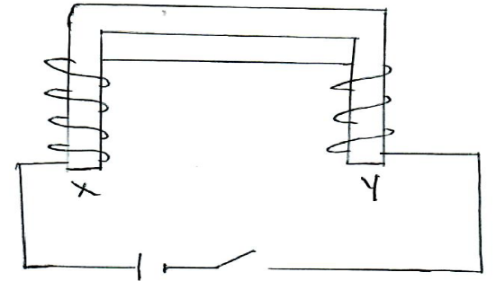

- A student standing between two walls shouts. He hears first echo after 2.16 seconds and next after 4.75 seconds. Determine distance between walls (speed of sound = 330m/s) (3 mks)

- Calculate heat supplied by heater rated 1.5kw operated for 3 minutes and 20 seconds. (2 mks)

- Define principal focus in mirrors. (1 mk)
………………………………………………………………………………………………………………………………………………………………………………………………………………………………………………………………………………………………………………………
- Sketch the reflected wave in figure below. (1 mk)

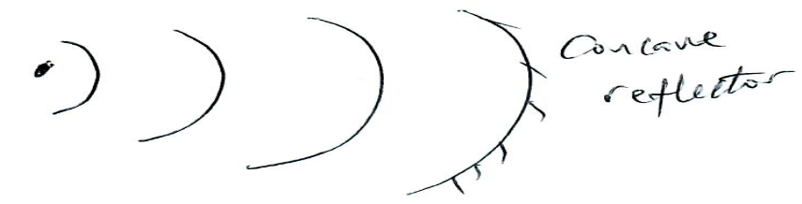
SECTION B (55 MKS)

- What property of sound enables people to hear sound round obstacles. (1 mk)
………………………………………………………………………………………………………………………………………………………………………………………………………….
- Ripples produced by 50Hz vibrator are

40 cm

Determine speed of wave. (3 mks)

- What is the effect of raising temperature on speed of sound. (1 mk)
………………………………………………………………………………………………………………………………………………………………………………………………………….
- Reflected sound was heard after 1.2 seconds from submerged ship and after 1.8 seconds from sea bed. If speed of sound in water was 1,500 m/s. determine height of submerged ship. (3 mks)

- State two conditions for formation of standing waves. (2 mks)
………………………………………………………………………………………………………………………………………………………………………………………………………….
- Determine wavelength in figure below. (2 mks)

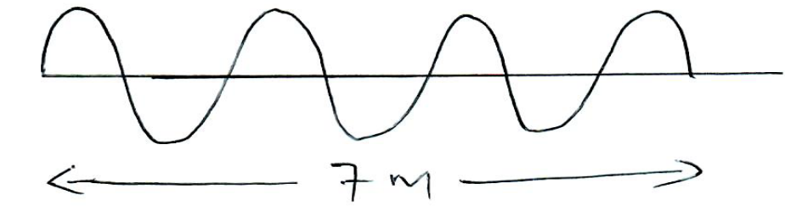

- State snell’s law. (1 mk)
………………………………………………………………………………………………………………………………………………………………………………………………………………………………………………………………………………………………………………
- An object is placed beneath transparent block of thickness 15cm and refractive index 1.5. Calculate the vertical displacement of the object. (3 mks)

- Determine reflactive index of a material if light travels at 1.94x10⁸ m/s (speed of light in air =3.0 x 10⁸m/s) (3 mks)

- Determine critical angle of material above. (3 mks)

- State two conditions for total internal reflection occur. (2 mks)
………………………………………………………………………………………………………………………………………………………………………………………………………………………………………………………………………………………………………………
- Find angle e in figure below. (3 mks)

n= ⁴/₃

60º
e
n = ³_{/2}

- State ohm’s law. (1 mk)
…………………………………………………………………………………………………………………………………………………………………………………………………………
- Use figure below to answer following questions:

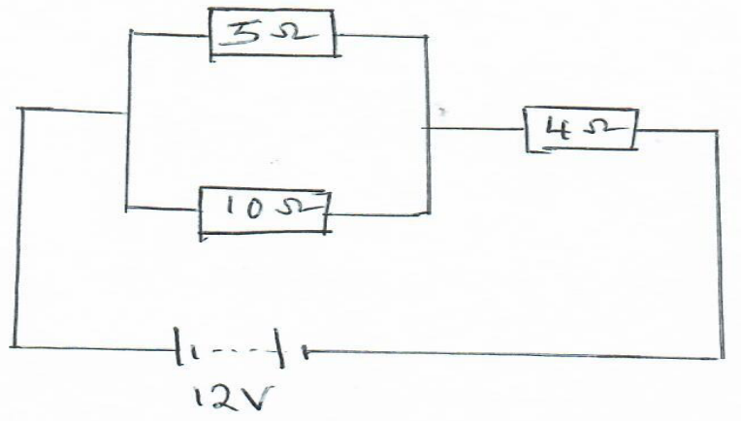

Determine:
- Total resistance. (2 mks)

- P.d across 4Ω resistor. (3 mks)

- Current through 10Ω resistor. (3 mks)

- Battery supplies 3.0V in open circuit and 2.8 v in closed circuit. Calculate internal resistance if current is 0.5A. (3 mks)

- Use figure below to answer following questions.

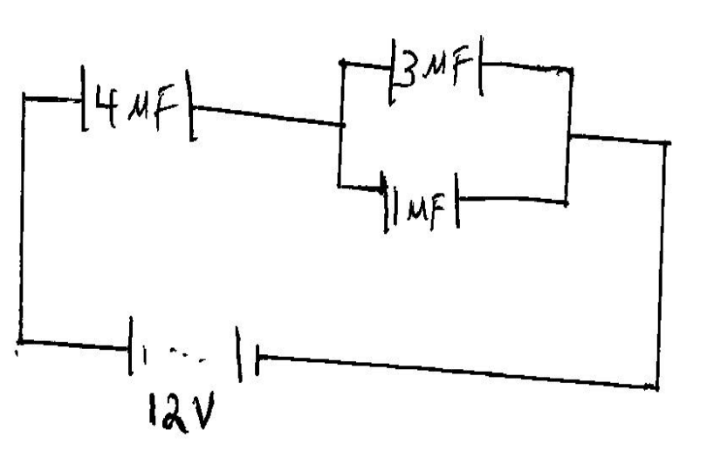

Determine
- Effective capacitance. (2 mks)

- Total charge in circuit. (3 mks)

- Charge across 3uf capacitor. (3 mks)

- P.d across 1 uf capacitor. (3 mks)

- Complete the diagram below and locate principal focus (f) (2 mks)

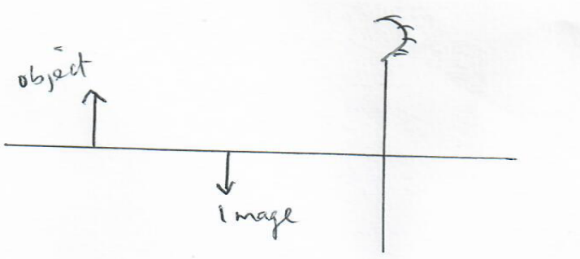

- An image is formed 3cm behind convex mirror of focal length 5cm. Determine object distance. (3 mks)

