Name...................................................................................Adm no…… Class: …....
Candidate’s Signature.......................................... Date...........................

FORM 3 PHYSICS
PAPER 1
(Theory)
TERM 3 2026
2 HOURS

INSTRUCTIONS TO CANDIDATES
i) Write your name, admission number in the spaces provided above.
ii) Sign and write the date of examination in the spaces provided above
iii) This paper consists of TWO sections A and B
iv) Answer ALL the questions in section A and B in the spaces provided
v) All working MUST be clearly shown
vi) Electronic calculators and mathematical tables may be used.
vii) ALL numerical answers must be expressed in decimal notation.
viii) This paper has 13 pages. It is the responsibility of the candidate to ascertain that all the pages are printed as indicated and that no questions are missing.
ix) Candidates should answer the questions in English.
For Examiners Use Only

Section | Question | Maximum Score | Candidates Score
A | 1 – 14 | 25
B | 15 | 10
B | 16 | 10
B | 17 | 11
B | 18 | 12
B | 19 | 12
 |  | Total = 80

SECTION A ( 25 MARKS )

1. The figure 1 below shows the scale of a micrometer screw gauge when a metallic ball is placed between it’s jaws. The micrometer has a positive zero error of 0.09mm. (1 mark)

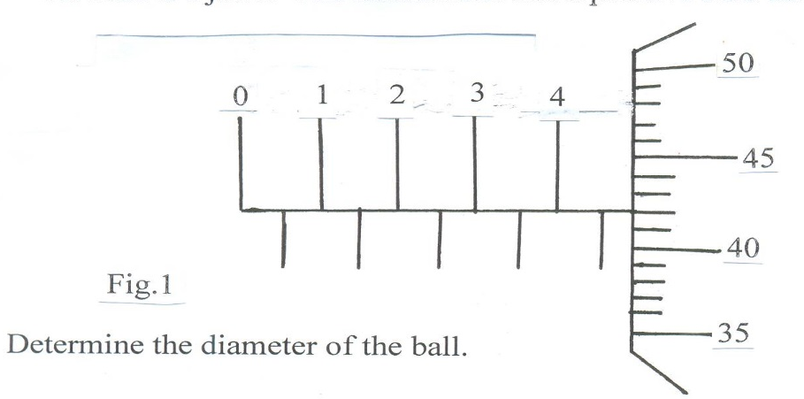

2. The figure 2 below shows two identical threads A and B attached to a large mass M.
Thread A is attached to a fixed support.

/ / / / / / / / / / / / / / / / / / / / / /

Thread A

M

Fig. 2 Thread B

Explain why thread B cuts when its free end is suddenly pulled downwards. (1 mark)

3. Three identical springs with a spring constant of 2N/cm each are arranged as shown.
Determine the combined extension of the system under the weight of 10N. (2 marks)
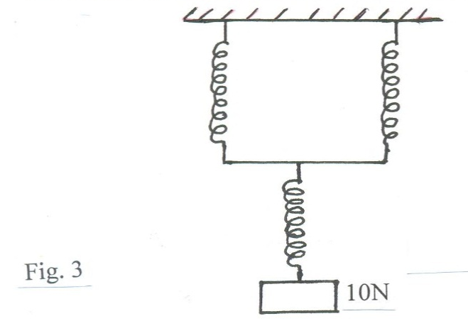
4. The fig. 4 below shows a uniform bar pivoted at its center and is at equilibrium.

W 35cm

Fig. 4 30cm 50cm
30N 5N

Determine the value of W. (3 marks)

5. The figure 5 below shows a rod made of wood on one end and a metal on the other end.
Suspended freely with a piece of thread so that it is in equilibrium.
Thread
Metal
Wood

Fig 5
HEAT

The side made of metal is now heated with Bunsen flame. State with a reason, the side
to which the rod is likely to tilt. (2 marks)

6. State how heat losses by convection and radiation are minimized in a thermos flask.
(2 marks)

7. Ndanu placed her finger on water surface as shown below in figure 6.
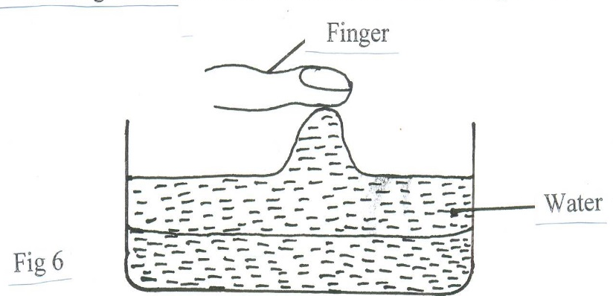

Name the force that lifts the water to her finger. (1 mark)

8. In Brownian motion experiment using a smoke cell, the smoke particles are observed
to move randomly. Explain the cause of this motion. (1 mark)

9. The figure 7 below shows an experiment set-up to demonstrate expansion in liquids.
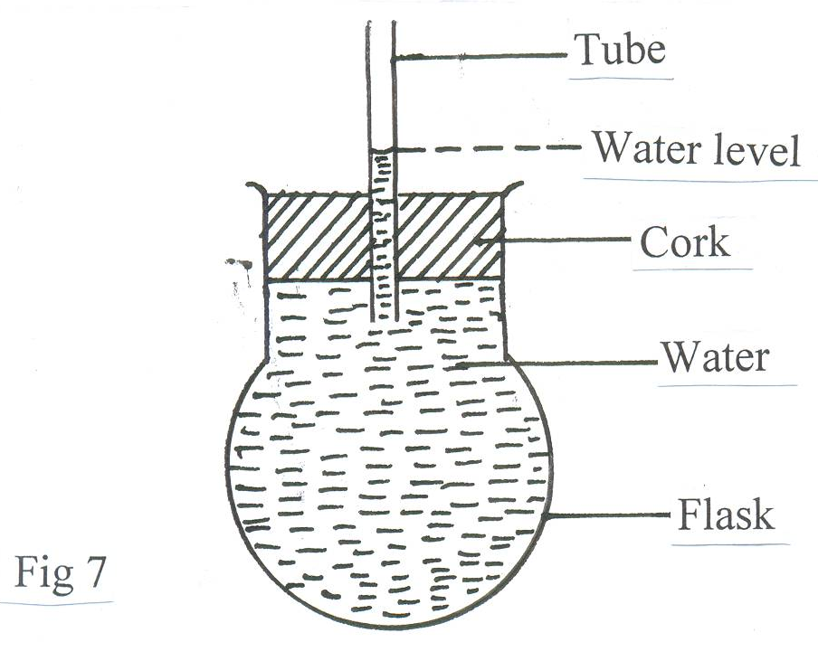

It is observed that the level of water in the tube falls slightly before it starts rising again
when the flask is heated. Explain why? (2 marks)

10. A drop of castor oil is released from a burette. If the volume of the drop is 5 x 10⁻⁶m³ and that it forms a circular patch of diameter 28cm on a water surface, estimate the thickness of a molecule of the oil. (3marks)

11. The figure 9 shows the velocity time graph of two identical spheres released from the
surface of two fluids A and B

Velocity B
m/s
A
Fig 9

Time (s)

Give a reason why the terminal velocity of the sphere in B is higher than in A. (1 mark)

The figure 10 below represents the velocity –time graph for a lift in Times Tower building. Use it to answer questions 12 and 13.

Velocity 20
m/s
15 A B

10

Fig 10 5
C

0 5 10 15 20Time(s)
12. Describe briefly the motion between:
(i) OA (1 mark)

(ii) AB (1 mark)

13. Calculate the total distance traveled by the lift. (3 marks)

14. Explain why water spilled on a glass surface wets the surface. (1mark)
.

SECTION B ( 55 MARKS )

15. (a) Distinguish between streamline and turbulent flow as applied to fluid flow. (2 marks )

(b) When a strong wind blew over a school with crowded buildings, the iron sheet roofs
were blown off and the walls that were close collapsed towards each other. Explain. (2 marks)

(c ) Water flows in a horizontal pipe with varying diameter as shown in the figure 11 below.

Y
x

Fig. 11.

If the cross-sectional area of X is 2.5cm² and that of Y is 40cm² and the rate at which water flows in X is 450cm per second.
(i) Find the speed of water through Y. (2 marks)

(ii) If the pipe is to be used to sprinkle water on a flower garden, which end should be
connected to the tap? Explain. (2 marks)

. (d) A student blew a gust of air over the mouth of a narrow glass tube in the direction
shown in the figure 12 below.

A gust
of air

(i) State the observation made in the above set-up. (1 mark)

(ii) Explain the observation in d(i) above. (1 mark)

16. (a) A bullet of mass 30g traveling at a speed of 200m/s embeds itself in a block of wood
of mass 970g suspended so that it swings freely as shown in the figure 13 below.

// / / / / / / / / / / / ///

Bullet Block + bullet
Wood
Fig. 13

Determine
(i) The velocity of the bullet and block immediately after collision. (3 marks)

(ii) The height through which the block and bullet rises. (2 marks)

(b) An immiscible liquid A is poured into one arm of a U-tube containing water.
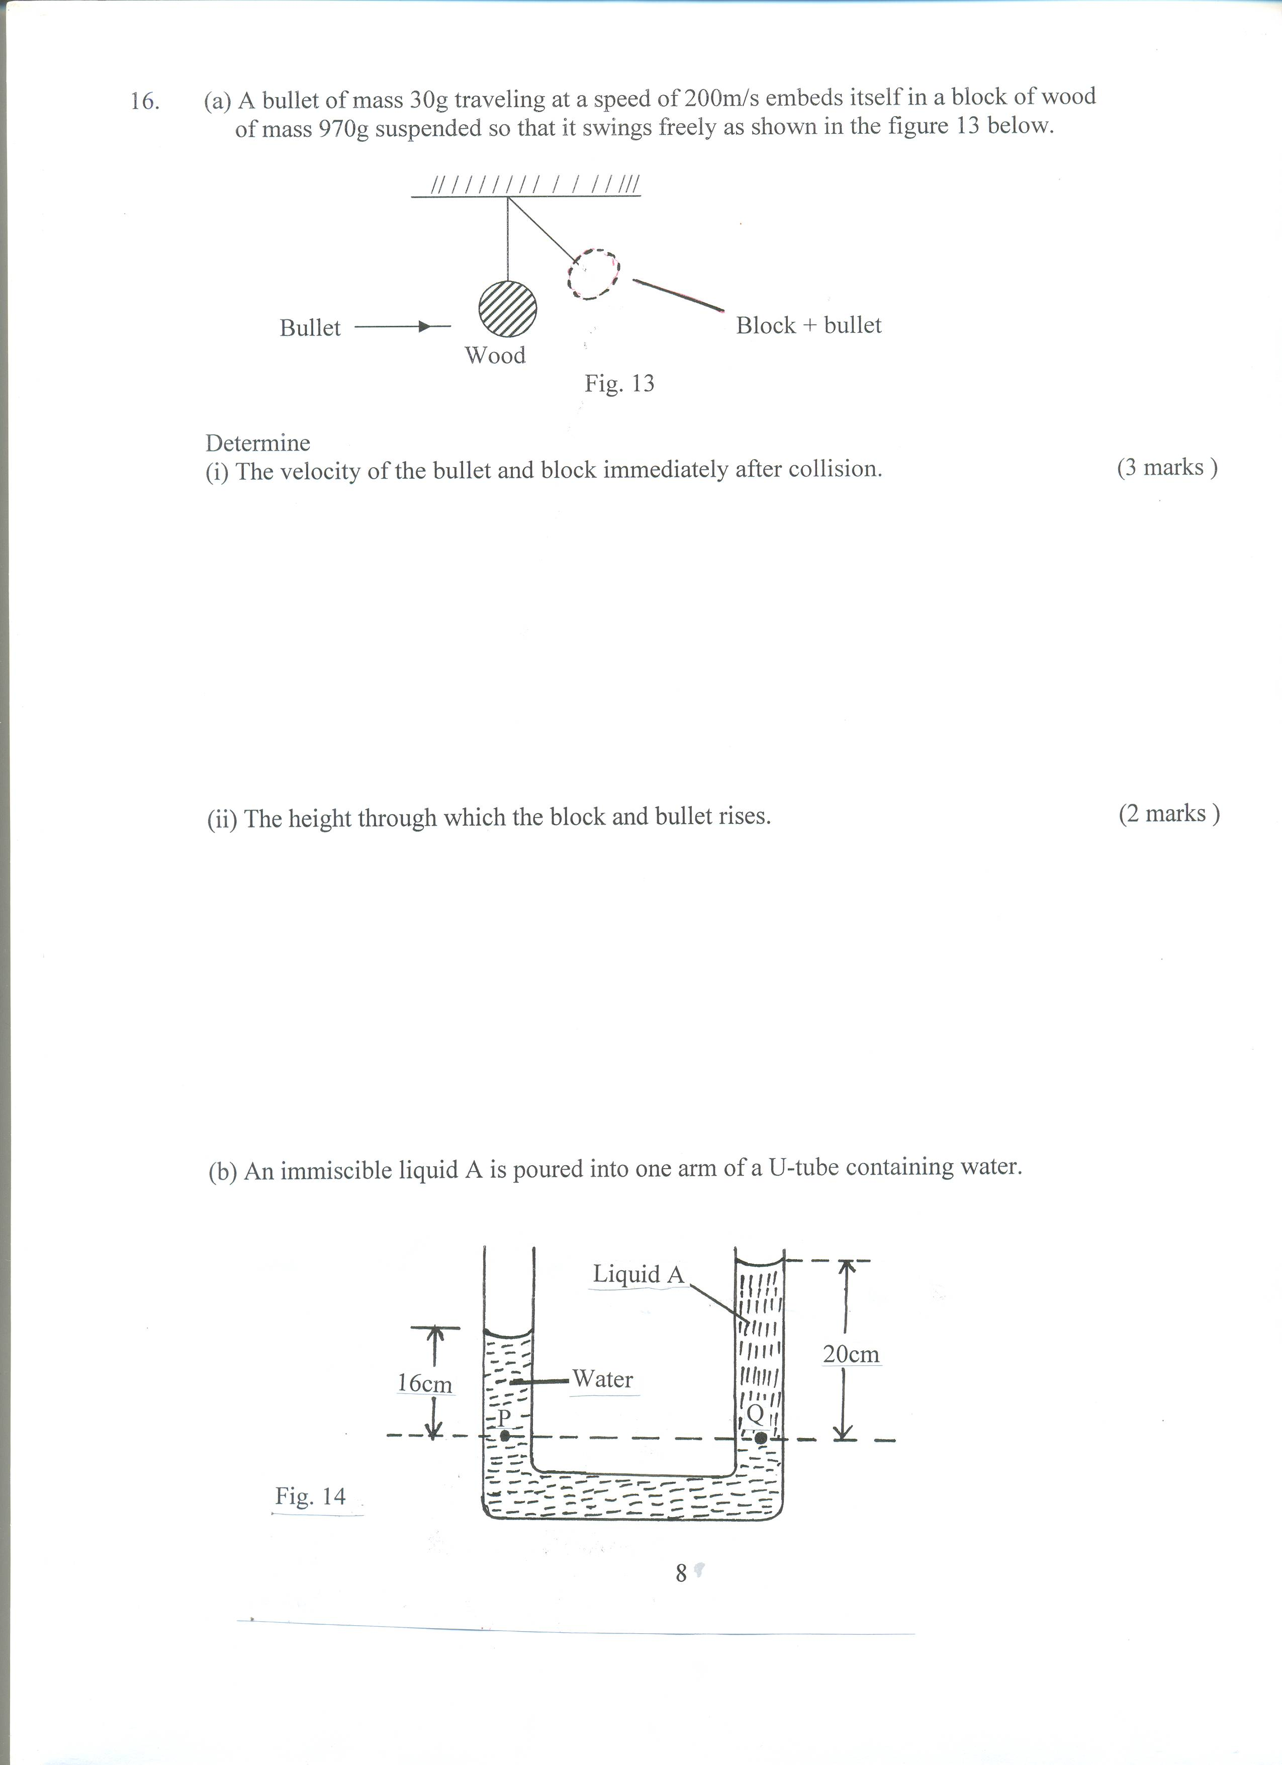

Given that density of water is 1g/cm³, determine
(i) Density of liquid A (2 marks)

(ii) Pressure at point Q due to the liquid column. (3 marks)

17. (a) Using the kinetic theory of gases explain how a rise in temperature of a gas causes
a rise in the volume of the gas if the pressure is kept constant. (3 marks)

(b) The fig. 15 below shows a set up that may be used to verify pressure law.
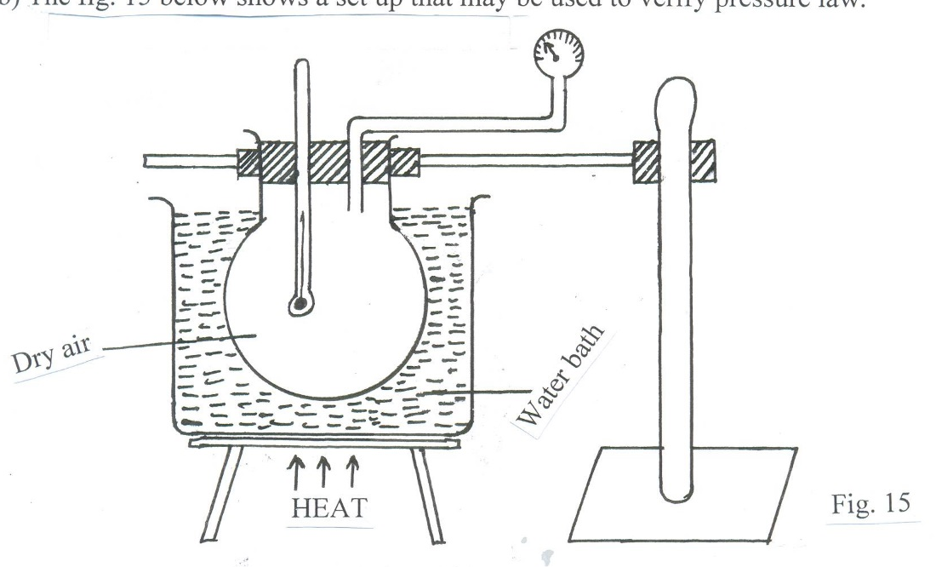
Explain how the measurements taken above may be used to verify pressure law. (4 marks)

(c) When an inverted beaker is placed on the surface of water, it contains 250cm³ of rapped air at atmospheric pressure. Assume the atmospheric pressure can support a column of water 9.5m high and temperature is kept constant, find the volume of the trapped air when beaker is taken 15m beneath the water surface. ( 4 marks )
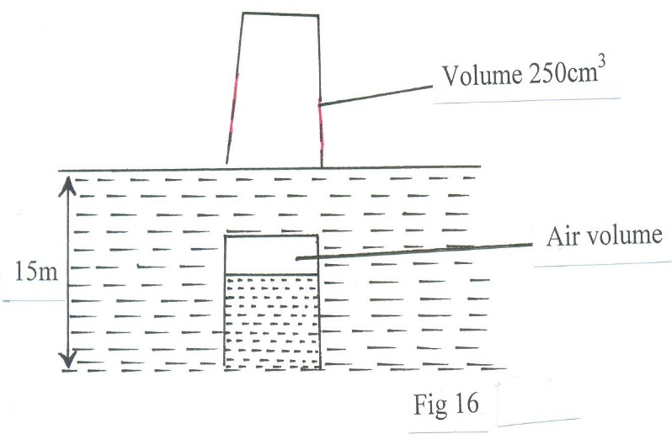
18. (a) The figure 17 shows a set up of apparatus used in an experiment to determine the specific latent heat of vaporization of water.
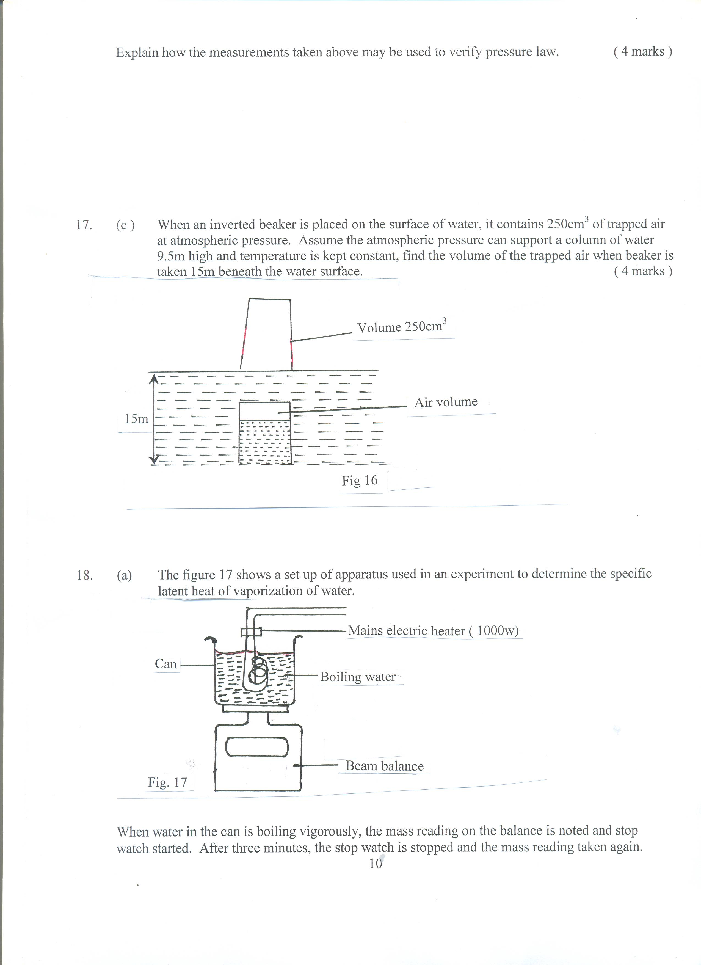
When water in the can is boiling vigorously, the mass reading on the balance is noted and stop watch started. After three minutes, the stop watch is stopped and the mass reading taken again.
Results
Mass of empty can = 122g
Initial mass of can + water = 178g
Mass of can + water after 3 minutes = 169g
Determine;
(i) Heat energy supplied by electric heater (1000w) for 4 minutes. (2 marks)

(ii) Specific latent heat of vaporization of water. (3 marks)

(iii) Suggest one possible source of error for this experiment. (1 mark)

(b) A block of metal of mass 0.2kg and temperature 98⁰C is placed in water of mass 0.42kg and temperature 16⁰C. If the final temperature of the metal and water is 21⁰C, determine the specific heat capacity of the metal.( Take specific heat capacity of water = 4200 J/kgK ). (3 marks)

(c ) The figure 18 below shows a section of a tape from a ticker-timer of frequency 50H_{Z} attached to a moving trolley.
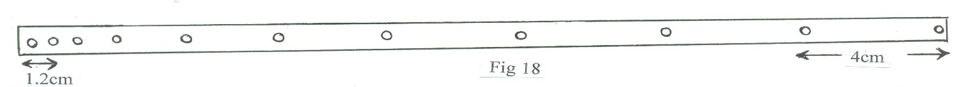
Determine the acceleration of the trolley. (3 marks)

19. (a) Define the following terms:
(i) Velocity ratio of inclined plane. (1mark)

(ii) Mechanical advantage of gear system (1mark)

(b) Name a device that is used to convert sound energy to electrical energy. (1mark)

(c) A bullet of mass 20g travelling at 400ms⁻¹ is stopped by a concrete wall. Calculate the amount of energy transferred to the wall. (3marks)

(d) A pulley system having a velocity ratio of 4 is used to raise a load of 80N through a height of 0.6m at a constant speed using an effort of 20N in a time of 15S.
(i) The efficiency of the system. (3marks)

(ii) The power developed by the effort. (3marks)

