Name _________________________________________________ ADM No. ____________________

Date _________________________

Candidate’s signature ____________

121/1
MATHEMATICS ALT A
PAPER 1
FORM 3
TIME: 2½ HOURS

FORM 3 END OF YEAR 2026 EXAMINATION
INSTRUCTIONS TO CANDIDATES
- Write your name and index number in the spaces provided above.
- Sign and write the date of examination in the space provided above.
- This paper consists of TWO sections: Section I and Section II.
- Answer ALL the questions in section I and only FIVE questions from Section II.
- All answers and working must be written on the question paper in the space provided below each question.
- Show all the steps in your calculations, giving your answers at each stage in the spaces below each question.
- Marks may be given for correct working even if the answer is wrong.
- Non-programmable silent calculators and KNEC mathematical tables may be used except where stated otherwise.
- This paper consists of 15 printed papers.
- Candidates should check the question paper to ascertain that all the pages are printed as indicated and that no questions are missing.

FOR EXAMINER’S USE ONLY
SECTION I
1 | 2 | 3 | 4 | 5 | 6 | 7 | 8 | 9 | 10 | 11 | 12 | 13 | 14 | 15 | 16 | TOTAL

SECTION II
17 | 18 | 19 | 20 | 21 | 22 | 23 | 24 | TOTAL |  | GRAND TOTAL

SECTION I (50 MARKS)
Answer ALL questions in the spaces provided.

1. Simplify:
³/₅ of 60 – 2²/₃ x 1 ½
5⁵/₈ x 1⁷/₉ ⁵/₄ x 4⁴/₅ + 2⁴/₅ ÷ ⁷/₁₀ ( 3 marks )

2. The LCM of two numbers is 180 and their GCD is 12. If the two numbers are 36 and y,
find the value of y. ( 2 marks )

3. Solve for x in the equation.
27^{x} x 3^{(2x-2)} = 9 ^{(x +2)} ( 3 marks )

4. The cost of a tablet is US $1000. Kaloki intends to buy one tablet through an agent who deals
in Japanese Yen. The agent charges him a commission of 5% on the price of the tablet and
further 1260 Yen as import tax. How many Ksh. Will he need to sent to the agent to obtain the
tablet given that
1 US $ = 105.00 Yen
1US $ = Ksh. 85. ( 3 marks )

5. The size of each interior angle of a regular polygon is five times the size of the exterior
angle. Find the number of sides of the polygon. ( 3 marks )

6. Francis who runs a clothing shop bought a shirt at ksh. 500 and marked it at ksh. 600. A customer bought it at ksh. 550 after engaging Francis in a lengthy negotiations process. What was the customer’s percentage discount. (3 marks)

7. In the following figure, O is the Centre. Find a and b (2 marks)
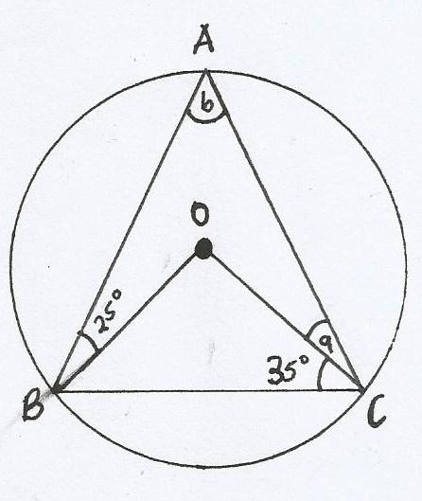
a_________________
b__________________

8. The table below shows height of 50 students
Height (cm) Frequency
140 – 144 3
145 – 149 16
150 – 154 20
155 – 159 10
160 – 164 1

(a) State the modal class ( 1 mark)

(b) Calculate the median height. ( 3 marks )

9. A line passes through ( 1, 3) and is perpendicular to the line y = 5 – 2x. What is the
equation of the line? ( 3 marks )

10. Mulwa bought 4 pencils and 6 biro pens for Ksh. 64 and Mwania bought 2 pencils
and 5 biro pens for sh. 50.

(a) Find the price for each items. ( 3 marks )

(b) Mutinda spend Ksh. 220 to buy the same type of pencils and biro pens. If the
number of biro pens he bought were 4 more than the number of pencils, find the
number of pencils he bought. ( 2 marks)

11. Two similar containers have capacities 256 litres and 108 litres. If the surface area of the
smaller container is 810cm², what is the surface area of the larger container in m²? ( 3 marks )

12. A stool is made by shaping a tree stump into a conical frustrum of vertical height 60cm. If the top radius is 12cm and the bottom is 24cm. calculate the surface area of the stool π=3.142. (4 marks)

13. Simplify the expression

3a² +4ab + b²
4a² + 3ab – b² ( 3 marks)

14. Given that cos θ = ²/₃ and θ is an acute angle, find:
(a) tan θ, giving your answer in surd form. ( 2 marks )

(b)1 – sin² θ ( 1 mark)

15. From the roof of a house, a boy can see an avocado tree which is 20m away from the house. He measures the angle of elevation of the top of the tree as 21° and the angle of depression of the bottom of tree as 31°. Find the height of the avocado tree. (3 marks)

16. Write down four inequalities which fully describe the unshaded region R in the figure below (4marks)

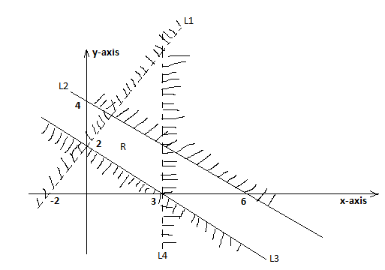

SECTION II (50 MARKS)
Answer ANY FIVE questions from this section
.
17. Draw a circle Centre 0 and radius 4 cm. (1 mark)
(a) From any point A on the circumference, draw two chords AB = 7cm and AC = 7.5cm on the
opposite sides of the Centre. (2 marks)

(b) Join B to C and locate the orthocenter (H) of triangle ABC. Join OH. (4 marks)

(c) Use the midpoint of OH as the Centre to inscribe a circle to triangle ABC and measure its
radius. (3 marks)

18.

T W

U S

R
P Q

In the above figure, PQR is a tangent at Q and RST is a straight line. ∠ QTU = 50⁰,
∠ UTW = 33⁰ and ∠ TRQ = 25⁰
Giving reasons in each case, calculate
(i) Angle TSQ ( 3 marks )

(ii) Angle TSW ( 3 marks )

(iii) Angle TUQ ( 2 marks )

(iv) Angle PQW ( 2 marks )

19. Matrix P is given by 4 7
5 8

(a) Find P⁻¹ ( 2marks )

(b) Two schools, Utaati sec. school and Ngosini sec. school purchased beans at Ksh.B per
bag and maize at Ksh. M per bag. Utaati purchases 8 bags of beans and 14 bags of maize
for Ksh. 99,600. Ngosini purchases 10 bags of beans and 16 bags of maize at
Ksh. 120,000

(i) Form a matrix equation to represent above information. (2 marks)

(ii) Using P⁻¹ in (a) above, determine the cost of a bag of beans and a
bag of maize. (3 marks )

(c ) The price of beans later went up by 5% and that of maize remained constant. Utaati
bought the same quantity of beans but spent the same total amount of money as before on
the two items. State the new ratio of beans to maize. ( 3 marks )

20. The table below shows marks obtained by 100 candidates at Mithila Secondary in a mathematics examination.
Marks | 15-24 | 25-34 | 35-44 | 45-54 | 55-64 | 65-74 | 75-84
Frequency | 6 | 14 | 24 | 14 | x | 10 | 10
(i) Determine the value of x (2 marks)

(ii) State the modal class (1 mark)

(iii) Calculate the mean (3 marks)

(iv) Determine the median mark. (4 marks)

21. In the figure below PQ = 2500m, U T= 1000m and TS =2350m. PQR is a straight line. Parallel to UT and angle UPQ =22.5º.
22.5⁰
S

2350m
U 1000m T V

P 2500m Q R
Calculate to the nearest meter
(a) (i) U Q (2marks)

(ii) T V (2marks)

(iii) V S (2marks)

(iv) P U (2marks)

(b) Find the perimeter of the figure. (2marks)

22. (a) Complete the table below for the function y = 6 + x – x². ( 2 marks )

x | -4 | -3 | -2 | -1 | 0 | 1 | 2 | 3 | 4 | 5
y | -14 |  |  |  | 6 |  | 4 |  | -6

(b) On the grid provided below, draw the graph of y = 6 + x – x² for -4 ≤ x ≤ 5. ( 3 marks )
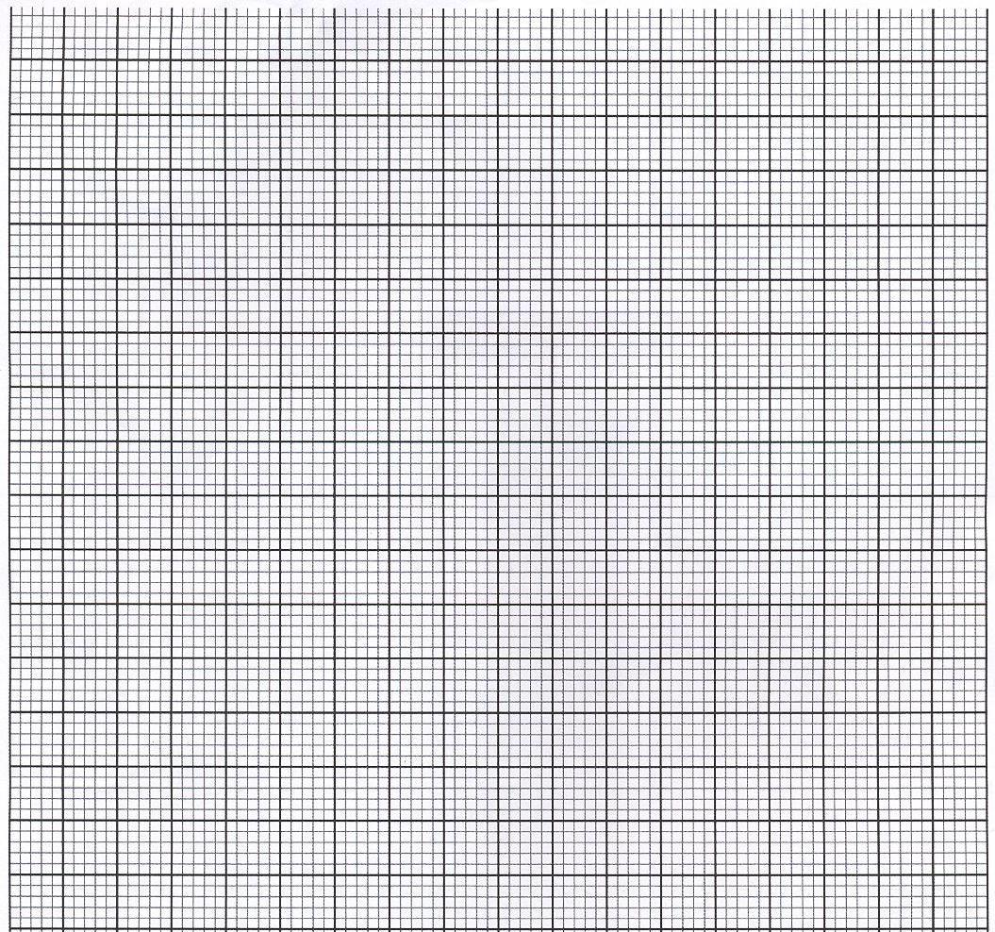

(c ) On the same axes draw the graph of y = 2 – 2x. ( 2 marks )

(d) From the graphs, find the values of x which satisfy the simultaneous equations.
y = 6 + x – x²
y = 2 – 2x. ( 1 marks )

(e) Write down and simplify a quadratic equation in the form ax² + bx + c = 0
which is satisfied by the values of x where the two graphs intersect. (2 marks )

23. (a) In a stadium, the cost per seat during a match is Ksh. 200. The stadium is built in a such a way that the first row has five seats more than the previous one and there are thirty-one rows. If during the match between AFC Leopards and GorMahia the stadium is 75% full, how much money is collected if every fan pays. (4 marks)

(b) The 3rd term of a geometric sequence is 20 and 6th term is -160.
Calculate:
(i) The common ratio (2 marks)

(ii) The first term (2 marks)

(iii) The 8th term (2 marks)

- The figure below is the speed – time graph of a journey
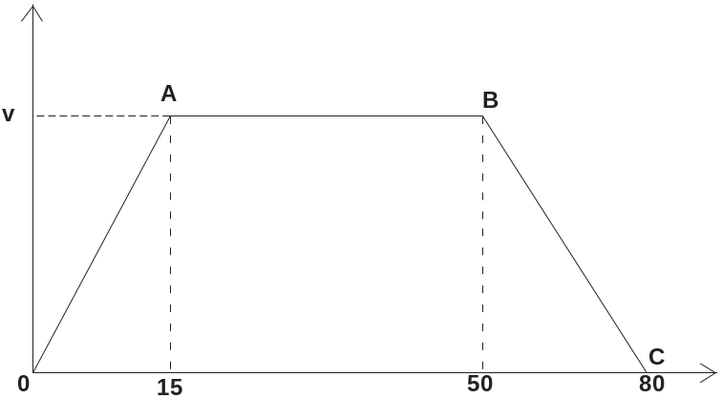
If the total distance travelled in the 80 seconds is 920m, calculate:
- The value of V. (4 marks)

- The acceleration during the first 15 seconds (3 marks)

- The distance travelled in the final 40 seconds. (3 marks)

