312/2
GEOGRAPHY
PAPER 2
TIME:2 ¾ Hours
Form 3 END OF TERM 3 2026

INSTRUCTIONS TO STUDENTS / CANDIDATES
This paper consist of two Sections A and B
Answer ALL Questions in section A
In section B answer question 6 and any other Two questions
All answers must be written in the answer booklet provided
SECTION A
Answer All questions in this section

- State two ways in which minerals occur (2mks)
- Describe panning as a method of mining (3mks)

- Name two types of dairy cattle in Denmark (2mks)
- Give three characteristics of dairy farming in Denmark (3mks)
- State five problems that affect forestry in Canada (5mks)

- What is Agriculture (2mks)
- Identify three characteristics of plantation farming in Kenya (3mks)

- Name two counties in Kenya where livestock ranches have been established (2mks)
- Give three food products from pastoral farming (3mks)
SECTION B
Answer question 6 and Any other Two questions from this section
- The table below shows land use in Nairobi City in the year 2003
Land use | Area in (000) km²
Settlement | 110
Grass | 30
Horticulture | 50
forest | 10
total | 200

- Apart from divided bar graph, name other Two statistical methods that can be used to represent the data in the table (2mks)
- Draw a divided rectangle to represent the data. Show your calculations. (6mks)
- State five characteristics of horticultural farming in Kenya (5mks)

- Name two towns in Netherlands that provide market for horticultural produce. (2mks)
- Name two international airports in Kenya that receive horticultural produce from farmers (2mks)
- Highlight four differences between horticultural farming in Kenya and Netherlands (8mks)

- Define the term forestry ( 2mks)
- Name four tropical hardwood trees in Kenya (4mks)
- State five reasons why agro- forestry is being encouraged in Kenya (5mks)
- Explain three problems facing forestry in Kenya. (6mks)
- Explain four measures the government of Kenya has put in place to conserve forest in Kenya. (8mks)

- What is mixed farming (2mks)
- State three economic factors influencing coffee farming in Kenya. (3mks)

- Give four physical factors influencing coffee farming in Kenya. (4mks)
- Describe coffee production in Kenya from harvesting to marketing. (8mks)
- Give three differences between coffee farming in Kenya and Brazil (6mks)
- You intend to carry out field study on coffee growing in a farm near your school. State two advantages of using secondary sources during data collection. (2mks)
- Use the map of East Africa below to answer questions
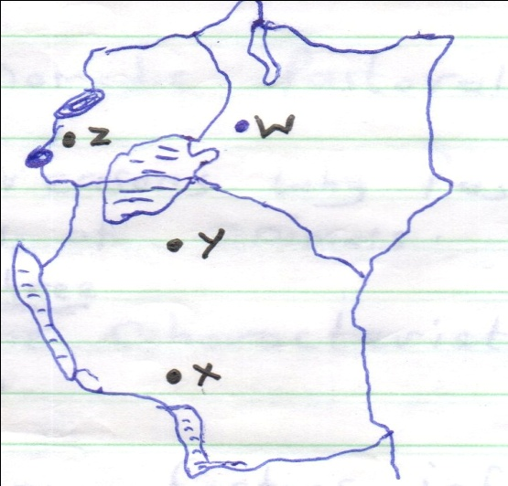

- Identify the mineral mined in the area marked (4mks)
W-
X-
Y-
Z-
- Name :
- Three methods of mining (3mks)
- Two sea ports through which some minerals mined in East Africa are exported (2mks)
- State five factors that influence the exploitation of minerals (5mks)
- Explain four ways in which soda ash contribute to the economy of Kenya (8mks)
- State three ways in which mining derelicts can be reclaimed (3mks)

- What is nomadic pastoralism (2mks)
- Give two reasons why pastoralists keep large herds of animals (2mks)

- Outline three characteristics of nomadic pastoralism (3mks)
- Explain three factors influencing pastoral farming in Kenya (6mks)
- Explain three measures being taken by the government to improve pastoral farming in Kenya (6mks)
- Some students carried out a field study in a cattle ranch in Kajiado
- Give four reasons why you need a route map for the study (4mks)
- State two problems affecting the ranch that students are likely to have identified. (2mks)

