312/1
GEOGRAPHY
PAPER 1
TIME:2 ¾ Hours
FORM 3 END OF TERM 3 2026
INSTRUCTIONS TO STUDENTS / CANDIDATES
- This paper consist of two Sections A and B
- Answer ALL Questions in section A
- In section B answer question 6 and any other Two questions
- All answers must be written in the answer booklet provided
Form 3 geography
PP1 (312/1)
SECTION A
Answer all the questions in this section

- Name three components of the solar system.(3mks)
- State two weaknesses of Nebular cloud theory.(2mks)

- Name two minerals that make up the inner core.(2mks)
- Identify three forces responsible for the spherical shape of the earth.(3mks)

- Give two physical conditions that may influence landside.(2mks)
- State three evidences of the occurrence of soil creep in an area.(3mks)

- The diagram below show a breaking wave in the sea
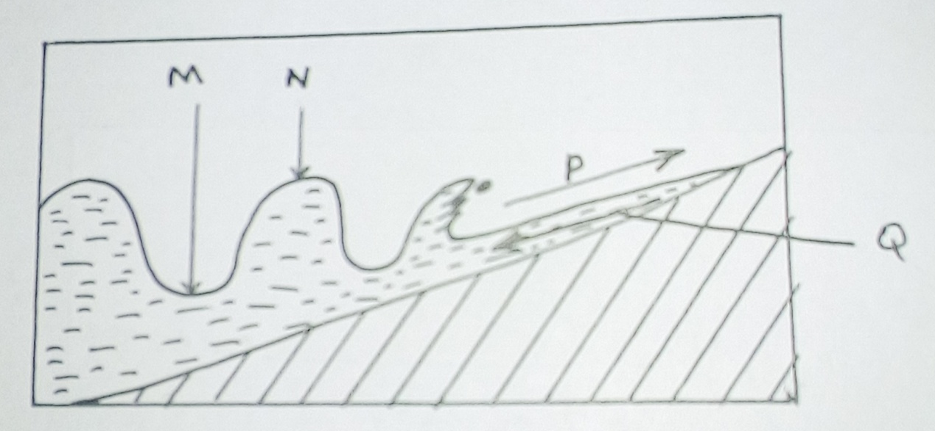

- Name the parts labeled M,N and P.(3mks)

- Briefly explain how the current marked Q occurs.(2mks)

- Identify three processes through which a river transports its load.(3mks)
- Differentiate between river capture and river rejuvenation.(2mks)
SECTION B
Answer question 6 and any other two questions from this section.
- Map work
Study the map of Oyugi’s (1:50000 Kenya) provided and answer the questions which follows.

- State the contour interval used in the map.(1mk)
- Give the height of the trigonometrical station at God ndori.(1mk)
- Name three man made features found in the grid square 8421.(3mks)
- Name two counties in the area represented by the map.(2mks)
- Measure the length of the all weather loose surface road from the junction at Rodi Kopany to the bridge at grid reference 727226. Give your answer in Km.
- Identify three types of natural vegetation found in Oyugi’s.(3mks)
- Draw a rectangle 14cm by 10cm to represent the area to the north of the Northings 35 and to the east of the eastings 80.(2mks)
- In the rectangle, mark and name the following features:- (4mks)
- Kodera forest
- District boundary
- All weather bound surface road
- Onjinyo market.
- Describe the drainage of the area covered by the map.(4mks).
- Citing evidence from the map name three social services offered at Asumbi.

- Define volcanicity.(2mks)
- Name three examples of active volcanoes in Kenya.(3mks)

- With the aid of a well labeled diagram describe the formation of a composite volcano.(8mks)

- Explain four ways in which volcanic features positively influence human activities.(8mks)
- You are required to carry out a field study on a region that had a recent volcanic activities.
- State two methods you would use to record the information corrected.(2mks)

- Differentiate between a well and a spring.(2mks)

- Name the three layers of saturation. (3mks)

- State four conditions necessary for the formation of an artesian well.(4mks)
- The diagram below shows features in a limestone area: use it to answer questions C(i) and C(ii) below.
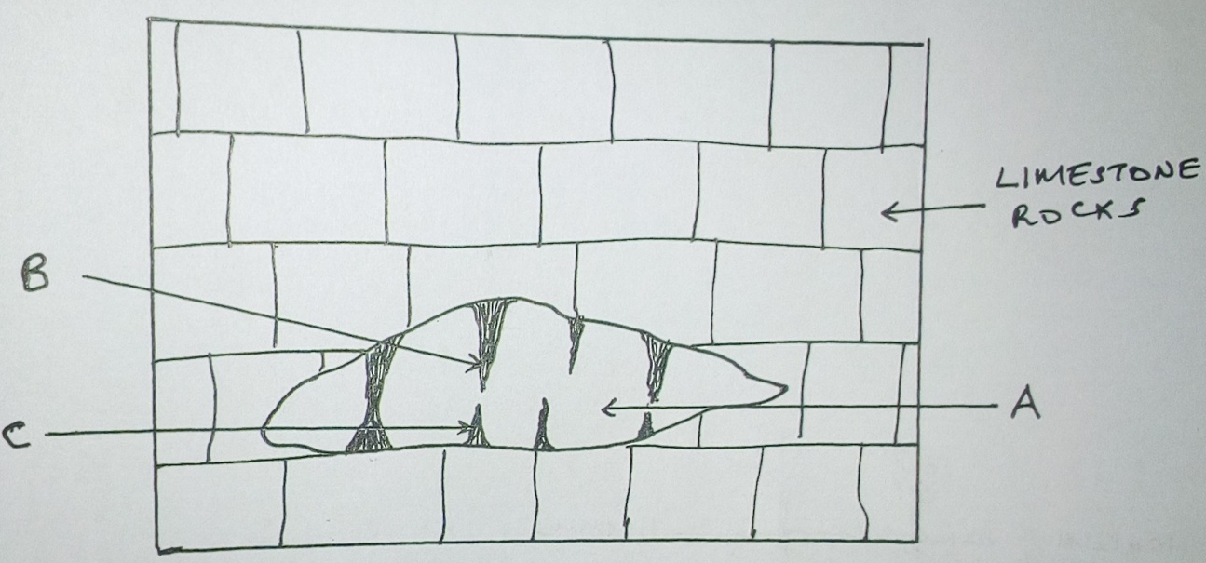

- Name the features marked A,B and C.(3mks)
- Describe the formation of the feature marked C.(4mks)

- State three conditions necessary for development of karst scenery.(3mks)

- Give three reasons why there are few settlement in karst landscapes(3mks)
- You intend to carry out a filed study in a karst landscape.(3mks)
- Name three depressions you are likely to identify in the region.(3mks)

- Distinguish between soil catena and soil profile.(2mks)
- State three factors that determine the color of soils.(3mks)

- Draw a well labelled diagram to show a mature tropical soil profile .(5mks)
- State three characteristics of the horizon marked ‘B’.
- Explain how the following practices cause soil erosion.(3mks)
- Mono culture(3mks)
- Burning (3mks)
- Continuous application of fertilizers.(3mks)
- A form 3 class intended to carry out a field study on soils around their school. Name three main types of soils they would identify.(3mks)

- Give three examples of temperate grasslands stating the countries where found.(6mks)
- Describe the characteristics of the Amazon rain forests.(8mks)
- Draw a well labeled diagram to show vegetation in a tropical mountain.

- Your class intends to conduct a field study on vegetation in the area around your school.
- Formulate two objectives for this study.(2mks)

- State three reasons why it would be necessary to conduct a reconnaissance.(3mks)

