Name ……………………………..………...… …….. Index No………….….…

Class ………………Adm………………Candidate’s Signature ……..…………

FORM 3
233/2
CHEMISTRY
PAPER 2
(THEORY)
TIME: 2 HOURS
END TERM 3 2026

INSTRUCTIONS

- Write your name and the Index Number in the spaces provided above.
- Answer ALL the questions in the spaces provided after each question.
- Use of Mathematical sets and electronic calculators may be used.
- All working should be clearly shown.

FOR OFFICIAL USE ONLY

QUESTIONS | EXPECTED SCORE | CANDIDATES SCORE
1 | 08
2 | 07
3 | 08
4 | 14
5 | 07
6 | 14
7 | 14
8 | 08
TOTAL | 80

1. (a)The electron arrangement of ions A³⁺ and B²⁻ are 2.8 and 2.8.8 respectively, Write down the electron arrangement of the elements A and B.(2mks)
A

B

b) Study the information in the table below and answer the questions that follow. The letters are not the actual symbols of the elements.

Element | Atomic number | Boiling point (ºC)
K | 3 | 1333
L | 13 | 2470
M | 16 | 445
N | 18 | -186
P | 19 | 774

- Which element
- Is a gas at room temperature? Explain, taking room temperature as 25ºC. (1mks)

- Does not form an oxide? Explain. (1mk)

- Write down the equation for the reaction between elements K and M. (1mk)

- What type of bond would exist in the compound formed when elements M and L react? Give a reason for your answer (1mks)

- Select the most electropositive element. Explain. (2mks)

(v)Why is the boiling point of element L is higher than that of element K. (1mks)

2.The set-up below was used to prepare and collect gas X. During the experiment cleaned magnesium ribbon was strongly heated before heating the wet glass wool.
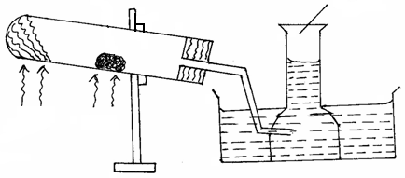
Heat
Heat
Reaction tube
Magnesium ribbon
Gas X

wet glass wool

(a) Name gas X (1 mark)

(b) Why is magnesium ribbon cleaned before it is used? (1 mark)

(c) State one observation that would be noted in the reaction tube. (1 mark)

(d) Write the equation for the reaction in the reaction tube. (1 mark)

(e) State one industrial use of the solid product formed in the reaction tube. (1 mark)

(f) At the end of the experiment 96.0cm³ of gas X were collected at 10°C and 1 atmosphere pressure. (Mg = 24, M.G.V = 22.4dm³)
(i) Determine the volume gas X would occupy at s.t.p? (2 marks)

3. In the preparation of magnesium carbonate magnesium was burnt in Oxygen and the product collected. Dilute sulphuric (VI) acid was added and the mixture filtered and cooled. Sodium carbonate was added to the filtrate and the content filtered. The residue was washed and dried to give a white powder.

a) Give the chemical name of the productformed when magnesium burns in Oxygen (lmk)

b) Write a chemical equation for the above reactions (lmk)

c) (i) Name filtrate collected after sodium carbonate was added (lmk)

(ii) Name the white powder. (lmk)

d) Write chemical equation for the reaction between product in (a) and acid. (lmk)

e) Name the ions present in the filtrate after addition of sodium carbonate. (1mk)

f) Write an ionic equation to show the formation of the white powder. (lmk)

g) Write an equation to show what happened when white powder is strongly heated. (lmk)

4 .a)Name the following compounds (2mks)
(i) 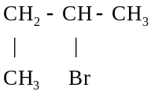

(ii) H₂SO_{4(l)}

- The diagram below is for the preparation of ethene gas in the school laboratory.

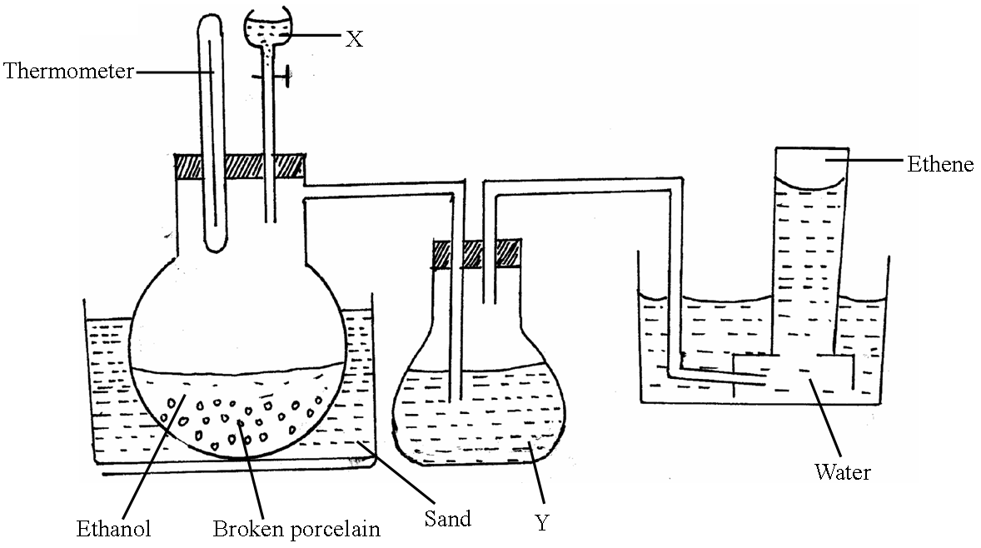

(i) Name substance (1mk)
X_____________________________
Y_____________________________
(ii) What is the use of substance Y? (1mk)

(iii) State one condition missing in the set up (1mk)

(iv) Explain why ethene can’t be collected by either upward or downward delivery (1mk)
(v)Write down an equation for the production of ethene in the above set up.(1mk)

c) Study the scheme below and answer the questions that follow.

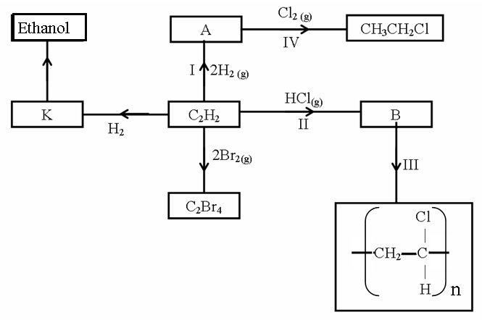

(i) Identify the catalyst used in step I (1mk)

(ii) Name the compounds A and B (2mk)
A_____________________________
B_____________________________
(iii) Give one disadvantage of compound formed in step III (1mk)

(iv) Name the reactions taking place at steps: (2mk)
III______________________________
IV______________________________
(v) Describe how substance K is converted to ethanol (2mks)
d) Under certain conditions, heptane can be converted to two products. The formula of one of the products is C₄H₁₀. Write down the structural formula of the other products. (1mk)

5. a) The flow diagram below shows several reactions starting with carbon.

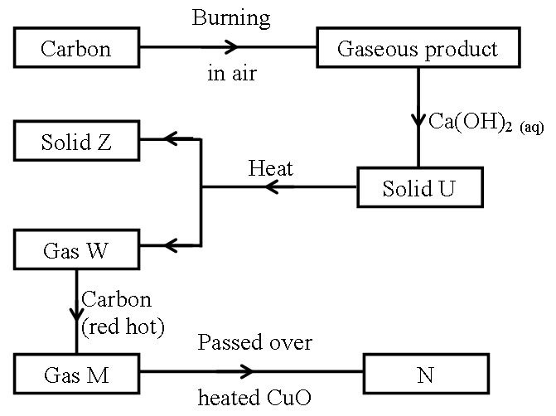

(i) Identify the following (2mks)
U________________________
Z________________________
W________________________
M________________________
(ii) State the observation made when gas M is passed over heated copper (II) oxide. (1mk)

(iii) State one application of solid Z (1mk)

(iv) Write an equation for the formation of gas M from gas W. (1mk)

(v) Explain the precaution to be taken in (ii) above. (2mks)

6.Below is a simplified diagram for the manufacture of sulphuric (VI) acid in large scale.
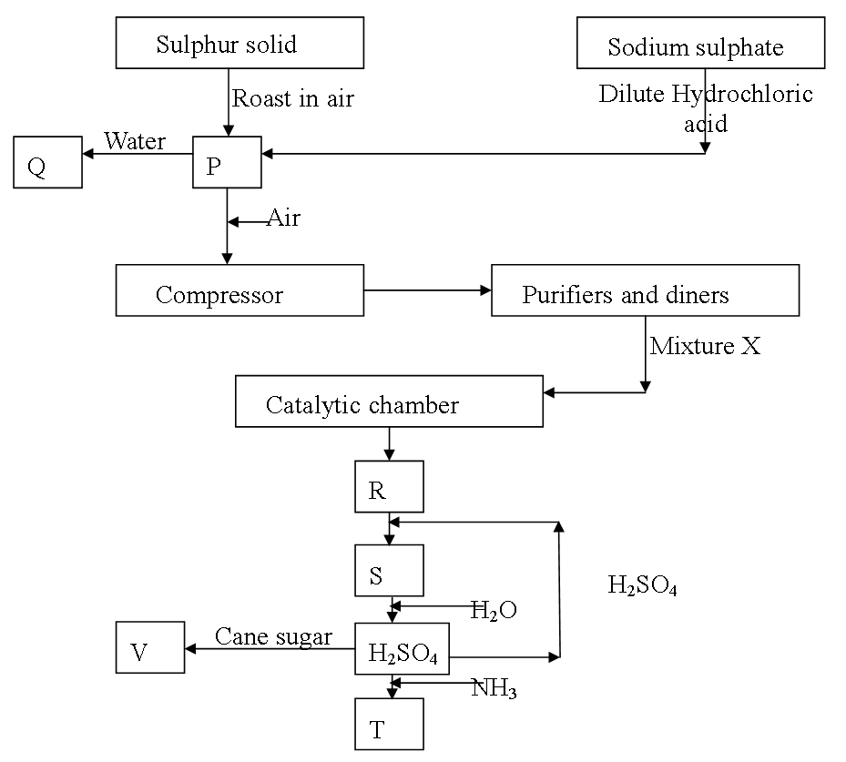

(a) Name the substances P, Q, R, S, T and V (4mks)
P…………………………(1mk) S……………………………(1/2mk)
Q…………………………(1/2mk) T……………………………(1mk)
R………………………… (1/2mk) V……………………………(1/2mk)
(b) (i) What is the use of the compressor? (1mk)

(ii) What is removed in the purification chamber? (1mk)

(c) (i) State any two specific conditions for the formation of R (2mk)

(ii) Write the chemical formula of the catalyst used in the catalytic chamber (1mk)

(iii) Write an equation for the formation of gases in the catalytic chamber (1mk)

(d) State a chemical test to confirm the presence of P (1mk)

(e) One of the uses of sulphuric (VI) acid is ‘pickling’ metals. What does the term ‘pickling’ mean? (1mk)

(f) The following diagram represents the method of preparing sulphuric (IV) acid solution.
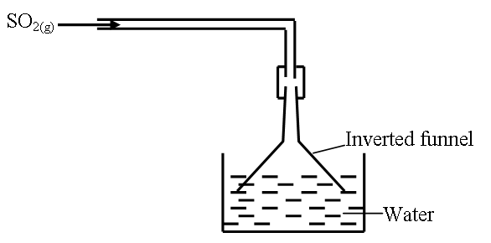
(i) Why is an inverted funnel used? (1mk)

(ii) Explain the observation made when sulphur (IV) oxide gas is mixed with moist blue litmus paper. (1mk)

(g) State and explain what would be observed if concentrated sulphuric (VI) acid is added to cane sugar leading to formation of substance V. (1mk)

(h) How can the pollution of the atmosphere be minimized in contact process? (1mk)

7. A form three student wanted to find the proportion by volume of one of the main constituents of air, a sample of air was passed through two wash bottles; the first containing aqueous sodium hydroxide and the second containing concentrated Sulphuric (VI) acid and was then collected in a gas syringe.

a) Why was the air passed through:
i) Aqueous sodium hydroxide (1mk)

ii) Concentrated sulphuric (VI) acid 1(mk)

b) The volume of gas collected in the syringe was 90cm³. This was passed several times over hot copper powder until no further contraction of volume took place. After cooling to the original temperature the volume was found reduced to 73.2cm³.
i) State and explain the observation made at the end of the experiment (2mk)

ii) Calculate the volume of gas that was used up in the process. (1mk)

iii) Calculate the percentage of this gas present in the 90cm³ (1mk)

i) Name the main gas remaining in the syringe ( 1mk)

- Is the main gas named in (i) above pure or not. Explain (2mks)

8. A hydrated salt has the following composition by mass. Iron 20.2%, Oxygen 23%, Sulphur 11.5% and water 45.3%. Its relative formula mass is 278
(i) Determine the formula of the hydrated salt. (3Marks)
(Fe = 56, S = 32, O = 16, H = 1)

(ii) 6.9g of the hydrated salt was dissolved in distilled water and the total volume made to 250cm³ of solution. Calculate the concentration of the salt solution in moles per litre (2Marks)

(d) Describe how a solid sample of lead (II) chloride can be prepared using the following reagents:- dilute nitric acid, dilute hydrochloric acid and lead carbonate. (3 Marks)

