NAME _____________________________________ ADM NO. _________
CLASS ____________________________________ DATE _____________

FORM III
2 HOURS
END TERM 3 2026
chemistry PAPER 1

INSTRUCTIONS
- Answer ALL questions in section A in the spaces provided.

- Explain how hotness of a Bunsen burner flame can be increased. (1 mk)

- Explain how the following substance conducts electric current.
- Molten magnesium chloride. (1mk)

- Magnesium metal. (1mk)

- The data given below was recorded when Metal Q was completely burnt in air. Q is not the actual symbol of the Metal. (RAM = 56, 0 = 16)
Mass of the empty crucible and lid = 10.240 g
Mass of crucible, lid and metal Q = 10.352 g
Mass of lid and metal oxide = 10.400g
- Determine the mass of:-

- Metal Q (1mk)

- Oxygen (1mk)

- Determine the empirical formula of Metal Oxide (2mks)

- State Graham’s Law of diffusion. (1mk)

- Hydrogen gas diffuses through a porous plug in 80 seconds. The same volume of gas Z through the same aperture in 300 seconds. Calculate the Molecular Mass of gas Z. (3mks)

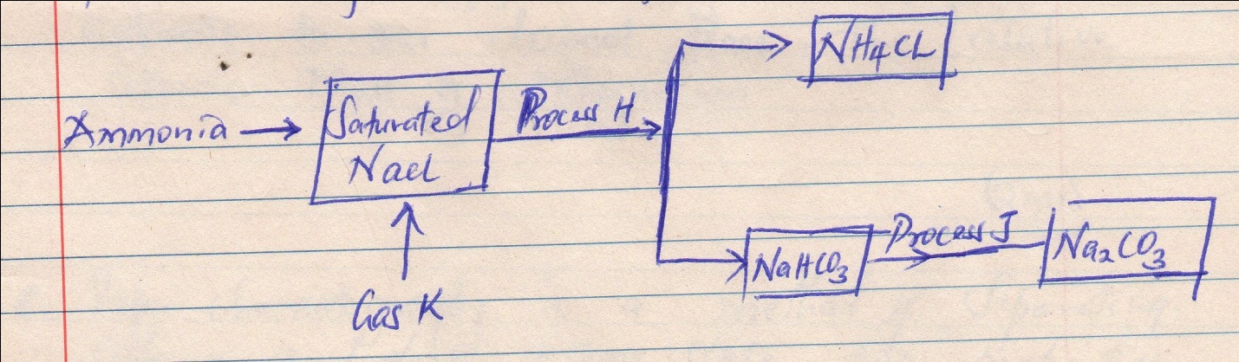
- The schematic diagram is part of the Solvay process used for the manufacture of Sodium Carbonate.

- Identify process H (1mk)

- Name gas K (1mk)

- Write an equation for the reaction in process J (1mk)

- The first step in the industrial manufacture of Nitric (v) acid is the catalytic oxidation of ammonia gas.
- Why is Nitric (v) acid kept in dark bottles? (1mk)

- What is the name of the catalyst used? (1mk)

- State two uses of ammonium nitrate. (1mk)

- Naturally occurring Magnesium consists of three isotopes 78.6% ²⁴Mg, 10% ²⁵Mg and ²⁶ Mg.
Calculate to one decimal place, the relative atomic mass of Magnesium. (2mks)

- Paper chromatography is a method of separating colours and dyes. State two properties the components of a mixture should have to make the separation possible. (2mks)

- Diamond and graphite are allotropes of Carbon, explain why:-
- Graphite is used as a lubricant. (1mk)

- Diamond is used in drilling hard rocks. (1mk)

- The following data gives PH values of solution X, Y and Z
Solution PH
X 12
Y 7
Z 2.5
- Which solutions would produce hydrogen gas with calcium metal? Give a reason (1 ½ mark)

- Which solution will react with Aluminum hydroxide? Give a reason? (1 ½ mk)

- Study the grid provided and answers the questions that follow.

 | E |  |  |  |  | A
G | F |  | D |  | C |  | B
 |  |  |  |  |  |  | H

- Select an element that can form an ion with a charge of 2- (1mk)

- What type of structure would the oxide of D have? (1mk)

- Compare the reactivity of B and H (1mk)

- Nitrates of metal K L M were heated and the products of the reactions recorded in the table below.
Metal nitrate Products
K Metal-Oxide, Nitrogen (IV) Oxide, Oxygen
L Metal nitrite and Oxygen
M Free metal, Nitrogen (IV) Oxide and Oxygen
- Name the identities of metal L (1 mk)

- Name the identities of metal M (1 mk)

- 20.0cm3 of a solution containing 5.6 g/dm³ of potassium hydroxide reacts exactly with 24.0 cm3 of dilute Sulphuric( VI) acid solution, using methyl-orange as indicator Calculate the molarity of the Sulphuric(VI) acid (K=39,O=16,H=1) (3mks)

- Chlorine gas can be prepared in the laboratory by reacting potassium manganate(VII) with concentrated hydrochloric acid.
State and explain the observation that would be made in experiments I and II (2 mk)
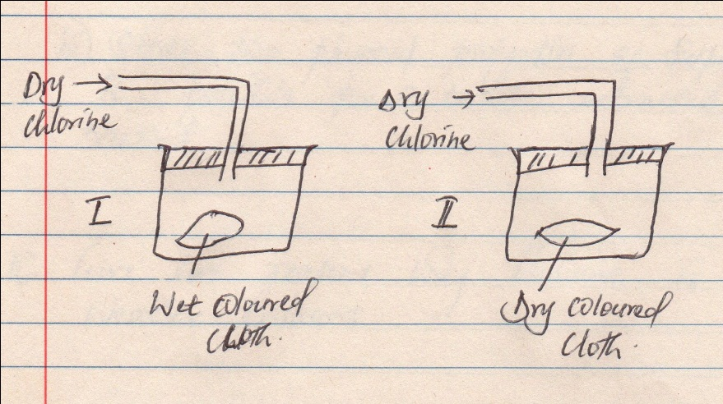

- The diagram below shows the Frasch process used for extraction of Sulphur. Use it to answer the questions that follow.
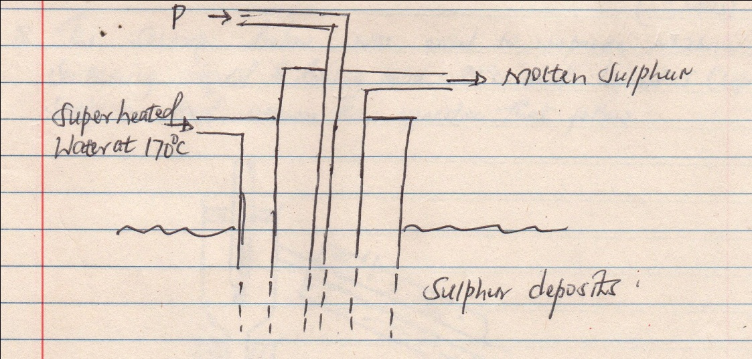

- Identify P. (1 mk)

- Why is it necessary to use super-heated water in this process. (1 mk)

- State two physical properties of Sulphur that makes it possible for it to be extracted by this method. (2 mks)

- Give two reasons why Helium is used in weather balloons. (2 mks)

- A given mass of a gas occupies 40 cm³ at 25 ˚C and 670 mmHg pressure. Calculate the volume it will occupy at 10 ˚C and 335 mmHg pressure. (3 mks)

- The set-up below was used to separate mixture containing liquid G boiling point 88 ˚C and liquid J (b.p = 102 ˚C). Study it and answer the questions that follow.

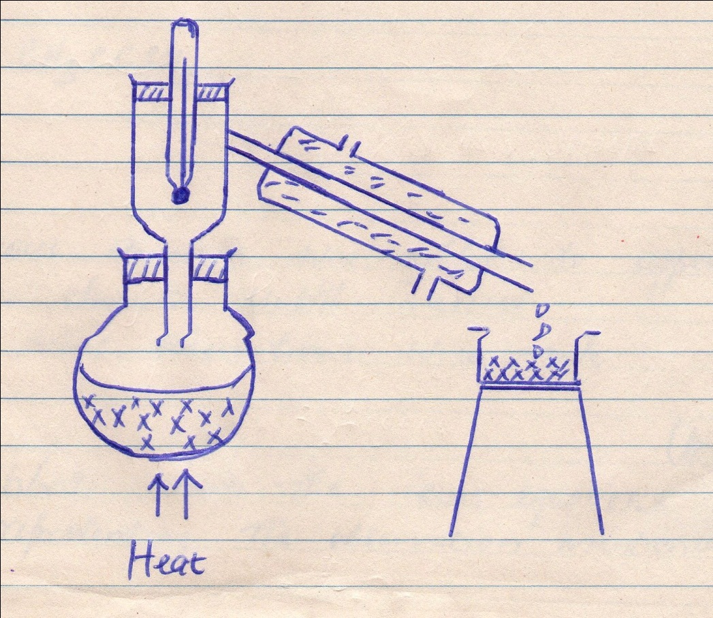

- Name the method used (1 mk)

- On the diagram indicate the direction of the flow of water (1 mk)

- Identify the liquid that would be collected first explain (1 mk)

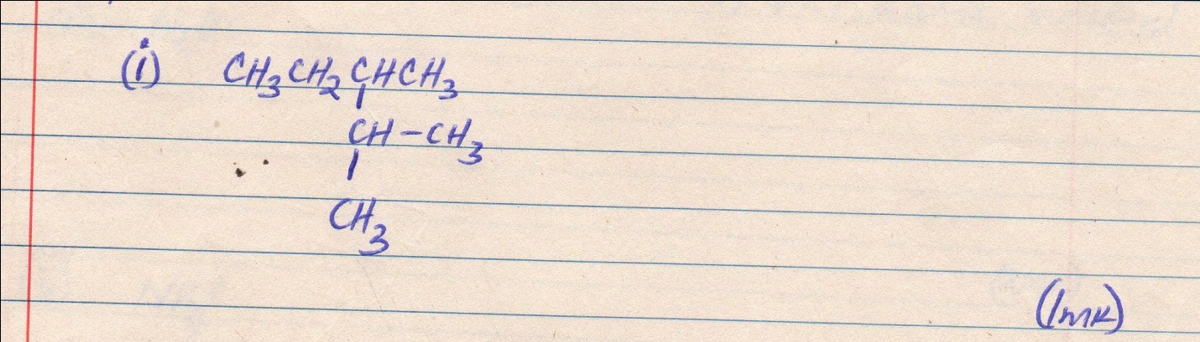
- Give the IUPAC names of the following organic compounds

(ii) CH₃CCCH₃ (1mk)

- Aqueous ammonia was added to Copper(ii)Sulphate solution drop wise until in excess.
- What observations were made? (1 mk)

- Write down the equations representing the observation mentioned above
(2 mk)

- a) State Gay-Lussac’s law (1 mk)

b) 10 cm³ of gaseous hydrogen carbon C₂H_{x} required 30 cm³ of oxygen for combustion.
If 1 mole of steam and 20 cm³ of Carbon(iv)Oxide were produced, what is the value of X (3mk)

- Using electrons in the outermost energy level, draw the dot ( ) and cross (× ) diagrams for the molecule of H₂O and (H = 1, O=8, N=7 atomic number)

- H₂O (2 mks)

- NH₄⁺ (2 mks)

- Bottles of Sodium carbonate, Sodium chloride and sugar have lost their labels. A student prepares and tests an aqeous solution of a sample from each bottle. The results obtained are as follows in the table below. Complete the table by filling the current label for each bottle.(3mks)
Bottle PH Electrical conductivity correct label
1 7 Conducts __________
2 7 Does not conduct __________
3 10 Conducts ___________

- a). Name two major components of air ( 2 mks)

b). Write an equation for the reaction that would take place when each of the components of air in (a) is passed over-heated magnesium. (2 mks)

- What is an amphoteric substances (1 mk)

- A student wanted to prepare Lead(II)Sulphate in the laboratory. He reacted Lead metal with dilute Sulphur(vi)acid.
- Give a reason why he did not succeed. (1 mk)

- Describe a suitable method he would use in order to prepare the salt above starting with Lead metal. (3 mks)

- With the help of a well labeled diagram, draw a set-up of an arrangement of assembled apparatus that can be used to prepare dry hydrogen gas including the appropriate reagents. (3 mks)

- a). Define the term allotropy (1 mk)

b). Sulphur has two allotropes; name them (2mks)

c). what is transition temperature (1 mk)

