NAME _____________________________________ ADM NO. _________
CLASS ____________________________________ DATE _____________

231/2
FORM III
2 HOURS
END TERM 3 2026
BIOLOGY PAPER 2

INSTRUCTIONS

Answer ALL questions in section A in the spaces provided.
In section B, answer question 6 (compulsory) and either Q7 or 8 in the space provided after question 8.

FOR OFFICIAL USE ONLY.

SECTION | QUESTION | MARKS | CANDIDATE’S SCORE
A | 1 | 08
A | 2 | 08
A | 3 | 08
A | 4 | 08
A | 5 | 08
B | 6 | 20
B | 7 | 20
B | 8 | 20
TOTAL MARKS |  | 80

SECTION A: Answer ALL questions in this section.

Q1. Study the diagram below and answer the questions that follow.

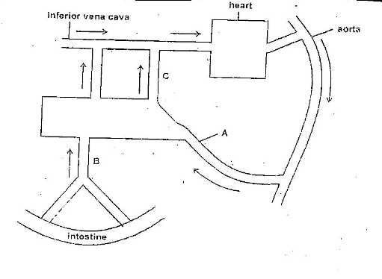
- Name the blood vessels labeled A, B and C. (3 mks)
A …………………………………………………………………
B …………………………………………………………………
C …………………………………………………………………
- If the animals had recently fed on a diet which is rich in proteins and carbohydrates, in which of the vessels labeled A, B and C would you expect to find the highest concentration of:
- Glucose ………………………………………………….. (1 mk)
- Amino acids …………………………………………. (1 mk)
- Urea ………………………………………………….. (1 mk)

- During starvation, the level of blood glucose in vessel C may be higher than the level in vessel B. Explain. (2 mks)
……………………………………………………………………………………………………………………………………………………………………………………………………………………………………………………………………………………………………………………………………………………………………………………………..

- The diagram below represents a longitudinal section of a maize grain.

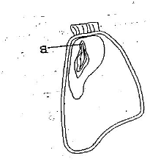

- On the diagram label endosperm and coleoptile. (2 mks)

- Shade the region that would stain blue black with iodine solution. (1 mk)
- Give a reason for your answer in b(i) above. (1 mk)
……………………………………………………………………………………………………………………………………………………………………………….
- Give a reason why maize is a fruit and not a seed. (1 mk)
……………………………………………………………………………………………………………………………………………………………………………………………….
- State the function of the part labeled B. (1 mk)
……………………………………………………………………………………………….
- What is the role of the following in germination
- Hypocotyl in epigeal germination. (1 mk)
……………………………………………………………………………………….

- Oxygen (1 mk)
………………………………………………………………………………………
- The following experiment was set up by form one students and left to stand for one hour.

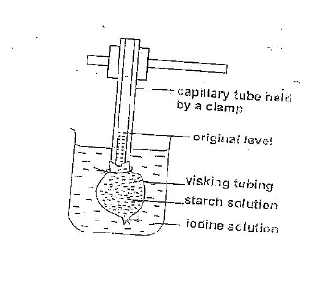
- Which physiological process was being investigated? (1 mk)

…………………………………………………………………………………………….

- What observation would you make after one hour? (2 mks)
……………………………………………………………………………………………………………………………………………………………………………………………………………………………………………………………………………………………..

- If the starch solution was replaced by 10% sucrose solution and the iodine solution replaced by distilled water, what observation would you make. (1 mk)
………………………………………………………………………………………………………………………………………………………………………………
- Account for your observation in b(i) above. (2 mks)
……………………………………………………………………………………………………………………………………………………………………………………………………………………………………………………………………….

- Explain the following:
- Osmotic pressure (1 mk)
……………………………………………………………………………………………………………………………………………………………………………….
- Osmotic potential (1 mk)
……………………………………………………………………………………………………………………………………………………………………………….

- State two ways in which the heart responds to a strenuous exercise. (2 mks)
……………………………………………………………………………………………………………………………………………………………………………………………….
- Give a reason why accumulation of lactic acid during vigorous exercise leads to increase the heartbeat. (2 mks)
………………………………………………………………………………………………………………………………………………………………………………………………
- Below is a diagram of an organelle that is involved in aerobic respiration.

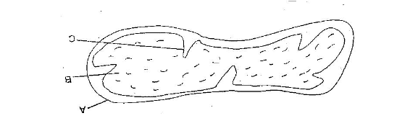

- Name the cell organelle. (1 mk)

…………………………………………………………………………………..
- Name the part labeled B. (1 mk)

………………………………………………………………………………………
- What is the purpose of the folding of part labeled C? (1 mk)
……………………………………………………………………………………………………………………………………………………………………………..
- Name the chemical compound which stores the immediate energy product in the cell. (1 mk)

……………………………………………………………………………………..

- Write three advantages of breathing through the nose than through the mouth. (3 mks)
………………………………………………………………………………………………………………………………………………………………………………………………………………………………………………………………………………………………
- Name the causative agents of the following respiratory diseases.
- Pneumonia (1 mk)

……………………………………………………………………………………
- Whooping cough (1 mk)

……………………………………………………………………………………..
- Asthma (1 mk)

………………………………………………………………………………………
- Give a reason why its not advisable to sleep in a partly ventilated room at night with many potted plants. (2 mks)
………………………………………………………………………………………………………………………………………………………………………………………………………………………………………………………………………………………………

SECTION B
Answer question 6 (compulsory) and either question 7 or 8 in the spaces provided after question 8.

- The glucose level in mg/100ml of blood of three people A, B and C who had been fasting for 12 hours was determined. The people were fed on equal amounts of glucose and the level of glucose was determined at 10 minutes intervals for two hours. The results obtained were as shown in the table.

Time in minutes |  | 0 | 10 | 20 | 30 | 40 | 50 | 60 | 70 | 80 | 90 | 100 | 110 | 120
Conc. Of blood glucose in mg/100 ml | A | 95 | 108 | 121 | 136 | 160 | 192 | 200 | 193 | 165 | 133 | 124 | 119 | 115
Conc. Of blood glucose in mg/100 ml | B | 146 | 155 | 162 | 168 | 172 | 175 | 176 | 175 | 173 | 171 | 168 | 166 | 164
Conc. Of blood glucose in mg/100 ml | C | 92 | 102 | 110 | 116 | 120 | 121 | 120 | 117 | 110 | 105 | 98 | 92 | 84

- On the grid provided and using the same axis, plot graphs showing glucose concentration of persons A, B and C against time. (6 mks)

- What idea is illustrated by the result shown in the table above? (1 mk)

…………………………………………………………………………………………….

- Explain the change in glucose level in person C.
During the first 30 minutes. (2mks)
………………………………………………………………………………………………………………………………………………………………………………………………………………………………………………………………………
- Between 60 and 90 minutes (3mks)
………………………………………………………………………………………………………………………………………………………………………………………………………………………………………………………………………………………………………………………………………………………………
- The level of blood glucose after 120 minutes increased in person C. Suggest a reason for the increase. (2 mks)
……………………………………………………………………………………………………………………………………………………………………………………………………………………………………………………………………………………………….

- Suggest a reason for high blood sugar level in person B. (1 mk)
………………………………………………………………………………………………………………………………………………………………………………
- How can the high blood sugar level in person B be controlled? (1 mk)
………………………………………………………………………………………………………………………………………………………………………………
- With a reason, suggest the diet you would administer to person B. (2 mks)
……………………………………………………………………………………………………………………………………………………………………………………………………………………………………………………………………….
- Other than the process investigated above, name two other processes in the human body in which homeostasis is involved. (2 mks)
………………………………………………………………………………………………………………………………………………………………………………………………………………………………………………………………………………………………………………………………………………………………………………………………

- Explain the difference between excretion and egestion. (2 mks)
- Describe the process of excretion in the kidney. (14 mks)
- State four adaptations of the kidney to its functions. (4 mks)
- Discuss the role of hormones in the reproduction of human beings. (20 mks)

