NAME _____________________________________ ADM NO. _________
CLASS ____________________________________ DATE _____________

231/1
FORM III
2 HOURS
END TERM 3 2026
BIOLOGY PAPER 2

INSTRUCTIONS

Answer ALL questions in section A in the spaces provided. BIOLOGY PAPER 1

- State the function of the following cell organelles. (3 mks)
- Ribosome

- Nucleolus

- Centriole

- State two ways in which the guard cell is adapted to its function. (2mks)

- Explain what happens when there is excess glucose in the human blood. (4 mks)

- Name the causative agents of the following human diseases. (3 mks)
- Whooping cough

- Typhoid

- Cholera

- Observe carefully the experimental set up below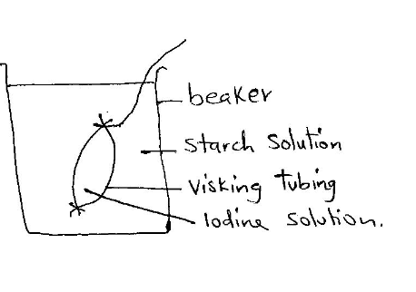
i)What process was being demonstrated? (1 mk)

ii) State two observations that were made. (2mks)

iii) Explain the observation above (2mks)

- What was the aim of the experiment? (1mk)

- a) What is photolysis? (1mk)

b) Name the organelle where the processes in (a) above occurs (1mk)

- State the major role of the following hormones in a human female.
- Luteinising hormone (1mk)

- Progesterone (1mk)

- Oxytocin (1mk)

- List three unique characteristics of members of the class crustacea (3 mks)

- Describe double fertilization in flowering plants (4mks)

- The diagram below shows a section of a root

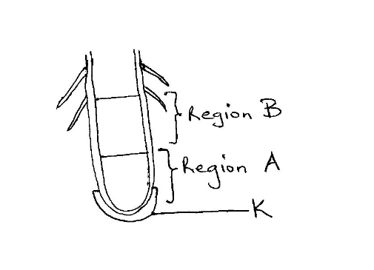

- Name regions A and B (2mks)
A……………………………………..
B……………………………………..
- List two characteristics of cells in region A (2mks)

- State the function of the part labeled k (1mk)

- State the differences between the products aerobic and anaerobic respiration. (2mks)

- Study the diagram below
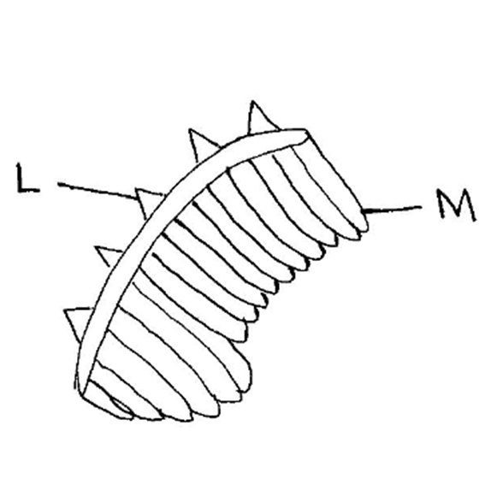

- Name the gaseous exchange structure (1mk)

- Name Parts M and L (2mks)
M…………………………………………………..
L…………………………………………………….
- A form two class set up the following experiment.

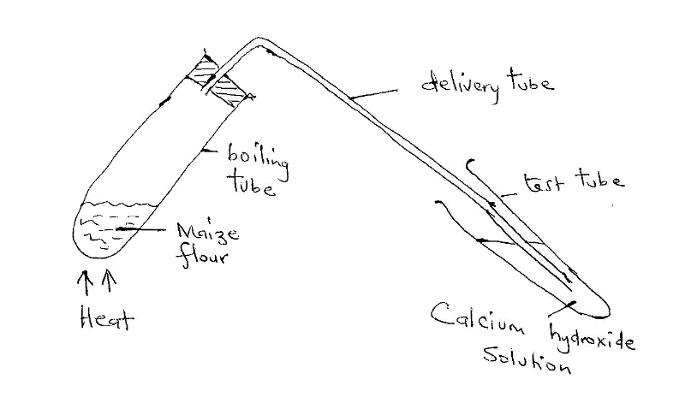

- State two observations made in the boiling tube. (2mks)
- State two observations made in the test tube. (2mks)

- State two aims of the experiment. (2mks)

- Name the study of :- (3mks)
- Birds

- Insects

- Environment

- Study the organism below.

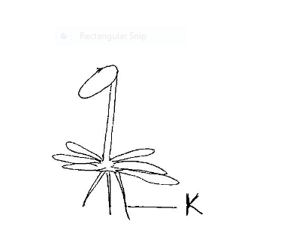

- Classify it into kingdom and division. (2mks)

- State two roles of the structure labeled k. (2mks)

- List three roles of water in seed germination. (3mks)

- a) Differentiate primary and secondary growth. (1mk)

b) Differentiate growth from development. (1mk)

- Define the following terms.
- Population (1mk)

- Community (1mk)

- Biomas (1mk)

- a)Name three disaccharides (3mks)

b) State two major differences between disaccharides and polysaccharides. (2mks)

- State three adaptations of a villus in ileum to its function. (3mks)

- What is fertilization? (1mk)

- Some form two students removed the bark of a young plant stem as follows.
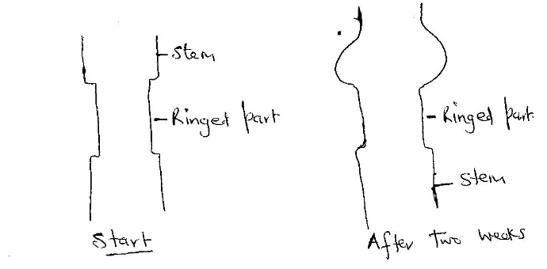
- What was the aim? (1mk)

- Explain the results after two weeks (2mks)

- List THREE major differences between mitosis and meiosis. (3mks)

- Why is the red blood cell biconcave? (1mk)

- A form one student observed 5 onion cells across the diameter of a field of view of 2mm in a light microscope. Calculate the size of one cell in micrometers. (2mks)

- Name the reagent used when testing for reducing sugar. (1mk)

