NAME________________________________________ADM. NO________ CLASS________
231/3
Biology Practical
Paper 3
Time: 1 ¾ Hours
END TERM 3 2026
Instructions to Candidates
- Answer all questions
- You are required to spend the first 15 minutes of the 1 ¾ Hours allowed for this paper reading the whole paper carefully before commencing your work.
For Examiners Use Only
Question | Maximum Score | Candidate’s Score
1 | 15
2 | 10
3 | 15
Total Score | 40

- You are provided with specimen M. Half fill it with distilled water, shake and make a suspension.
- Using the reagents provided carry out food test on the suspension of specimen M. (9 marks)
Food | Procedure | Observation | Conclusion

- With a reason explain why specimen M is good for a growing child (2 marks)

- Based on observation above, name an excretory product other than gaseous that would be produced if M is consumed in excess by man. Explain your answer.
- Excretory product (1 mark)

- Reason (1 mark)

- Name two enzymes that are used to digest the food substance present in M. (2 mark)

- Below are photographs of specimens. Examine them;
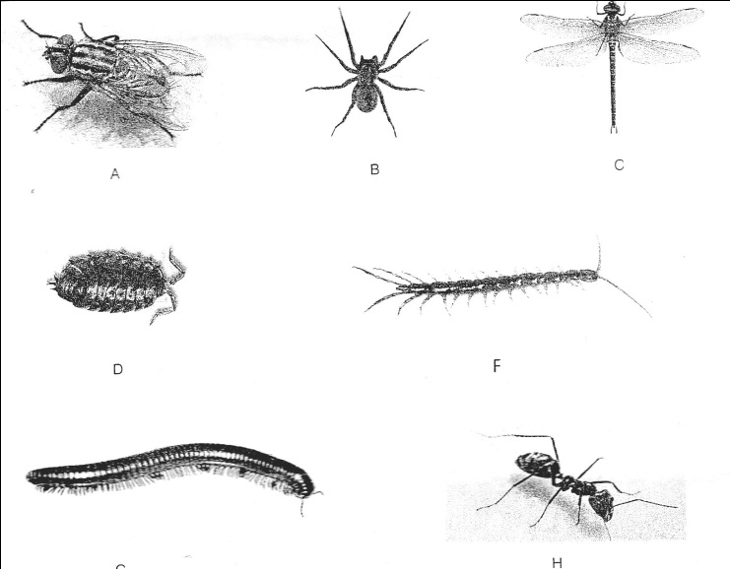
G

Use the dichotomous key below to identify the above specimens;

- (a) Animal with wings………………………………………..go to 2
(b) Animal without wings…………………………………….go to 3
- (a) With one pair of wings ………………………………….Housefly
(b) With two pairs of wings …………………………….....Dragonfly
- (a) With three pairs of legs……………………………………….Ant
(b) With more than 3 pairs of legs……………………………go to 4
- (a) With four pairs of legs …………………………………….Spider
(b) With more than four pairs of legs………….........................go to 5
- (a) With two pairs of antennae………………………………...go to 6
(b) With one pair of antennae…………………………….……go to 7
- (a) With six pairs of legs……………………………….....Water skater
(b) With ten pairs of legs ………………………….Fresh water shrimp
- (a) With a cylindrical body………………………...................Millipede
(b) With a dorso-ventrally flattened body…………………....Centipede

a) Identify the steps followed and then identify of the specimen. (7 marks)
Specimen | Steps | Identity
A
B
C
D
E
F
G
H

b) Name the phylum in which all the above organisms belong to (1 mark)

c) Identify the class to which organism F belong to (1 mark) (1 mark)

- Give a reason for your answer in (c) above (1mark)

- The photographs shown below are organisms found in the ecosystem.
Examine them and answer the questions that follow.

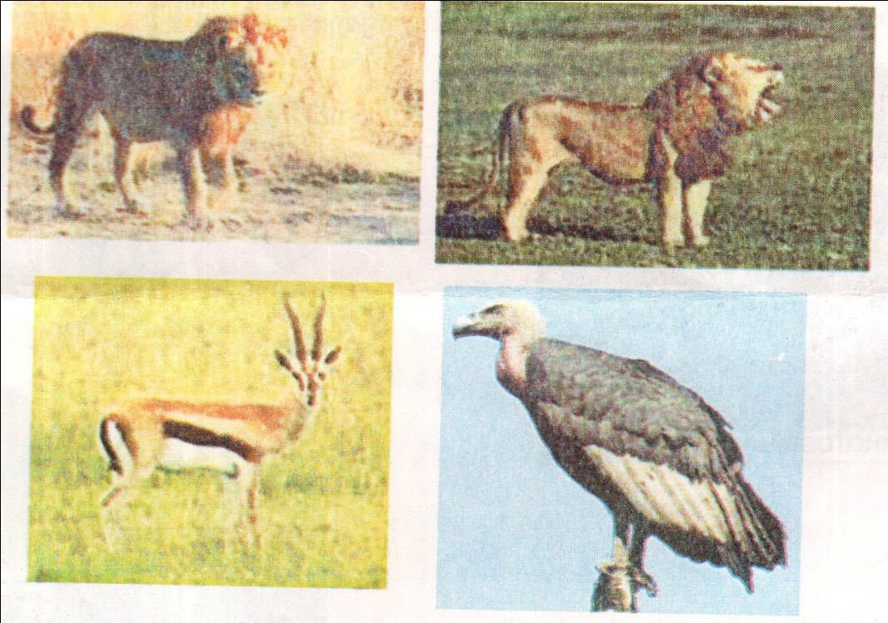
- Name the ecosystem in which the organisms are found? (1 mark)

- Name three abiotic factors that affect the distribution of the organisms in the photographs. (3 marks)

- i) Construct a food chain involving the organisms in the above ecosystem. (1 mark)

ii) Identify the trophic levels occupied by the following organisms. (2 marks)
- Gazelle

- Grass

c) Draw a pyramid of biomass for the three organisms in the ecosystem. (3 marks)

d) What name is given to the feeding interrelationship between the gazelle and the lion? (1 mark)

e) Name two observable adaptive features of the vulture to its mode of feeding. (4 marks)

