NAME..................................................................................... ADM NO......................
443/2
AGRICULTURE
PAPER 2
END TERM 3 2026
TIME: 2 HOURS

INSTRUCTIONS TO CANDIDATES:
- Write your name and index number in the spaces provided.
- Sign and write the date of examination in the spaces provided
- This paper consists of three section A, B and C
- Answer all questions in section A and B
- Answer two questions in section C.

FOR OFFICIAL USE ONLY
SECTION | QUESTIONS | MAX SCORE | CANDIDATES SCORE
A | 1-20 | 30
B | 21-25 | 20
C | 26 | 20
C | 27 | 20
C | 28 | 20
TOTAL |  | 90

Section a (30marks )
Attempt all questions in this section in the spaces provided
- Name two types of roughages. (1mk)
------------------------------------------------------------------------------------------------------------------------------------------------------------------------------------------------------------------------------------------------------------------------------------------------------------------------------------
- Give two reasons for docking in sheep rearing. (1mk)
------------------------------------------------------------------------------------------------------------------------------------------------------------------------------------------------------------------------------------------------------------------------------------------------------------------------------------

- Name the tools used for the following management practices in livestock.
- Deworming animals (¹/₂ mk)
--------------------------------------------------------------------------------------------------------------------------------------------------------------------------------------------------------------------------------------------------------------------------------------------------------------------
- Ear notching (¹/₂mk)
-----------------------------------------------------------------------------------------------------------------------------------------------------------------------------------------------------------------------------------------------------------------------------------------------------------------

- Define the following terms as used in livestock health.
- Zoonotic diseases (¹/₂mk)
------------------------------------------------------------------------------------------------------------------------------------------------------------------------------------------------------------------------------------------------------------------------------------------------------------------------------------

- Predisposing factors (¹/₂mk)
------------------------------------------------------------------------------------------------------------------------------------------------------------------------------------------------------------------------------------------------------------------------------------------------------------------------------------

- List four economic importance of internal parasites in livestock. (2mks)
------------------------------------------------------------------------------------------------------------------------------------------------------------------------------------------------------------------------------------------------------------------------------------------------------------------------------------------------------------------------------------------------------------------------------------------------------------------------------------------------------------------------------------------------------------
- Name two qualities of concrete which make it suitable for construction of farm building. (1mk)
------------------------------------------------------------------------------------------------------------------------------------------------------------------------------------------------------------------------------------------------------------------------------------------------------------------------------------

- Distinguish mothering ability and prolificacy as used in livestock.
- Mothering ability (¹/₂mk)
------------------------------------------------------------------------------------------------------------------------------------------------------------------------------------------------------------------------------------------------------------------------------------------------------------------------------------

- Prolificacy (¹/₂mk)
------------------------------------------------------------------------------------------------------------------------------------------------------------------------------------------------------------------------------------------------------------------------------------------------------------------------------------

- State two advantages of using wood in farm building. (1mk)
------------------------------------------------------------------------------------------------------------------------------------------------------------------------------------------------------------------------------------------------------------------------------------------------------------------------------------

- State three differences between dromedary and bacteria camel. (1¹/₂mks)
------------------------------------------------------------------------------------------------------------------------------------------------------------------------------------------------------------------------------------------------------------------------------------------------------------------------------------
- What do the figures in the ration 1:2:4 stand for in construction. (1¹/₂mks)
------------------------------------------------------------------------------------------------------------------------------------------------------------------------------------------------------------------------------------------------------------------------------------------------------------------------------------

- State the appropriate use of each of the following farm tool. (1mk)
- Stock and die
------------------------------------------------------------------------------------------------------------------------------------------------------------------------------------------------------------------------------------------------------------------------------------------------------------------------------------
- Oil stone
------------------------------------------------------------------------------------------------------------------------------------------------------------------------------------------------------------------------------------------------------------------------------------------------------------------------------------

- State the use of the P.V.C sheet when laying a foundation of a farm structure. (1mk)
------------------------------------------------------------------------------------------------------------------------------------------------------------------------------------------------------------------------------------------------------------------------------------------------------------------------------------

- Name three methods of applying acaricides on livestock. (1¹/₂ mks)
------------------------------------------------------------------------------------------------------------------------------------------------------------------------------------------------------------------------------------------------------------------------------------------------------------------------------------

- What should be done to a ram during the mating season to enable a farmer to identify the ewes it has mated? (1mk)
------------------------------------------------------------------------------------------------------------------------------------------------------------------------------------------------------------------------------------------------------------------------------------------------------------------------------------

- Give the meaning of the following terms as used in livestock health. (2mks)
- Mortality
------------------------------------------------------------------------------------------------------------------------------------------------------------------------------------------------------------------------------------------------------------------------------------------------------------------------------------

- Incubation period
------------------------------------------------------------------------------------------------------------------------------------------------------------------------------------------------------------------------------------------------------------------------------------------------------------------------------------

- Name two recommended methods of identifying goats. (1mk)
------------------------------------------------------------------------------------------------------------------------------------------------------------------------------------------------------------------------------------------------------------------------------------------------------------------------------------------------

- Identify two methods used in castration of cocks. (1mk)
------------------------------------------------------------------------------------------------------------------------------------------------------------------------------------------------------------------------------------------------------------------------------------------------------------------------------------

- Outline four advantages of Kenya Top Bar Hive over the Log hive. (2mks)
------------------------------------------------------------------------------------------------------------------------------------------------------------------------------------------------------------------------------------------------------------------------------------------------------------------------------------

- State two functions of the crop in the digestive system of a hen. (1mk)
------------------------------------------------------------------------------------------------------------------------------------------------------------------------------------------------------------------------------------------------------------------------------------------------------------------------------------

- What is the significance of microbial activities in the rumen? (2mks)
------------------------------------------------------------------------------------------------------------------------------------------------------------------------------------------------------------------------------------------------------------------------------------------------------------------------------------

- State six methods a farmer can use to control livestock diseases. (3mks)
------------------------------------------------------------------------------------------------------------------------------------------------------------------------------------------------------------------------------------------------------------------------------------------------------------------------------------

- Name four method s of dehorning . (2mks)
------------------------------------------------------------------------------------------------------------------------------------------------------------------------------------------------------------------------------------------------------------------------------------------------------------------------------------

- State the gestation period for a cow. (¹/₂mks)
------------------------------------------------------------------------------------------------------------------------------------------------------------------------------------------------------------------------------------------------------------------------------------------------------------------------------------

Section b (20mks)
Answer all the questions in this section in the spaces provided.
- The diagrams below represent farm tools and equipment.
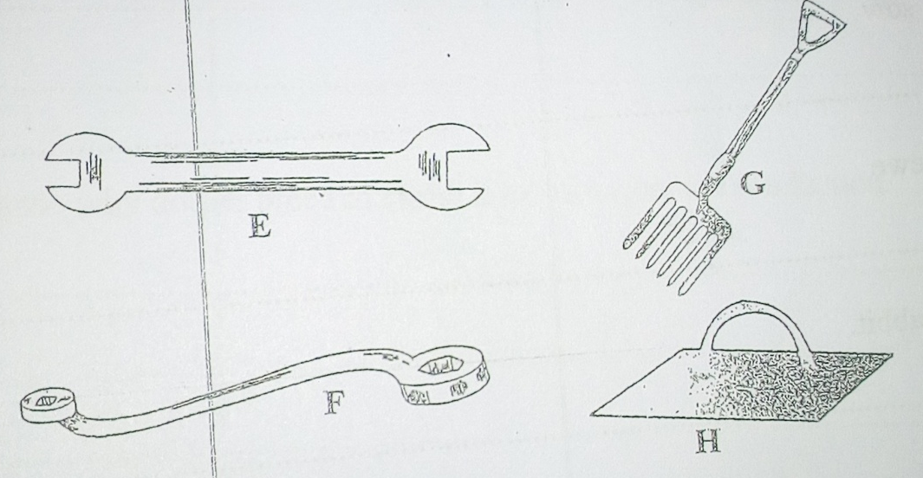

- Identify the tools E and F.
E ------------------------------------------------------------- (1mk)

F -------------------------------------------------------------- (1mk)

- State one use of each of the tools labelled F and G.

F ---------------------------------------------------------------------------------------------(1mk)

G ---------------------------------------------------------------------------------------------(1mk)

- State one advantage the tool labelled F has over E. (1mk)

- Study the diagrams and answer the questions that follow:-

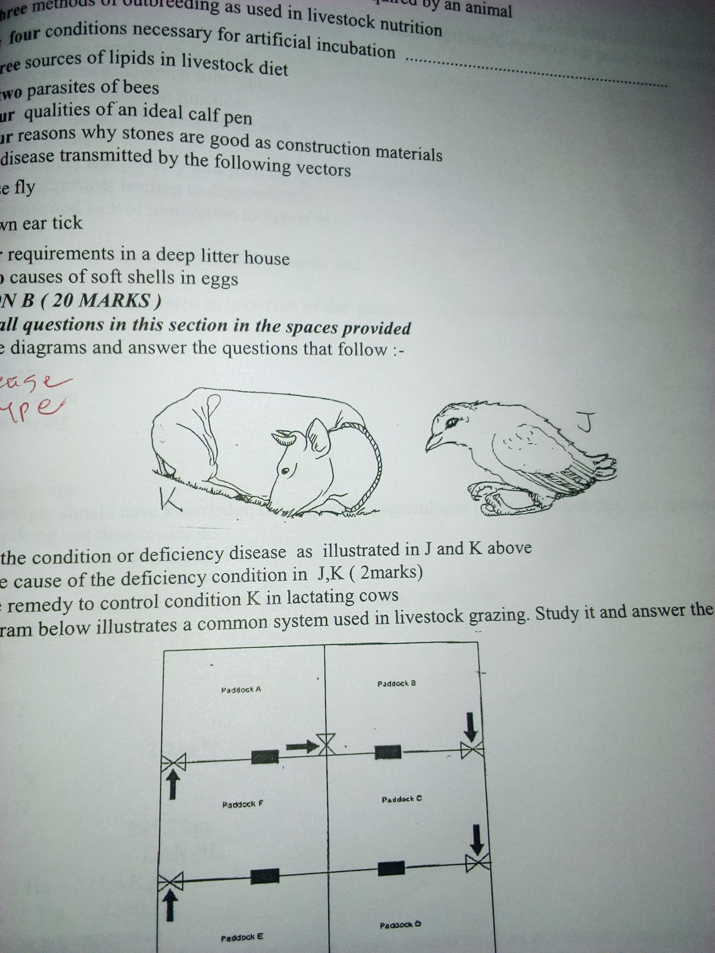

- Identify the condition or deficiency disease as illustrated in J and K above. (2mks)
------------------------------------------------------------------------------------------------------------------------------------------------------------------------------------------------------------------------------------------------------------------------------------------------------------------------------------

- Name the cause of the deficiency condition in J, K. (2mks)
------------------------------------------------------------------------------------------------------------------------------------------------------------------------------------------------------------------------------------------------------------------------------------------------------------------------------------

- Give one way to control condition K in lactating cows. (1mk)
------------------------------------------------------------------------------------------------------------------------------------------------------------------------------------------------------------------------------------------------------------------------------------------------------------------------------------

- Below is a diagram of a farm structure.

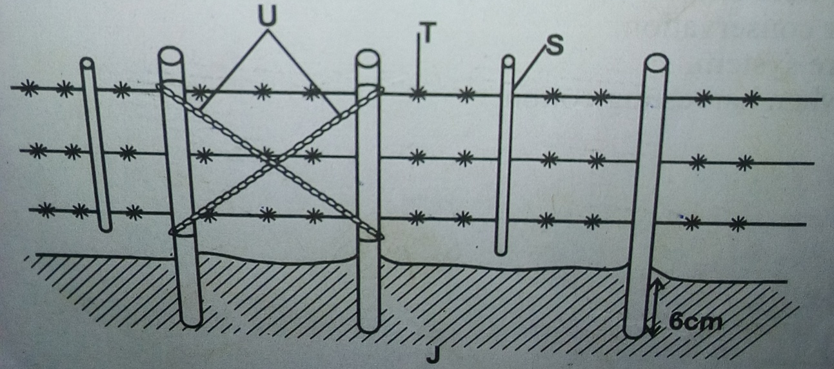

- Identify the structure J. (1mk)
------------------------------------------------------------------------------------------------------------------------------------------------------------------------------------------------------------------------
- Identify the parts labelled S,T and U (3mks)
---------------------------------------------------------------------------------------------------------------------------------------------------------------------------------------------------------------------------------------------------------------------------------------------------------------------
- State the functions of the parts labelled S and U (2mks)
---------------------------------------------------------------------------------------------------------------------------------------------------------------------------------------------------------------------------------------------------------------------------------------------------------------------

- A dairy farmer is required to prepare 100kg of dairy meal containing 20% digestive crude protein (DCP). Using Pearson’s method, calculate the quantity of soya bean (40% DCP) and maize (16% DCP) the farmer require for the dairy meal. (4mk)
------------------------------------------------------------------------------------------------------------------------------------------------------------------------------------------------------------------------------------------------------------------------------------------------------------------------------------------------------------------------------------------------------------------------------------------------------------------------------------------------------------------------------------------------------------------------------------------------------------------------------------------------------------------------------------------------------------------------------------------------------------------------------------------------------------------------------------------------------------------------------------------------------------------------------------------------------------------------------------------------------------------------------------------------------------------------------------------------------------------------------------------------------------------------------------------------------------------------------------------------------------------------------------------------------------------------------------------------------------------------------------------------------------------------------------------------------------------------------------------------------------------------------------------------------------------------------------------------------------------------------------------------------------------------------------------------------------------------------------------------

Section C (40 mks)
Answer any two questions in this section in the spaces provided.

- State five indicators that can be observed on a goat to confirm sickness. (5mks)
- Explain the maintenance practices of a cattle dip. (5mks)
- Explain the procedure for harvesting honey from Kenya Top Bar hive. (10mks)

- Describe six factors to consider when siting farm structure. (6mks)

- Discuss fish farming in a fish pond under the following sub headings.
- Stocking the pond. (4mks)
- Feeding the fish. (4mks)
- Harvesting fish (3mks)
- Outline precautions observed when using tools and equipments. (3mks)

- Explain eight ways in which ticks can be controlled on a livestock farm. (8mks)
- Describe the body conformation of a dairy cow. (4mks)
- State five disadvantages of natural method of mating. (5mks)
- Give three differences in digestion process between a ruminant and
Non-ruminant. (3mks)

