NAME…………………….....................SCHOOL…………………ADM NO…………
443/1
AGRICULTURE
FORM 3
END TERM 3 2026
PAPER 1
TIME: 2 HOURS
INSTRUCTIONS TO CANDIDATES:
- Write your name and index number in the spaces provided.
- Sign and write the date of examination in the spaces provided
- This paper consists of three section A, B and C
- Answer all questions in section A and B
- Answer two questions in section C.
FOR OFFICIAL USE ONLY
SECTION | QUESTIONS | MAX SCORE | CANDIDATES SCORE
A | 1-17 | 30
B | 18-21 | 20
C | 22 | 20
C | 23 | 20
C | 24 | 20
TOTAL |  | 90

SECTION A 30 MARKS (ANSWER ALL QUESTIONS)
1 .Define the term domestication as used in Agriculture (1mark) _____________________________________________________________________________________________________________________________________________________________________________________________________________________________________________________________________________________________________________________________________________
2. List four disadvantages of shifting cultivation. (2 marks)
__________________________________________________________________________________________________________________________________________________________________________________________________________________________________________________________________________________________________________________________________________________________________________________________________________________________________________________________________________________________________________________________________________________________________
3. State three disadvantages of burning as a method of bush clearing (1 ½ marks)
____________________________________________________________________________________________________________________________________________________________________________________________________________________________________________________________________________________________________________________________________________________________________________________________________________________________________________________________________________________
4.List four factors that determine the number of secondary cultivation operations carried out in a seedbed before planting (2marks)
______________________________________________________________________________________________________________________________________________________________________________________________________________________________________________________________________________________________________________________________________________________________________________________________________
5.state two maintenance practices done on sprinklers used for overhead irrigation. ( ½*2=1)
_______________________________________________________________________________________________________________________________________________________________________________________________________________________________________________________________________________________________________________________

6.state four importance of drainage before establishing a crop in water logged soil {2marks)
____________________________________________________________________________________________________________________________________________________________________________________________________________________________________________________________________________________________________________________________________________________________________________________________________________________________________________________________________________________
7.state four factors that influence the choice of crops used for green manure (2marks)
____________________________________________________________________________________________________________________________________________________________________________________________________________________________________________________________________________________________________________________________________________________________________________________________________________________________________________________________________________________
8.list four importance of farm records (2marks)
______________________________________________________________________________________________________________________________________________________________________________________________________________________________________________________________________________________________________________________________________________________________________________________________________
9.state four factors that influence the choice of inorganic fertilizer used during crop production (2marks)
________________________________________________________________________________________________________________________________________________________________________________________________________________________________________________________________________________________________________________________________________________________________________________________________________________________________________________________________________________________________________________________________________________________________________________________________________________________________________________
10.state four conditions when seed rate used is usually high (2marks)
_________________________________________________________________________________________________________________________________________________________________________________________________________________________________________________________________________________________________________________________________________________________________________________________________________________________________________________________________________________________________________________________________________________________________
11.list four practices that ensure uniform germination of seeds in crop establishment (2marks)
___________________________________________________________________________________________________________________________________________________________________________________________________________________________________________________________________________________________________________________________________________________________________________________________________________________________________________________________________________________
12.state four conditions that would allow planting seeds deeper in the soil (2marks)
____________________________________________________________________________________________________________________________________________________________________________________________________________________________________________________________________________________________________________________________________________________________________________________________________________________________________________________________________________________
13.Name two ways of treating seed potatoes before planting (2marks)
________________________________________________________________________________________________________________________________________________________________________________________________________________________________________________________________________________________________________________________
______________________________________________________________________________

14.state four reasons for the selection of a nursery site (2marks)
____________________________________________________________________________________________________________________________________________________________________________________________________________________________________________________________________________________________________________________________________________________________________________________________________________________________________________________________________________________
15.Outline four reasons for grafting in citrus trees (2 marks)
___________________________________________________________________________________________________________________________________________________________________________________________________________________________________________________________________________________________________________________________________________________________________________________________________________________________________________________________________________________
16.state four management practices carried out on tree seedlings after transplanting(
___________________________________________________________________________________________________________________________________________________________________________________________________________________________________________________________________________________________________________________________________________________________________________________________________________________________________________________________________________________
17.Name the types of vegetables listed below
Spinach_________________________________________________ (1/2mark)
Spring onion_____________________________________________ (1/2mark)
Radish__________________________________________________ (1/2mark)
Tomatoes_______________________________________________ (1/2mark)

SECTION B (20 MARKS)ANSWER ALL THEQUESTIONS
18.The diagram below shows a farm tool,
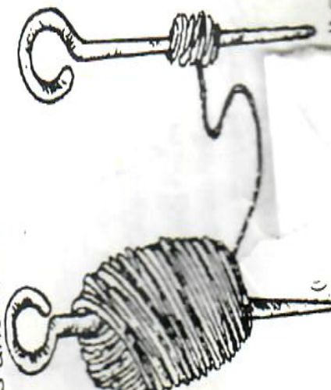

- Name the above tool 1mark)
________________________________________________________________________

- State two functions of the tool (2marks)

________________________________________________________________________________________________________________________________________________________________________________________________________________________________________________________________________________________________________________________
- state two maintenance practice carried out on the tool (1mark
____________________________________________________________________________________________________________________________________________________________________________________________________________________________________________________________________________________________________________________

19.Thediagram below illustrates a field practice, Study it carefully and answer the questions that follow

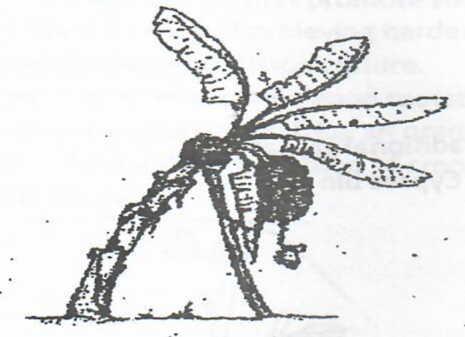
- Name the practice shown (1mark)
________________________________________________________________________
b. State two reasons for carrying out the practice (2marks)
______________________________________________________________________________________________________________________________________________________________________________________________________________________________________________________________________________________________________________________________________________________________________________________________________c. Name two similar practices carried out in crop production ( 2marks)
________________________________________________________________________________________________________________________________________________________________________________________________________________________________________________________________________________________________________________________

20.the diagram below shows a soil conservation structure
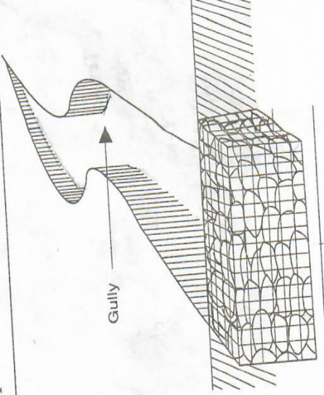

a. identify the structure above (1mark)

b. Give two importance of the structure above (2marks) ________________________________________________________________________________________________________________________________________________________________________________________________________________________________________________________________________________________________________________________
c. State two ways in which the above structure can be improved to become more efficient (2marks)
____________________________________________________________________________________________________________________________________________________________________________________________________________________________________________________________________________________________________________________________________________________________________________________________________________________________________________________________________________________

21.the diagrams below show weeds found in a field of cultivated crops labeled A and B
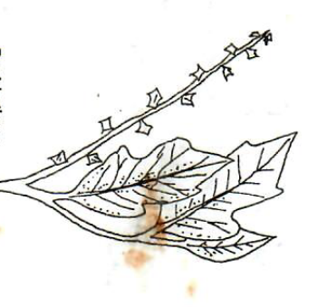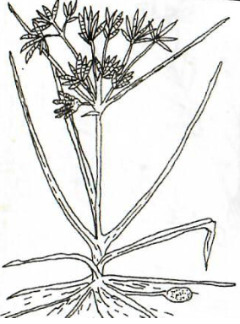
A B

a.Name weed A and B
A______________________________________________________(1mark)
B______________________________________________________(1mark)

b. State the harmful effect of the weeds
A (1mark)

B (1mark)

c.State one reason why it is difficult to control weed B (1Mark)
……………………………………………………………………………………………….
_________________________________________________________________________

SECTION C ANSWER ANY TWO QUESTIONS (40 MARKS)
22.aState and explain the importance of crop rotation (10marks)
b. State five reasons for practicing minimum tillage (5marks)
c.List five physical methods of pest control (5marks)
23a.Explain five ways through which soil losses fertility (10marks)
b.State five advantages of land consolidation in agricultural production (5marks)
c.i)Name two types of mulching materials used in crop production (2marks)
ii)State three advantages of mulching (3marks)
24.Discuss cabbage production under the following subheadings
a. I) Transplanting (6marks)
ii). Cabbage pests and their control (4marks)

b .State and explain biotic factors that affect agricultural production (10marks)

