K.J.S.E.A

JUNIOR SCHOOL EDUCATION ASSESSMENT

TERM 2: ENDTERM ASSESSMENT 2026
GRADE 9 – PRETECHNICAL STUDIES
Time: 1 Hour 30 Minutes
LEARNER’S DETAILS
Name: ________________________________________________. School: _____________________________________________________.
Assessment Number: _________________________________. Date: ______________________________________________________.
School Code: _______________________________________. Signature: _________________________________________________.

Instructions for Learners
- Write your full name and assessment number in the spaces provided above.
- Indicate your school name and school code clearly.
- Sign and date this paper in the spaces provided.
- This paper consists of TWO sections: Section A and Section B.
- Answer ALL questions in BOTH sections.
- Write your answers in the spaces provided in this question paper.
- Do NOT remove any page from this paper.
- All responses must be written in English

FOR EXAMINER’S USE
SECTION | SECTION A | SECTION B | % SCORE | EE1 | EE2 | ME1 | ME2 | AE1 | AE2 | BE1 | BE2
SCORE RANGE | 20 MARKS | 30 MARKS |  | 90-100 | 75-89 | 58-74 | 41-57 | 31-40 | 21-30 | 11-20 | 1-10
POINTS |  |  |  | 8 POINTS | 7 POINTS | 6 POINTS | 5 POINTS | 4 POINTS | 3 POINTS | 2 POINTS | 1 POINT
LEARNER’S TOTAL SCORE

SECTION A (20 MARKS) Answer ALL questions in this section

- Peter works with a construction company and often encounters various hazards.
Which of the following hazards is he NOT likely to encounter when working on raised platforms?
A. Slips and trips B. Sunburn
C. Electric hazards D. Falling objects
- Joan and Joy are preparing for a Pre-Technical drawing class. Their teacher gives them a set square.
What is the primary function of a set square in technical drawing?
A. Creating accurate circles
B. Measuring length
C. Constructing angles
D. Drawing straight lines
- The following are technical drawing lines. Identify the type of line that is correctly matched with its image.
A. Construction line B. Centre line
C. Break line D. Hidden line
- Calvince is an interior designer. How is plane geometry likely to help him improve efficiency?
A. Ensures all elements are proportionate and functional
B. Makes furniture look more modern
C. Reduces the number of items needed in a room
D. Adds more space to the room
- Brian is drawing the front view of a building as shown below.
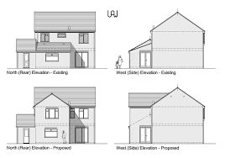
Which type of projection is most appropriate?
A. Orthographic projection
B. Perspective projection
C. Oblique projection
D. Isometric projection
- A learner wants to add shading in her drawing to create depth. Which technique is most appropriate?
A. Blending
B. Stippling
C. Pointillism
D. Cross-hatching
- A Grade 9 learner wants to draw 3D objects. What must the learner understand first?
A. Colour theory
B. Basic shapes
C. Perspective drawing
D. Shading
- Which of the following metals is most suitable for medical implants due to its biocompatibility?
A. Copper
B. Zinc
C. Aluminium
D. Titanium
- A constructor mixes sand, cement, gravel, and water. What composite material are they making?
A. Mud
B. Fiberglass
C. Concrete
D. Soda ash
- A fire broke out in a welding workshop. Which of the following is NOT a likely cause?
A. Errors caused by workers
B. Faulty electrical equipment
C. Improper storage of inflammables
D. Knowledge of handling fire
- Ivy is preparing a presentation on recycling. What is one sustainable way to use materials in production?
A. Burning waste
B. Disposing of all materials
C. Reusing or recycling materials
D. Using non-renewable resources
- During a Pre-Technical Studies lesson, learners discussed angles used in oblique projection.
Who gave the correct answer?
A. Nicole – 30° B. Marya – 45°
C. Yvonne – 60° D. James – 90°
- Lavender, a safety officer, trains workers on handling flammable materials. How does this improve safety?
A. By decreasing costs
B. By preventing accidents
C. By increasing risks
D. By promoting complacency
- Mr. Watete guided his learners on materials used in boat building. Which one is commonly used?
A. Plywood B. Fiberglass
C. Carbon fiber D. Aluminium
- Which of the following items is a product of clay?
A. Metal fork B. Wooden chair
C. Plastic bottle D. Ceramic mug
- Which of the following businesses arises from observing market trends?
A. Selling customer-suggested products
B. Transport services to remote areas
C. Opening a branch of a business
D. A plumber starting his own firm
- What is a key characteristic of an entrepreneur?
A. Avoiding risk
B. Fear of failure
C. Innovativeness and calculated risk-taking
D. Preferring routine tasks
- Identify the active source of income.
A. Wages B. Dividends C. Interest D. Rent
- What is market research?
A. Selling products in a market
B. Gathering information about customer needs
C. Advertising products
D. Managing business finances
- What does “target market” mean?
A. Group of customers a business aims to serve
B. Total global population
C. Marketing strategy
D. Business location
- Which of the following is a need a business can address?
A. New video game B. Food and shelter
C. Luxury car D. Designer clothing
- Which computer characteristic allows it to perform multiple tasks?
A. Versatility B. Speed
C. Storage capacity D. Accuracy
- What is the primary function of the CPU?
A. To store data
B. To process instructions and perform calculations
C. To display images
D. To connect to the internet
- What is the purpose of RAM in a computer?
A. Permanent data storage
B. Temporary storage of active data
C. Performing calculations
D. Displaying information
- In programming, what does syntax refer to?
A. Meaning of code
B. Rules governing code structure
C. Logic of the program
D. Design of the interface
- Which element is used to store data in Visual Basic?
A. Control
B. Variable
C. Event
D. Form
- What is an event in Visual Basic?
A. A specific user action such as a button click
B. A line of code
C. A type of variable
D. A design element
- What is the main purpose of application software?
A. To manage hardware
B. To perform specific user tasks
C. To connect networks
D. To translate code
- What is the main function of antivirus software?
A. Store data
B. Increase typing speed
C. Protect from malware
D. Improve performance
- Which of the following defines a computer?
A. A device that stores raw data
B. A device used to perform tasks and process data
C. A device that only sends messages
D. A machine used for entertainment

SECTION B: (50 MARKS)

Answer all questions in the spaces provided below
- State the difference between natural seasoning and artificial seasoning of wood. (4 marks) __________________________________________________________________________________________
__________________________________________________________________________________________
__________________________________________________________________________________________
- Explain three importance of Pre-Technical Studies in daily life. (3 marks)
i)_________________________________________________________________________________________
ii)________________________________________________________________________________________
iii)________________________________________________________________________________________
- Name three types of pliers. (3 marks)
i)_________________________________________________________________________________________
ii)________________________________________________________________________________________
iii)________________________________________________________________________________________

- The picture below shows one of the tools used for general purpose.
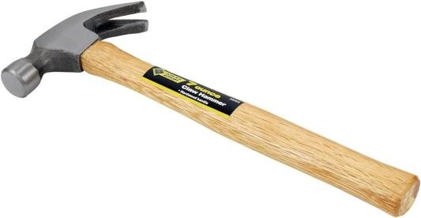
P
Q
- Identify the parts labeled P and Q (2 marks)
P _______________________________ Q _____________________________________
- State two uses of the tool. (2 marks)
(c) Mwangi has a workshop and uses the following tools
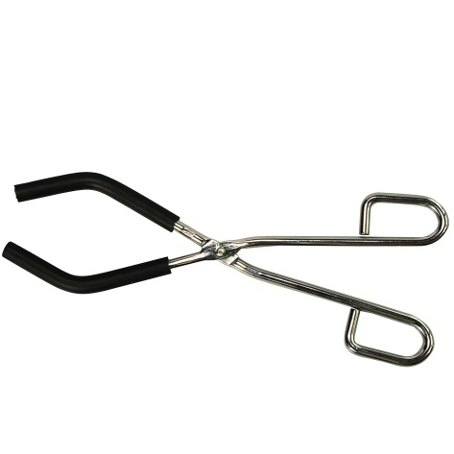
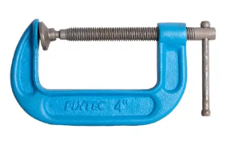
Name them

X Y
X: __________________________________________. Y: _________________________________________.
(d) List TWO tools needed to mark a circular distance on wood. (4 marks)
i)_________________________________________________________________________________________
ii)________________________________________________________________________________________
- (a) Name one safety rules when working with timber. (1 mark)
_________________________________________________________________________________________
________________________________________________________________________________________
b) Mention two hardwood trees. (3 marks)
i)_________________________________________________________________________________________
ii)________________________________________________________________________________________
- State two reasons why citizens should pay taxes. (2 marks)
i)_________________________________________________________________________________________
ii)________________________________________________________________________________________
- Give three factors to consider before starting a business. (3 marks)
i)_________________________________________________________________________________________
ii)________________________________________________________________________________________
iii)________________________________________________________________________________________
- Calculate: Precious wants to buy a motorbike worth Ksh 3,000.
She has saved Ksh 500 and earns Ksh 100 weekly.
How many weeks will it take her to buy the bike? (2 marks)

- (a) List two methods of payment in a business. (2 marks)
i)_________________________________________________________________________________________
ii)________________________________________________________________________________________
(b) John bought goods worth Ksh 25,000 and later sold them for Ksh 32,000.
Calculate the profit he made from the sale. (2 marks)

- Differentiate between short-term and long-term financial goals. (1 mark)
_________________________________________________________________________________________
__________________________________________________________________________________________
- Explain the difference between data and information. (1 mark)
_________________________________________________________________________________________
__________________________________________________________________________________________
- Match input, storage, and output devices:
(Light pen, Printer, MICR, Flash disk, Speakers, DVD) (3 marks)
Input devices | Storage devices | Output devices
- Define data privacy. (1 mark)
_________________________________________________________________________________________
__________________________________________________________________________________________
- Identify the function performed by the following keyboard shortcuts instructions. (3 marks)
Ctrl + X
Ctrl + V
Ctrl + C
Ctrl + P
- State one reason why online personal safety is important. (1 mark)
____________________________________________________________________________________________________________________________________________________________________________________
- Draw and label a data processing cycle. (3 marks)

- Explain how visual programming languages differ from text-based ones. (1 mark)
____________________________________________________________________________________________________________________________________________________________________________________
- Give two ways ICT tools can improve workplace efficiency. (2 marks)
i)_________________________________________________________________________________________
ii)________________________________________________________________________________________

THIS IS THE LAST PRINTED PAGE

