K.J.S.E.A

JUNIOR SCHOOL EDUCATION ASSESSMENT

TERM 2: ENDTERM ASSESSMENT 2026
GRADE 8 – PRETECHNICAL STUDIES
Time: 1 Hour 30 Minutes
LEARNER’S DETAILS
Name: ________________________________________________. School: _____________________________________________________.
Assessment Number: _________________________________. Date: ______________________________________________________.
School Code: _______________________________________. Signature: _________________________________________________.

Instructions for Learners
- Write your full name and assessment number in the spaces provided above.
- Indicate your school name and school code clearly.
- Sign and date this paper in the spaces provided.
- This paper consists of TWO sections: Section A and Section B.
- Answer ALL questions in BOTH sections.
- Write your answers in the spaces provided in this question paper.
- Do NOT remove any page from this paper.
- All responses must be written in English

FOR OFFICIAL USE ONLY
SECTION | SECTION A | SECTION B | % SCORE | EE1 | EE2 | ME1 | ME2 | AE1 | AE2 | BE1 | BE2
SCORE RANGE | 20 MARKS | 30 MARKS |  | 90-100 | 75-89 | 58-74 | 41-57 | 31-40 | 21-30 | 11-20 | 1-10
POINTS |  |  |  | 8 POINTS | 7 POINTS | 6 POINTS | 5 POINTS | 4 POINTS | 3 POINTS | 2 POINTS | 1 POINT
LEARNER’S TOTAL SCORE

SECTION A (20 MARKS) Answer ALL questions in this section

- Grade 7 learners were asked to carry out a research on the need to learn fire safety. They gave the following reasons. Which among them is incorrect?
A. Prevent risk of injury in both employees and customers.
B. To protect items from loss especially those that are irreplaceable.
C. To cook more food in case of fire outbreak.
D. Increase productivity because the environment is safe for working.
- Which one of the following is not a safe practice while using the internet?
A. Sharing personal information with strangers.
B. Using strong passwords.
C. Avoiding suspicious passwords.
D. Being respectful to others online.
- Grade 8 learners wanted to make a drawing of their football pitch. They suggested some ways to accurately interpret the scale they would use to draw the field. Which one of the following was not a correct way?
A. Convert measurement.
B. Identify the scale ratio used.
C. Measure distances.
D. Indicate alterations.
- Which one of the following materials is non- metallic?
A. Aluminum B. Wood C. Steel D. Iron
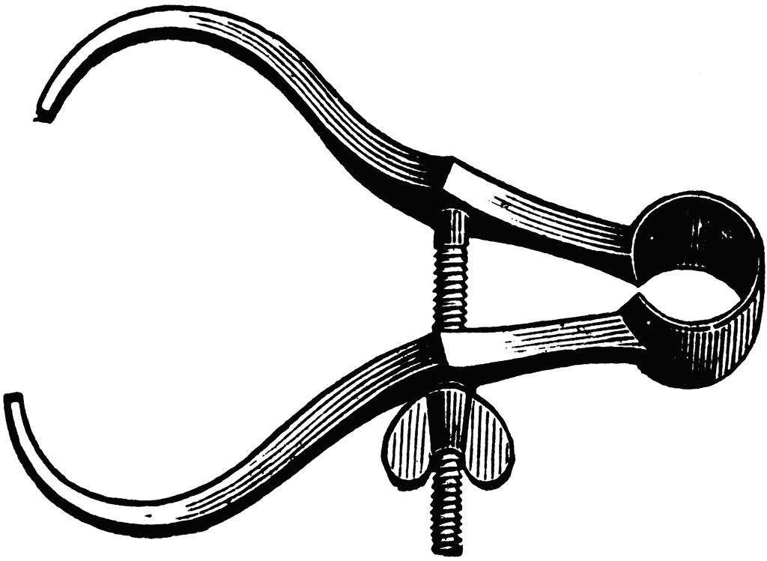
- Identify the following instrument used in drawing.

A. Compass B. Protractor C. Calliper D. Set square
- During a computer class, a teacher instructed her learners to install a software that could prevent damage of data on their computers. Which of these was it?
A. Malware software.
B. Anti-virus software.
C. Spyware software.
D. Ransomware software.
- Leila is tasked with dimensioning a circular water tank. Which measurement is crucial for her drawing? The
A. height of the tank
B. diameter of the tank
C. volume of the tank
D. shape of the tank.
- A teacher drew a fire triangle on the board. Which of the following components of fire safety did he include in the fire triangle?
A. Earth, water, air.
B. Copper, iron, oxygen.
C. Oxygen, fuel, heat.
D. Carbon dioxide, nitrogen, hydrogen.
- The tool below was used for communication in a meeting.

What is it called?
A. Emails B. Computers
C. Mobile phones D. Video conferencing
- A threat can do one of the following on a device. Which one?
A. Damage data. B. Protect information.
C. Prevent infiltration. D. Keep the data for long.
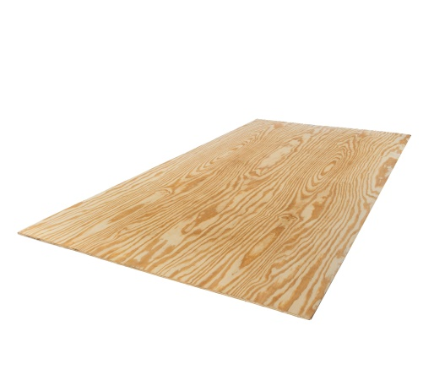
- The diagram below shows an example of a composite material commonly found in the construction sites in the locality.

Identify the composite material in the picture above.
A. Steel
B. Copper
C. Plywood
D. Concrete
- Grade 8 learners are setting up their drawing boards for an exercise. Why is it essential to include a title block in a technical drawing?
A. It provides a place to make corrections.
B. It helps in organizing and identifying the drawing.
C. It is used to draw lines.
D. It adds decoration to the drawing.
- Which one of the following items is likely made from clay?
A. Plastic water bottle B. Wooden chair
C. Ceramic mug D. Metal fork
- Merisa identified some household items in their house that contain fiberglass. Which household item could it be?
A. Wooden chair B. Plastic bottle
C. Bathtub D. Ceramic plate
- Sandpaper is one of the products made from ceramics and it is used as a cutting tool. What key characteristic makes it suitable for cutting tools?
A. High hardness B. Light weight
C. Wear resistance D. Low hardness
- Which one of the following is an example of physical threat to digital devices?
A. Installation of antivirus software.
B. Use of strong password.
C. Backing up data.
D. Damages caused by natural disasters.
- Kelvin is designing a playground and wants to explain to his classmates why accurate dimensioning is essential. What is the main reason he should highlight?
A. It makes the drawing colourful.
B. It ensures the construction meets safety standards.
C. It saves time during drawing.
D. It allows for creativity in design.
- Grade 8 learners were asked to define visual programming. Which of the following response did they give?
A. A method of programming using text-based code.
B. A method of programming using graphical elements.
C. A type of drawing software.
D. A video editing tool.
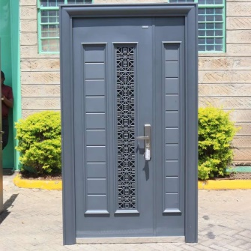
- Which one of the following is a metallic material that cab used to make the tools below?
A. Oak
B. Polyvinyl chloride
C. Iron
D. Nylon

- Grade 8 learners were taught about traditional ceramics and their examples. Which of the following is the odd one out?
A. Bone China B. Earthenware
C. Porcelain D. Stoneware

SECTION B (30 MARKS)
- A faulty electric cooker caused fire at a restaurant and caused injuries to people. Outline three types of possible injuries caused. (3 marks)
- ______________________________________________________________________________________________
- ______________________________________________________________________________________________
- ______________________________________________________________________________________________
- Stevo went to a shop and bought the following ceramic tiles.
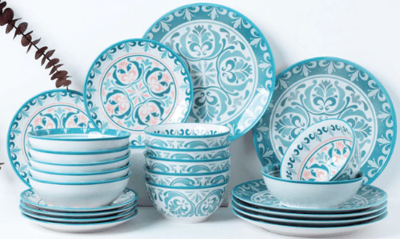
Highlight three properties of ceramic tiles he bought. (3 marks)
- ______________________________________________________________________________________________
- ______________________________________________________________________________________________
- ______________________________________________________________________________________________
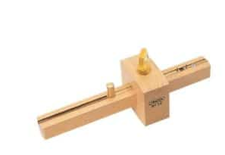
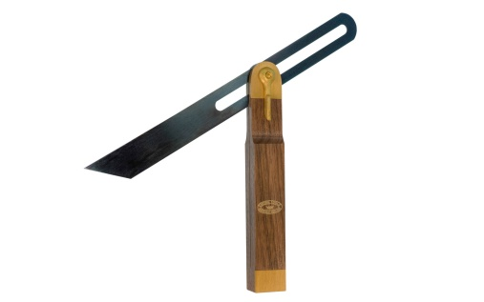
- Name the following measuring tools used in Pre-Technical Studies. (2 marks)

(a) (b)
__________________________________ ___________________________________
- State three importance of keeping financial records or book keeping. (3 marks)
- ______________________________________________________________________________________________
- ______________________________________________________________________________________________
- ______________________________________________________________________________________________
- Shankoe primary school has some essential fire safety fighting equipment in their school. Highlight three safety equipment they are likely to have. (3 marks)
- ______________________________________________________________________________________________
- ______________________________________________________________________________________________
- ______________________________________________________________________________________________
- Outline three factors to consider when choosing an application software. (3 marks)
- ______________________________________________________________________________________________
- ______________________________________________________________________________________________
- ______________________________________________________________________________________________

- During a Pre-Technical Studies lesson, grade 7 learners were asked by their teacher how they can care for cutting tools. Give two possible answers they gave. (2 marks)
- ______________________________________________________________________________________________
- ______________________________________________________________________________________________
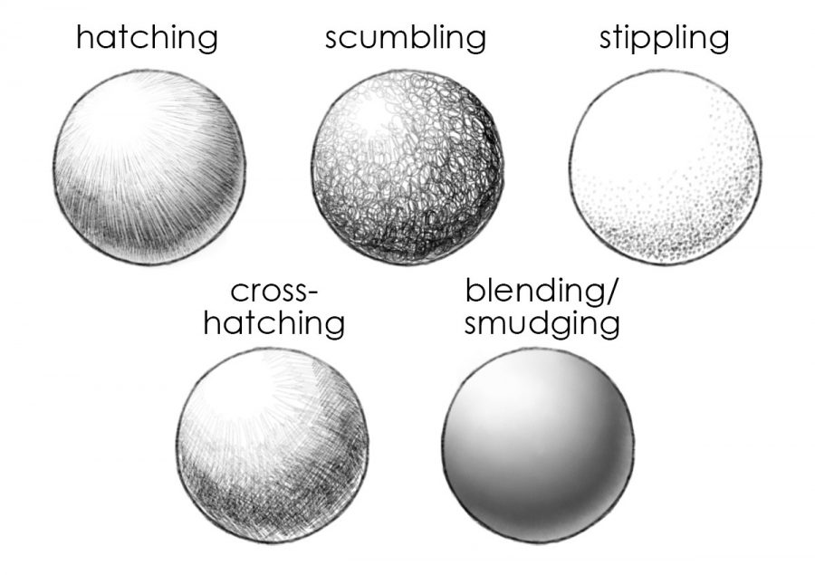
- Grade 7 learners were taught the different components of free hand sketching.

(a) (b)
Identify the ones shown in the pictures above. (2 marks)
a:________________________________ b: __________________________________
- Grade 8 learners were asked to identify the importance of visual programming. Outline three points they identified. (3 marks)
- ______________________________________________________________________________________________
- ______________________________________________________________________________________________
- ______________________________________________________________________________________________
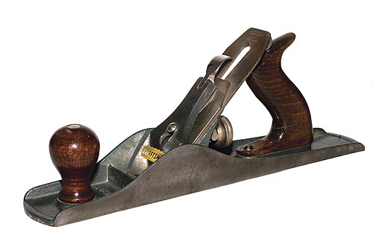
- Kamwenje used the following tools during a Pre-technical project. Identify the tools. (2 marks)
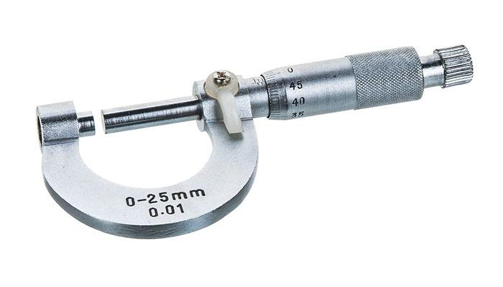

(a) (b)
________________________________ __________________________________
- Outline one online threat in the work environment. (1 mark)
_____________________________________________________-
- Identify one line used in drawing. (1 mark)
_______________________________________________________________

- Mahamud used the following hardware devices during a computer lesson. Identify their names (1 mark)
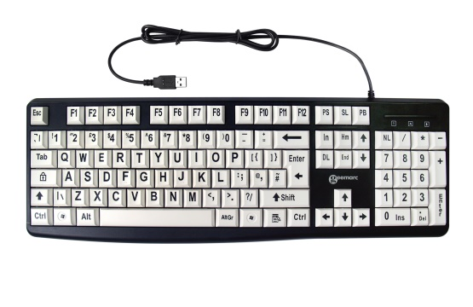
(a) (b)

______________________________________ _______________________________________
THIS IS THE LAST PRINTED PAGE

