K.J.S.E.A

JUNIOR SCHOOL EDUCATION ASSESSMENT

TERM 2: ENDTERM ASSESSMENT 2026
GRADE 7 – MATHEMATICS
Time: 2 Hours
LEARNER’S DETAILS
Name:_____________________________________________________________. School: ____________________________________________.
Assessment Number: _______________________________________________. Date: ____________________________________________.
School Code: ______________________________________________________. Signature: _______________________________________.

INSTRUCTIONS TO CANDIDATES
- Write your full name in the space provided above.
- Indicate your school, stream, admission number, and date clearly.
- This paper has TWO sections: A and B.
- Attempt ALL questions in both sections.
- Show all working clearly where necessary. Silent non-programmable calculators may be used
- Write all answers in the spaces provided.
- Do NOT remove any page from this paper.

EXAMINER’S USE
SECTION | SECTION A | SECTION B | % SCORE | EE1 | EE2 | ME1 | ME2 | AE1 | AE2 | BE1 | BE2
SCORE RANGE | 20 MARKS | 30 MARKS |  | 90-100 | 75-89 | 58-74 | 41-57 | 31-40 | 21-30 | 11-20 | 1-10
POINTS |  |  |  | 8 POINTS | 7 POINTS | 6 POINTS | 5 POINTS | 4 POINTS | 3 POINTS | 2 POINTS | 1 POINT
LEARNER’S TOTAL SCORE

SECTION A (20 MARKS) Answer ALL questions in this section.
- A teacher wrote the following number on a white board 425,600 and wanted to record the number in words. Which of the following is the correct way?
A. Four hundred twenty-five thousand six hundred
B. Four hundred and twenty-five thousand and six hundred
C. Four hundred twenty-five thousand sixty
D. Four hundred twenty-five thousand and sixty

- The value of the digit 7 in the number 457,839,216 is:
A. Seven million B. Seventy million
C. Seven hundred million D. Seventy thousand
- Round off 478, 543, 216 to the nearest hundreds of millions.
A. 500,000,000 B. 480,000,000
C. 470,000,000 D. 400,000,000

WORKING SPACE

- Simplify:
$\frac{3}{4}-\frac{5}{12}+\frac{7}{6}$ ​
$$A.\frac{7}{6} \\ B.\frac{3}{2} \\ C.\frac{5}{3} \\ D.\frac{9}{4}$$
- Which of the following numbers is NOT divisible by 2, 3, 5, and 6?
A. 1,230
B. 1,140
C. 1,320
D. 200
- Evaluate:
12.5×0.8+4.2÷0.7
A. 16
B. 20
C. 18
D. 22
- Solve:
$$\frac{4x-5}{3}+2=\frac{2x+1}{2}$$
A. 7
B. 5
C. 6
D. $\frac{1}{2}$
- A container is $\frac{3}{5}$ ​ full of water. If 12 litres are added, it becomes $\frac{4}{5}$ ​ full. Find the capacity of the container.
A. 60 L B. 50 L C. 45 L D. 30 L
- A right-angled triangle has one side 6 cm and hypotenuse 10 cm. Find the other side.
A. 8 cm B. 7 cm C. 9 cm D. 6 cm

WORKING SPACE

- A rectangle of length 10 cm and width 6 cm has a smaller rectangle cut from it of dimensions 4 cm × 2 cm. Find the remaining area.
A. 52 cm² B. 54 cm² C. 56 cm² D. 50 cm²
- $\frac{7}{8}×\frac{16}{21}÷\frac{2}{3}$​
A. 1 B. 2 C. $\frac{4}{3}$D. $\frac{8}{7}$
- Find: 6²−4×5+12÷3
A. 30 B. 20 C. 28 D. 26
- A ladder leans against a wall reaching 12 m high. Its base is 5 m from the wall.
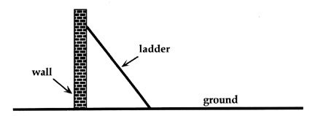

12m

5m
Find the length of the ladder.
A. 13 m B. 12.5 m C. 14 m D. 11.5 m
- Find $\{\sqrt{625}+\sqrt{256}\}-49+4$
A. 6 B. -4 C. 8 D. 5
- A cylinder has diameter of 6 cm and height 7 cm.
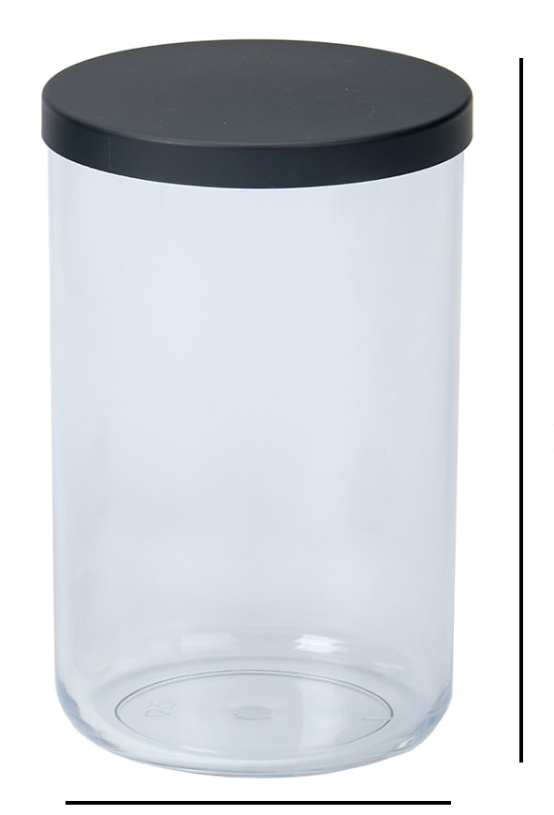

7cm

6cm
Find its volume. (Use π=3.14)
- 197.82 cm³ B. 198 cm³ C. 210 cm³ D. 200 cm³

WORKING SPACE

- A rectangular field is 80 m long and 60 m wide.
80m
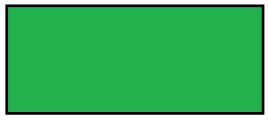

60m

Find the diagonal.
A. 90 m B. 95 m C. 100 m D. 105 m
- Simplify:
$$\frac{3x2y}{6xy2}$$
A. $\frac{x}{2y}$ B.$\frac{x2}{y2}$ C. $\frac{x}{y}$D. $\frac{x2}{2y}$
- The area of a trapezium is 960 cm². Its parallel sides are 20 cm and 28 cm. Find its height.
A. 30 cm B. 32 cm C. 35 cm D. 40 cm
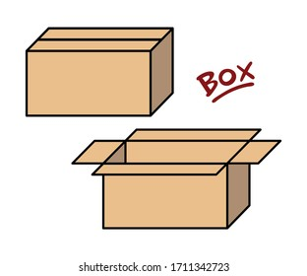
- The external dimensions of a closed rectangular box are 50 cm × 40 cm × 30 cm.

30cm

40cm

50cm
If the thickness of the material is 2 cm, what is the volume of the material used?
A. 7,088 cm³ B. 16944 cm³
C. 77,488 cm³ D. 600 cm³
- A tank of base area 2 m² is being filled with water at the rate of 200 liters per minute. How many minutes will it take to fill the tank to a height of 2.5 m?
A. 15
B. 20
C. 25
D. 30

WORKING SPACE

SECTION B (80 Marks)
- A tank is $\frac{5}{6}$ full of water. 15 litres are removed. (4 Marks)
a) Find the total capacity of the tank.

b) If $\frac{1}{3}$ of the total capacity is poured into another tank, how many litres is that?

- Simplify: (4 Marks)
$$\frac{〖{(12〗}^{2}-5×6+18÷3)}{2+\frac{1}{2}of 10}$$

- Evaluate: (4 Marks)
$$12.45+23.067-5.012$$

- Evaluate: (4 Marks)
$$\sqrt{324}+\sqrt{196}-\sqrt{64}$$

- Simplify: (4 Marks)
$$3\left(2x+5\right)-4\left(x-3\right)+7$$

- A father is 4 times as old as his son. In 10 years, the sum of their ages will be 70. Find their current ages. (4 Marks)

- Study the figure below; calculate the area of the shaded region. (4 Marks)

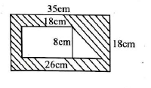
- Convert: (4 Marks)
a) 5 km 250 m = __________ m

b) 3.5 hm = _____m and __________dm

- A rectangle has length 14 cm and width 8 cm. A square of 4 cm is cut from it. (4 Marks)
a) Find the remaining area.

b) Express as a fraction of the original area.

- A rectangle of length 9cm and breath of 4.5cm has a semicircle of diameter 5 cm cut from it. (4 Marks)

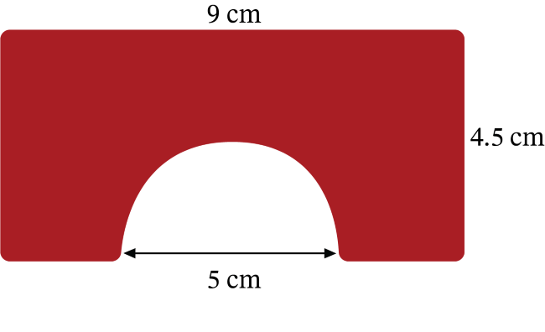
a) Find the area of the rectangle.

b) Find the area of the semicircle.

c) Find the remaining area.

- A certain figure has the dimensions as shown below. (4 Marks)

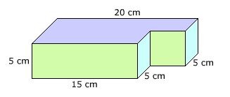
a) Find its volume in m³.

b) Convert the volume to litres.

- A cylinder has radius 3 cm and height 10 cm. (4 Marks)
a) Find its volume in cm³.

b) Convert the volume into litres.

- Simplify: (4 Marks)
$$\frac{3}{4}+\frac{5}{6}-\frac{7}{12}$$

- Evaluate: (4 Marks)
$$12.5×0.4÷2.5$$

- A rectangular plot has length 3x+5 m and width 10x-15 m. Its perimeter is 400 m. (4 Marks)
a) Find the value of x.

b) Find the length and width.

- Solve: (4 Marks)
$\sqrt{\left(100-64\right)}$- 2(0.125 × 8)

- A triangle’s measurements are gives as below. (4 Marks)

X⁰

(x-10)⁰

a) Find the value of angle x.

b) What is the sum of the two largest angles of the triangle above?

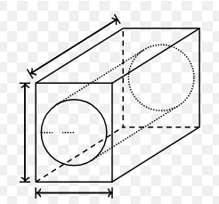
- A cylindrical part of diameter 21 cm and a length of 1.5m was cut from a wooden cuboid log measuring 3 m × 2 m × 1.5 m. (4 Marks)

1.5m

3m

2m
a) Find the volume of the cut cylindrical part in m³.

b) What is the volume of the remaining section of the wooden log in m³?

- Find the area of the shaded region in. (4 Marks)
a)

14m

- A trapezium below was drawn by a grade 7 learner. (4 Marks)
a) Find the area of the trapezium.
10cm

10cm
h

16cm

- A trader sells $\frac{1}{3}$ of his rice and is left with 140 kg. (4 Marks)
a) How much rice did he have initially?

b) If he sells another $\frac{1}{4}$ of the original stock, how much remains?

- a) Find the LCM of 18, 24, 30 using prime factorization. (4 Marks)

b) Find the GCD of 36, 48, 60 using prime factors.

- Solve: (4 Marks)
a) 2.5x + 3.75 = 13.25

b) 0.5x + 0.25 = 1.25

- Find the sum of the next three terms in the sequence: (4 Marks)
$$\frac{1}{2}, 1,\frac{3}{2}, 2, _____,______,_______$$

- Simplify: (4 Marks)
a) 3x + 2y – x + 4y – 5

b) Solve: 3x – 7 = 2x + 5

- A square field has side x+5 m. Its area is 144 m².(4 Marks)

x+5 m
- Find x.

b) Find the perimeter of the field.

- A rectangle has sides as shown below. (4 Marks)
x+2

2x–1
x+5

2x–1
a) Find the value of x.

b) Find.
i) Perimeter of the rectangle

ii) Area of the rectangle

- A rectangular field measures 120 m × 80 m and is divided into 4 equal rectangular plots. (4 Marks)
a) Find the area of one plot.

b) Find the perimeter of one plot

.
- A circular bottle top has a small circle of diameter 28 cm inside a larger circle of radius 42 cmwater is poured between the two bottle tops. (4 Marks)

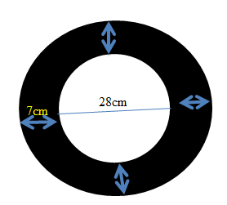

a) Find the area of the larger circle.

b) Find the area of the small circle.

c) Find the area of the water surrounding the small circle.

- a) A cube has volume 343 cm³. Find the length of one side. (2 Marks)

b) A cylinder has radius 7 cm and height 10 cm. Find its volume.(2 Marks)

THIS IS THE LAST PRINTED PAGE

