K.J.S.E.A

JUNIOR SCHOOL EDUCATION ASSESSMENT

TERM 2: ENDTERM ASSESSMENT 2026
GRADE 9 – MATHEMATICS
Time: 2 Hours
LEARNER’S DETAILS
Name:_____________________________________________________________. School: ____________________________________________.
Assessment Number: _______________________________________________. Date: ____________________________________________.
School Code: ______________________________________________________. Signature: _______________________________________.

INSTRUCTIONS TO CANDIDATES
- Write your full name in the space provided above.
- Indicate your school, stream, admission number, and date clearly.
- This paper has TWO sections: A and B.
- Attempt ALL questions in both sections.
- Show all working clearly where necessary. Silent non-programmable calculators may be used
- Write all answers in the spaces provided.
- Do NOT remove any page from this paper.

FOR OFFICIAL USE ONLY (EXAMINER’S USE)
SECTION | SECTION A | SECTION B | % SCORE | EE1 | EE2 | ME1 | ME2 | AE1 | AE2 | BE1 | BE2
SCORE RANGE | 20 MARKS | 30 MARKS |  | 90-100 | 75-89 | 58-74 | 41-57 | 31-40 | 21-30 | 11-20 | 1-10
POINTS |  |  |  | 8 POINTS | 7 POINTS | 6 POINTS | 5 POINTS | 4 POINTS | 3 POINTS | 2 POINTS | 1 POINT
LEARNER’S TOTAL SCORE

SECTION A (20 MARKS) Answer ALL questions in this section.

    - Evaluate:
$$\frac{3}{27}×\left(5^{2}-10\right)÷5$$
A. 9 B. 5 C. 15 D. 3
- Simplify:
$${10}^{4}×{10}^{7}×{10}^{-2}$$
A. ${10}^{-9}$ B. ${10}^{5}$ C. ${10}^{1}$ D. ${10}^{9}$

WORKING SPACE

- The gradient of the line $4x-2y=8$ is:
A. −2 B. 2 C. 4 D. −4
- A sphere has a diameter of 6 cm.
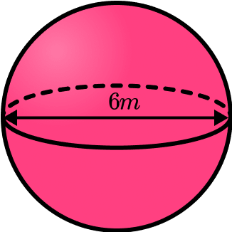
Its volume is (Take π =$\frac{22}{7}$):
A. $113.14{\text{ cm}}^{3}$ B. $37.71{\text{ cm}}^{3}$ C. $905.14{\text{ cm}}^{3}$ D. $452.17{\text{ cm}}^{3}$
- A rectangular prism has a mass of 1000 g and a volume of 250 cm³. Its density is:
A. 4 kg/m³ B. 4 g/cm³ C. 0.25 g/cm³ D. 250000 g/cm³
- Which linear inequality is represented by the shaded region?
A. $y>x+3$ B. $y<x+3$ C. $y≥x+3$ D. $y≤x+3$
- The curved surface area of a cone with radius 5 cm and slant height 10 cm is:
A. $78.57$cm² B. $157$cm² C. $235$cm² D. $314$cm²
- The x-intercept of the line $y=-2x+10$ is:
A. (0,10) B. (5,0) C. (−5,0) D. (10,0)
- The matrix
$$\left[\begin{matrix}2 & 5 & 7\end{matrix}\right]$$
has the order:
A. 1×3 B. 3×1 C. 3 D. 1

WORKING SPACE

- The term deceleration means:
A. Constant speed B. Increase in velocity C. Decrease in velocity D. Zero acceleration
- If a Kenyan imports goods worth KES 100,000, and the Import Duty is 20%, the duty paid is:
A. 2,000 B. 20,000 C. 80,000 D. 120,000
- Using the law of logarithms:
$$\log_{10}100+\log_{10}10=$$
A. 3 B. $\log_{10}110$ C. 2 D. 10
- The area of a regular pentagon with side $a$ is given by
$$A=\frac{1}{4}\sqrt{25+10\sqrt{5}} a^{2}.$$
If $a=1$, the area is approximately:
A. 1.72 units² B. 2.5 units² C. 3.46 units² D. 4.0 units²
- Given the exchange rate $1 USD=150 KES$. 300 USD is equivalent to:
A. 2 KES B. 45,000 KES C. 4,500 KES D. 0.5 KES
- The following are properties of quadrilaterals
  - All sides are equal
  - Diagonals are equal
  - All angles are equal
  - Has a pair of parallel lines
  - Diagonals are perpendicular bisectors
  - Opposite sides are equal and parallel
  - The sum of interior angles equals 3600
Which properties are for all quadrilaterals?
    - v and vii
    - vii
    - iii
    - iii and vii

WORKING SPACE

- The figure below holds 24.948 liters. If its diameter is 42cm. What is its height?
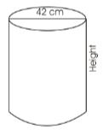
(Take pi = 22/7)
  - 16cm
  - 14cm
  - 12cm
  - 18cm
- The table below shows the number of cars that passed near Waka school in certain week. Number for Thursday is not shown.
Day | Mon | Tue | Wed | Thur | Fri | Sat
No. of  Cars | 29 | 33 | 41 |  | 47 | 37
If the mean num ber of cars was 36, what is the sum of mode and median?
A.29 B.64 C. 35 D.55
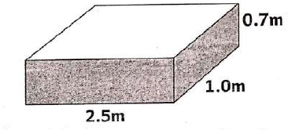
- The figure below shows a container which measures 2.5m by 1.0m by 0.7m.

What is its capacity in litres? .
A. 175 B.1.75 C.1750 D. 17500
- Grade Nine learner wrote the matrix below.
3 8 6 7
2 9 5 1
6 4 8 5
State the order of the matrix above
A.3x4 B.4x3 C.4x2 D.3x2
- Find the perimeter of the figure below Use (π=3.142)
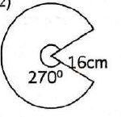
A.75.41cm B.107.41cm
C.91.41cm D.53.70cm

WORKING SPACE

- The graph below shows apart of Nyaga’s Journey from Tharaka Nithi to Nyahururu a distance of 280km. After driving for 1½hrs his vehicle broke down and took one hour to repair.

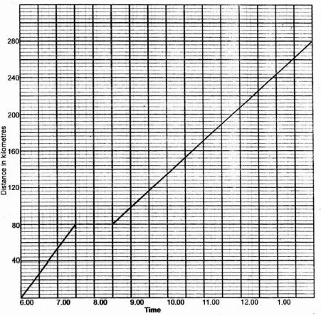
What was his speed of repairing the car?
  - 16 ⁸/₁₇ km/hr
  - 25 km/hr
  - 40 km/hr
  - 12 ½km/hr

SECTION B
Answer all questions
- (a) Evaluate: (2 marks)
$${\left(-3\right)}^{3}+{\left(-2\right)}^{3}+4^{3}$$

(b) Find the cube root of $512$. (2 marks)

(c) The difference between two integers is 9. If the smaller is $-5$, find the larger integer. (2 marks)

- (a) Simplify: (2 marks)
$$\left(2^{3}×4^{2}\right)÷8$$

(b) Evaluate ${10}^{2.5}$ using logarithm tables. (2 marks)

(c) Using logarithms (4 significant figures), find the value of: (2marks)
$${\left(25.6×0.0321\right)}^{\frac{1}{3}}$$

- A contractor employs 8 workers to complete a building in 15 days.
How many days will 12 workers take to complete the same job, working at the same rate? (2 marks)

- (a) Simplify: (2 marks)
$$3a-2b+4a+5b-7$$

(b) Expand and simplify: (2 marks)
$$\left(x+3\right)\left(x-4\right)$$

(c) Factorize completely: (2 marks)
$$2x^{2}-8$$

- Given:
$$A=\left[\begin{matrix}2 & 3 \\ 1 & 4\end{matrix}\right], B=\left[\begin{matrix}1 & 2 \\ 3 & 0\end{matrix}\right]$$
(a) Find $A+B$. (2 marks)

(b) Hence find $2A-B$(2 marks)

c) Given
$$P=\left[\begin{matrix}5 & y \\ 2x & -3\end{matrix}\right], Q=\left[\begin{matrix}1 & 6 \\ -4 & 1\end{matrix}\right].$$

Determine the order of matrix P. (1 mark)

(d) If
$$P+Q=\left[\begin{matrix}6 & 2 \\ 2 & -2\end{matrix}\right],$$
Find the values of $x$ and $y$. (2 marks)

- Find the equation of the line passing through points (2, 3) and (6, 11).
(a) Find the gradient. (2 marks)

(b) Write the equation in the form $y=mx+c$. (2 marks)

(c) Hence find the y-intercept. (2 marks)

- (a) Find the area of a regular hexagon of side 6 cm. (2 marks)

(b) A rectangular-based prism measures 10 cm × 6 cm × 4 cm. Find its surface area. (2 marks)

(c) A cone has radius 7 cm and slant height 25 cm. Find its curved surface area. (2 marks)

- A ladder leans against a wall. The foot of the ladder is 3 m from the wall, and the top touches the wall 4 m above the ground.
Find the length of the ladder. (2marks)
(Include a right-angled triangle diagram.)

- Solve and represent on a number line:
$$2x-3<7$$
Then shade the solution region on the number line. (2 marks)

- A cyclist travels as follows:
- 0–2 hours → 20 km
- 2–3 hours → Rest
- 3–5 hours → 30 km
(a) Draw a distance–time graph for the journey. (2 marks)

(b) Find the average speed for the whole journey. (2 marks)

- A TV costs Ksh 60,000. Mwangi paid a Deposit of 20% of cost, and the balance is paid in 12 equal monthly instalments.
Find:
(a) The deposit amount. (2 marks)

(b) The monthly installments. (2 marks)

(c) The total amount paid. (2 marks)

- (a) Find the simple interest on Ksh 20,000 at 8% p.a. for 3 years. (2 marks)

(b) Find the compound interest on Ksh 15,000 at 10% p.a. for 2 years (compounded yearly). (2 marks)

- (a) Construct a rhombus PQRS with sides 6 cm and one diagonal 8 cm. (2 marks)

(b) Measure and state the size of the acute angle. (2 marks)

(c) Draw and label the diagonals. (2 marks)

- The table shows marks scored by learners:
Marks | 10 | 20 | 30 | 40 | 50
No. of Learners | 2 | 5 | 8 | 3 | 2

(a) Find the mean mark. (2 marks)

(b) Find the mode. (2 marks)

(c) Find the median. (2 marks)

d) Represent the information on a bar graph. (3 marks)

- Plot the points:
A(1, 2), B(4, 5), C(6, 1).
(a) Join the points to form triangle ABC. (3 marks)

(b) Find the area of the triangle formed. (3 marks)

(c) Find the gradient of line AB. (2 marks)

THIS IS THE LAST PRINTED PAGE

