K.J.S.E.A

JUNIOR SCHOOL EDUCATION ASSESSMENT

TERM 2: ENDTERM ASSESSMENT 2026
GRADE 9 – AGRICULTURE
Time: 1 Hour 30 Minutes
LEARNER’S DETAILS
Name: ________________________________________________. School: _____________________________________________________.
Assessment Number: _________________________________. Date: ______________________________________________________.
School Code: _______________________________________. Signature: _________________________________________________.

Instructions for Learners
- Write your full name and assessment number in the spaces provided above.
- Indicate your school name and school code clearly.
- Sign and date this paper in the spaces provided.
- This paper consists of TWO sections: Section A and Section B.
- Answer ALL questions in BOTH sections.
- Write your answers in the spaces provided in this question paper.
- Do NOT remove any page from this paper.
- All responses must be written in English
FOR EXAMINER’S USE
SECTION | SECTION A | SECTION B | % SCORE | EE1 | EE2 | ME1 | ME2 | AE1 | AE2 | BE1 | BE2
SCORE RANGE | 20 MARKS | 30 MARKS |  | 90-100 | 75-89 | 58-74 | 41-57 | 31-40 | 21-30 | 11-20 | 1-10
POINTS |  |  |  | 8 POINTS | 7 POINTS | 6 POINTS | 5 POINTS | 4 POINTS | 3 POINTS | 2 POINTS | 1 POINT
LEARNER’S TOTAL SCORE

SECTION A (20 MARKS) Answer ALL questions in this section

- Before storing beans, Amina checked that their moisture content was low. This practice helps to:
A. Improve the colour of the beans
B. Prevent rotting and mould growth
C. Increase weight for sale
D. Keep them warm
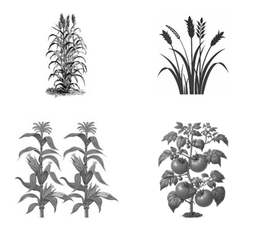
- Wangari was asked to list forage crops. Which of the following is NOT a forage crop?
A B

C D
- John wants to reheat leftover cassava from last night’s meal. He plans to deep-fry it. What should he do to avoid getting burned by the hot oil?
A. Drop the cassava quickly into the oil
B. Gently lower the pieces into the oil
C. Use bare hands to lower the cassava
D. Cover the pan completely
- Silvopasture combines:
A. Trees and poultry
B. Crops and water
C. Fish and vegetables
D. Trees and livestock grazing

- A greenhouse is mainly used for:
A. Growing high-value vegetables or fruits
B. Breeding fish
C. Rearing rabbits
D. Keeping bees
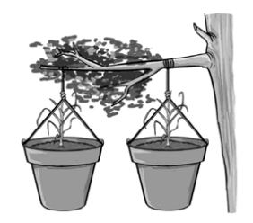
- Identify the type of seedbed drawn below.

A. Hanging garden B. Suspended garden C. Conical garden D. Container garden
- Moha is preparing his land for an organic vegetable garden. The spacing recommended for transplanting cabbage seedlings is:
A. 30 cm × 30 cm B. 60 cm × 60 cm C. 15 cm × 15 cm D. 90 cm × 90 cm
- How does organic gardening support sustainable agriculture?
A. By relying on synthetic fertilizers
B. By increasing pollution
C. By maintaining soil health and reducing environmental pollution
D. By depleting soil nutrients
- Why are granaries elevated from the ground?
A. To catch more sunlight
B. To prevent moisture damage
C. To increase airflow
D. To make them mobile
- Marjorie found that some of her stored maize had developed mold. What should she do with the moldy produce?
A. Spray it with pesticide
B. Mix it with fresh produce
C. Dispose of the spoiled maize
D. Cover it with newspaper
- Agnes cleaned her storage containers but forgot to dry them. What might happen if she stores her maize in wet containers?
A. The maize will be heavier
B. The maize will turn white
C. The maize will dry faster
D. The maize may spoil due to moisture
- Miriam noticed her family’s sink had lost its shine. She cleaned it properly and dried it with a cloth after rinsing. Why was drying an important final step?
A. To make it smell good
B. To prevent water spots and ensure a shiny finish
C. To disinfect the cloth
D. To prepare it for repainting
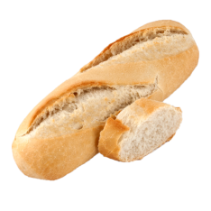
- During a Nutrition project, Grade 9 learners at Mazuri Junior School made the wheat product below.

This is a:
A. Croissant B. Chapatti C. Snail D. Baguette
- What happens if baking powder is omitted in mandazi preparation?
A. Mandazi become sour
B. Mandazi cook faster
C. Mandazi do not rise properly
D. Mandazi become soft
- Janet decided to use a new cleaning solution on the dustbin. She first put on the protective gear below before starting. Why was this step important?
A. To look professional
B. To avoid sweating
C. To work faster
D. To protect her skin from dirt and chemicals
- Sarah washes her socks and wants to disinfect them naturally. What is the best method for her to use?
A. Boiling B. Sun drying with pegs C. Ironing D. Drying indoors
- What is the purpose of salting in disinfecting clothes?
A. Brightens colors
B. Prevents shrinking
C. Adds fragrance
D. Removes mucus and bloodstains and disinfects
- Mrs. Odhiambo dried a large batch of vegetables in her homemade dryer. She tested a few slices and found they bent but didn’t break. What should she do?
A. Store them immediately
B. Wash them again
C. Add water
D. Continue drying them
- The type of stitch shown is a:
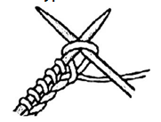
A. Knit stitch B. Purl stitch C. Garter stitch D. Seed stitch

- Which of the following is NOT a reason why we should conserve leftover food?
A. To prevent food wastage
B. To save money
C. To save gas
D. To save time
- Which type of erosion is shown below?
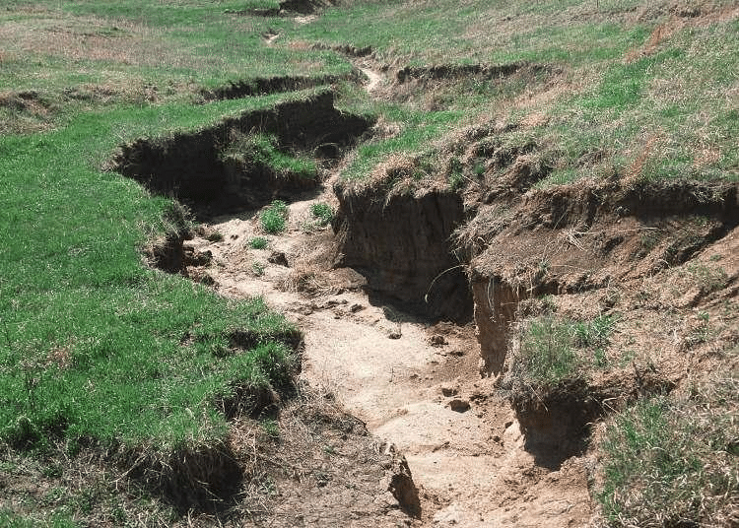
A. Wind erosion B. Gully erosion C. Sheet erosion D. Rill erosion
- The county government of Makueni is launching a project to plant trees in areas that were previously dry and bare. This exercise is called:
A. Deforestation B. Reforestation C. Afforestation D. Agroforestry
- The best method of preventing post-harvest losses in cereals is:
A. Using pesticides
B. Mixing grains with fresh produce
C. Proper drying and storage
D. Keeping grains in plastic bags
- During a farm activity, learners noticed maize turning black in storage. This was likely caused by:
A. Overdrying
B. Poor ventilation and high moisture
C. Excess dusting
D. Cleaning before storage
- When cleaning a store, the following tools are used except:
A. Broom B. Duster
C. Wheelbarrow D. Whisk
- Learners disinfected kitchen towels by drying them under sunlight. This method works because sunlight:
A. Adds colour
B. Kills germs using heat and UV rays
C. Bleaches fabric only
D. Increases moisture
- The main reason for disinfecting household items is to:
A. Keep them shiny
B. Prevent spread of infections
C. Save time
D. Make them smell nice
- A Learner was ironing a school apron.
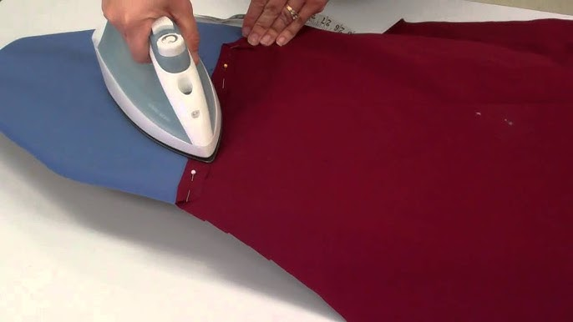
Ironing clothes helps to:
A. Remove wrinkles and kill germs
B. Dry clothes quickly
C. Add perfume
D. Make clothes heavier
- A kitchen that is cleaned daily will likely:
A. Attract cockroaches
B. Remain hygienic and safe
C. Smell bad
D. Be dark and wet
- The correct order when preparing chapati dough is:
A. Add oil → mix water → knead → rest
B. Mix flour, salt, and water → knead → rest → cook
C. Add sugar → bake → fry
D. Mix water only

SECTION B: STRUCTURED QUESTIONS (50 MARKS)

PART A: AGRICULTURE (25 MARKS)
- During an educational trip, Grade 9 learners of St. Johns Nyamagwa visited a nearby school farm.
a) List three activities that cause soil pollution. (3 marks)
i) …………………………………………….……………………………………………………………..…………
ii) …………………………………………………………………………………………………………..…………
iii) ………………………………………….……………………………………………………………..…………
b) Name two effects of soil pollution. (2 marks)
i) …………………………………………….……………………………………………………………..…………
ii) …………………………………………………………………………………………………………..…………
c) State two ways of mitigating soil pollution. (2 marks)
i) ……………………………………………….…………………………………………………………..…………
ii) …………………………………………………………………………………………………………..…………
- The diagram below shows a method of soil and water conservation
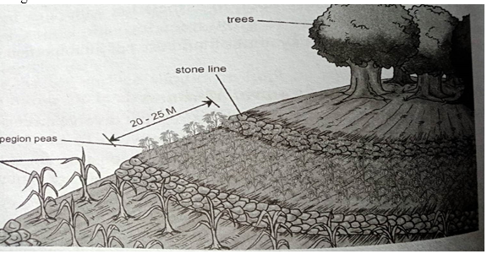
(a) Identify the structure shown above (1 mk)
……………………………………………………………………………………………………………..
(b) Give two other structures that can be used in place of the one in (a) above (2 mks)
i) ……………………………………………….…………………………………………………………..…………
ii) …………………………………………………………………………………………………………..…………
(c) Give two factors that influence soil erosion (2 mks)
i) ……………………………………………….…………………………………………………………..…………
ii) …………………………………………………………………………………………………………..…………

- Grade 8 learners went for a field excursion. They came across the method shown in the picture below of storing water.
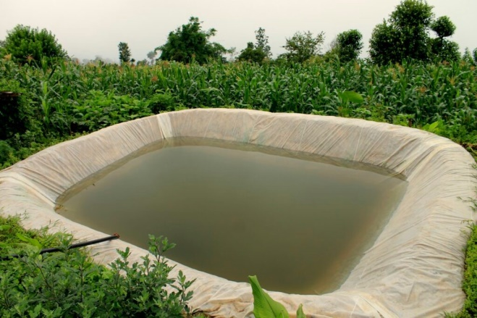
a. Identify the method of storing water. (1mk)
………………………………………………………………………………………………………………………….
b. Name two tools that might have been used to construct the structure named in (2mks)
i) ……………………………………………….…………………………………………………………..…………
ii) …………………………………………………………………………………………………………..…………
c. How is the structure in the picture above important to a farmer? (2mks)
i) …………………………………………….……………………………………………………………..…………
ii) …………………………………………………………………………………………………………..…………
- At the school farm, beans stored in a sack got mouldy.
a) State two factors that could have caused the spoilage. (2 marks)
i) ……………………………………………….…………………………………………………………..…………
ii) …………………………………………………………………………………………………………..…………
b) Mention two ways of preventing spoilage of cereals during storage. (2 marks)
i) ……………………………………………….…………………………………………………………..…………
ii) …………………………………………………………………………………………………………..…………
c) Give one importance of checking moisture content before storage. (1 mark)
……………..………………………………….……………………………………………………………..………
………………………………………………………………………………………………………………..………
- Learners established an organic garden behind the classroom.
a) List three organic materials used in making manure. (3 marks)
i) …………………………………………….……………………………………………………………..…………
ii) …………………………………………………………………………………………………………..…………
iii) ………………………………………….……………………………………………………………..…………
b) Explain two benefits of using organic manure in farming. (2 marks)
i) …………………………………………….……………………………………………………………..…………
ii) …………………………………………………………………………………………………………..…………
c) Identify two ways farmers conserve soil in their farms. (2 marks)
i) …………………………………………….……………………………………………………………..…………
ii) …………………………………………………………………………………………………………..…………
- Farmers in the community were trained to use ICT in agriculture.
a) State two ICT services used by farmers. (2 marks)
i) …………………………………………….……………………………………………………………..…………
ii) …………………………………………………………………………………………………………..…………
b) Mention two benefits of using ICT in agriculture. (2 marks)
i) ……………………………………………….…………………………………………………………..…………
ii) ………………………………………………………………………………………………………..…………
c) Explain one role of an agricultural extension officer. (2 marks)
……………….…………………………….……………………………………………………………..…………
……….…….……………………………………………………………………………………………..…………

PART B: HOME SCIENCE (25 MARKS)
- Learners disinfected aprons and towels used in the Home Science lab.
a) Mention three methods used to disinfect clothing. (3 marks)
i) …………………………………………….……………………………………………………………..…………
ii) …………………………………………………………………………………………………………..…………
iii)…………………………………………………………………………………………………………………..
b) Outline three steps followed when disinfecting towels using boiling water. (3 marks)
i) …………………………………………….……………………………………………………………..…………
ii) …………………………………………………………………………………………………………..…………
iii) ………………………………………….……………………………………………………………..…………
c) State two reasons for disinfecting household articles. (2 marks)
i) ……………………………………………….……………………………………………………………..…………
ii) ……………………………………………………………………………………………………………..…………
- The Home Science club cleaned waste bins and open drains in the school compound.
a) List three materials used when cleaning waste bins. (3 marks)
i) …………………………………………….……………………………………………………………..…………
ii) …………………………………………………………………………………………………………..…………
iii) …………………………………………………………………………………………………………..…………
b) State two precautions taken during cleaning. (2 marks)
i) …………………………………………….……………………………………………………………..…………
ii) …………………………………………………………………………………………………………..…………
c) Give two reasons for cleaning waste disposal facilities. (2 marks)
i) …………………………………………….……………………………………………………………..…………
ii) …………………………………………………………………………………………………………..…………
- During a cookery lesson, learners prepared pancakes using flour mixtures.
  - Identify the use of each of the following type of wheat flour. (3 marks)
A | B | C
 |  | 
b) List four ingredients used in making pancake batter. (2 marks)
i) ……………………………………………….……………………………………………………………..…………
ii) ……………………………………………………………………………………………………………..…………
iii) ……………………………………………….……………………………………………………………..…………
iv) ……………………………………………………………………………………………………………..…………
c) Explain two hygiene practices to observe when preparing the mixture. (2 marks)
i) …………………………………………….……………………………………………………………..…………
ii) …………………………………………………………………………………………………………..…………
d) Mention two tools used in preparing the batter. (2 marks)
i) …………………………………………….……………………………………………………………..…………
ii) …………………………………………………………………………………………………………..…………
- Learners were guided to preserve fish and milk for the school feeding program.
a) Mention two methods of preserving fish. (2 marks)
i) …………………………………………….……………………………………………………………..…………
ii) …………………………………………………………………………………………………………..…………
b) List two methods used to preserve milk. (2 marks)
i) …………………………………………….……………………………………………………………..…………
ii) …………………………………………………………………………………………………………..…………
c) State two reasons for preserving animal products. (2 marks)
i) …………………………………………….……………………………………………………………..…………
ii) …………………………………………………………………………………………………………..…………
- Learners cleaned the school kitchen after cooking practicals.
a) Identify three daily cleaning practices done in the kitchen. (3 marks)
i) …………………………………………….……………………………………………………………..…………
ii) …………………………………………………………………………………………………………..…………
iii) ………………………………………….……………………………………………………………..…………
b) Explain two reasons for keeping the kitchen clean. (2 marks)
i) …………………………………………….……………………………………………………………..…………
ii) …………………………………………………………………………………………………………..…………

c) Give two examples of equipment used for kitchen cleaning. (2 marks)
i) …………………………………………….……………………………………………………………..…………
ii) …………………………………………………………………………………………………………..…………
- Grade 8 learners were learning preparation of animal products. They visited a fish processing factory and were taken through how fresh fish is processed after being harvested from water to avoid spoilage.

a) Mention two processes that are carried out on fish. (2 marks)
i) ………………………………………….……………………………………………………………..…………
ii) ………………………………………………………………………………………………………..…………

b) Identify the method of dressing poultry carcass shown below. (1 mark)

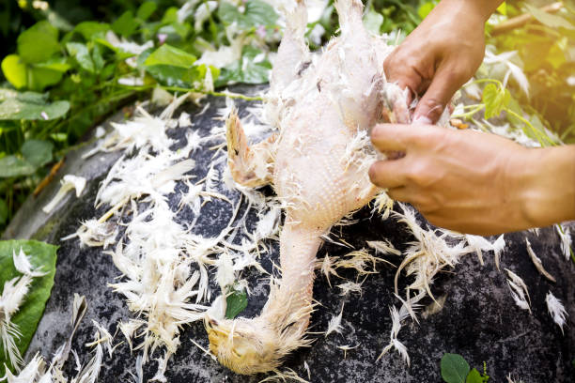

……………………………………………………………………………………………………

c) Name two other methods of dressing poultry carcass (2 marks)
i) …………………………………………….……………………………………………………………..…………
ii) …………………………………………………………………………………………………………..…………

THIS IS THE LAST PRINTED PAGE

