K.J.S.E.A

JUNIOR SCHOOL EDUCATION ASSESSMENT

TERM 2: ENDTERM ASSESSMENT 2026
GRADE 8 – SOCIAL STUDIES
Time: 1 Hour 30 Minutes
LEARNER’S DETAILS
Name: ________________________________________________. School: _____________________________________________________.
Assessment Number: _________________________________. Date: ______________________________________________________.
School Code: _______________________________________. Signature: _________________________________________________.

Instructions for Learners
- Write your name, school name, and assessment number in the spaces provided.
- This paper consists of five questions.
- Check the question paper carefully to ensure all pages are printed and no questions are missing.
- Answer all the questions in the spaces provided.

FOR OFFICIAL USE ONLY
SECTION | SECTION A | SECTION B | % SCORE | EE1 | EE2 | ME1 | ME2 | AE1 | AE2 | BE1 | BE2
SCORE RANGE | 20 MARKS | 30 MARKS |  | 90-100 | 75-89 | 58-74 | 41-57 | 31-40 | 21-30 | 11-20 | 1-10
POINTS |  |  |  | 8 POINTS | 7 POINTS | 6 POINTS | 5 POINTS | 4 POINTS | 3 POINTS | 2 POINTS | 1 POINT
LEARNER’S TOTAL SCORE

SECTION A (20 MARKS)

Answer all questions by choosing the correct option

- The process of enhancing one’s abilities, skills, and qualities to achieve personal growth and development is known as
A. Self-awareness B. Personal growth
C. Self-esteem D. Self-improvement
- All the following are effects of unhealthy self-esteem except
A. Improved confidence and motivation
B. Relationship difficulties
C. Stress and depression
D. Social isolation
- ______ refers to the study of the human past using material remains.
A. Meteorology B. Archaeology
C. Cartography D. Museology
- Evolution of early man through changes in their genes and body behaviour was described by Darwin as
A. Isolation B. Natural selection
C. Mutation D. Adaptation
- Which of the following visitors to the East African coast brought goods, Islamic culture, and significantly influenced Swahili?
A. Arabs B. Chinese C. Romans D. Portuguese
- All the following are civilizations that resulted from hieroglyphics. Which one was not?
A. Writing system
B. Modern education
C. Weather forecasting techniques
D. Record keeping methods
- Which one of the following is not a primary source of information?
A. Artefacts B. Cultural remains
C. Journals D. Interviews
- The following are French colonies except
A. Niger
B. Congo
C. Central African Republic
D. Sierra Leone
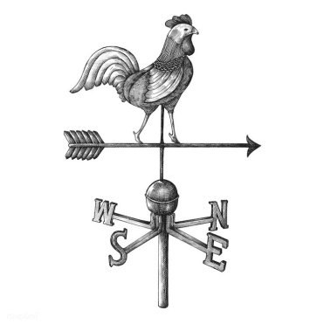
- The weather element determined by the instrument below is

A. Windsock B. Wind
C. Windvane D. Speed of wind
- All the following problems can be solved through community service except
A. Terrorism
B. Waste disposal
C. Drug and substance abuse
D. Early pregnancies
- Mwalimu Amina asked Ian to mention examples of social, civic, and political rights. Which one was wrongly mentioned?
A. Freedom of speech
B. Right to education
C. Right to own property
D. Right to vote
- During the Trans-Saharan trade, which of the following goods were bought from West Africa?
A. Salt B. Glassware
C. Clothes D. Gold
- The following are effects of healthy relationships except
A. Happiness B. Conflict
C. Personal growth D. Gratitude
- Movement of the Earth on its axis results in
A. Four seasons
B. Lunar eclipse
C. Days and nights
D. Variation in the length of day and night
- After the Berlin Conference, River ______ was left for navigation by all Europeans.
A. Nile B. Athi
C. Zambezi D. Congo
- ______ is the first step when carrying out a community service-learning project.
A. Identifying the problem
B. Designing the solution
C. Planning to implement
D. Implementing the solutions
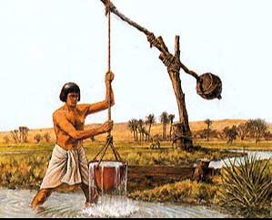
The irrigation method below was used in ancient civilization. Use it to answer questions 17 and 18.

- Identify the method above.
A. Basin B. Shadoof
C. Canal D. Archimedean
- The method of irrigation was practised in
A. Zimbabwe B. Congo
C. Egypt D. Rift Valley
- The following are challenges associated with carrying out fieldwork except
A. Adequate tools
B. Exaggerated responses
C. Hostile community
D. Lack of finances
- Community service projects give a learner an opportunity to apply skills learnt.
i. Perform tasks allocated as planned.
ii. Set deadline for each task.
iii. Break down project into tasks.
iv. Set clear objectives.
v. Gather resources required for the project.
vi. Assign responsibilities for individuals.
vii. Regularly monitor progress of each activity.
Which is the correct order to use when solving an identified problem in a community service project?
A. (iv), (ii), (v), (vi), (i), (iii), (vii)
B. (iii), (iv), (ii), (v), (i), (vii), (vi)
C. (iv), (iii), (vi), (ii), (v), (i), (vii)
D. (vi), (ii), (i), (iii), (vii), (v), (iv)

Section B (30 marks)
Answer ALL the questions in this section.
- Wema School invited a resource person to talk about factors that have led to population growth in Africa. Write down any three factors. (3 marks)
- _____________________________________________________________________________________________________________
- _____________________________________________________________________________________________________________
- _____________________________________________________________________________________________________________
- Your teacher has asked you to present various causes of migration. Give four points you will mention during the presentation. (4 marks)
- _____________________________________________________________________________________________________________
- _____________________________________________________________________________________________________________
- _____________________________________________________________________________________________________________
- _____________________________________________________________________________________________________________
- Mention the four stages of human evolution. (4 marks)
- _____________________________________________________________________________________________________________
- _____________________________________________________________________________________________________________
- _____________________________________________________________________________________________________________
- _____________________________________________________________________________________________________________
- A resource person was invited to discuss self-exploration with Grade 7 learners.
a) State three personal values for a steady personality. (3 marks)
- _____________________________________________________________________________________________________________
- _____________________________________________________________________________________________________________
- _____________________________________________________________________________________________________________
b) Identify four ways of managing emotions in day-to-day life. (4 marks)
- _____________________________________________________________________________________________________________
- _____________________________________________________________________________________________________________
- _____________________________________________________________________________________________________________
- _____________________________________________________________________________________________________________
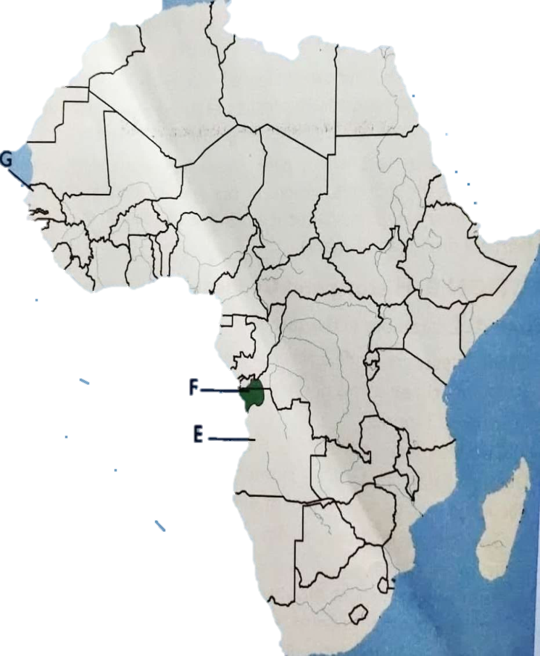
- The map below was drawn by a group of Grade 8 learners during group activities. Use it to answer questions 25(a), (b), and (c).

a) Name the country marked E. (1 mark)
__________________________________________________________________________________________________________
b) Identify the early civilization that existed in the shaded area marked F. (1 mark)
___________________________________________________________________________________________________________
c) Give the name of the European colonial power that colonized the country marked G. (1 mark)
___________________________________________________________________________________________________________
- Give any three non-violent ways of solving conflicts in the society. (3 marks)
- _____________________________________________________________________________________________________________
- _____________________________________________________________________________________________________________
- _____________________________________________________________________________________________________________
- State three ways of preserving sources of historical information over the years. (3 marks)
- _____________________________________________________________________________________________________________
- _____________________________________________________________________________________________________________
- _____________________________________________________________________________________________________________
- A radio broadcast was made in Accra, Ghana, at 9.00 p.m. At what local time was the broadcast received in Kampala, 30° East? (3 marks)

THIS IS THE LAST PRINTED PAGE

