K.J.S.E.A

JUNIOR SCHOOL EDUCATION ASSESSMENT

TERM 2: ENDTERM ASSESSMENT 2026
GRADE 8 – MANDARIN
Time: 1 Hour 30 Minutes
LEARNER’S DETAILS
Name: ________________________________________________. School: _____________________________________________________.
Assessment Number: _________________________________. Date: ______________________________________________________.
School Code: _______________________________________. Signature: _________________________________________________.

Instructions for Learners
- Answer all questions.
- Respond in Mandarin.

FOR EXAMINER’S USE
SECTION | SECTION A | SECTION B | % SCORE | EE1 | EE2 | ME1 | ME2 | AE1 | AE2 | BE1 | BE2
SCORE RANGE | 20 MARKS | 30 MARKS |  | 90-100 | 75-89 | 58-74 | 41-57 | 31-40 | 21-30 | 11-20 | 1-10
POINTS |  |  |  | 8 POINTS | 7 POINTS | 6 POINTS | 5 POINTS | 4 POINTS | 3 POINTS | 2 POINTS | 1 POINT
LEARNER’S TOTAL SCORE

TASK 1: LISTENING AND SPEAKING (15 MARKS)
A. Listening (Teacher reads the script provided below) (5 Marks) Listen to the descriptions of family members and their professions. Match the person to their job.
- 叔叔 (Shūshu) — ________
- 姑姑 (Gūgu) — ________
- 舅舅 (Jiùjiu) — ________
- 阿姨 (Āyí) — ________
- 表妹 (Biǎomèi) — ________
Teacher’s Script:
- 我的叔叔是医生 (Yīshēng)。
- 我的姑姑是护士 (Hùshì)。
- 我的舅舅是老师 (Lǎoshī)。
- 我的阿姨是厨师 (Chúshī)。
- 我的表妹是记者 (Jìzhě)。
B. Speaking (Oral Interaction) (10 Marks) Respond to the following prompts in Mandarin:
- Greeting: Use a formal greeting for your teacher (老师好).
- Self-Introduction: State your name and age (我叫... 我今年...岁).
- Origin: Say where you come from (我来自肯尼亚).
- Needs: Express that you are hungry or thirsty (我饿了 / 我渴了).
- Time: Answer the question: "现在几点?" (Look at your watch or the classroom clock).

TASK 2: COMPREHENSION (5 MARKS)
Read the passage below and answer the questions.
Text: 今天是星期六。大卫要去商场。他要买衣服和鞋子。他下午两点一刻坐出租车去。大卫很高兴，因为他喜欢去商场。
- 大卫要去哪里？ (Where is David going?) _________________________ (1 Mark)
- 他要买什么？ (What does he want to buy?) _______________________ (1 Mark)
- 他几点去？ (What time is he going?) ____________________________ (1 Mark)
- 他怎么去？ (How is he traveling?) ______________________________ (1 Mark)
- 他今天的感觉怎么样？ (How is he feeling?) _______________________ (1 Mark)

TASK 3: DIALOGUE (5 MARKS)
Complete the dialogue between Alfred and Benta using the words in the box:
[ 做什么 , 怎么 , 医院 , 看病 , 坐 ]
Alfred: 你好！你要去哪里？
Benta: 我要去 (1) __________。
Alfred: 你去那里 (2) __________？
Benta: 我去 (3) __________。我身体不舒服。
Alfred: 你 (4) __________ 去？
Benta: 我 (5) __________ 公交车去。

TASK 4: GRAMMAR (15 MARKS)
A. Write the Chinese characters (5 Marks)
- 8:30 — 八点 ( )
- 6:15 — 六点一 ( )
- 7:45 — ( ) 一刻八点
- 12:00 — ( ) 十二点
- 10:05 — 十点 ( ) 分
B. Match the Recreational Activity to the Place (5 Marks)
- 游泳 (Swimming) --- A. 山 (Mountain)
- 爬山 (Climbing) --- B. 动物园 (Zoo)
- 看动物 (Seeing animals) --- C. 游泳池 (Pool)
- 钓鱼 (Fishing) --- D. 操场 (Playground)
- 踢足球 (Football) --- E. 湖 (Lake)

C. Fill in 坐 (zuò - sit/ride) or 骑 (qí - ride astride) (5 Marks)
- ( ) 自行车
- ( ) 飞机
- ( ) 摩托车
- ( ) 出租车
- ( ) 火车

TASK 5: WRITING (10 MARKS)
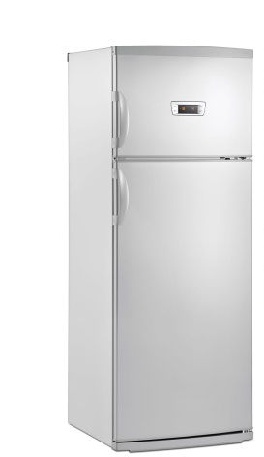
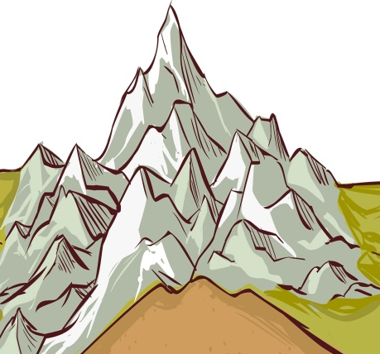
A. Label the items/features using the words provided: (5 Marks)



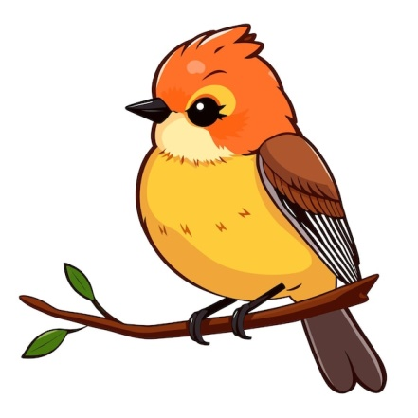
1. ________________ 2. _________________________ 3. _____________________

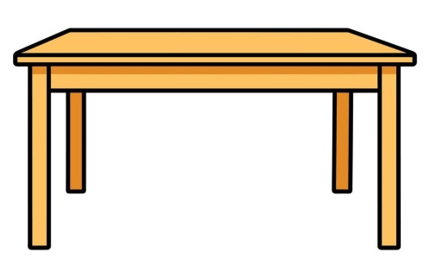

4.________________. 5.________________

B. Guided Writing (5 Marks)
Write five simple sentences in Pinyin or Characters about yourself. (Include: Name, Age, Where you live, a hobby you like, and how you feel today).
______________________________________________________________________________________________________________________________________________________________________________________________________________________________________________________________________________________________________________________________________________________________________________________________________________________________________________________________________________________

THIS IS THE LAST PRINTED PAGE

