K.J.S.E.A

JUNIOR SCHOOL EDUCATION ASSESSMENT

TERM 2: ENDTERM ASSESSMENT 2026
GRADE 8 – INTEGRATED SCIENCE PAPER 1
Time: 1 Hour 30 Minutes
LEARNER’S DETAILS
Name: ________________________________________________. School: _____________________________________________________.
Assessment Number: _________________________________. Date: ______________________________________________________.
School Code: _______________________________________. Signature: _________________________________________________.

Instructions for Learners
- Write your full name and assessment number in the spaces provided above.
- Indicate your school name and school code clearly.
- Sign and date this paper in the spaces provided.
- This paper consists of TWO sections: Section A and Section B.
- Answer ALL questions in BOTH sections.
- Write your answers in the spaces provided in this question paper.
- Do NOT remove any page from this paper.
- All responses must be written in English

FOR OFFICIAL USE ONLY
SECTION | SECTION A | SECTION B | % SCORE | EE1 | EE2 | ME1 | ME2 | AE1 | AE2 | BE1 | BE2
SCORE RANGE | 20 MARKS | 30 MARKS |  | 90-100 | 75-89 | 58-74 | 41-57 | 31-40 | 21-30 | 11-20 | 1-10
POINTS |  |  |  | 8 POINTS | 7 POINTS | 6 POINTS | 5 POINTS | 4 POINTS | 3 POINTS | 2 POINTS | 1 POINT
LEARNER’S TOTAL SCORE

SECTION A (20 MARKS)
Answer ALL questions in this section

- Grade 8 learners did an experiment in the lab.
At Station A, learners place an ice cube in a beaker and watch it turn into water.
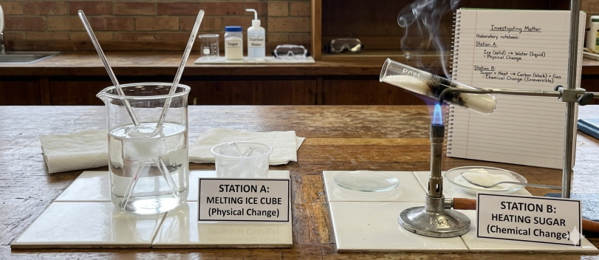
At Station B, learners place a spoonful of sugar in a test tube and heat it over a Bunsen burner until it turns black and gives off a burnt smell.


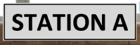
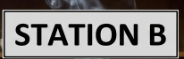

At Station B, the learners noticed the sugar turned into a black solid (carbon) and could not be turned back into white sugar. This is a characteristic of a chemical change because: A. The change is temporary. B. No new substance is formed. C. The change is irreversible. D. There is no change in weight.
- In an Integrated Science lesson, learners tested different kitchen substances using litmus paper. Lemon juice turned blue litmus red, while baking soda turned red litmus blue. Which of the following conclusion is correct based on the observations?
A. Lemon juice is basic and baking soda is acidic.
B. Lemon juice is acidic and baking soda is basic.
C. Both are acidic substances.
D. Both are neutral substances.

- During a school fire safety demonstration, learners observed that oil fires in the kitchen should not be extinguished using water. What is the safest method to extinguish a kitchen oil fire?
A. Use a fire blanket or sand. B. Pour water on it.
C. Switch off lights. D. Use alcohol.
- A learner put marbles into a glass and then poured water into the same glass. The water flowed round the marbles and took the shape of the glass. Which of the following is true about the behavior of solids and liquids in this scenario?
A. Solids have no fixed shape but liquids do.
B. Liquids have a definite shape.
C. Solids and liquids both take the shape of the container.
D. Solids have a definite shape while liquids do not.
- Which one of the following is not a recommended practice for maintaining healthy kidneys?
A. Drinking plenty of water.
B. Eating salty snacks regularly.
C. Getting enough sleep.
D. Eating a balanced diet.
- At school, Mariam learnt that copper was widely used in household wiring. What is the main reason for using copper?
A. It is shiny and decorative.
B. It is lightweight and floats in water.
C. It is a very good conductor of electricity.
D. It is cheap and magnetic.
- Grade 8 learners placed a lighted candle inside a glass jar and closed it tightly. After some time, the flame went out. What is the most likely reason the candle went out?
A. The jar became too hot.
B. The air pressure increased.
C. All the oxygen was used up.
D. The candle wax melted too fast.
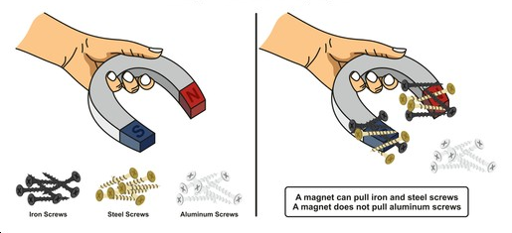
- A teacher placed various metallic materials iron, aluminum and steel screws near a bar magnet during a demonstration. Only the nail was pulled toward the magnet as illustrated in the picture below.

What conclusion did the learners make from the above experiment?
A. All metals are magnetic
B. Only plastic materials are magnetic
C. Some metals are non-magnetic
D. All materials are magnetic
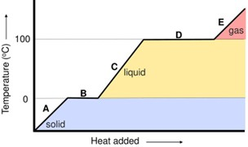
- A learner conducted an experiment by heating a beaker of ice using a hot plate. They record the temperature every minute and plot a heating curve. The graph below shows temperature changes from ice at –5°C to water boiling at 100°C.
Gas
Liquid
Solid
Heat added →

What does the flat section of the heating curve at 0°C represent?
A. Ice is increasing in temperature
B. Water is evaporating
C. Ice is melting into water
D. Water is freezing into ice
- The following are characteristics of vertebrates.
(i) Breathes through lungs
(ii) Lays unfertilised eggs
(iii) Breeds in water
The above vertebrate is most likely to be
A. Gecko
B. Shark
C. Whale
D. Newt
- Learners viewed onion cells under a microscope and observed a large structure filled with fluid in the centre of the cell. What is the name and main function of this structure?
A. Nucleus – controls cell activities
B. Cell wall – provides shape
C. Vacuole – stores water and minerals
D. Mitochondria – produces energy

- A Grade 9 Integrated Science teacher placed a balloon filled with air in the sun. After a while, the balloon expanded noticeably as shown in the picture below.
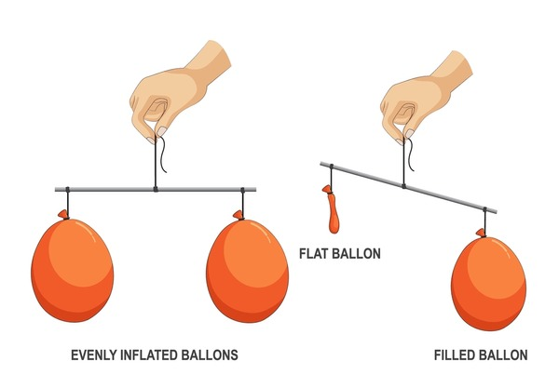
Which property of gases best explains this observation?
A. Gases have weight.
B. Gases expand when heated due to increased kinetic energy.
C. Gases condense into liquids when exposed to sunlight.
D. Gases become solids at high temperatures.
- Susan is tracking her menstrual cycle to better understand her fertility. She read that ovulation occurs in the middle of the cycle. If Susan’s menstrual cycle is 28 days long, around which day is she likely to ovulate?
A. 28
B. 14
C. 8
D. 10
- Which of the following can be classified as a compound as well as a molecule?
A. Crude oil
B. Water
C. Oxygen
D. Sodium
- A learner cut identical potato cubes and places them in different concentrations of salt solution. After 30 minutes, the cube in the most concentrated salt solution becomes smaller and shriveled. What conclusion can be drawn?
A. Osmosis did not occur.
B. Water moved into the potato cube.
C. The potato cube absorbed the salt.
D. Water moved out of the potato cube into the salt solution.
- In a classroom experiment, a teacher places a few crystals of potassium permanganate in a beaker of water.

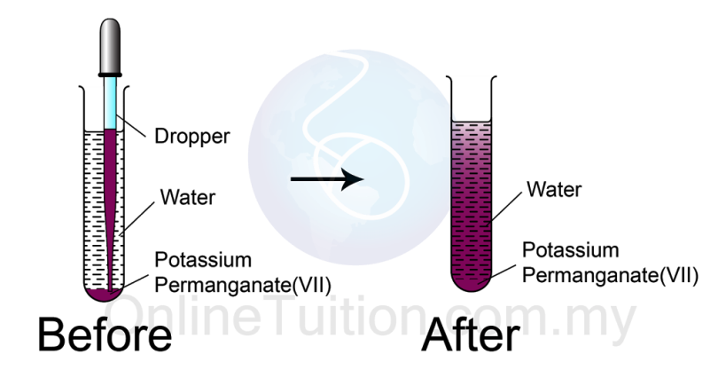
After a while, the purple color spreads evenly throughout the water. What does this demonstrate?
A. Osmosis of solute
B. Filtration process
C. Diffusion of particles
D. Evaporation of water
- Which of these is not a component of the fire triangle?
A. Oxygen
B. Heat
C. Water
D. Fuel
- Grade 9 learners were shown videos of different fire outbreaks: one in a school kitchen with burning cooking oil, one in a computer lab with sparking electrical cables and another in a storage room containing wood and papers.
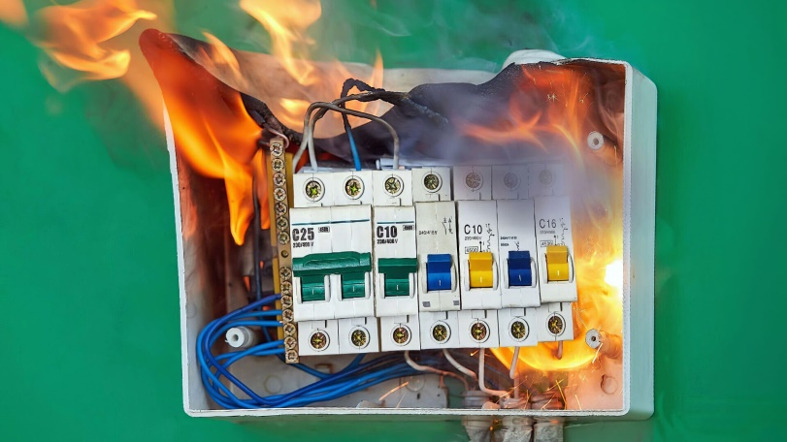
Which of the following classes of fire did the learners observe in the computer laboratory?
A. Class A fire
B. Class D fire
C. Class C fire
D. Class F fire
- A learner observed an electrical fire sparking out in an electronics shop. Which of the following fire extinguishers is most suitable to put out the fire?
A. Water extinguisher
B. CO₂ extinguisher
C. Wet chemical extinguisher
D. Foam extinguisher
- During the first few days of her cycle, a Grade 9 learner experienced bleeding and abdominal cramps. Which stage of the menstrual cycle is this?
A. Ovulation phase
B. Follicular phase
C. Menstrual phase
D. Luteal phase

SECTION B (30 MARKS)
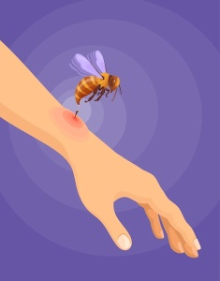
- A Grade 8 learner accidentally got stung by an insect while playing near a compost pit.

The parent applied a paste made from baking soda on the sting and the learner felt relief.
(a) Identify the type of substance (acid or base) likely injected by the insect. (1 mark)
_______________________________________________________________
(b) Explain how baking soda helped relieve the pain. (2 marks)
____________________________________________________________________________________________________________________________________________________________________________________________
- A learner prepared a slide of onion epidermal cells and viewed it under a microscope.
(a) List two structures that can be clearly seen in an onion cell under a light microscope. (2 marks)
- ________________________________________________________________________________________
- ________________________________________________________________________________________
(b) State one safety rule to follow when using a microscope. (1 mark)
____________________________________________________________________________________________
- Grade 8 science club members visited a workshop where they saw shiny, silver-gray metal rods used for making frames. The guide said the rods were made from pure aluminum. Why is aluminium classified as an element? (2 marks)
______________________________________________________________________________________________________________________________________________________________________________________
- James accidentally dropped his metal ruler and a rubber eraser. He noticed that the ruler made a loud sound and did not change shape, but the eraser bounced and slightly squished. Explain two properties of solids shown by the ruler and the eraser. (2 marks)
- _____________________________________________________________________________________
- _____________________________________________________________________________________
- Classify the following components of air as elements or compounds. (3 marks)
[carbon (iv) oxide, oxygen, nitrogen]
Elements
- ________________________________________________________________________________________
- ________________________________________________________________________________________
Compounds
- ________________________________________________________________________________________
- ________________________________________________________________________________________
- A group of learners were instructed to heat a small amount of salt solution to recover the salt. Each group carried out the experiment as shown below.

A | B
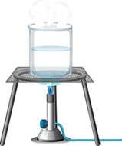 | 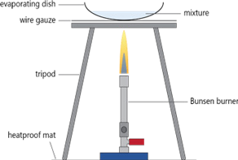  Evaporating dish Mixture  Wire guage  Tripod  Bunsen burner  Heat proof mat
The teacher observed that one group poured the salt solution directly into the beaker and heated it over a Bunsen burner using the tripod and wire gauze. Another group used an evaporating dish for heating the salt solution instead.
(a) Name the most suitable set up that should be used to recover salt from the salt solution. Give a reason. (2 marks)
____________________________________________________________________________________________________________________________________________________________________________________________
(b) Explain why it is safer to use an evaporating dish instead of a beaker for heating the salt solution directly. (2 marks)
____________________________________________________________________________________________________________________________________________________________________________________________
(c) State the use of the wire gauze in this experiment. (1 mark)
_____________________________________________________________________________________________

- Grade 8 learners did experiments of changes of state of matter.

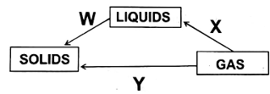
Using the diagram above
- Name the process marked. (2 marks)
W: ___________________________. X: ___________________________. Y: __________________________.
(b) Identify one process that requires an increase in temperature. (1 mark)
______________________________________________________________________________________________
- Ahmed poured juice into a tall glass and then into a wide bowl. The amount was the same, but the shape changed. What property of liquids does this show? (2 marks)
______________________________________________________________________________________________________________________________________________________________________________________
- During a Science practical, Grade 8 learners were asked to investigate how the number of cells affect the brightness of a bulb in a simple circuit. The materials provided included:
Three dry cells, wires, a bulb, a switch and a bulb holder
The learners first connected one dry cell to the circuit and observed the bulb glowed dimly.
They then connected two cells in series, and the bulb glowed brighter. Finally, they connected three cells, and the bulb glowed very brightly.
(a) What is the role of the dry cells in the circuit? (1 mark)
____________________________________________________________________________________________
(b) Explain why the bulb became brighter as more cells were added. (3 marks)
____________________________________________________________________________________________________________________________________________________________________________________________
(c) Explain what would happen if one of the wires in the circuit became loose or disconnected. (2 marks)
____________________________________________________________________________________________________________________________________________________________________________________________
THIS IS THE LAST PRINTED PAGE

