K.J.S.E.A

JUNIOR SCHOOL EDUCATION ASSESSMENT

TERM 2: ENDTERM ASSESSMENT 2026
GRADE 8 – CREATIVE ARTS AND SPORTS
Time: 1 Hour 30 Minutes
LEARNER’S DETAILS
Name: ________________________________________________. School: _____________________________________________________.
Assessment Number: _________________________________. Date: ______________________________________________________.
School Code: _______________________________________. Signature: _________________________________________________.

Instructions for Learners
- Write your full name and assessment number in the spaces provided above.
- Indicate your school name and school code clearly.
- Sign and date this paper in the spaces provided.
- This paper consists of TWO sections: Section A and Section B.
- Answer ALL questions in BOTH sections.
- Write your answers in the spaces provided in this question paper.
- Do NOT remove any page from this paper.
- All responses must be written in English
FOR EXAMINER’S USE
SECTION | SECTION A | SECTION B | % SCORE | EE1 | EE2 | ME1 | ME2 | AE1 | AE2 | BE1 | BE2
SCORE RANGE | 20 MARKS | 30 MARKS |  | 90-100 | 75-89 | 58-74 | 41-57 | 31-40 | 21-30 | 11-20 | 1-10
POINTS |  |  |  | 8 POINTS | 7 POINTS | 6 POINTS | 5 POINTS | 4 POINTS | 3 POINTS | 2 POINTS | 1 POINT
LEARNER’S TOTAL SCORE

SECTION A (20 MARKS) Answer ALL questions in this section
- Which one of the following is not an element of a verse?
A. Character B. Audience C. Theme D. Setting
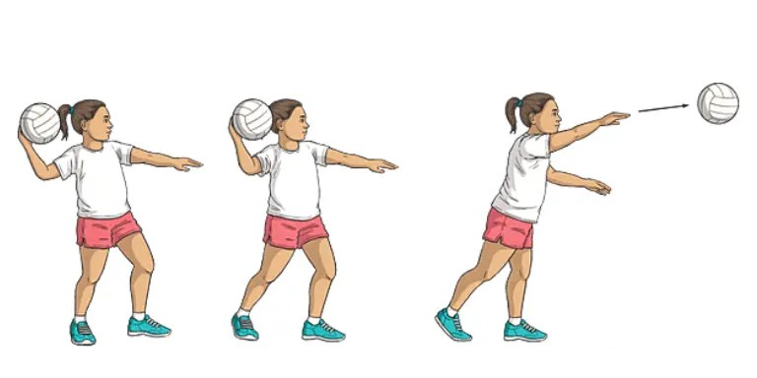
- While reading and interpreting a piece of melody, a learner found the word D.C. al Fine. Which of the following is the correct interpretation of the word?
A. Go back to the beginning and play until the point marked “Fine”.
B. Repeat from the middle and end at the coda.
C. Start from the end and play backwards to the beginning.
D. Play only the final section of the piece.
- The picture below shows two players marked A and B participating in the game of netball.

Which netball skill was player A executing?
A. Dodging B. Marking C. Passing D. Shooting
- Mustafa played a melody on a descant recorder in the scale of C-Major. Which one of the following was the correct melody?
A. C D E F G A# B C
B. C D E F# G A B C
C. C D E F G A B C
D. C D E F G A B C
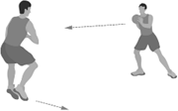
- Grade 8 learners performed the exercise below to enhance a component of physical fitness.

Which of the following components of physical fitness was enhanced by this activity?
A. Power B. Strength
C. Agility D. Coordination

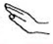
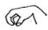
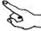
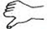
- Which of the following hand sign represents the highest solfa syllable?

A. B. C. D.
- Which one of the following is not one of the components used to analyse a folk song?
A. Community of origin
B. Gender
C. Attire
D. Occasion
- Which one of the following is not a reason for executing the dodge?
A. Create space and get free from a defender.
B. Confuse the opposing team and change direction quickly.
C. Delay the game and waste time.
D. Receive the ball more easily from a teammate.
- Which of the following is the correct time signature for the beat shown below?
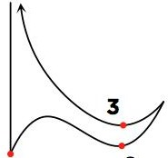
A. 3/4 B. 4/4 C. 3/3 D. 2/3
- Which of the following notes has the longest beat?
A. Quaver rest B. Minim rest
C. Semibreve rest D. Crotchet rest
- During a football friendly match, players sometime do some light activities. Which one of the following was not one of the activities?
A. Jogging around the field.
B. Stretching exercises.
C. Playing a full competitive match.
D. Arm and leg swings.
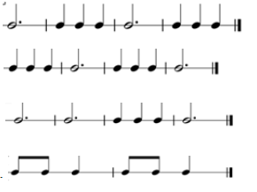
- Which of the following patterns is not composed in 3/4 time signature?
A.
B.
C.
D.

- Mr. Victor instructed the learners to use complementary colours to create a pictorial composition. Which of the following was not an effect of using complementary colours?
A. Contrast B. Visual Interest
C. Vibrancy D. Harmony
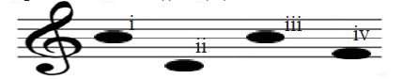
- Which of the following is the correct order of the pitches labelled (i) to (iv) in the treble staff below?

A. B E E A B. B A E E
C. B E A E D. E B A E
- Which of the following is not a characteristic of a photomontage composition?
A. Superimposed
B. Use of different media
C. Use of photographs
D. Overlapping
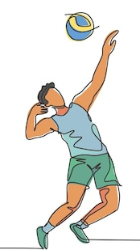
- The skill shown below is used in the game of volleyball.

Which of the following does not explain when the skill is used? To
A. accurately set the ball for a teammate to attack
B. control the ball during a rally
C. serve the ball over the net
D. pass the ball to a better-positioned teammate
- Which of the following shows the technique that was used to decorate the fabric below?
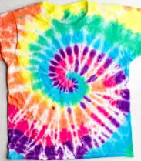
A. Stencil printing B. Marbling
C. Tie and dye D. Pleating
- Imagery is used when composing a verse for all the following reasons except
A. conveying complex ideas
B. establishing atmosphere and mood
C. exposing the reader to difficult language
D. engaging the reader’s imagination

- Which of the following is not a way of making folk song performance more interesting?
A. Using facial expressions to show emotion.
B. Including simple movements and gestures.
C. Maintaining a dull and flat vocal tone.
D. Wearing traditional costumes during performance.
- Which of the following is a quality of a good melody?
A. Moves in a stepwise motion
B. Ends in f
C. Not singable
D. It is not easy to perform

SECTION B (30 MARKS)

PART I: PERFORMING ARTS (10 MARKS)
- Creative Arts and Sports has different categories. State two categories that are related to Performing Arts. (2 marks)
- _________________________________________________________________________________________________
- _________________________________________________________________________________________________
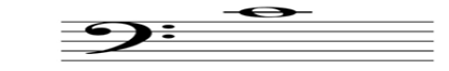
- The staff below was drawn by a grade 8 learner during a music lesson.

(a) Give the name of the staff. (1 mark)
___________________________________________________________________
(b) Identify the pitch note above the staff. (1 mark)
____________________________________________________________________
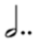
- Mr. Kithuku wrote a minim and two dots as shown below to explain to learners how to extend note values using dots.

(a) Give the correct interpretation of the dotted minim below. (1 mark)
___________________________________________________________________________________________
(b) State one other method of extending note values. (1 mark)
____________________________________________________________________________________________
- Below is a piano keyboard that learners used to play different melodies.
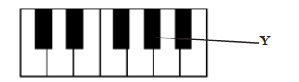
(a) Name the two pitches that were played when the key labelled Y is pressed. (2 marks)
(i) _____________________________________________
(ii) ____________________________________________
(b) State two factors considered when composing melodies. (2 marks)
- _________________________________________________________________________________________________
- _________________________________________________________________________________________________

PART II: SPORTS (10 MARKS)
- Explain two ways in which a volley pass can make a volleyball game interesting. (2 marks)
- _________________________________________________________________________________________________
- _________________________________________________________________________________________________
- A Creative Arts and Sports teacher demonstrated how to start some races as shown in the picture below.
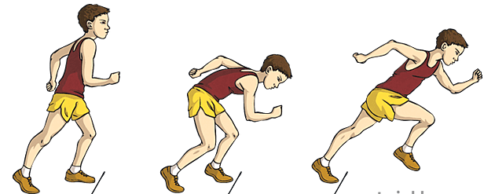
(a) Name the starting technique shown in the picture above. (1 mark)
_____________________________________________________
(b) State the race in which the starting technique shown above is used. (1 mark)
_______________________________________________________________________________________
- Explain one incident when a netball player may decide to use an overhead pass. (1 mark)
______________________________________________________________________________________________
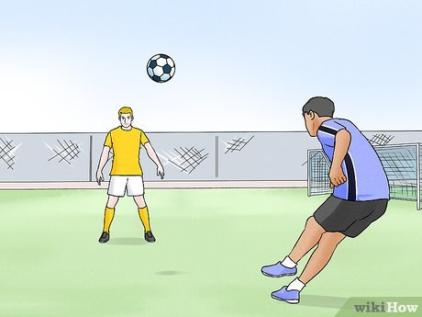
- Mutili, a football player likes kicking the ball using the technique shown in the picture below.

(a) Name the type of pass in football as shown above. (1 mark)
_____________________________________________________________________________
(b) List two key characteristics of the kicking technique named above. (2 marks)
- _________________________________________________________________________________________________
- _________________________________________________________________________________________________
- State one safety measure to emphasize on when practising javelin throw. (1 mark)
__________________________________________________________________________________________________________________________________________________________________________________________________
- State one component of physical fitness we should enhance in order to keep our bodies fit. (1 mark)
__________________________________________________________________________________________________________________________________________________________________________________________________

PART III: VISUAL ARTS (10 MARKS)
- The picture below is a composition that was created by a grade 8 learner to show a certain principle of art.

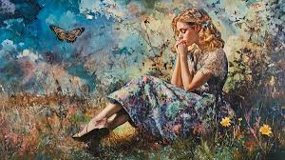
(a) Identify the principle of art the learner intended to create. (1 mark)
____________________________________________________
(b) Explain how the learner achieved the principle of art identified above. (1 mark)
__________________________________________________________________________________________
(c) Give one importance of the principle of art identified in visual artworks. (1 mark)
____________________________________________________________________________________________
- Give two examples of 2D artworks. (2 marks)
(i) __________________________________________________________________________
(ii) __________________________________________________________________________
- Susan prepared a background surface in preparation for making a photographic storyboard. State one technique that she may use to prepare the background. (1 mark)
_______________________________________________________________________________
- A group of Grade 8 learners created a presentation as part of their Creative Arts and Sports activity.
(a) Identify the social role of Creative Arts and Sports demonstrated in their work. (1 mark)
___________________________________________________________________________________
(b) State one other social role of Creative Arts and Sports in society. (1 mark)
____________________________________________________________________________________
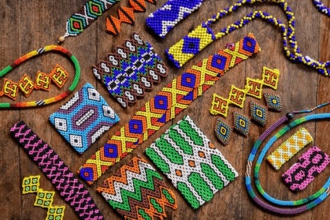
- Below is a picture showing one of the indigenous Kenyan crafts.

(a) Name the indigenous Kenyan craft shown in the picture above. (1 mark)
____________________________________________________________________________________________
(b) Explain one importance of the indigenous Kenyan craft named above. (1 mark)
___________________________________________________________________________________________
THIS IS THE LAST PRINTED PAGE

