K.J.S.E.A

JUNIOR SCHOOL EDUCATION ASSESSMENT

TERM 2: ENDTERM ASSESSMENT 2026
GRADE 8– AGRICULTURE
Time: 1 Hour 30 Minutes
LEARNER’S DETAILS
Name: ________________________________________________. School: _____________________________________________________.
Assessment Number: _________________________________. Date: ______________________________________________________.
School Code: _______________________________________. Signature: _________________________________________________.

Instructions for Learners
- Write your full name and assessment number in the spaces provided above.
- Indicate your school name and school code clearly.
- Sign and date this paper in the spaces provided.
- This paper consists of TWO sections: Section A and Section B.
- Answer ALL questions in BOTH sections.
- Write your answers in the spaces provided in this question paper.
- Do NOT remove any page from this paper.
- All responses must be written in English
FOR EXAMINER’S USE
SECTION | SECTION A | SECTION B | % SCORE | EE1 | EE2 | ME1 | ME2 | AE1 | AE2 | BE1 | BE2
SCORE RANGE | 20 MARKS | 30 MARKS |  | 90-100 | 75-89 | 58-74 | 41-57 | 31-40 | 21-30 | 11-20 | 1-10
POINTS |  |  |  | 8 POINTS | 7 POINTS | 6 POINTS | 5 POINTS | 4 POINTS | 3 POINTS | 2 POINTS | 1 POINT
LEARNER’S TOTAL SCORE

SECTION A (20 MARKS) Answer ALL questions in this section

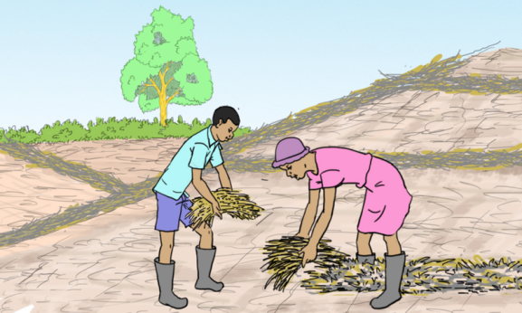
- The picture below shows a soil conservation method spotted in one of the farmer’s farm in a village.

Identify the soil conservation method shown above.
A. Mulching
B. Trash lines
C. Terracing
D. Grassed waterways
- Which of the following is not an economic benefit of planting trees?
A. To get timber for making furniture.
B. To get fruits for sale.
C. To get nuts for the birds to feed on.
D. To get ingredients for medicine.
- A grade 8 learner was asked to give his understanding of kitchen and backyard gardening. Which of the following was the response given?
A. Gardening methods used exclusively by professional chefs
B. Growing herbs and vegetables in small spaces around your home
C. Industrial farming techniques for large scale food production
D. Landscaping practices for enhancing backyard aesthetics

- Which one of the following is a key consideration when selecting protein sources for a balanced meal?
A. Colour of the protein B. Price per serving
C. Fat content D. Cooking time
- At a beginners gardening workshop, what preparations are necessary before starting kitchen and backyard gardening?
A. Testing soil quality and choosing suitable crops.
B. Installing a swimming pool for water conservation.
C. Purchasing high end gardening equipment.
D. Hiring a landscape architect for garden layout.
- What is the benefit of frying fish after processing it?
A. It enhances flavor and texture.
B. It preserves the fish for a long time.
C. It makes the fish easier to scale.
D. It helps remove internal organs.
- Identify the method of water storage below.
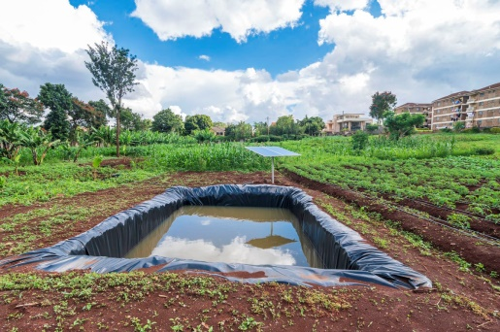
A. Reservoirs and ponds
B. Underground storage
C. Shallow water pans
D. Groundwater recharge
- Grade 8 learners were asked by their Agriculture teacher to state the factors to consider when constructing a poultry fold. Who among them gave the correct answer?
A. Kelvin – Feeding and water systems
B. Hilda – High prices of feeds
C. Jabez – Diseases
D. Ann – Availability of market
- Lena needs to choose a preservation method for her homemade cheese. Which method is traditionally used for dairy products?
A. Drying
B. Fermentation
C. Salting
D. Canning
- Auma wants to peel vegetables. When should she peel them to retain nutrients?
A. Before washing.
B. After washing.
C. Immediately before cooking.
D. Just before serving.
- Which of the following practices can help reduce the risk of predators when rearing poultry in a fold?
A. Moving the fold frequently.
B. Providing a shade.
C. Using strong materials in construction of the fold.
D. Chasing away predators.
- Jedina’s corn plants started showing stunted growth and had galls or knots on the roots. What pest is likely causing this issue on Jedina’s corn plants?
A. Root-knot nematodes
B. Aphids
C. Cutworms
D. Leafhoppers
- A fisherman is planning to preserve a large catch of fish for the winter. Which of the following is an effective method to extend the shelf life of fresh fish?
A. Boiling
B. Steaming
C. Baking
D. Salting
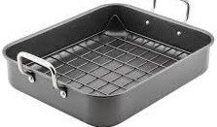
- The picture below shows an equipment used in roasting.

What is its use?
A. It allows for controlled heat distribution and even cooking.
B. It is used to cover roasts loosely to prevent excessive browning or drying out.
C. It is used to hold the food being roasted and can catch drippings for making sauces or gravies.
D. Used for applying oils, marinades or juices to the food during roasting to keep it moist and add flavor.
- Grade 8 learners are conducting an experiment on food preservation for their science fair. They need to demonstrate a method that uses acid to preserve food. Which food and method should they choose for their demonstration?
A. Canning peaches in vinegar
B. Freezing strawberries
C. During apple slices
D. Fermenting cabbage into sauerkraut
- Which one of the following is a role played by hydration in maintaining a balanced diet?
A. It enhances flavor of meals.
B. It prevents dehydration.
C. It reduces calorie intake.
D. It improves digestion.
- Zelda notices food splatters inside the microwave after heating meals throughout the day. How should she clean the microwave?
A. Use a damp cloth with soap and water.
B. Wipe with a dry cloth.
C. Heat vinegar inside the microwave and wipe clean.
D. Use the microwave as is; the splatters will evaporate eventually.
- Which one of the following is a reason why we should use a separate sponge for cleaning dishes and wiping countertops?
A. To save money on sponges.
B. To prevent spread of bacteria.
C. To avoid scratching countertops.
D. To reduce clutter in the kitchen.

- Which of the following cleaning materials prevents colour loss from coloured items?
A. Vinegar
B. Salt
C. Soap
D. Lemon
- Which one of the following is a main challenge faced when using farmed suspended gardening?
A. Soil compaction
B. Excessive sunlight
C. Lack of plant diversity
D. Overwatering

SECTION B (30 MARKS)
- A farmer noticed his bean plants had water-soaked spots on their leaves, which later turned brown and necrotic.
(a) Identify the type of disease affecting the farmer’s beans. (1 mark)
_______________________________________________________________________
(b) Mention two methods the farmer can use to control the diseases. (2 marks)
- _________________________________________________________________________________________
- _________________________________________________________________________________________
- Grade 7 learners learnt about crop management practices.
(a) Name two tools used for thinning. (2 marks)
- _________________________________________________________________________________________
- _________________________________________________________________________________________
(b) Outline two importance of crop management practices the learners learnt. (2 marks)
- _________________________________________________________________________________________
- _________________________________________________________________________________________
- Macharia constructed the poultry fold below for his chicken.
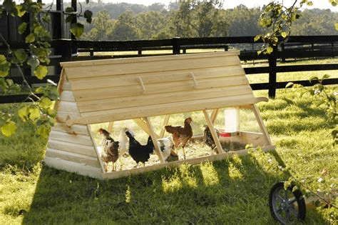
(a) Identify two factors he considered when constructing the poultry fold. (2 marks)
- _________________________________________________________________________________________
- _________________________________________________________________________________________
(b) Mention three practices for rearing chicken in a fold he should consider. (3 marks)
- _________________________________________________________________________________________
- _________________________________________________________________________________________
- _________________________________________________________________________________________
- Onesmus was preparing a presentation on the importance of soil conservation measures. List three points he included in his presentation. (3 marks)
- _________________________________________________________________________________________
- _________________________________________________________________________________________
- _________________________________________________________________________________________
- Mary wants to plan a menu for a family reunion with guests of all ages. What considerations should she have to ensure a balanced meal for everyone? (2 marks)
- _________________________________________________________________________________________
- _________________________________________________________________________________________
- Jared wants to plant flowers and carrots in his farm.
(a) Which tilth is suitable for the crops? (1 mark)
_________________________________________________________________
(b) What should he do before planting the crops? (2 marks)
- _________________________________________________________________________________________
- _________________________________________________________________________________________
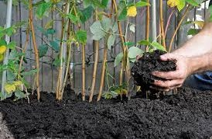
- Reri village has experienced a lot of soil pollution as a result of poor farming methods. An agricultural officer asked them to apply the method below.

(a) Identify the practice of controlling soil pollution shown above. (1 mark)
___________________________________________________________________
(b) Name any two other practices for controlling soil pollution at home. (2 marks)
- _________________________________________________________________________________________
- _________________________________________________________________________________________
- State three benefits of a kitchen garden in food production. (3 marks)
- _________________________________________________________________________________________
- _________________________________________________________________________________________
- _________________________________________________________________________________________
- Your teacher invited a resource person to talk to you on the importance of processing fish and dressing poultry carcass. Highlight two points mentioned by the resource person. (2 marks)
- _________________________________________________________________________________________
- _________________________________________________________________________________________
- State two reasons for maintaining a clean kitchen. (2 marks)
- _________________________________________________________________________________________
- _________________________________________________________________________________________
THIS IS THE LAST PRINTED PAGE

