K.J.S.E.A

JUNIOR SCHOOL EDUCATION ASSESSMENT

TERM 2: ENDTERM ASSESSMENT 2026
GRADE 7 – SOCIAL STUDIES
Time: 1 Hour 30 Minutes
LEARNER’S DETAILS
Name: ________________________________________________. School: _____________________________________________________.
Assessment Number: _________________________________. Date: ______________________________________________________.
School Code: _______________________________________. Signature: _________________________________________________.

Instructions for Learners
- Write your name, school name, and assessment number in the spaces provided.
- This paper consists of five questions.
- Check the question paper carefully to ensure all pages are printed and no questions are missing.
- Answer all the questions in the spaces provided. FOR EXAMINER’S USE
SECTION | SECTION A | SECTION B | % SCORE | EE1 | EE2 | ME1 | ME2 | AE1 | AE2 | BE1 | BE2
SCORE RANGE | 20 MARKS | 80 MARKS |  | 90-100 | 75-89 | 58-74 | 41-57 | 31-40 | 21-30 | 11-20 | 1-10
POINTS |  |  |  | 8 POINTS | 7 POINTS | 6 POINTS | 5 POINTS | 4 POINTS | 3 POINTS | 2 POINTS | 1 POINT
LEARNER’S TOTAL SCORE

SECTION A (20 MARKS) Answer ALL questions in this section

- During a visit to the planetarium, Grade 7 learners observed that the Earth moves around the Sun once every 365 days. This movement is called
A. rotation B. orbiting C. revolution D. tilting
- Learners observed that when it is 12 noon in Nairobi, it is earlier in Lagos, Nigeria. The difference is due to
A. longitude B. latitude C. altitude D. seasons

- A class discussion on the importance of the Equator concluded that it
A. separates day and night
B. divides Earth into Eastern and Western hemispheres
C. divides Earth into Northern and Southern hemispheres
D. marks the boundary between continents

- A teacher asked learners to name the largest ocean on Earth. The correct answer was
A. Atlantic B. Indian C. Pacific D. Arctic
- During a study on soil erosion, learners found that planting trees prevents it because trees
A. dry the soil
B. make soil slippery
C. hold soil firmly using roots
D. attract rainfall directly
- Grade 7 learners watched a documentary on the Great Zimbabwe Kingdom. It was famous for
A. iron-smelting B. stone architecture C. gold trading D. cattle keeping
- A group of learners traced early human origin to East Africa because of
A. fossils found in Olduvai Gorge
B. presence of fertile soils
C. early kingdoms nearby
D. existence of trade routes
- When the class visited a historical site, the guide explained that archaeologists use carbon dating to
A. determine language of artifacts
B. test chemical composition of soil
C. find the age of artifacts
D. preserve fossils
- The Asante Kingdom was located in the present-day country of
A. Nigeria B. Ghana C. Sudan D. Ethiopia
- The main reason for the growth of early trade along the East African coast was
A. discovery of diamonds
B. monsoon winds aiding sailing
C. development of roads
D. missionary activities
- A teacher displayed Kenyan currency and asked learners to identify its security features. One such feature is
A. signature of the President
B. portrait of a wild animal
C. watermark image
D. bright colours
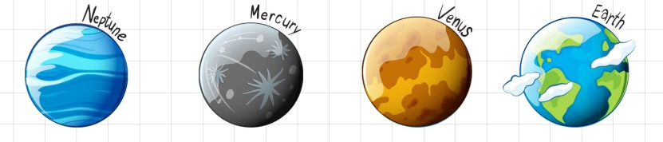
- Johanna was asked to name the coldest Planet. The planet is likely to be?

A. B. C. D.
- Learners acted a skit on resolving conflicts peacefully. The key life skill demonstrated was
A. negotiation B. withdrawal C. avoidance D. competition
- The body responsible for maintaining peace in Kenya is
A. National Museums of Kenya
B. Kenya Defence Forces
C. Kenya Red Cross
D. National Police Service
- A learner from Isiolo explained that her community practices pastoralism mainly because
A. land is rocky
B. rainfall is low
C. rivers are many
D. soils are fertile

- During an environmental clean-up, learners collected plastics for recycling. This promotes
A. waste production
B. environmental conservation
C. air pollution
D. soil exhaustion
- Which of the following statements about democracy is TRUE?
A. Citizens are forced to vote
B. Leaders are chosen by inheritance
C. People participate in decision-making
D. Power belongs to the army
- When a learner keeps promises and tells the truth, the value shown is
A. honesty B. obedience C. generosity D. humility
- The best method of resolving disputes in school peacefully is
A. fighting B. mediation C. ignoring D. gossiping
- Learners agreed to plant trees around their school compound. This activity mainly promotes
A. patriotism B. conflict C. pollution D. deforestation

SECTION B: (80 MARKS)

PART 1: MAPWORK (10 MARKS)

- Use the map of Mayoni Area below to answer questions 1-7

SCALE
0
1
2
3
4
5
6
7
8
Km
9

KEY
Forest
River and Bridge
Houses
Murram road
School
Post Office
PO

Scrub
Permanent buildings
Salt deposits
S S

Church

Maize farm

Shrine
Cattle ranch
Mayoni Town

Market
CC
PP
PO
Airstrip

`
Game sanctuary

Shrine

S
S
S
Lake Katwe

N

CC – county commissioner Tarmac

  - Land in Mayoni area slopes towards the. (1 mark) ___________________________________________________________________________________
  - What is approximate length of the tarmac road in Mayoni area? (2 marks)
___________________________________________________________________________________
  - Outline two religions likely to be found in Mayoni area (2 marks)
- ___________________________________________________________________________________
- ___________________________________________________________________________________
  - Write two statements about Lake Katwe? (2 marks)
- ___________________________________________________________________________________
- ___________________________________________________________________________________

  - Mention two social services offered in Mayoni town(2 marks)
- ___________________________________________________________________________________
- ___________________________________________________________________________________
  - The airstrip in Mayoni area is used to transport(1 mark)
___________________________________________________________________________________

PART 2: GEOGRAPHY (35 MARKS)
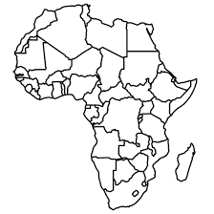
Use the map of Africa provided.

- On the map:
a) Shade and label the Sahara Desert. (1 mark)
b) Label the River Nile. (1 mark)
c) Mark and name Kenya. (1 mark)
d) Draw and label the Equator. (1 mark)
e) Identify and label the Atlantic Ocean. (1 mark)
- Name two countries that border Kenya. (2 marks)
- ___________________________________________________________________________________
- ___________________________________________________________________________________

  - Mention two major physical features found in East Africa. (2 marks)
- ___________________________________________________________________________________
- ___________________________________________________________________________________
  - State one use of a scale on a map. (1 mark)
- ___________________________________________________________________________________

  - Define the term rotation of the Earth. (1 mark)
____________________________________________________________________________________________________________________________________________________________________________________________
  - Write two differences between rotation and revolution of the earth.(2 mks)
Rotation of the Earth | Revolution of the Earth
  - The diagram below shows the internal structure of the Earth.
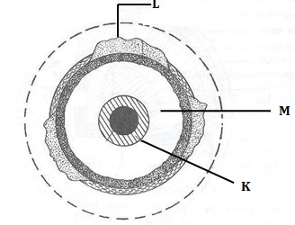
i) Name parts labeled L and M. (2 marks)
L: ____________________ M: _____________________
  - Name any two theories explaining the origin of the earth.(2 mks)
- ___________________________________________________________________________________
- ___________________________________________________________________________________
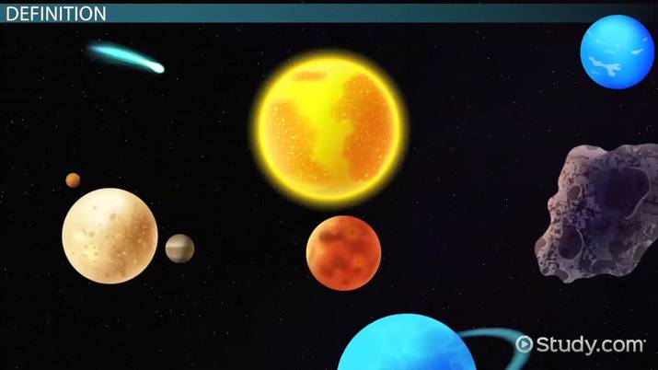
  - Mr. Suke displayed a burner showing the components of the solar system as shown below.

E

F

Identify the following solar system components. (2 mks)
E: ___________________________________. F: ____________________________________.
- During a map lesson, learners were taught about three types of maps. Name two types of maps. (2 mks)
- ___________________________________________________________________________________
- ___________________________________________________________________________________
- Define weather. (2 marks)
___________________________________________________________________________________
___________________________________________________________________________________
- State two factors to consider when siting a weather station.(2 mks)
- ___________________________________________________________________________________
- ___________________________________________________________________________________
- Identify the following weather measuring instruments.(2 mks)
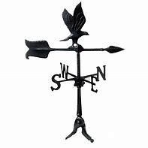
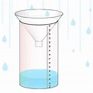

A B
A: _________________________________________________________________________
B: _________________________________________________________________________
- a) Discuss two methods of collecting fieldwork data. (2 marks)
- ___________________________________________________________________________________
- ___________________________________________________________________________________
b) Explain two methods of data presentation. (2 marks)
- ___________________________________________________________________________________
- ___________________________________________________________________________________
c) Mention two challenges faced during fieldwork and propose solutions. (2 marks)
- ___________________________________________________________________________________
- ___________________________________________________________________________________
d) Describe the passing star theory about origin of the earth. (2 marks)
__________________________________________________________________________________________________________________________________________________________________________________________________________________________________________________________________________________________

PART 3: HISTORY (25 MARKS)
- (a) Define the term history. (2 marks)
______________________________________________________________________________________________
______________________________________________________________________________________________
(b) List three sources of historical information. (3 marks)
- ___________________________________________________________________________________
- ___________________________________________________________________________________
- ___________________________________________________________________________________
- Explain two advantages of oral traditions as a source of history. (2 marks)
- ___________________________________________________________________________________
- ___________________________________________________________________________________
- (a) State two reasons why early humans moved from place to place. (2 marks)
- ___________________________________________________________________________________
- ___________________________________________________________________________________
(b) Give two ways early humans adapted to their environment. (2 marks)
- ___________________________________________________________________________________
- ___________________________________________________________________________________
- (a) Identify three achievements of the Ancient Egyptian civilization. (3 marks)
- ___________________________________________________________________________________
- ___________________________________________________________________________________
- ___________________________________________________________________________________
(b) Name two rivers that supported its development. (2 marks)
- ___________________________________________________________________________________
- ___________________________________________________________________________________
- The Kingdom of Kongo was known for strong leadership.
(a) State two roles of the King (Manikongo). (2 marks)
- ___________________________________________________________________________________
- ___________________________________________________________________________________
(b) Mention two reasons for the decline of the kingdom. (2 marks)
- ___________________________________________________________________________________
- ___________________________________________________________________________________
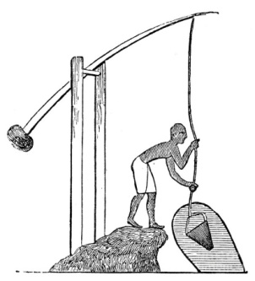
- (a) Name the type of irrigation practiced in ancient Egypt in Africa. (1 mark)

___________________________________________
(b) Name one type of crop grown during early agriculture in Africa. (1 mark)
___________________________________________________________________________________
(c) Explain two benefits of agriculture to ancient communities. (2 marks)
- ___________________________________________________________________________________
- ___________________________________________________________________________________
- (a) What was the main reason for the Indian Ocean trade? (2 marks)
- ___________________________________________________________________________________
- ___________________________________________________________________________________
(b) Mention two goods traded through this route. (2 marks)
- ___________________________________________________________________________________
- ___________________________________________________________________________________

PART 4: CITIZENSHIP (5 MARKS)
- (a) Name any two colours of the National Flag of Kenya. (2 marks)
- ___________________________________________________________________________________
- ___________________________________________________________________________________
(b) State two occasions when we sing the Kenya National Anthem. (2 marks)
- ___________________________________________________________________________________
- ___________________________________________________________________________________
- Mention one responsibility of a good citizen. (1 mark)
- ___________________________________________________________________________________

PART 5: LIFE SKILLS (5 MARKS)
- (a) Define assertiveness. (2 marks)
- ___________________________________________________________________________________
- ___________________________________________________________________________________
(b) State two advantages of being assertive. (2 marks)
- ___________________________________________________________________________________
- ___________________________________________________________________________________
- Identify one life skill that helps learners resist negative peer pressure. (1 mark)
- ___________________________________________________________________________________

THIS IS THE LAST PRINTED PAGE

