K.J.S.E.A

JUNIOR SCHOOL EDUCATION ASSESSMENT

TERM 2: ENDTERM ASSESSMENT 2026
GRADE 7 – PRETECHNICAL STUDIES
Time: 1 Hour 30 Minutes
LEARNER’S DETAILS
Name: ________________________________________________. School: _____________________________________________________.
Assessment Number: _________________________________. Date: ______________________________________________________.
School Code: _______________________________________. Signature: _________________________________________________.

Instructions for Learners
- Write your full name and assessment number in the spaces provided above.
- Indicate your school name and school code clearly.
- Sign and date this paper in the spaces provided.
- This paper consists of TWO sections: Section A and Section B.
- Answer ALL questions in BOTH sections.
- Write your answers in the spaces provided in this question paper.
- Do NOT remove any page from this paper.
- All responses must be written in English

FOR EXAMINER’S USE
SECTION | SECTION A | SECTION B | % SCORE | EE1 | EE2 | ME1 | ME2 | AE1 | AE2 | BE1 | BE2
SCORE RANGE | 20 MARKS | 30 MARKS |  | 90-100 | 75-89 | 58-74 | 41-57 | 31-40 | 21-30 | 11-20 | 1-10
POINTS |  |  |  | 8 POINTS | 7 POINTS | 6 POINTS | 5 POINTS | 4 POINTS | 3 POINTS | 2 POINTS | 1 POINT
LEARNER’S TOTAL SCORE

SECTION A (20 MARKS) Answer ALL questions in this section

- Which one of the following is not a day-to-day activity that needs to use computer skills?
A. Driving vehicles.
B. Monitoring weather.
C. Calculating amount in supermarkets.
D. Treating patient.s
- Which of the following is a component of a web threat?
A. Poor posture B. Heavy workload
C. Relationship D. Threat motive
- Valary has a laptop that she uses for her online work. Which of the following is a physical threat to her laptop?
A. Cyberbullying
B. Data theft
C. Hacking
D. Hardware failure.
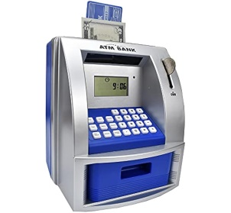
- An ATM Machine is said to be a type of computer.

Which classification does it belong to?
A. Digital computer B. Analogue computer
C. Hybrid computer D. Mainframe computer
- Grade 7 learners were discussing about characteristics of computers. Which characteristic helps you to avoid getting tired when performing tasks?
A. Versatility B. Diligence
C. Accuracy D. Automatic
- What is the benefit of using drawing as a tool for communication in scientific research?
A. It complicates data interpretation.
B. It simplifies complex concepts and data.
C. It ignores experimental findings.
D. It excludes visual learners.
- In mechanical engineering drawings, Paul came across a couple of symbols and abbreviations. Which symbol below represents arc length?

10
A B C D
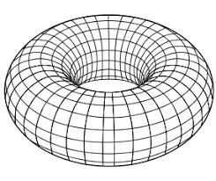
- During a drawing lesson, a teacher displayed the picture below.

Name the shape of the picture.
A. Cuboid B. Torus C. Triangle D. Circle
- Janet shaded her picture after drawing. Which impression did she make after shading?
A. Real picture.
B. Darkened the picture.
C. Made the picture lighter.
D. Scratched the picture.
- Which of the following ICT tools is commonly used to send mail messages communication?
A. Email B. Social media
C. Video conferencing D. Instant messaging
- The tool below can be used in an office for communication.

What is its name?
A. Online collaboration B. Social networking
C. Web conferencing D. Computer
- Mwangi and his friends are working on a project to build eco-friendly toys for children. What is the most suitable material they could use for their project?
A. Recycled paper
B. Single-use plastic
C. Metal
D. Glass
- Grade 7 learners were tasked with sorting materials into metallic and non-metallic categories. Which among the following materials is metallic?
A. Rubber band
B. Copper wire
C. Wood
D. Plastic bottle
- Most beverage cans manufacturers use aluminum for production. What makes aluminum a suitable choice for beverage cans?
A. It is very dense.
B. It is corrosion resistant and lightweight.
C. It is magnetic.
D. It has high tensile strength.
- In relation to the use of metallic materials in the health sector, which metal is often used in medical implants because of its biocompatibility?
A. Aluminum
B. Copper
C. Titanium
D. Zinc
- Which one of the following is not a non-metallic material?
A. Log of wood
B. Glasee
C. Alminium
D. Stone
- Most non-metallic materials do not allow conductivity. Which non-metallic material is commonly used for insulation in buildings?
A. Steel
B. Concrete
C. Fiberglass
D. Aluminum
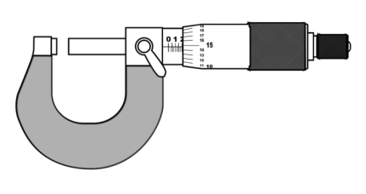
- Chris went into a hardware store and saw the tool shown below.

What is it called?
A. Voltmeter
B. Ammeter
C. Steel rule
D. Micrometre screw gauge
- A punch is used to make indentations on various surfaces in preparation for drilling. What material is it made of?
A. Wood
B. Plastic
C. Metal
D. Rubber
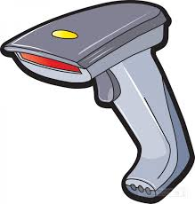
- Vera came across the device below.
What is it called?
A. Barcode reader
B. Projector
C. Speech generating device
D. Braille reader
SECTION B (30 MARKS)
- The computer consists of primary and secondary memory. State three examples of the secondary memory. (3 marks)
- _____________________________________________________________________________________
- _____________________________________________________________________________________
- _____________________________________________________________________________________
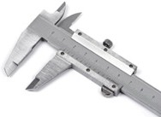
- A plumber uses several marking and measuring tools. Below is a tool he frequently uses.

(a) What is the name of the tool? ________________________________ (1 mark)
(b) What is the tool used for? (1 mark) __________________________________________________________________________________
- State four roles of Pre-technical studies in day-to-day life. (4 marks)
- _____________________________________________________________________________________
- _____________________________________________________________________________________
- _____________________________________________________________________________________
- _____________________________________________________________________________________
- Imagine you are designing a new playground for your school. Identify three non-metallic materials you would use for the playground equipment. (3 marks)
- _____________________________________________________________________________________
- _____________________________________________________________________________________
- _____________________________________________________________________________________
- If you were an engineer tasked with creating a new underwater pipeline, which metal would you choose and why? (3 marks)
- _____________________________________________________________________________________
- _____________________________________________________________________________________
- _____________________________________________________________________________________
- Jude, a Grade 7 learner, was asked by his teacher to name ICT tools in communication. State any three tools he mentioned. (3 marks)
- _____________________________________________________________________________________
- _____________________________________________________________________________________
- _____________________________________________________________________________________
- The teacher displayed the picture below to class.

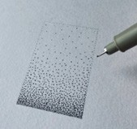
He asked the learners to identify the technique used in drawing the picture. What response did the learners give? (1 mark)
________________________________________________________________________________________________________________________________________________________________________________
- Name the following lines used in drawing. (3 marks)

(a) (b) (c)
- ______________________________________
- ______________________________________
- ______________________________________
- Outline three characteristics of computers. (3 marks)
- _____________________________________________________________________________________
- _____________________________________________________________________________________
- _____________________________________________________________________________________
- State two online threats in the work environment. (2 marks)
- _____________________________________________________________________________________
- _____________________________________________________________________________________
- Grade 7 learners were grouped to discuss the meaning of an alloy and explain why it is important in the use of metallic materials. What were their research findings? (3 marks)
- _____________________________________________________________________________________
- _____________________________________________________________________________________
- _____________________________________________________________________________________

THIS IS THE LAST PRINTED PAGE

