K.J.S.E.A

JUNIOR SCHOOL EDUCATION ASSESSMENT

TERM 2: ENDTERM ASSESSMENT 2026
GRADE 7 – CREATIVE ARTS AND SPORTS
Time: 1 Hour 30 Minutes
LEARNER’S DETAILS
Name: ________________________________________________. School: _____________________________________________________.
Assessment Number: _________________________________. Date: ______________________________________________________.
School Code: _______________________________________. Signature: _________________________________________________.

Instructions for Learners
- Write your full name and assessment number in the spaces provided above.
- Indicate your school name and school code clearly.
- Sign and date this paper in the spaces provided.
- This paper consists of TWO sections: Section A and Section B.
- Answer ALL questions in BOTH sections.
- Write your answers in the spaces provided in this question paper.
- Do NOT remove any page from this paper.
- All responses must be written in English
FOR OFFICIAL USE ONLY -FOR EXAMINER’S USE
SECTION | SECTION A | SECTION B | % SCORE | EE1 | EE2 | ME1 | ME2 | AE1 | AE2 | BE1 | BE2
SCORE RANGE | 20 MARKS | 30 MARKS |  | 90-100 | 75-89 | 58-74 | 41-57 | 31-40 | 21-30 | 11-20 | 1-10
POINTS |  |  |  | 8 POINTS | 7 POINTS | 6 POINTS | 5 POINTS | 4 POINTS | 3 POINTS | 2 POINTS | 1 POINT
LEARNER’S TOTAL SCORE

SECTION A (20 MARKS) Answer ALL questions in this section
- Mutiso, a Grade 7 learner, discussed about the components of Creative arts and sports, Which one of the following is not?
A. Performing arts
B. Visual arts
C. Sports
D. Anatomy
- Which of the following is not a reason why the Government of Kenya emphasizes Creative Arts and Sports in schools?
A. To promote national unity and cultural heritage
B. To enhance learners’ creativity and talent development
C. To promote community rivalry
D. To provide alternative career opportunities
- Which of the following does not explain the meaning of visual arts?
A. Art forms that involve painting, drawing and sculpture
B. Creative works meant to be seen with the eyes
C. Performances involving singing and instruments
D. Artistic expressions using colour, shape and texture
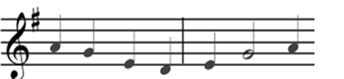
- A Grade 7 learner composed the rhythm shown below.
Which of the following shows the correct major scale used?
A. C Major B. D Major C. G Major D. F Major
- Grade 7 learners practiced the skill shown below.
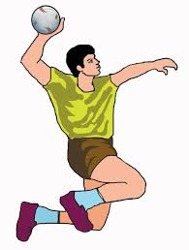
In which ball game is the skill used?
A. Netball
B. Handball
C. Volleyball
D. Baseball
- Which of the following best explains the meaning of dynamics in music?
A. Speed of music
B. Type of instruments
C. Variation in loudness or softness
D. Sequence of notes
- Learners observed virtual images of a javelin. Which was not a focus?
A. Shape B. Thickness
C. Weight D. Material
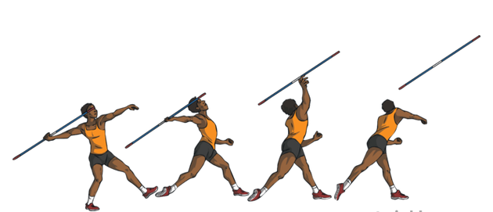
- A symbol ( # ) was found behind a music note. What does it mean?
A. Played softly
B. Restored to original pitch
C. Raised by half step
D. Lowered by half step
- The picture shows an athlete throwing a javelin.

U V W X
Which of the phases shown is called follow through?
A. U B. V C. W D. X
- Which is not an importance of songs in storytelling?
A. Make stories engaging
B. Emphasize key parts
C. Distract audience
D. Enhance memory
- Learners composed a rhythm.

Which is the correct French interpretation?
A. ta-te taa ta-te ta-te taa ta-te taa-aa
B. ta-te taa-aa ta-te ta-te taa ta-te taa-aa
C. ta-te taa ta-te ta-te taa ta-te taa-aa-aa
D. ta-te taa ta-fa te-fe taa ta-te taa-aa
- The picture shows a football kicking skill.
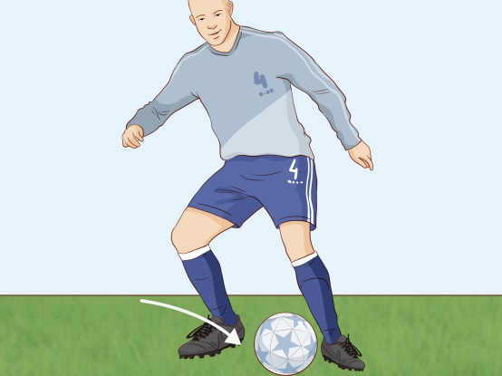
Which skill is demonstrated?
A. Toe kick
B. Inside foot kick
C. Foot trapping
D. Outside foot kick
- Which is not an importance of good craftsmanship?
A. Improves quality
B. Expresses ideas clearly
C. Makes artwork attractive
D. Finishes work quickly
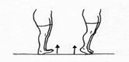
- The activity shown improves physical fitness.

Which component is not improved?
A. Coordination B. Balance
C. Flexibility D. Strength
- Which is not an element of a story?
A. Plot
B. Characters
C. Time
D. Setting
- Learners used stippling technique.
Which elements of art were achieved?
A. Tonal value and texture
B. Depth and tonal value
C. Rhythm and movement
D. Overlapping and tonal value
- Which colour does not evoke excitement?
A. Red
B. Orange
C. Blue
D. Yellow
- Which is not a factor in interpreting melodies?
A. Movement of melody
B. Time signature
C. Variation of notes
D. Length of notes
- Which of the following is not a semitone?
A. B–C
B. C–D
C. G–A
D. E–F
- Which artwork does not belong in the group?
A. Play
B. Verse
C. Folk song
D. Montage

SECTION B (30 MARKS)

PERFORMING ARTS (10 MARKS)
- Give the meaning of the following terms: (2 marks)
(a) Staff: ____________________________________________________________________________________________________________________________________________________________________
(b) Ledger line: ____________________________________________________________________________________________________________________________________________________________________
- State two careers related to music: (2 marks)
- _____________________________________________________________________________
- _____________________________________________________________________________
- A group of grade 7 learners drew the staff below during a Creative Arts and Sports lesson.
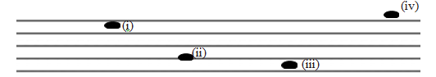
(a) Draw a G clef on the staff. (2 marks)

(b) Name the pitches labelled i, ii, iii, iv. (4 marks)
(i) __________________________________________________________
(ii) _________________________________________________________
(iii) _________________________________________________________
(iv) _________________________________________________________

SPORTS (10 MARKS)
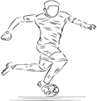
- Alex a grade 7 learner created the pictorial composition shown below and displayed it in class.

(a) Which technique was used in the artwork? (1 mark)
_______________________________________________________________________
(b) Name the skill the player was executing. (1 mark)
______________________________________________________________________
- Explain two ways sports can reduce drug abuse: (2 marks)
(i) _______________________________________________________________________________
(ii) _______________________________________________________________________________
(a) Name the component of fitness enhanced: (2 marks)
__________________________________________________________________
(b) One activity for each: (2 marks)
____________________________________________________________________________
- Yusuf demonstrated the skill shown below to his fellow learners during a handball lesson
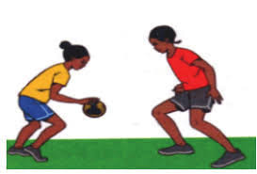
(a) Identify the handball skill: (1 mark)
_________________________________________________________
(b) When is the skill used? (1 mark)
___________________________________________________________________________
VISUAL ARTS (10 marks)
- During a group discussion, grade 7 learners grouped visual arts artworks into two categories. Name the two categories of visual arts artworks. (2 marks)
- __________________________________________________________________________________
- __________________________________________________________________________________
- The government of Kenya is investing in creative arts and sports to address unemployment among the youths. Explain the following careers related to visual arts. (2 marks)
(a) Animator ____________________________________________________________________________________________________________________________________________________________________
(b) Illustrator ____________________________________________________________________________________________________________________________________________________________________
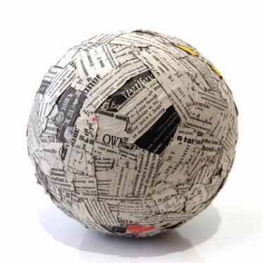
- The picture below shows a ball that was drawn by Grade 7 learners using dry media materials.

(a) Give one examples of possible dry media materials used by the learners. (1 mark)
___________________________________________________________
(b) Which technique was used to create the light and dark effect? (1 mark)
____________________________________________________________________________
- A group of grade 7 learners grouped different colours based on their temperature. Give one example of colours that they grouped together with the ones shown in the table below. (2 marks)
a. Red_________________________________ b. Blue________________________________
- Your grandmother makes pots using clay. State two ways she can ensure that the pots do not crack. (2 marks)
- __________________________________________________________________________________
- __________________________________________________________________________________
THIS IS THE LAST PRINTED PAGE

