K.J.S.E.A

JUNIOR SCHOOL EDUCATION ASSESSMENT

TERM 2: ENDTERM ASSESSMENT 2026
GRADE 7 – AGRICULTURE
Time: 1 Hour 30 Minutes
LEARNER’S DETAILS
Name: ________________________________________________. School: _____________________________________________________.
Assessment Number: _________________________________. Date: ______________________________________________________.
School Code: _______________________________________. Signature: _________________________________________________.

Instructions for Learners
- Write your full name and assessment number in the spaces provided above.
- Indicate your school name and school code clearly.
- Sign and date this paper in the spaces provided.
- This paper consists of TWO sections: Section A and Section B.
- Answer ALL questions in BOTH sections.
- Write your answers in the spaces provided in this question paper.
- Do NOT remove any page from this paper.
- All responses must be written in English
FOR OFFICIAL USE ONLY -FOR EXAMINER’S USE
SECTION | SECTION A | SECTION B | % SCORE | EE1 | EE2 | ME1 | ME2 | AE1 | AE2 | BE1 | BE2
SCORE RANGE | 20 MARKS | 30 MARKS |  | 90-100 | 75-89 | 58-74 | 41-57 | 31-40 | 21-30 | 11-20 | 1-10
POINTS |  |  |  | 8 POINTS | 7 POINTS | 6 POINTS | 5 POINTS | 4 POINTS | 3 POINTS | 2 POINTS | 1 POINT
LEARNER’S TOTAL SCORE

SECTION A (20 MARKS) Answer ALL questions in this section

- Which of the following is a common cause of soil pollution in home gardening?
A. Use of organic manure
B. Use of compost pits
C. Use of excessive chemical fertilizers
D. Use of kitchen leftovers
- A farmer was using minimum tillage practices to control soil pollution. What is the main aim of controlling soil pollution?
A. To increase rainfall
B. To reduce water usage
C. To maintain soil fertility
D. To kill pests
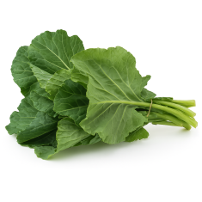
- Winter is preparing vegetables for dinner.

How should she wash them to retain the most nutrients for her family?
A. Wash under cold running water
B. Soak in warm water with vinegar
C. Scrub vigorously with a brush
D. Peel off the outer layers
- Which one of the following is the best method to manage surface run-off in gardening?
A. Burn all plant wastes
B. Construct water pans
C. Increase tillage
D. Use chemical sprays
- Which one of the following should be used when laundering a loose coloured item?
A. Hot water and bleach
B. Gentle soap and cold water
C. Salt and kerosene
D. Detergent and vinegar
- Which one of the following is not a key aspect in environmental conservation?
A. Natural resource management
B. Pollution control
C. Climate change monitoring
D. Reduction of biodiversity
- Cate plans to roast a turkey for her Thanksgiving ceremony. What are the basic requirements she needs?
A. Grill, foil, vegetables
B. Oven, roasting pan, meat thermometer
C. Microwave, paper towels, marinade
D. Skillet, oil, potatoes
- Ella put her processed honey in a large container to ripen as shown below.
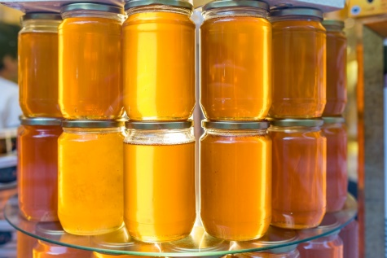
What is the purpose of doing so?
A. To reduce moisture content
B. To improve flavour
C. To increase shelf life
D. To remove impurities
- Which of the following is a benefit of growing trees?
A. Increased pest infestation
B. More open spaces
C. Shade and wind protection
D. Soil hardening
- The most suitable tilth for planting carrots and onions is:
A. Medium tilth B. Loose tilth
C. Rocky and firm D. Fine tilth
- Jude noticed that the hill behind his house experiences a lot of erosion during heavy rains. What could be constructed to help slow down the water flow and reduce erosion?
A. Terraces B. A slide
C. A zipline D. A viewing deck
- What role does the community play in successful environmental conservation through tree planting?
A. It promotes ownership and stewardship
B. It has no significant contribution
C. It denies funding
D. It increases delays and costs
- The diagram below shows a tool used in crop management.

What is its function?
A. Gapping B. Earthing up
C. Thinning D. leveling the soil
- Which one of the following is a reason for cleaning a pet regularly?
A. To make it look pretty
B. To make it smell nice
C. To save money
D. To prevent diseases
- A fabric softener is used to launder after buying coloured clothes because of all the following reasons except that it prevents:
A. Stretching B. Fading
C. Wrinkling D. Fuzzing
- Mr. Timothy was breaking soil clumps in his farm when preparing a planting site for his trees. What was the main reason for loosening the soil?
A. To have an easier time when planting
B. To improve soil structure
C. To enable water absorption
D. To enhance aeration in the soil
- Tamara wants to do organic farming. Which of these methods should she avoid when weeding?
A. Using hand tools like hoes
B. Pulling weeds by hand
C. Using herbicides to kill the weeds
D. Covering the soil with mulch
- Which one of the following is a safety measure to observe when grilling food?
A. Keep grill indoors, use short handled tools, wear loose clothing
B. Keep grill outdoors, use long-handled tools, keep a water spray bottle
C. Preheat grill, use plastic utensils, wear gloves
D. Place grill on grass, use short tongs, wear sandals

- Honey crystallizes over time. What technique should be used to delay the crystallization process?
A. Keep it in a warm, dry place
B. Mix it with cold water
C. Store it in the refrigerator
D. Expose it to direct sunlight
- Why should coloured clothes be separated before washing?
A. To use less water
B. To save detergent
C. To prevent colour running
D. To wash faster

SECTION B: (30 MARKS)

(a) What do you understand by soil pollution? (1 mark)
________________________________________________________________________________________________________________________________________________________________________________________
(b) Mention two causes of soil pollution in home environments. (2 marks)
- ___________________________________________________________________________________.
- ___________________________________________________________________________________.
- Grade 7 learners visited a certain area after it had rain as shown below
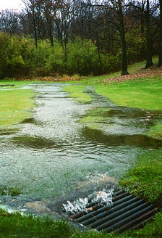
Identify three factors contributing to surface runoff in this area. (3 marks)
- ___________________________________________________________________________________.
- ___________________________________________________________________________________.
- ___________________________________________________________________________________.

(a) List two ways of conserving vitamins in vegetables when cooking. (2 marks)
- ___________________________________________________________________________________.
- ___________________________________________________________________________________.

(b) Why is it important to conserve food nutrients? (1 mark)
________________________________________________________________________________________________________________________________________________________________________________________
- State three environmental benefits of planting trees. (3 marks)
- ___________________________________________________________________________________.
- ___________________________________________________________________________________.
- ___________________________________________________________________________________.
- Grade 7 learners have been appointed to establish a tomato garden in their school which has clay soil.
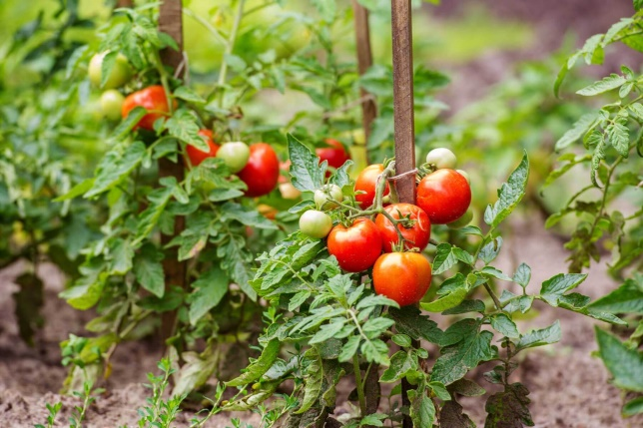
State three factors they will consider when adopting appropriate tilth. (3 marks)
- ___________________________________________________________________________________.
- ___________________________________________________________________________________.
- ___________________________________________________________________________________.

(a) Name one tool used in crop thinning. (1 mark)
__________________________________________________________________________
(b) State two reasons why thinning is done in crop management. (2 marks)
- ___________________________________________________________________________________.
- ___________________________________________________________________________________.
- ___________________________________________________________________________________.
- The picture below shows a planting material.
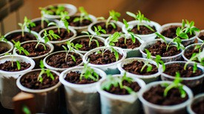
(a) Which planting material is shown in the picture above? (1 mark)
_____________________________________________________________
(b) State two requirements for every planting material in a planting site. (2 marks)
- ___________________________________________________________________________________.
- ___________________________________________________________________________________.
- Outline three precautions to take when sorting and grading eggs. (3 marks)
- ___________________________________________________________________________________.
- ___________________________________________________________________________________.
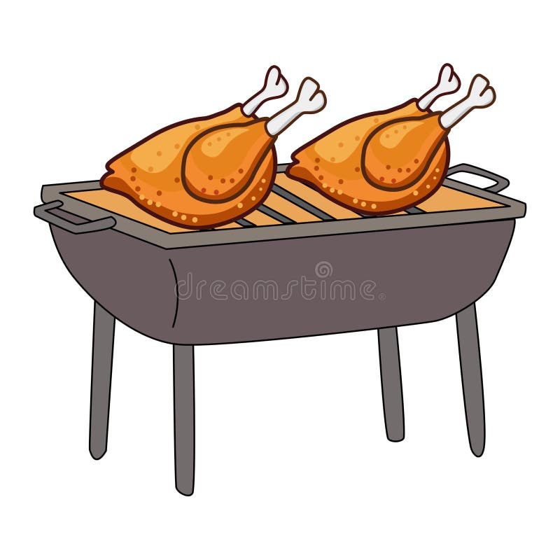
- ___________________________________________________________________________________.
- Angie and her classmates were discussing cooking methods. They preferred the method shown below.

(a) Give two equipment used in preparing the food using the method above. (2 marks)
- ___________________________________________________________________________________.
- ___________________________________________________________________________________.
(b) Why is grilling preferred when preparing some foods? (1 mark)
________________________________________________________________________________________________________________________________________________________________________________________
- Grade 7 learners carried out a presentation on hygiene practices in animal rearing.
(a) List two hygiene practices they presented. (2 marks)
- ___________________________________________________________________________________.
- ___________________________________________________________________________________.
(b) What is the importance of hygiene in animal rearing? (1 mark)
________________________________________________________________________________________________________________________________________________________________________________________

THIS IS THE LAST PRINTED PAGE

