KENYA CERTIFICATE OF BASIC EDUCATION

SENIOR SCHOOL ASSESSMENT

TERM 2: ENDTERM ASSESSMENT 2026
GRADE 10 – FINE ARTS
Time: 2 Hours
LEARNER’S DETAILS
Name: _____________________________________________________________. School: ____________________________________________.
Assessment Number: _______________________________________________. Date: ____________________________________________.
School Code: ______________________________________________________. Signature: _______________________________________.

INSTRUCTIONS TO CANDIDATES
- Fill in your name, school name, your assessment number, date, the school code and signature in the spaces provided above.
- This paper consists of two sections: A and B.
- Answer all questions in section A and section B.
- Answer the questions in English.
- All answers MUST be written in the spaces provided in PAPER.
- Do NOT remove any page from this question paper.

FOR OFFICIAL USE ONLY (EXAMINER’S USE)
SECTION | SECTION A | SECTION B | % SCORE | EE1 | EE2 | ME1 | ME2 | AE1 | AE2 | BE1 | BE2
SCORE RANGE | 30 MARKS | 50 MARKS |  | 90-100 | 75-89 | 58-74 | 41-57 | 31-40 | 21-30 | 11-20 | 1-10
POINTS |  |  |  | 8 POINTS | 7 POINTS | 6 POINTS | 5 POINTS | 4 POINTS | 3 POINTS | 2 POINTS | 1 POINT
LEARNER’S TOTAL SCORE

SECTION A: (30 marks)
Answer ALL questions in this section.

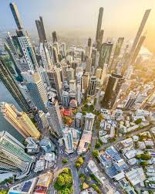
During an academic trip to the city, Fine Arts learners took the image shown below.

(a) Identify the perspective view shown in the image below. (1 Mark) _________________________________________________
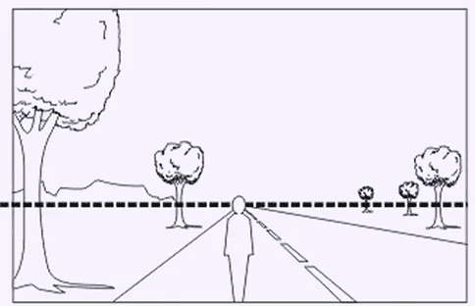
(b) Name the parts labeled X and Y in the diagram below. (2 Marks)

Y
X

X: ____________________________________________.
Y: ____________________________________________.

At Alliance High School, a student named Agnes wants to store her 2D sketches safely for the final KNEC assessment.
(a) Name the folder used for this purpose. (1 Mark)
_________________________________________________
(b) List two recyclable materials Amani can use to make this folder. (2 Marks)
i. _________________________
ii. _________________________

Match the painting techniques with the correct description. (4 Marks)
Technique | Description
A. Flat Wash | i. Applying paint through a stencil using a stiff brush
B. Graded Wash | ii. An even layer of color with no visible brush strokes
C. Brush-Spraying | iii. A wash that changes gradually from dark to light
D. Stenciling | iv. Flicking bristles to create a mist of color droplets

Write True or False in each of the following statement. (3 Marks)
(a) Mixed-media collage uses only one type of material. ________
(b) Juxtaposition is placing two different images side-by-side to create contrast. ________
(c) Superimposition involves layering one material on top of another. ________

Identify the elements in the graphic design image below: (3 Marks)
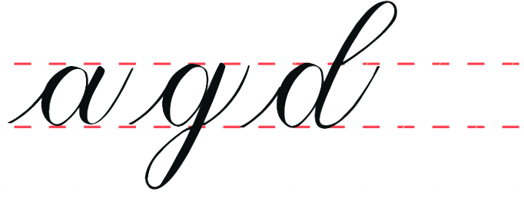
i

ii
iii
i. __________________________________________
ii. _________________________________________
iii. _________________________________________

Learners at Tumaini Senior School are discussing Tie and Dye effects:
Kendi: Sunburst pattern
Otieno: Folded triangles for geometric shapes
Wanjiku: Continuous swirl effect
Mutua: Stone and string circles
(a) Identify the technique Otieno is describing. (1 Mark)
_________________________________________________
(b) Name the effect Wanjiku is aiming for. (1 Mark)
_________________________________________________

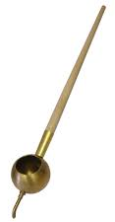

Identify the tool shown in the picture used in Batik making.

_________________________________________________

Define the following terms used in Fine Arts (3 Marks)
(a) Plasticity: ______________________________________________________________________________________________________________________________________________________________________________________________
(b) Porosity: ______________________________________________________________________________________________________________________________________________________________________________________________
(c) Vitrification: ______________________________________________________________________________________________________________________________________________________________________________________________

Distinguish between a Relief Sculpture and a Sculpture in the Round. (2 Marks)
____________________________________________________________________________________________________________________________________________________________________________________________________________________________________________________________________________________________________________________________________________________________________________________________________________________________

List three legal issues artists must consider when marketing their work online in Kenya. (3 Marks)
i. ____________________________________________________________________________________________
ii. ____________________________________________________________________________________________
iii. ____________________________________________________________________________________________

SECTION B (50 MARKS)
- Baraka is setting up a still life composition using some fruits.
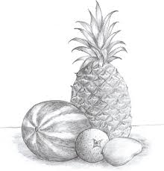
(a) Identify the shading technique used to create smooth transition of light. (1 Mark)
____________________________________________
(b) Outline four stages Baraka should follow in drawing. (4 Marks)
i. ____________________________________________________________________________________________
ii. ___________________________________________________________________________________________
iii. __________________________________________________________________________________________
iv. __________________________________________________________________________________________
(c) Identify the error in the two-point perspective diagram. (2 Marks)
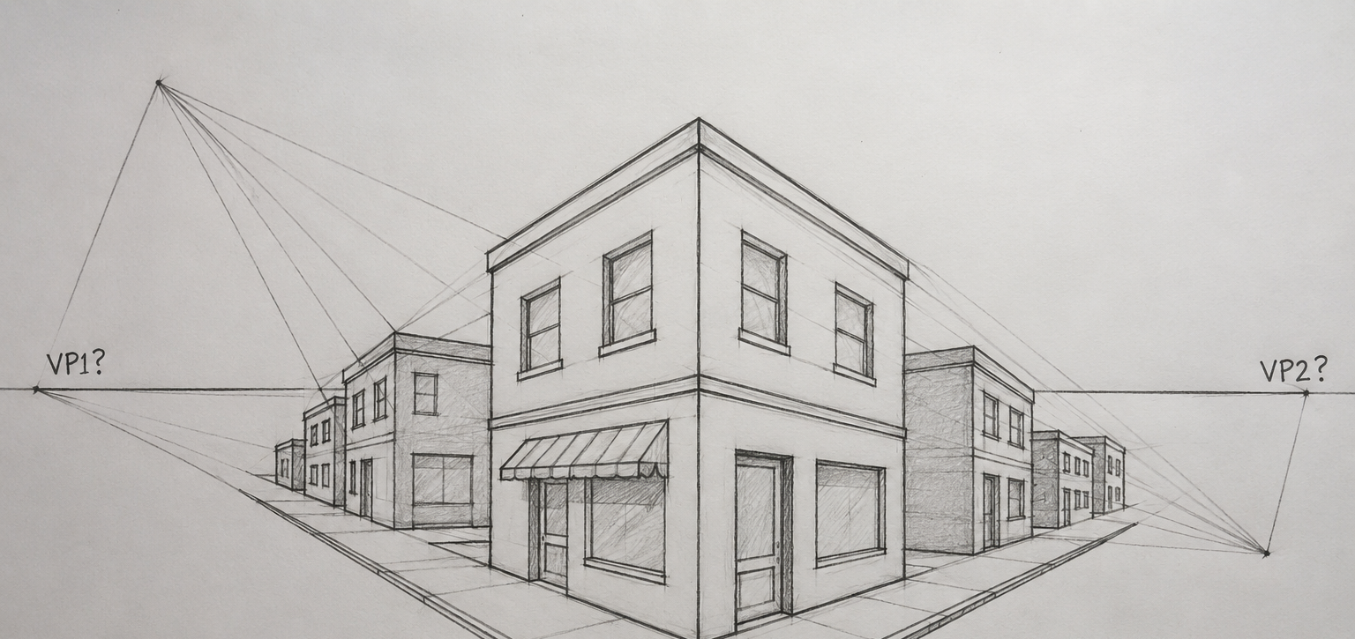
______________________________________________________________________________________________________________________________________________________________________________________________
(d) Explain tactile texture and simulated texture. (3 Marks)
____________________________________________________________________________________________________________________________________________________________________________________________________________________________________________________________________________________________________________________________________________________________________________________________

- Learners are designing a brand for a milk company.

(a) Name the graphic symbol shown. (1 Mark)
___________________________________________
(b) Describe the Batik crackled effect process. (4 Marks)
________________________________________________________________________________________________________________________________________________________________________________________________________________________________________________________________________________________________________________________
(c) Why is rinsing fabric important in Tie and Dye? (2 Marks)
________________________________________________________________________________________________________________________________________________________________________________________________________________
(d) Identify calligraphy pen tips: (3 Marks)
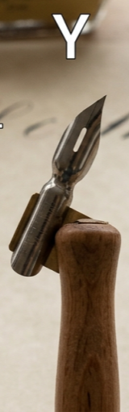
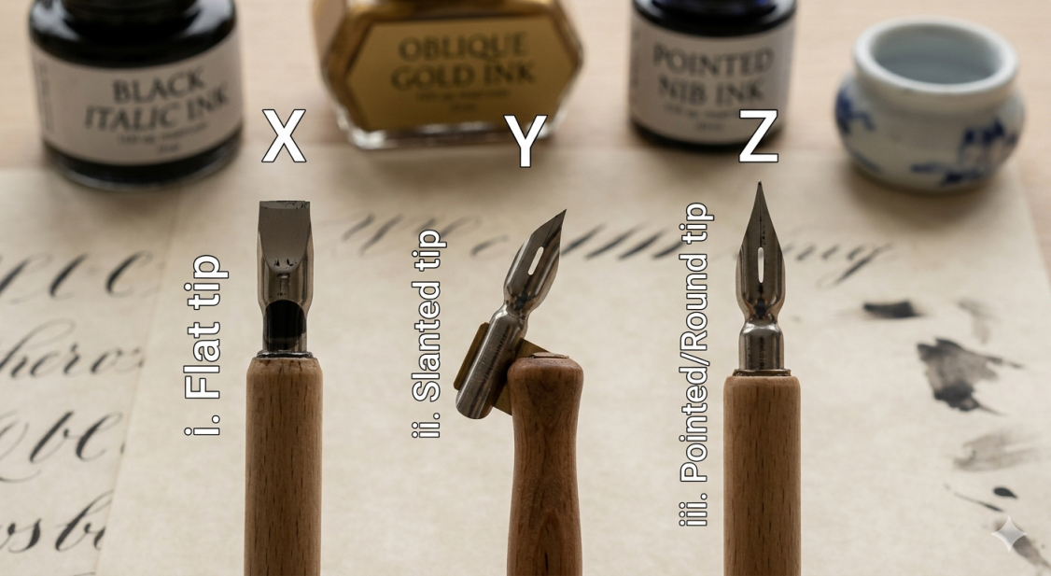

X: ________________________ Y: __________________ Z: ____________________

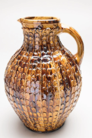
- (a) Identify the clay building technique shown. (1 Mark)

__________________________________________________
(b) Give two reasons for wedging clay. (4 Marks)
i. _________________________________________________
ii. _________________________________________________
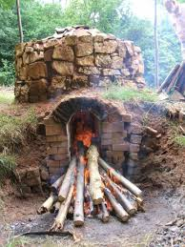
(c) Name the kiln shown in the diagram. (2 Marks)

________________________________________________
(d) State three elements of 3D art in a clay vase. (3 Marks)
i. __________________________________________________________________________________________
ii. _________________________________________________________________________________________
iii. _________________________________________________________________________________________
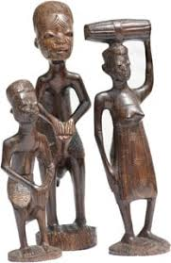
14. (a) Identify the indigenous sculpture style with elongated forms. (1 Mark)

_____________________________________
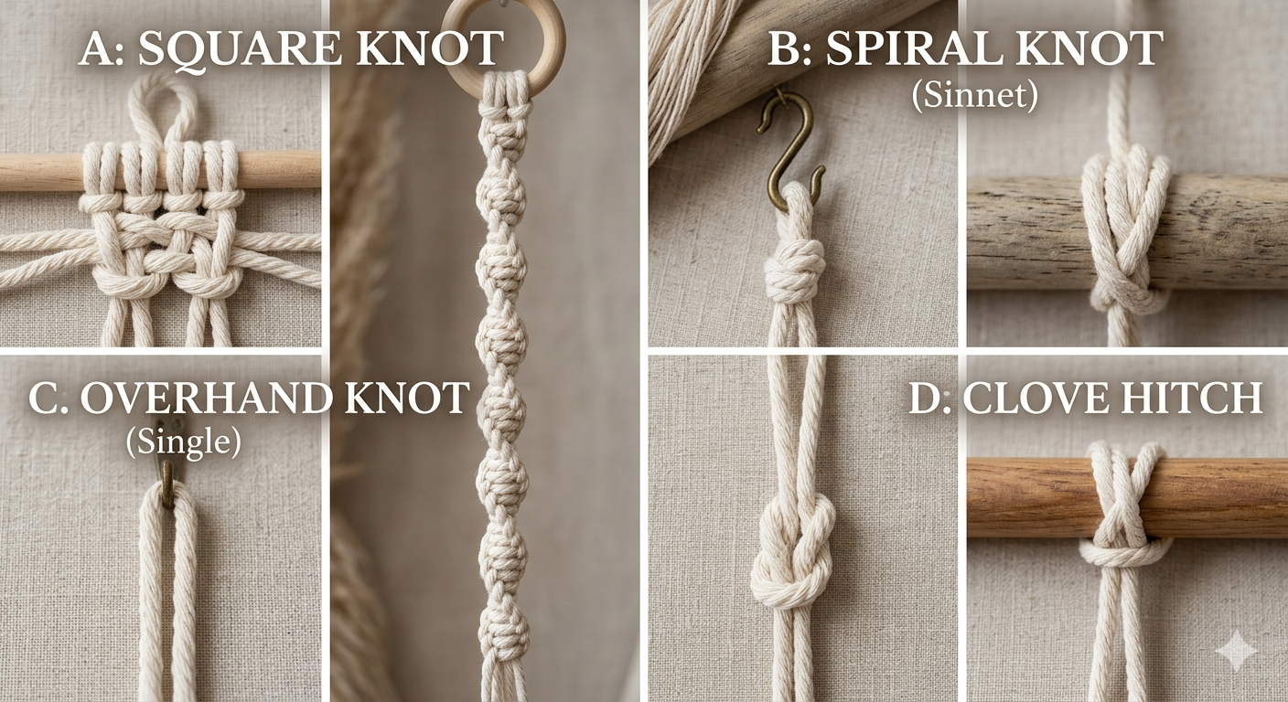
(b) Name the type of macrame knots shown below:
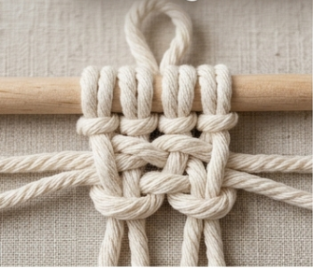

A B C D
- _______________________________________________
- _______________________________________________
- _______________________________________________
- _______________________________________________
(c) Outline finishing steps of wood sculpture. (3 Marks)
i. _________________________
ii. _________________________
iii. _________________________

(d) Distinguish between loose web and tight web in macrame. (2 Marks)
________________________________________________________________________________________________________________________________________________________________________________________________________________________________________________________________________________________________________________________
- (a) Identify finishing technique for shining pendant. (1 Mark)
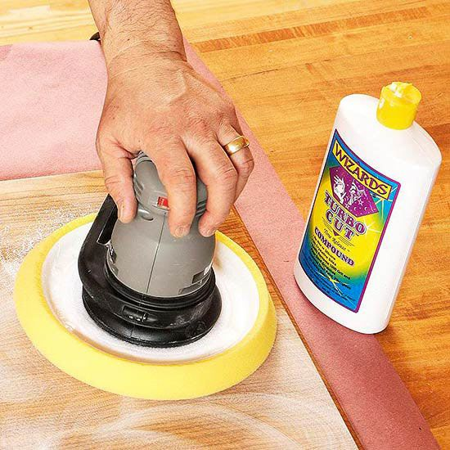
____________________________________________
(b) List four found materials for jewellery. (4 Marks)
i. ____________________________________ ii. _____________________________________
iii. ___________________________________ iv. ________________________________
(c) Advantages of social media marketing for art. (4 Marks)
i. _________________________________________________
ii. _________________________________________________
(d) Why is quality control important in jewellery production? (1 Mark) ______________________________________________________________________________________________________________________________________________________________________________________________

THIS IS THE LAST PRINTED PAGE

