NAME: ………………………………………………. INDEX NO: ..…...…………………

232 / 3 Candidate’s signature: ……………
PHYSICS Date…………………………………
PAPER 3
(PRACTICAL)

July-August 2026
2 ½ HOURS
INSTRUCTION TO CANDIDATES
- Write your name and index number in the spaces provided above.
- Sign and write the date of examination in the spaces provided above.
- Answer ALL the questions in the spaces provided in the question paper.
- You are supposed to spend the first 15 minutes of the 2 ½ hours allowed for this paper reading the whole paper carefully before commencing your work
- Marks are given for a clear record of the observation actually made, their suitability, accuracy and the use made of them.
- Candidates are advised to record their observations as soon as they are made.
- Mathematical tables and electronic calculators may be used.
- Candidates should check the question paper to ascertain that all the pages are printed as indicated and that no questions are missing. Paper has 8 printed pages

For Examiner’s Use Only

Question 1
 | a | b
Maximum score | 13 | 7
Candidate’s score

Total
Question 2

 | a | b(i) | ii | iii | (c)i | ii | d
Maximum Score | 2 | 6 | 5 | 1 | 2 | 2 | 2
Candidate’s score

Total
Grand total

QUESTION 1A
You are provided with the following apparatus
- A clean burette
- Retort stand
- Two clamps and 2 bosses
- A metre rule
- Water
- 100ml beaker
- A stop watch
PROCEDURE
- Clamp the burette and metre rule vertically and as close to each other as possible
- Adjust the position of the burette so that its lower end is 10cm above the bench and place the 100ml beaker underneath it.
- Fill the burette with water to a height above the 70cm mark of the metre rule as shown below.
80
70
60
50
40
30
20
Stand
Burette
Metre rule
100ml Beaker

- By trial and error method adjust the rate of flow of the water until the time taken for the water to flow from 70cm mark to 65cm is between 25-30 seconds.
- Once this flow rate has been achieved do not alter the flow rate for the rest of the experiment.
- Fill the burette again with water to a level above the 70cm mark.
- With the water level at the 70cm mark (at t=0) start the stop watch. Note the time taken for the height h of the water surface in the burette to decrease by 5cm;Do not stop the watch.
- Continue to record the time taken for the height h of water surface to decrease by successive 5.0cm marks till you have 10 more readings.
- Enter the results in the table below
- Stop the watch and close the burette tap.
- Repeat the procedure to get second and third set of readings for t.

Height h(cm) | Time (s)
 | Trial 1 |  | Trial 2 | Trial 3 |  | Mean time t
70
65
60
55
50
45
40
35
30
25
20
(5marks)
Complete the table above and calculate the mean time t

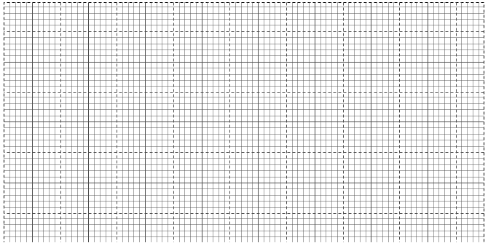
c) Plot a graph of height h (y-axis) against mean time t (5marks)

d)Use your graph to determine the time taken for the height h to change from 64cm to 32cm. (2marks)
........................................................................................................................................................................................................................................................................................................................................................................................................................................................................................................................................................................................................................................................................................................................................................................................................................................................................
e) From the graph determine the time t when h=35cm
(b)You are provided with the following:-
- A boiling tube.
- Some dry sand.
- A liquid in a measuring cylinder labelled L.
- Half metre rule.
- A vernier calipers (to be shared)
- A weighing machine (one per form)
- Tissue paper.
- A measuring cylinder.
Proceed as follows:
(i).Measure the length of the boiling tube.
h = _____________________ cm (1mk)
(ii).Put a little amount of sand in the boiling tube and place it in the measuring cylinder which is almost filled with liquid L. Add sand, little by little until the tube floats upright as shown in fig.
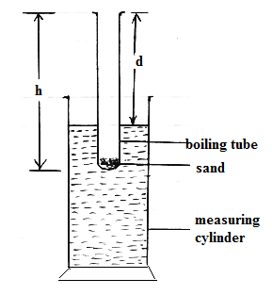
(iii).Measure the length, d, of the boiling tube which is above the liquid.
d= _____________________ cm (1mk)
(iv).Determine the length, t, of the boiling tube which is immersed in the liquid.
t = _____________________ cm (1mk)
(v).Remove the boiling tube from the measuring cylinder, wipe it dry (on the outside) and measure its mass, m, including the sand inside.
m = _____________________ g (1mk)

(vi).Measure the external diameter, D, of the boiling tube.
D = _____________________ cm (1mk)

(vii).Determine the external radius, R
R = _____________________ cm (1mk)

(viii).Using the formula m = 12ρπR², determine ρ for the liquid.
ρ_____________________ cm (2mks)

2. You are provided with the following
A micrometer screw gauge ( to be Shared)
A voltmeter ( 0 – 3 or 0 -5 v)
Ammeter ( 0 -1A)
Nichrome wire mounted on a mm scale, AB.
A switch.
A jockey / long wire with crocodile clip attached.
One dry cell.
8 new connecting wires with clips attached to one end.
Proceed as follows:
a)Set up the circuit below. Ensure that when the switch is open, both meters read zero. Keep the switch open when readings are not being taken.
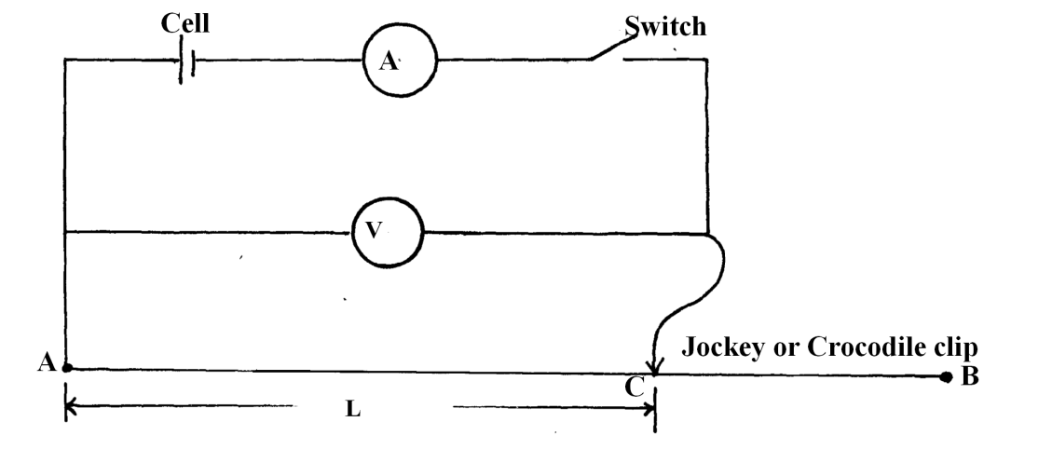
i)Measure and record the diameter d of the nichrome wire AB Using the micrometer screwgauge.
d = …………………………………………………………m (1 mark)

ii)Disconnect the jockey from wire AB and close the switch. Record the value E of the voltmeter reading.
E = …………………………………………………………… ( 1mark)
b)Now, connect the Jockey on AB at a distance L = 2.5 cm. Close the switch and record the voltmeter and ammeter readings, V and I respectively in the table below.
L (cm) | 2.5 | 5.0 | 7.5 | 10 | 15 | 18 | 20 | 30 | 40 | 50
P.d V ( Volts)
Current, I ( A)
IV ( Watts)
(6marks)
i) Complete the table for values of IV.
ii) Plot a graph of IV ( Vertical axis) against L.(cm) (5marks)
INSERT GRAPH PAPER

iii) Using your graph, Find the value L0 where your graph cuts, the horizontal axis.
L₀ =…………………………………………………….m (1mark)

c)i)Now, place the jockey on wire AB such that length L is equal to the value of L₀ Obtained in (iii) above. Close the switch and record both the voltmeter reading, V and the ammeter reading I.
V = ……………………………………………………………………………………… (1 mark)
I = ………………………………………………………………………………………....(1mark)

ii)Work out the value r where:
r = (2marks)
…………………………………………………………………………………………………..
…………………………………………………………………………………………………
d) Work out the value of e where
e = (2marks)
…………………………………………………………………………………………………………………………………………………………

…………………………………………………………………………………………………………………………………………………………

