END TERM 2 EXAMINATION. July-August 2026

232/2 - PHYSICS -Paper 2

(THEORY)

– 2 hours

Name……………………………………………………Stream…………..Adm No……..

Candidate’s signature……………………Date…………………..

Instructions to candidates
(a) Write your name, index number in the spaces provided above. (b) Sign and write the date of the examination in the spaces provided (c) This paper consists of TWO Sections: A and B.
- Answer ALL the questions in section A and B in the spaces provided.
- All working MUST be clearly shown.
- KNEC mathematical tables and silent non-programmable electronic calculators may be used.
- This paper consists of 15 printed pages
- Candidates should check the question paper to ascertain that all the pages are printed as indicated and that no questions are missing
- Candidates should answer the questions in English

For examiners use only

Section | Question | Maximum score | Candidates score
A | 1-13 | 25
B | 14 | 5
B | 15 | 11
B | 16 | 13
B | 17 | 10
B | 18 | 6
B | 19 | 10
B | TOTAL SCORE | 80

SECTION A: 25marks
1. The chart below shows an arrangement of different parts of the electromagnetic spectrum.
Radio wave | A | Infrared rays | B | Ultra-violet | -Rays
Name the radiation represented by
A …………………………………………………………. (1mark)
State one use of radiation represented by B (1mark)
……………………………………………………………………………………………………………
……………………………………………………………………………………………………….……
- An object O is placed in front of convex mirror as shown in the diagram below. Complete the diagram
to locate the position of the image, 1. (3 marks)
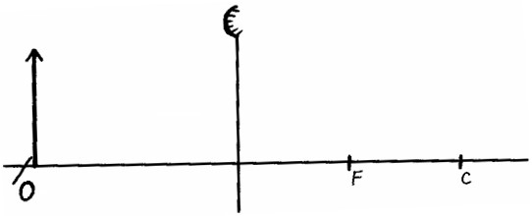

- The figure below shows a wire carrying current whose direction is out of the paper. The wire is placed in a magnetic field.
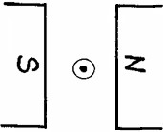

(a)Indicate on the figure the direction of the force F, acting on the wire. (1 mark)
(b)State what would be observed on the wire if the direction of the current is reversed. (1 mark)
……………………………………………………………………………………………………………
……………………………………………………………………………………………………………

- The length of a pinhole camera is 20cm. Determine the height of a sloppy building 300m away from a pinhole camera which forms an image 2.5cm high on the screen of the camera.
(3mks)
..................................................................................................................................................................... .....................................................................................................................................................................
..................................................................................................................................................................... .....................................................................................................................................................................
.......................................................................................................................

- Figure 5 below shows a simple transformer connected to a 12v a.c source and an a.c voltmeter.

V
12
V

Determine the reading on the voltmeter. (2 marks)
.....................................................................................................................................................................
.....................................................................................................................................................................
- (a) State the basic law of magnetism. (1 mark)
……………………………………………………………………………………………………………
………………………………………………………………………………………………………
b) The figure below shows how magnets are stored in pairs with keepers at the ends.


S

N

N

S

Bar magnets

Keeper

Keeper

Explain how this method of storing helps in retaining magnetism longer. (2 marks)

- State Snell’s law. (1 mark)
..................................................................................................................................................................... .....................................................................................................................................................................
.....................................................................................................................................................................
- The figure below shows a displacement-time graph for a wave motion
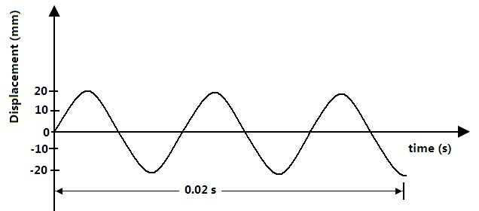
What is the frequency of the wave? (2marks) .........................................................................................................................................
.........................................................................................................................................
- Waves pass from deep water to shallow water and refraction occurs.
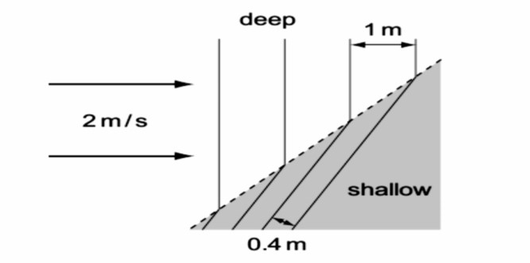
Calculate the speed of the waves in the shallow water (2 marks)
.....................................................................................................................................................................
.....................................................................................................................................................................
..............................................................................................................................................................
- The diagram below shows a ray of light striking the plane at 35º as shown below.
State the angle of reflection. (1 mark)
35
o

- A ray of light incident on the surface of a glass prism is observed as represented in the



Wh
ite Light

Colours of the spectrum

Explain this observation. (2mrks)
……………………………………………………………………………………………………………
……………………………………………………………………………………………………………

- An echo sounder of a ship transmits sound waves to the depth of the sea and receives the echo after
2.4 seconds. If the speed of sound in water is 1600ms^{1}, determine the depth of the sea. (3 marks)
……………………………………………………………………………………………………………
……………………………………………………………………………………………………………
……………………………………………………………………………………………………………
- It is observed that when a charged body is brought near the cup of a positively charged electroscope,
the divergence of the leaf increases. State the type of charge on the body. (1mark)
……………………………………………………………………………………………………………
…………………………………………………………………………………………………………

SECTION B (55 marks)
14. (a) The figure below shows a diagram of a Geiger Muller tube connected to a power supply and a pulse counter.

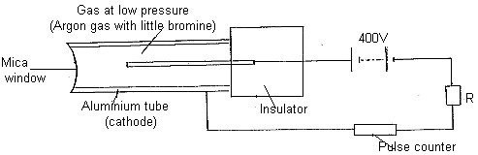

(i)Why should the argon gas be at low pressure? (1mark)
……………………………………………………………………………………………………………
……………………………………………………………………………………………………………
(ii)State the purpose of the bromine gas in the tube. (1mark)
……………………………………………………………………………………………………………
……………………………………………………………………………………………………………
(iii)Suggest one way of increasing the sensitivity of the tube (1mark)
……………………………………………………………………………………………………………
……………………………………………………………………………………………………………
(iv) Find the value of a and b in the following equation. (2marks)
234U  aX 2
92 b

15. The figure below shows a cathode ray tube

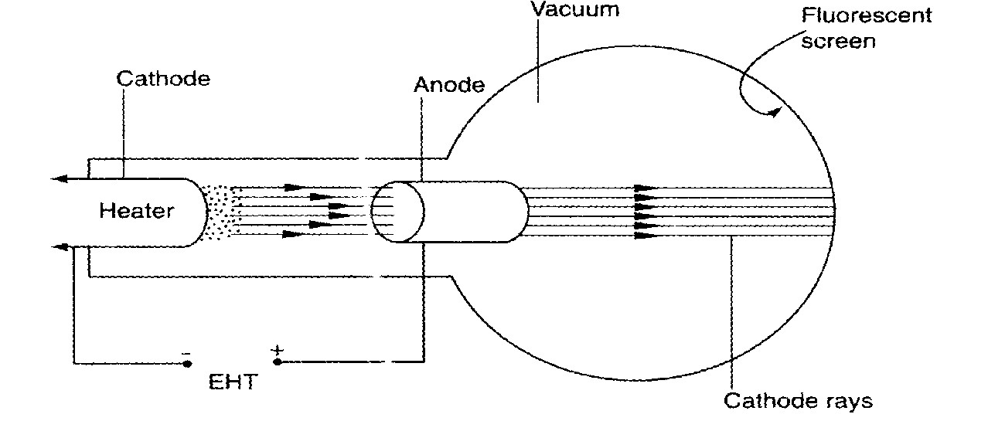
a) State the function of the
- Heater (1mark)
........................................................................................................................................................................
..........................................................................................................................
- Extra High Tension (E.H.T.) (1 mark)
........................................................................................................................................................................ ..........................................................................................................................
- State how the intensity of the fluorescence on the screen can be increased. (1 mark)
........................................................................................................................................................................
..........................................................................................................................
.................................................................................................................................................
- State the effect of having air in the tube instead of a vacuum (1 mark)
........................................................................................................................................................................
..........................................................................................................................
- State one property of cathode rays (1 mark)
........................................................................................................................................................................ ..........................................................................................................................
- Distinguish between cathode rays and X-rays (1 mark)
........................................................................................................................................................................
........................................................................................................................................................................ ........................................................................................................................................................................
.......................................................................
- Give one advantages of using a C.R.O instead of a voltmeter in measuring voltages
(1 mark)
........................................................................................................................................................................
..........................................................................................................................
- The figure below shows an a.c. voltage. If the Y-gain control reads 10V/cm and the time base reads 5 milliseconds/cm
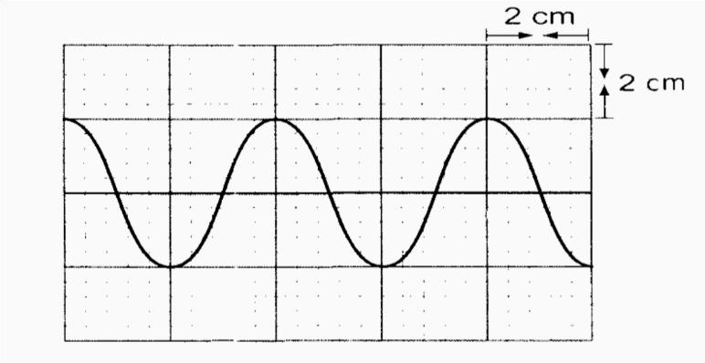
Calculate:
- The frequency of the alternating voltage (2 marks)
........................................................................................................................................................................
......................................................................................................................
- Peak to peak voltage of the alternating voltage (2 marks)
........................................................................................................................................................................
......................................................................................................................

16 (a)(i) It is observed that when ultra- violet radiation is directed onto a clean zinc plate connected to the cap of a negatively charged leaf electroscope, the leaf falls .Explain this observation
( 2 marks)
........................................................................................................................................................................
........................................................................................................................................................................
...................................................................................................
(ii) State why this observation does not occur if the electroscope is positively charged
(1 mark)
………………………………………………………………………………………………………………
………………………………………………………………………………
(iii),Explain why the leaf of the electroscope does not fall when infra- red radiation is directed onto the zinc plate ( 1 mark)
........................................................................................................................................................................
........................................................................................................................................................................
...................................................................................................
b)State the effect on the electrons emitted by the photoelectric effect when:
- The intensity of incident radiation is increased (1 mark)
…………………………………….……………………………………………………………………… ………………………………………………………………………………….
- The frequency of the incident radiation is increased (1 mark)
……………….……………………………………………………………………………………………
…………………………………………………………………………………

c) Light of wavelength 4.3 x 10⁻⁷m is incident on two different metal surfaces, nickel and potassium. (Take speed of light as 3.0 x 10⁸ ms⁻¹ and planks constant h as
6.63 x l0⁻³⁴Js).
- Determine the energy of the incident radiation. (3 marks)
........................................................................................................................................................................ ........................................................................................................................................................................
...................................................................................................
- If the work function of nickel is 8.0 x 10⁻¹⁹J and that of potassium is 3.68 x 10⁻¹⁹J, state with a reason
from which of the two metals the given light will eject electrons.
(2 marks)
........................................................................................................................................................................
........................................................................................................................................................................
...................................................................................................
- Determine the velocity of the emitted electrons from the metal surface in b(ii).
(Take the mass of an electron as 9.1 x 10⁻³¹ kg). (2 marks)
…………………………………………………………………….……………………………………… ………………………………………………………….………………………………………………… …………………………………………………………………….

17. (a) What do you understand by the following terms
- Open circuit (1 mark)
………………………………………………………………………………………………
…………………………………………………………………
- Closed circuit (1 mark)
………………………………………………………………………………
………………………………………………………………………………
b) In the circuit shown below, the battery has an e.m.f of 6.6 V and internal resistance of 0.3 ohms.
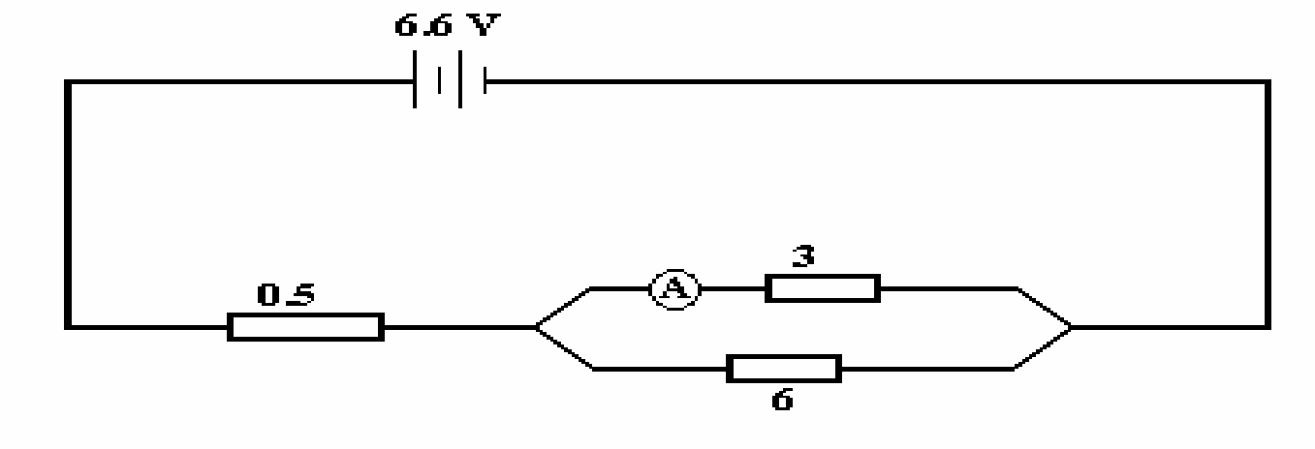

Ω

Ω

Ω

- Determine the reading of the ammeter. (3marks)
………………………………………………………………………………………………………
………………………………………………………………………………………………………
………………………………………………………………………………………………

The graph below shows the Voltage current relationship for a certain battery.
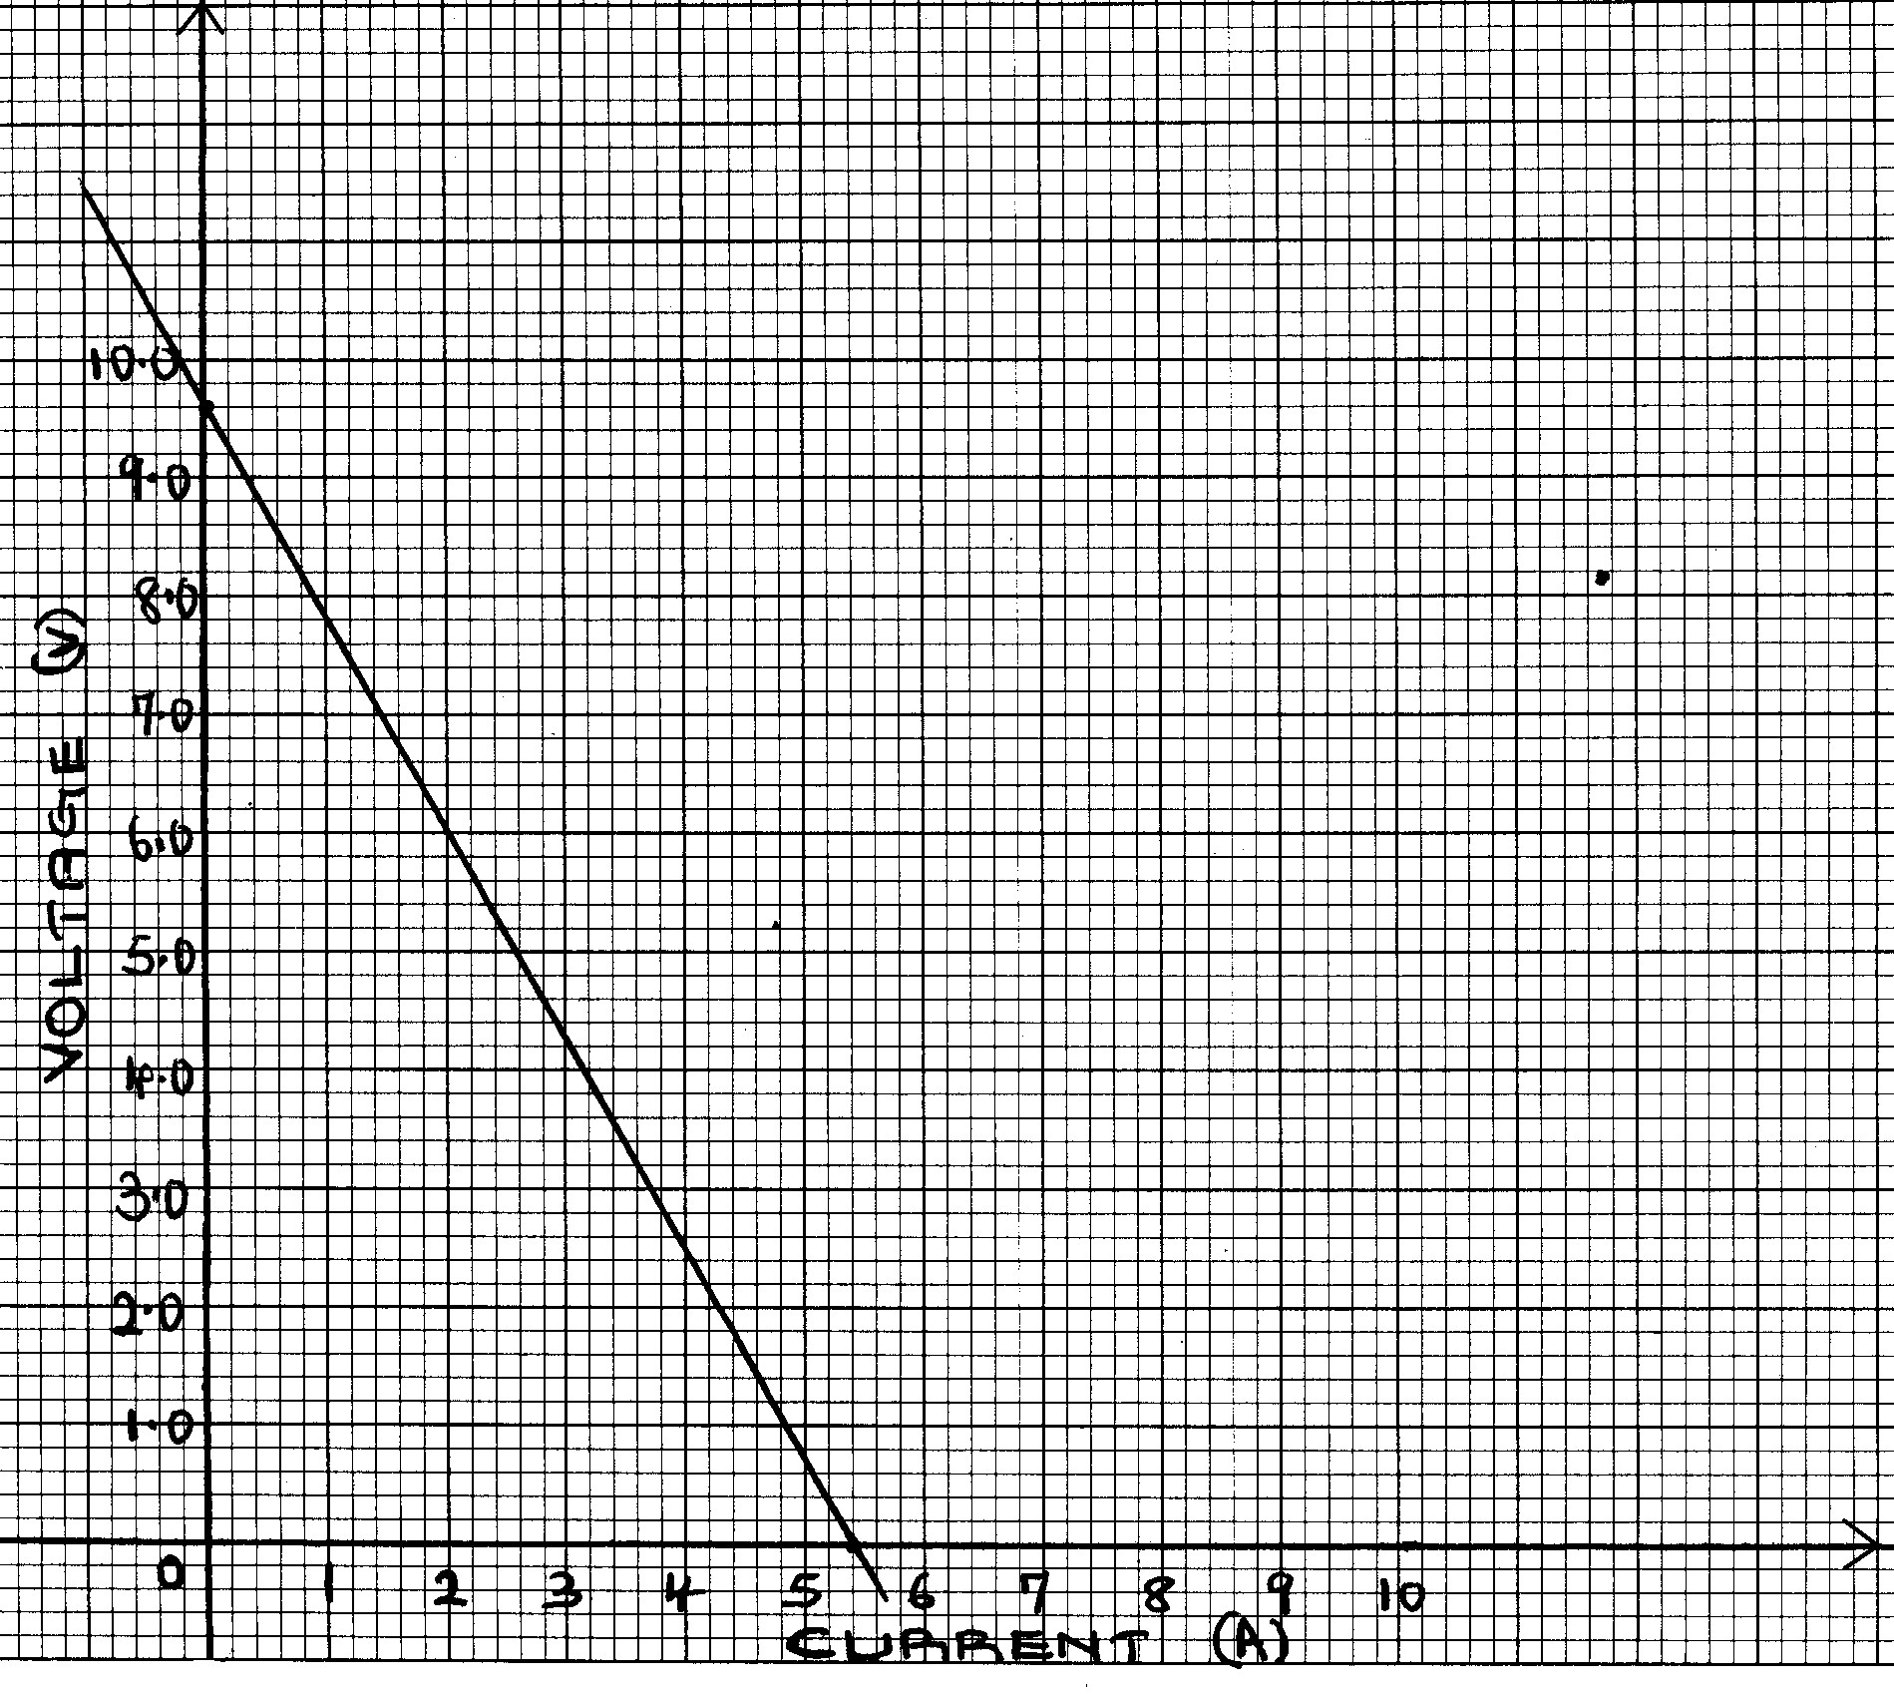

- Draw the circuit that could be used to obtain the results shown on the graph. (2 marks) iii) From the graph determine the e.m.f of the battery. (1 mark)
………………………………………………………………………………………………
……………………………………………………………………………………………..

iv) . From the graph, determine the internal resistance of the battery. (2 marks)
………………………………………………………………………………………………
………………………………………………………………………………………………
…………………………………………………………………………………………….

18. The figure below is drawn to scale (1cm rep 1cm). The focal length of the lens is 3.0 cm.
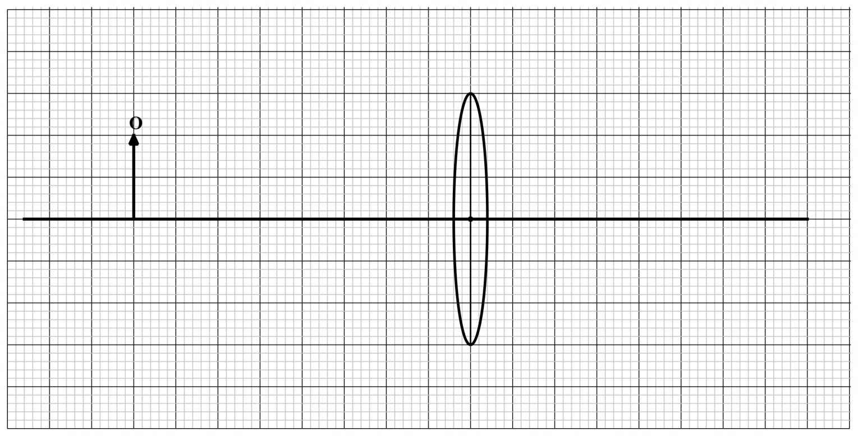

- On the figure above draw two rays from the top of the object O that meet at the image. (2marks)

- Determine the magnification produced by the lens in the above figure. (2 marks)

- The figure below shows a normal eye viewing an object close to it and that of is a Long-sighted eye
Viewing an object at the same distance.


Normal
Eye

Long
-
sighted

Eye

Figure a figure b
Complete figure b to show the rays travelling through the eye. (2marks)

19.a) The diagram on figure shows part of the National Grid system.
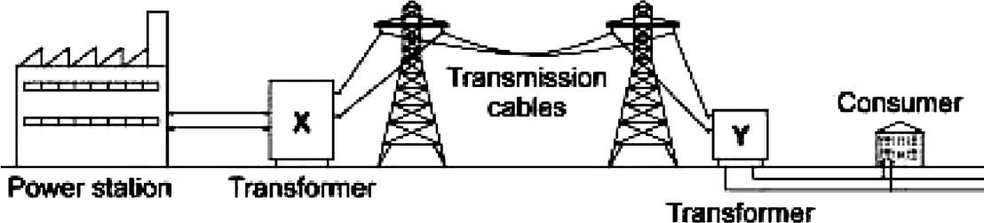

i. State the type of transformer that is placed at the location marked Y (1 mark)

ii.Calculate the cost of using the following appliances in one month (30 days)
If the company rate is Ksh.9.50 per unit. (3mks)

A 2000W water heater for 2 hours per day.
A 75W bulb for 10 hours per day.
An 1500W electric iron box for 1 hour per day

- The figure shows a three-pin plug with parts labeled A, B and C. Study the diagram and answer the and answer the questions that follow.
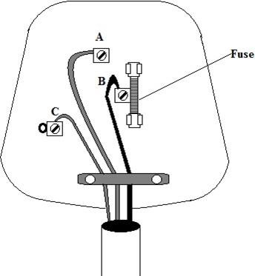

  - Name the plug marked B. (1 mark)
…………………………………………………………………………………………………………
…………………………………………………………………………………………………………

  - Give a reason why why the plug marked A is longer. (1 mark)
…………………………………………………………………………………………………………
…………………………………………………………………………………………………………
- The figure below shows a section of a house wiring system.
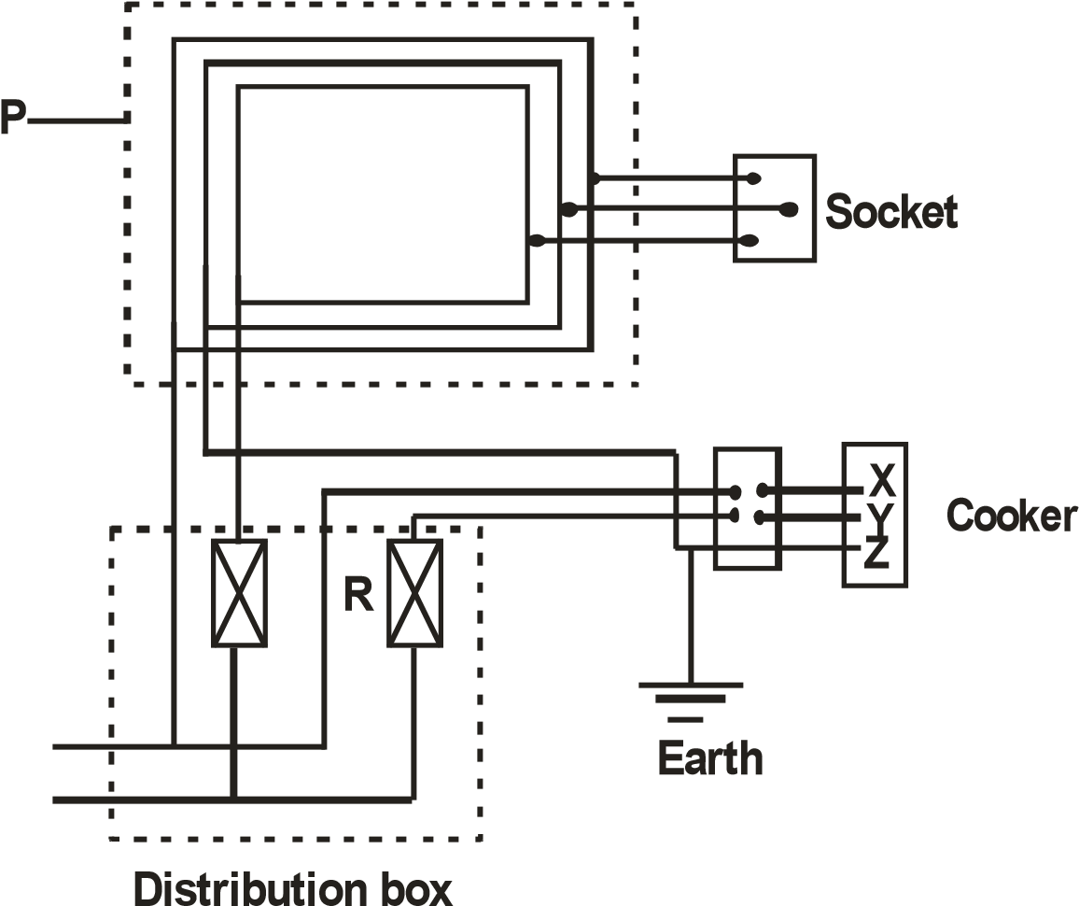
    - Name the circuit labeled P. (1 mark)
……………………………………………………………………………………………………
    - Name the terminals labeled X and Y. (2 marks)
      - ……………………………………………
      - ……………………………………………
iii) State the purpose of R in the circuit. (1 mark)
……………………………………………………………………………………………………
…………………………………………………………………………………………………….

END

