NAME………………………………………………...……. INDEX……………..…………
ADM……………………………………SCHOOL…………………………………..
SIGNATURE…………….…………………………………
232/ 1
PHYSICS
PAPER 1
TIME 2hrs
Kenya Certificate of Secondary Education 2026
INSTRUCTIONS TO CANDIDATES
- Write your name and your class in spaces provided
- This paper consists of two sections, section A and section B
- Answer ALL the questions in each section in the spaces provided.
- Mathematical tables and electronic calculators may be used
- All work must be clearly shown where necessary.
- This paper consists of 12 printed pages

For Examiner’s Use Only
SECTION | QUESTION | MAXIMUM SCORE | CANDIDATES SCORE
A | 1-14 | 25
B | 15 | 10
B | 16 | 19
B | 17 | 10
B | 18 | 08
B | 19 | 8
B | TOTAL | 80

SECTION A [25MARKS]
Answer all questions in this section
- The figure I below shows the reading of a Vernier caliper used to get the diameter of a cylindrical tin.

9
10
11
0
10

If the Vernier caliper had a negative error of 0.02 cm, what is the actual diameter of the tin?
(2 marks)

2 .A body is projected vertically upwards from the top of a building. Assuming that it lands at the base of the building. Sketch the velocity time graph of the motion. (2marks)

3. When a mercury thermometer is used to measure the temperature of hot water, it is observed that the mercury level first drops before beginning to rise. Explain. (2marks)

4. A uniform 120 cm metal rod is pivoted near one of its ends and kept in equilibrium by a spring balance as shown in figure 2.
26cm
12cm

Fig. 2
The reading indicated by the spring balance is 2.0N. Work out the mass of the metal rod. (g = 10N/kg) ( (3marks)

- Heat transfer by radiation is faster than heat transfer by conduction. Explain. [ (1mark)

- The tape shown in figure 3 below was pulled through a ticker timer by a trolley down a runway length. The frequency of the ticker timer was 50Hz
Figure 3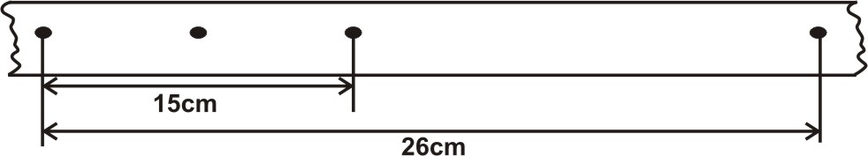
Find the acceleration of the trolley in cm/s² (3mks)

- If you are a weatherman stationed in the arctic region (at the earth poles) state with a reason the thermometric liquid most suitable for your thermometer. (2marks)

- State a reason why more energy is required to change ice from 0⁰C to water at 1⁰C, than to change equal mass of water from 0⁰C to 1⁰C. (1mark)

- State a reason why an air bubble increases in volume as it rises up the surface in a boiler. (1mk)

- A car of mass 800kg is initially moving at 25m/s, calculate the force needed to bring the car to rest over a distance of 20m. (2mks)

- An electric kettle with shiny outer surface is more efficient than one with a dull outer surface, give a reason for this. (1mark)

- The system in figure 4 is in equilibrium
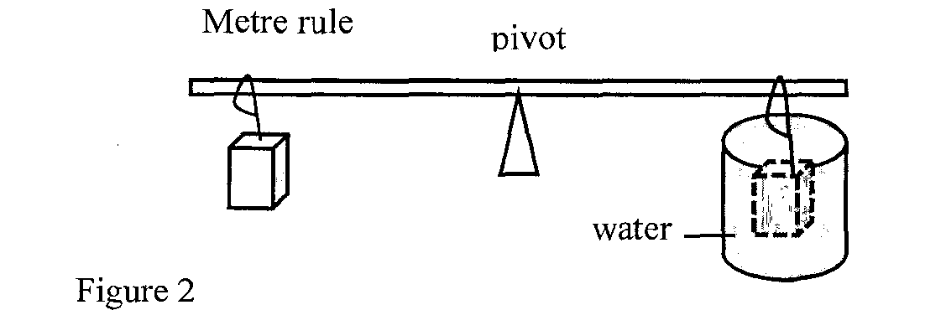

When the temperature of the water is raised the system is observed to tilt to the right, state the reason for this observation (2marks)

- A student observed the smoke particles in a smoke cell and noted that they moved in a random way. Explain this observation. (1mark)

- The figure 5 below shows a glass tumbler filled with water at room temperature.

Glass tumbler

Water
Fig 5
Briefly explain what happens to the stability of the tumbler when water is cooled to a temperature of0º from 5ºC. (2 marks)

SECTION B [55MARKS]

- The figure below shows a set up that can be used to determine the specific heat capacity of a
metal block.
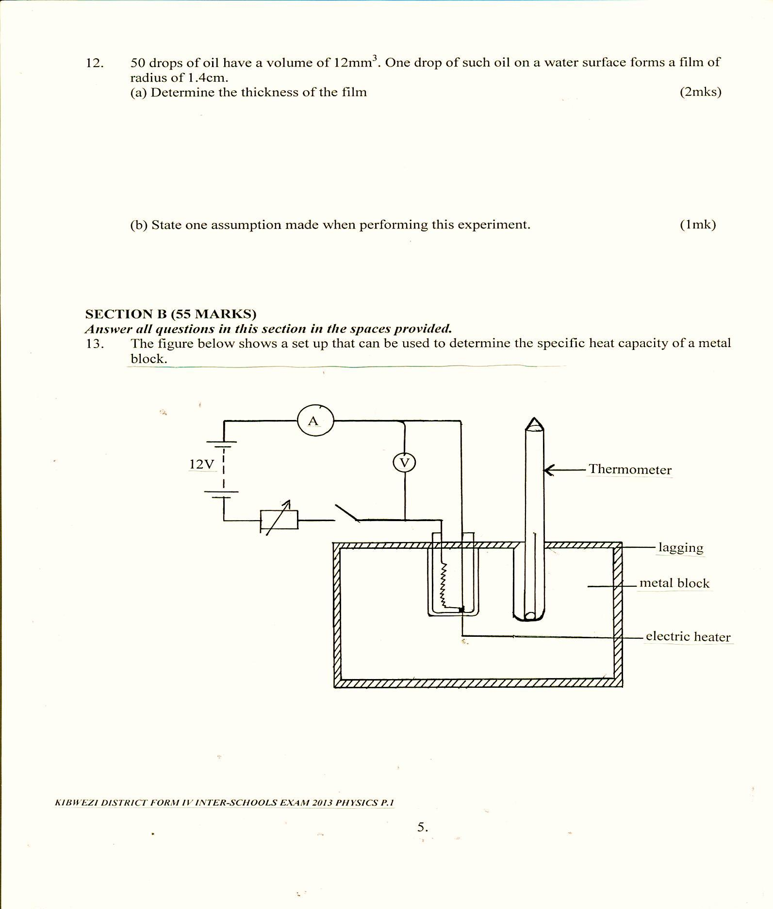

(i) State the measurement that should be taken in the experiment to determine specific heat capacity of the metal block. (3marks)

(ii) Show how the measurement above can be used to determine the specific heat capacity of the metal block. (2marks)

(iii) State the function of the drops of oil in the holes containing thermometer and the electric heater
[1mark]

(b) A copper can together with stirrer of total heat capacity 600J/K contains 200g of water at 15⁰C. Dry steam at 100⁰C is passed through the water while stirring until it reaches a final temperature of 55⁰C. Calculate the mass of the steam condensed. Take specific heat of capacity of water as 4200J/Kg/k and specific latent heat of steam as 2,260,000J/kg (4marks)

- (a) Sometimes work is not done even if there is an applied force. Give a reason (1mk)

(b) A lorry weighing 6400kg is lifted with a jack screw of 11mm pitch. If the handle is 28cm
From the screw
(i) Find the velocity ratio (2mks)

(ii) Neglecting the frictional force, Calculate mechanical advantage, MA (1mk)

(iii) Determine the force applied (2mks)

16.The figure below shows a cork floating on water and held to the bottom of the beaker by
a thin thread

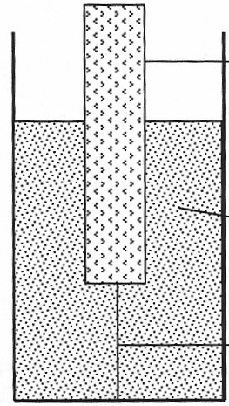
Cork
Water
Thread

(i) Name the forces acting on the cork (3mks)
\

(ii) State how each of the forces mentioned in (i) above changes when water is added into
the beaker until it is filled up (3mks)

- A test tube of mass 10g and uniform cross-sectional area 4cm² is partly filled with lead shots and floats vertically in water with 5cm of its length submerged.
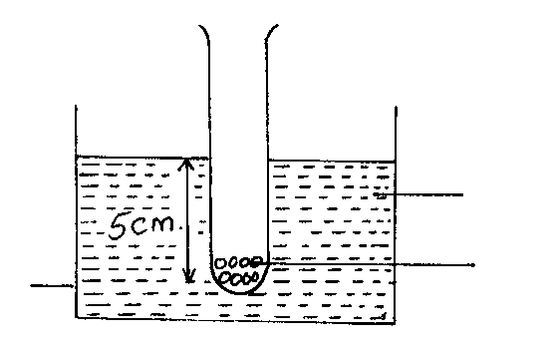
water
beaker
Lead shots in a test tube
Find the Length of the test tube that would be submerged in a liquid of density 0.75g/cm³.Given the density of water is 1g/cm³ (4 marks)

c) Abaloon weighs 10N and it has a gas capacity of 2m³.The gas in the baloon has a density of 0.1kg/m³.If the density of the air is 1.3kg/m³ calculate the resultant force on the balloon when it is floating in air. (3marks)

17. (a) In areas of the world where a plane is unable to land, free fall drops can be used to deliver supplies. A plane travelling at a speed of 80m/s and at a height of 70m releases a package of supplies.
i) Sketch the path of the falling package. (1 mark)

ii) Calculate how far the package will land from the drop zone. (3 marks)

(b) Sketch a velocity – time graph for a body initially moving at a velocity u before a force F acting in the opposite direction is applied to it for 5 seconds and thereafter the force F is withdrawn. (2 marks)

- Explain the importance of safety belts to a passenger in a vehicle. (1 mark)

(d).i) Distinguish between elastic and inelastic collision. (1 mark)

ii) An object of mass 150kg moving at 20ms-1 collides with a stationary object of mass 90kg. They couple after collision. Determine their common velocity after collision. (2 marks)

18.(a)Give reason why a body moving in a circular path with constant speed is said to be accelerating(1mark)

- The graph below was obtained when an experiment to investigate the variation of the centripetal force, F, with the radius, r of the circle on a turn table.
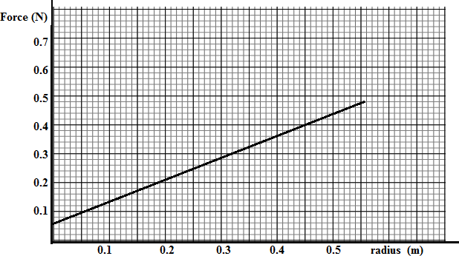
Given that the relationship between force, F, and radius, r, is of the form F = mw²r + C. Where c is a constant. Determine the angular velocity, w and the constant C of the body given that m = 100g (4 marks)

C. Astone of mass 1kg is attached to the end of a string 1m long of breaking strength 600N And is whirled in a horizontal circle on a frictionless table top. The other end of the string is kept fixed. Find the maximum velocity that the stone can achieve without breaking the string. (3marks)

19 a. Figure shows a set up that may be used to verify Boyle’s law.
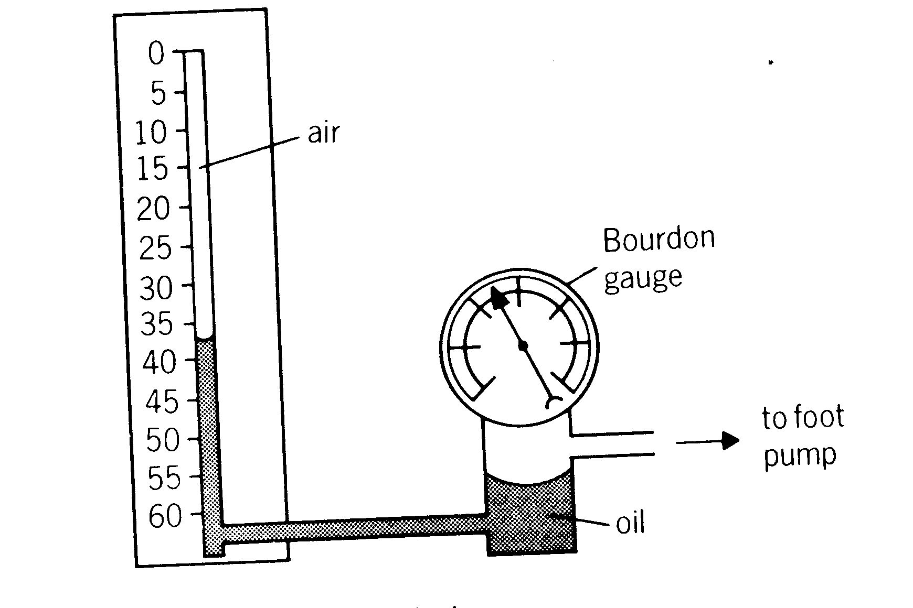

- Describe the measurements that should be taken in the experiment (3marks)

- Explain how the measurements taken in (i) above may be used to verify Boyle’s law (2marks)

(b). A certain mass of hydrogen gas occupies a volume of 1.6m³ at a pressure of 1.5 x 10⁵ N/M² and a temperature of 27⁰C. Determine the volume when the temperature is 0⁰C at a pressure of 8.0 10⁴ N/M². (3marks)

